Department: | PRC | Area: | Horticulture
Subject: | Giant Hogweed Removal SWP

Giant Hogweed Removal SWP
Warning:
The plant exudes a clear watery sap, which sensitizes the skin to ultraviolet radiation. This can result in severe burns to the affected areas resulting in severe blistering and painful dermatitis. These blisters can develop into purplish or blackened scars. Proliferating populations in urban and suburban areas represents an increasing public health hazard.

Background:
Giant Hogweed (Heracleum mantegazzianum) is a member of the parsley or carrot family, Apiaceae (Umbelliferae). As its name indicates it is characterized by its size and may grow to 15 to 20 feet in height. Except for size, it closely resembles cow parsnip, Heracleum lanatu. It is further distinguished by a stout dark reddish-purple stem and spotted leaf stalks. Stalks and stem produce sturdy pustule bristles. The stem and stalks are hollow. Stems vary 2 to 4 inches in diameter. The compound leaves of giant hogweed may expand to five feet in breadth. Each leaflet is deeply incised. Giant hogweed is a perennial with tuberous root stalks, which form perennating buds each year. The inflorescence is a broad flat-topped umbel composed of many small white florets. Each inflorescence may attain a diameter of 2-1/2 feet. The florets produce large elliptic dry fruits marked with brown swollen resin canals up to 1 mm in diameter. Targeting all known populations for control will prevent the further spread of giant hogweed.
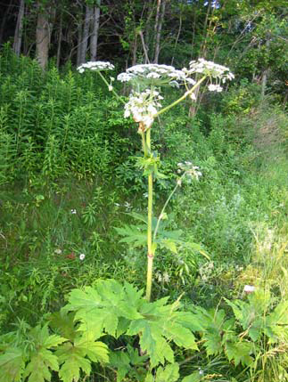

Hazards:
- Severe skin damage and or blindness caused by contact with sap.

PPE Required:
- Safety footwear | - Thick long pants and long sleeves or coveralls. | - Safety glasses
- Long hair tied back | - Thick high wristed chemical resistant rubber gloves. | - First Aid kit

Pre Set-Up:
- Tools needed: heavy duty large garbage bags, bypass loppers, spade shovel
- Check the area where plants are to be removed for overhead or tripping hazards.
- Ensure all your PPE is on and all required tolls and equipment are with you.

Procedure:
- Make sure you have properly identified the plant.
- Use loppers and start to cut off small sections of the plant.
- After each cut securely place in garbage bag.
- Ensure you are not stepping into nearby Hogweed plants.
- When plant is cut down and securely in the garbage bag dig out as much of the root mass as possible with your spade shovel and place in bag.
- When you are satisfied you have removed all of the Hogweed, securely tie your garbage bag(s) closed.

Post Procedure/Take Down:
- Dispose of Hogweed in City of Nanaimo secured garbage bins.
- Dispose of or wash your gloves.
- Rinse off your loppers or anything else that may have contacted sap.
- Change your clothes or dispose of disposable coveralls.

Summary:
- Wear PPE.
- Be aware of your surroundings.
- Exercise extreme caution.

First Aid:
- If your skin comes into contact with the sap, wash immediately and thoroughly with soap and water. Remain out of direct sunlight for 48 hours.
- If sap should get in your eye, rinse thoroughly, stay out of direct sunlight, and seek medical attention.

Please contact Jason Duchak @250.755.4411, if you have any questions regarding what is expected for the procedure or for clarification.

Created: 2010-Jul-28  Revised: February 8, 2011 | Author: Patrick McIntosh  Approved by: Gail Pasaluko

