

“Backed Up Sewers - Call before you Clear” – procedures

Stay safe. Don’t risk hitting a natural gas line inside a sewer line. Call Before You Clear.
It’s important that you know what’s inside the pipe before using equipment to clear it. Some natural gas lines were installed in a way that may have caused the gas line to cross through a sewer service line. Also called cross bores, these intersecting lines can go undetected until clearing a blocked sewer service line damages the natural gas line.

If rotating equipment or water jets rupture the cross bore, a natural gas leak could result. That’s why it’s vitally important to find out if natural gas lines may be intersecting the sewer line before beginning work to clear a blocked sewer.

 | ​
  ​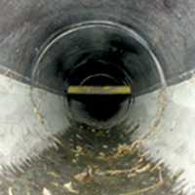
  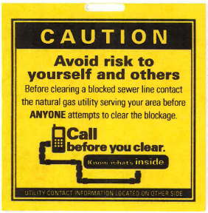
  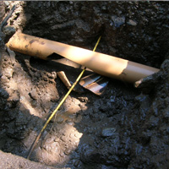
To protect yourself, co-workers, and the public, follow these steps when you receive a call regarding a backed up sewer and before anyone attempts to clear the sewer pipe.

- Call (604) 257-1940 or 1-800-474-6886 (BC One Call - Call Before You Clear).
- Inform the agent you are calling about a “sewer service line blockage.”
- Provide the agent with your name and who you work for.
- Provide the agent with your cell phone number so they can contact you directly.
- Provide them with the location (i.e. address of the house) of the blocked sewer service or sewer main.
- Answer any other questions and provide as much information as possible to the agent.
- The agent will provide you with a ticket number. Record the ticket number.
- Record the time you called the agent
- Record the time FortisBC arrives.

Once off the phone with the agent, wait for FortisBC to call you. The agent will notify FortisBC immediately and FortisBC will make every effort to respond in two hours or less to locate gas lines. They treat the call as an emergency. It’s a free service available 24 hours a day.

When FortisBC calls you, they may ask for further details and information. They will examine their records to determine if any potential conflicts exist between their natural gas pipes and whether an in-sewer camera inspection may be needed. They will inform you a crew has been sent out to perform an inspection and locate. The FortisBC crew should be on site within an hour of the call. FortisBC works with professionally trained sewer camera contractors who can be sent to your location to complete an inspection. The contractor uses a special camera that goes inside the sewer pipe to identify any conflicts or “cross bores” with underground natural gas lines.

Once the FortisBC crew has performed the inspection, locate and assessed the situation, they will provide you with instructions on when you can proceed with the work (i.e. to clear the line).

OHS 2014

