Gripping | Compounding Factors | Comments/Recommendations?
- 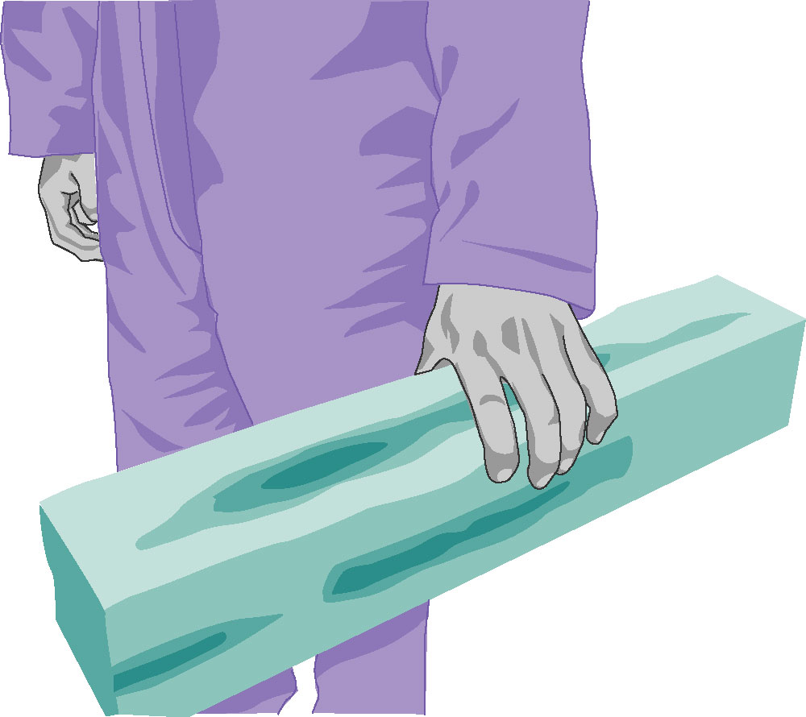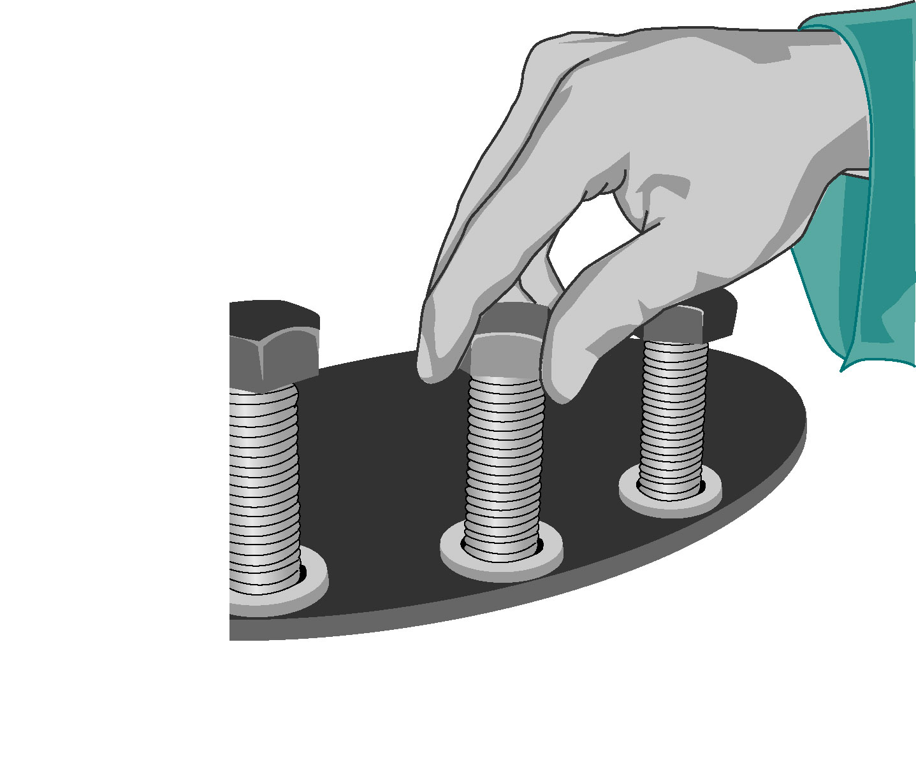Is there pinching of objects with the thumb or strong gripping with the hand? | - Grip too narrow or too wide
 | - Object is slippery
 | - Awkward wrist posture
 | - Contact stress in the hand
 | - Glove style and fit is wrong
 | - Vibration is present
 | - No handles or cut-outs
Lifting/Carrying | Compounding Factors | Comments/Recommendations?
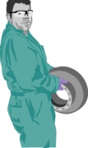  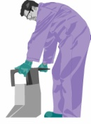  - Is there heavy, awkward or frequent lifting or carrying? | - Unilateral lift (one handed lift or carry)
 | - Grasp is poor (no handles or cutouts)
 | - Twisting is required
 | - Load is unstable
 | - Restricted space for movement
 | - Ground surface is rough or slippery
Pushing/Pulling | Compounding Factors | Comments/Recommendations?
- Is there heavy whole body pushing/ pulling?  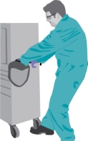 | - Unilateral (one handed activity)
 | - Only upper body is used (not legs)
 | - Hand height when pushing/pulling is below waist
 | - Poor wheel design, maintenance or improper size
 | - Ground surface is rough, slippery, sloped, etc.
 | - Restricted space affecting body movement
Awkward Postures | Compounding Factors | Comments/Recommendations?
- 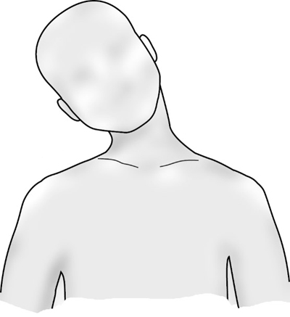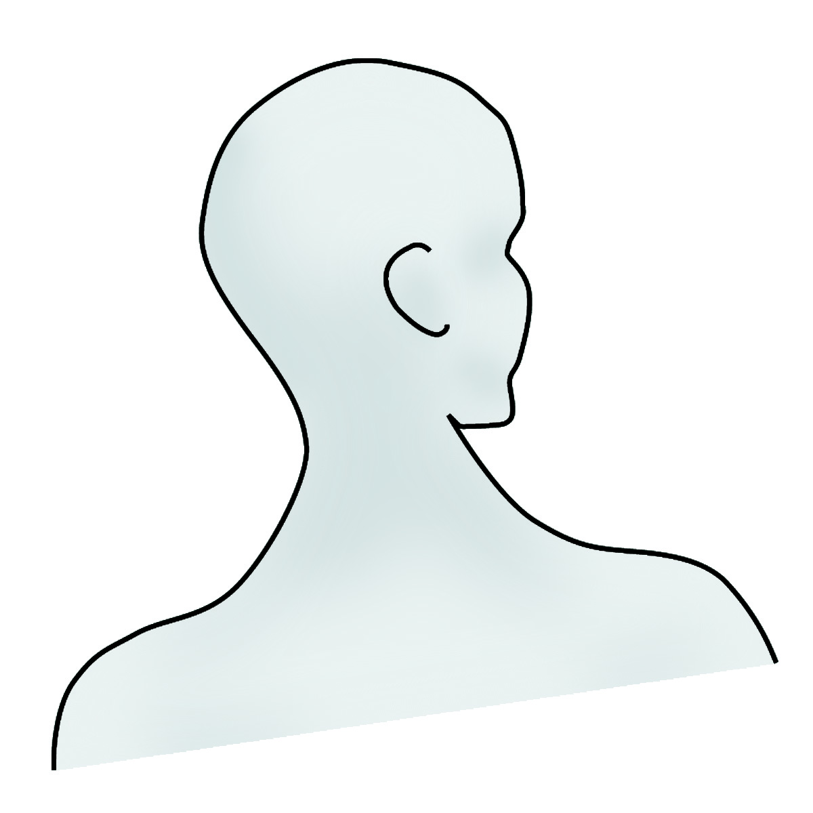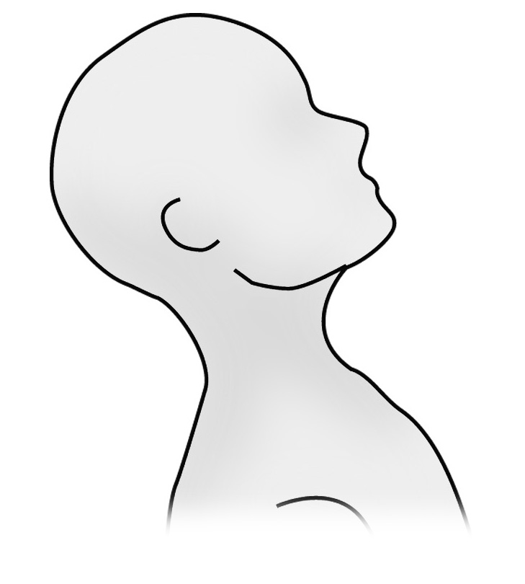Is there neck bending or twisting?
- 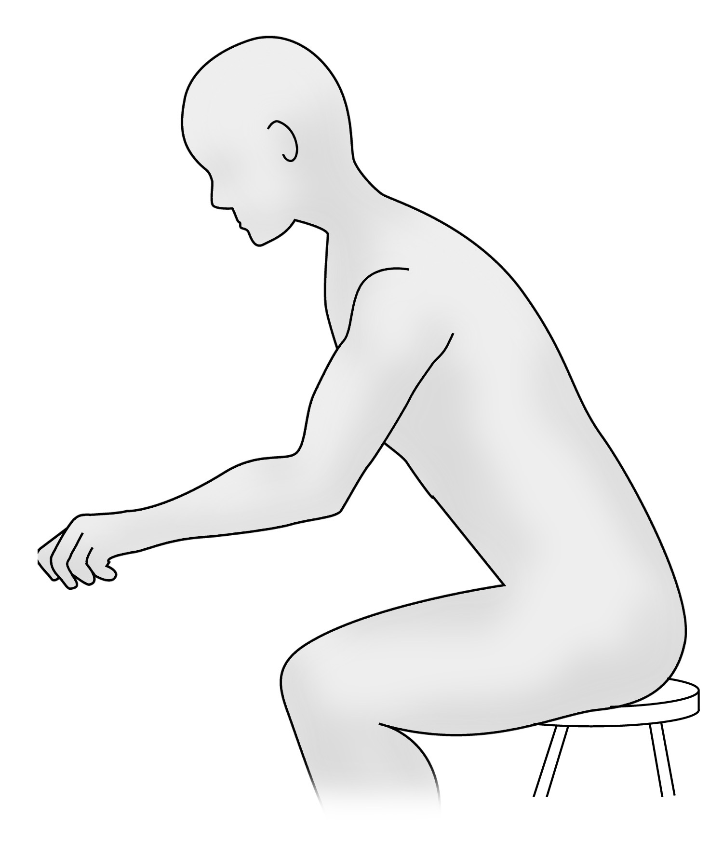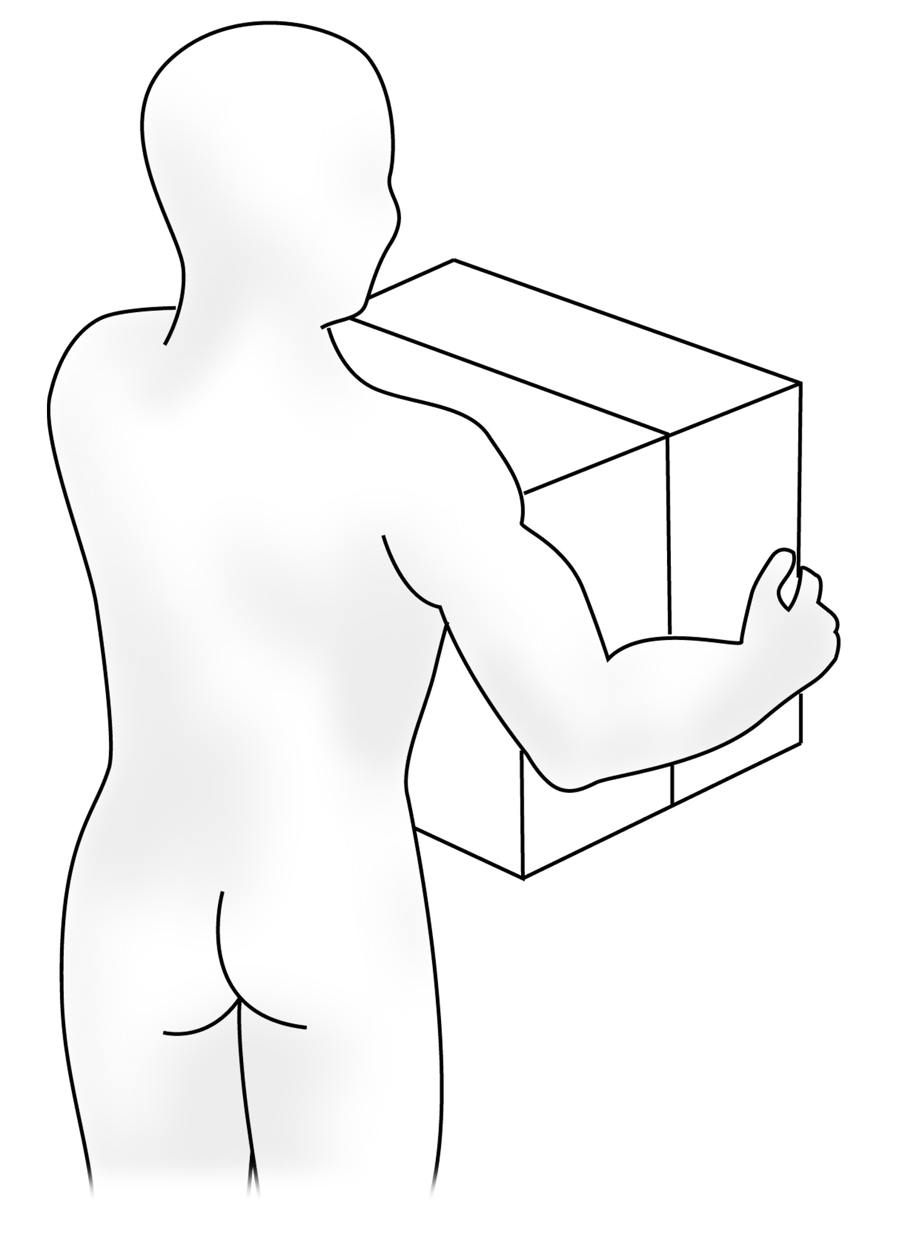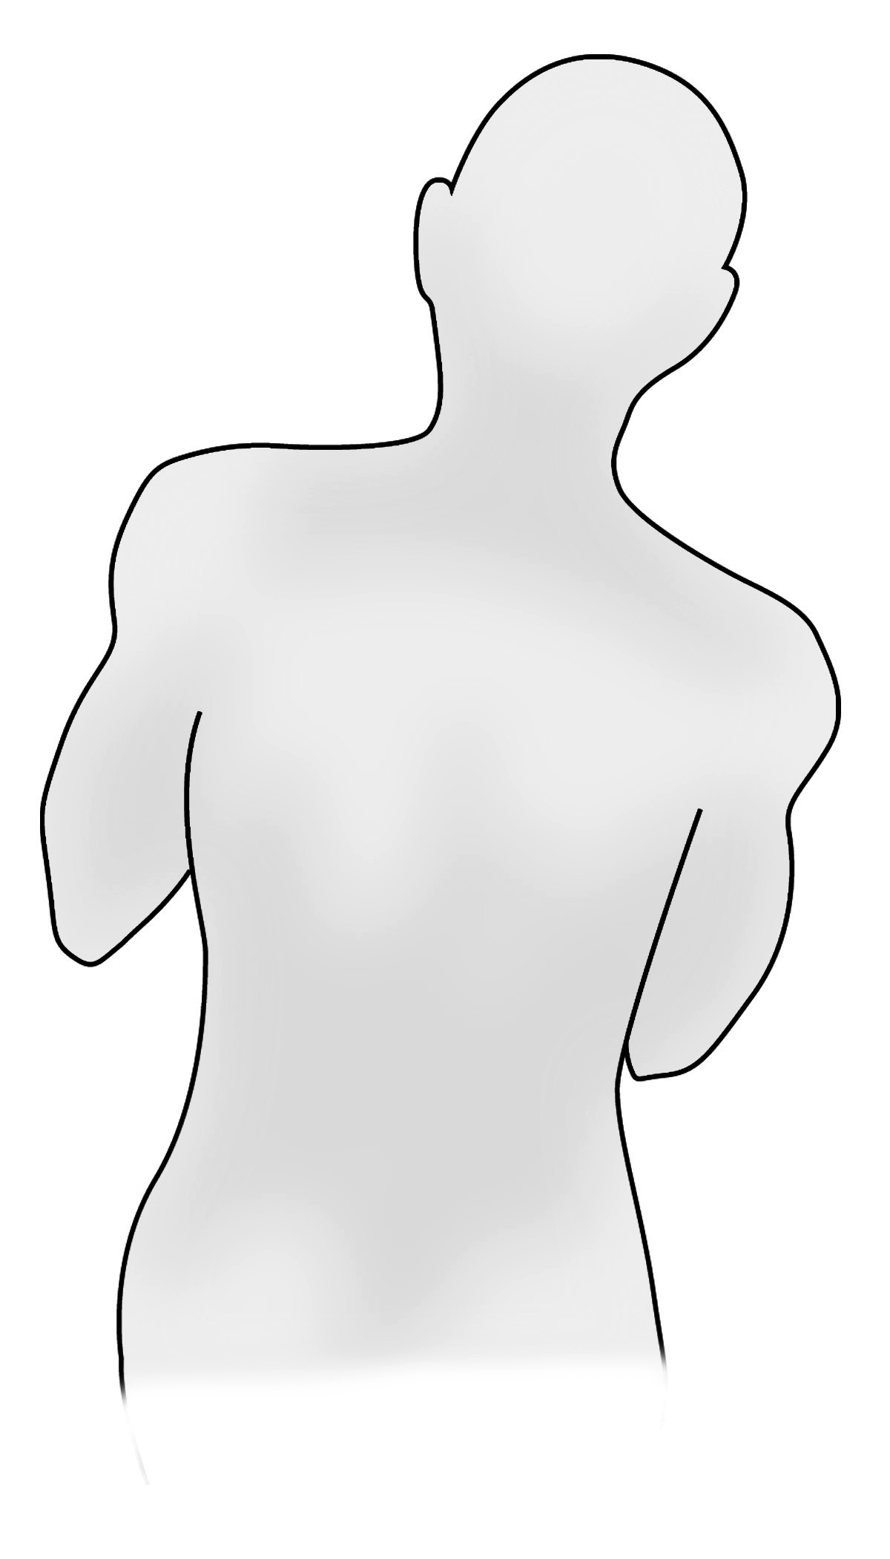Is there back bending or twisting?
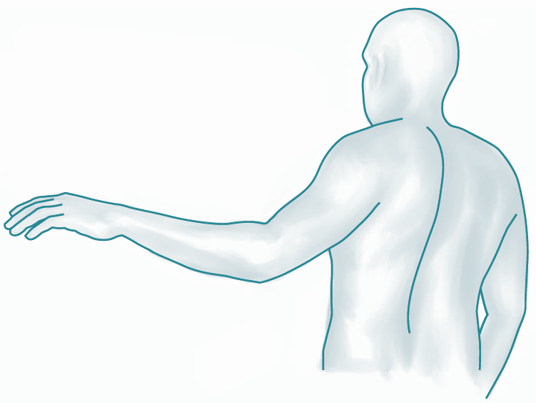
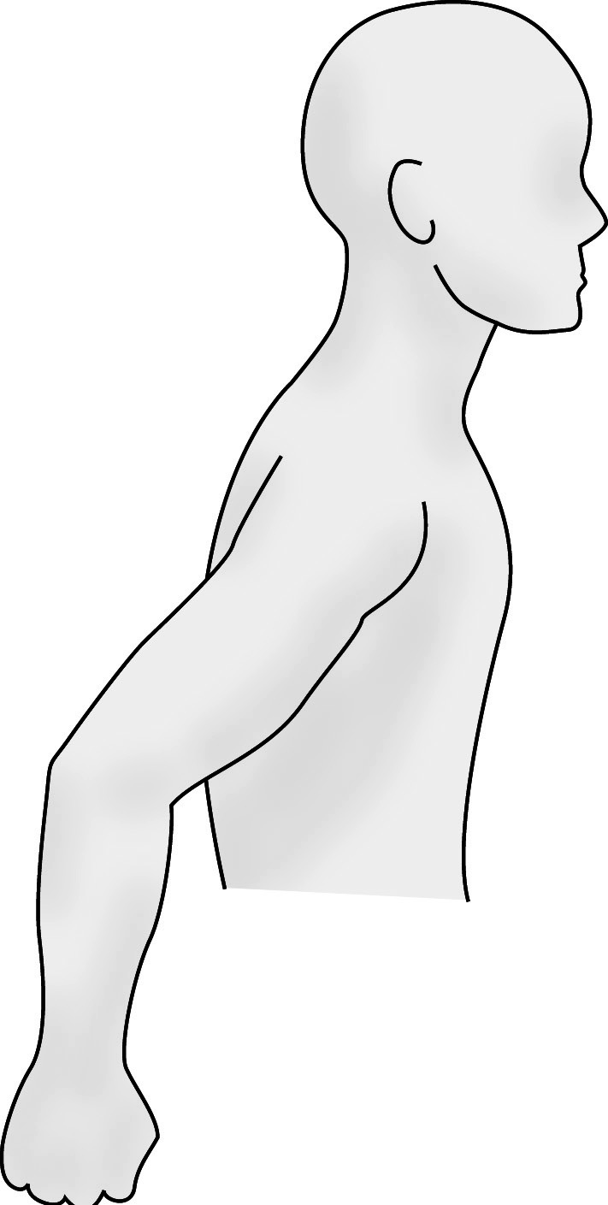
- Do the elbows extend away from the body?
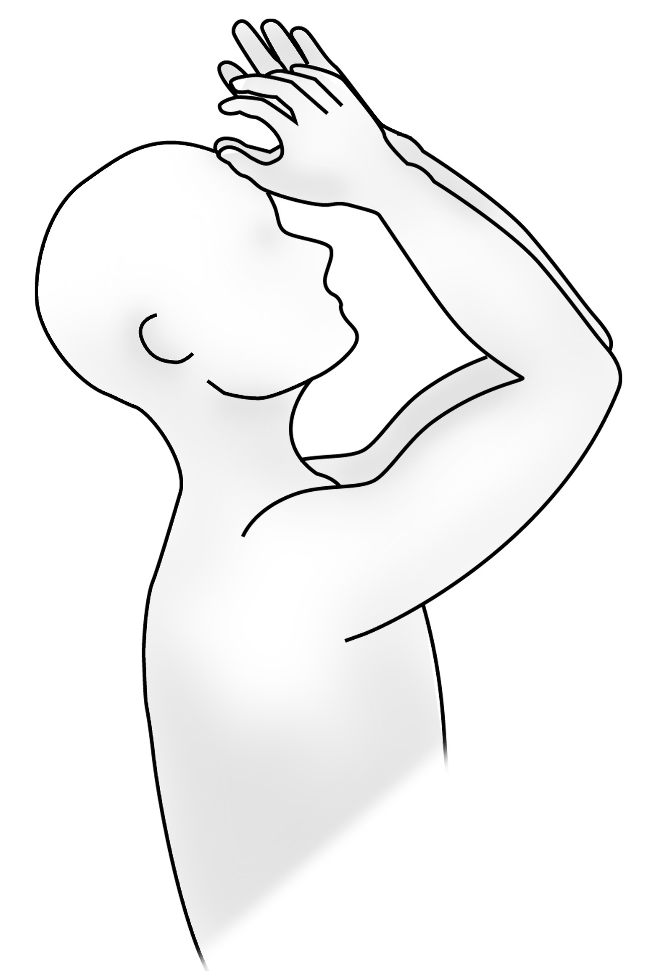
- Do the hands reach above shoulder height?
- 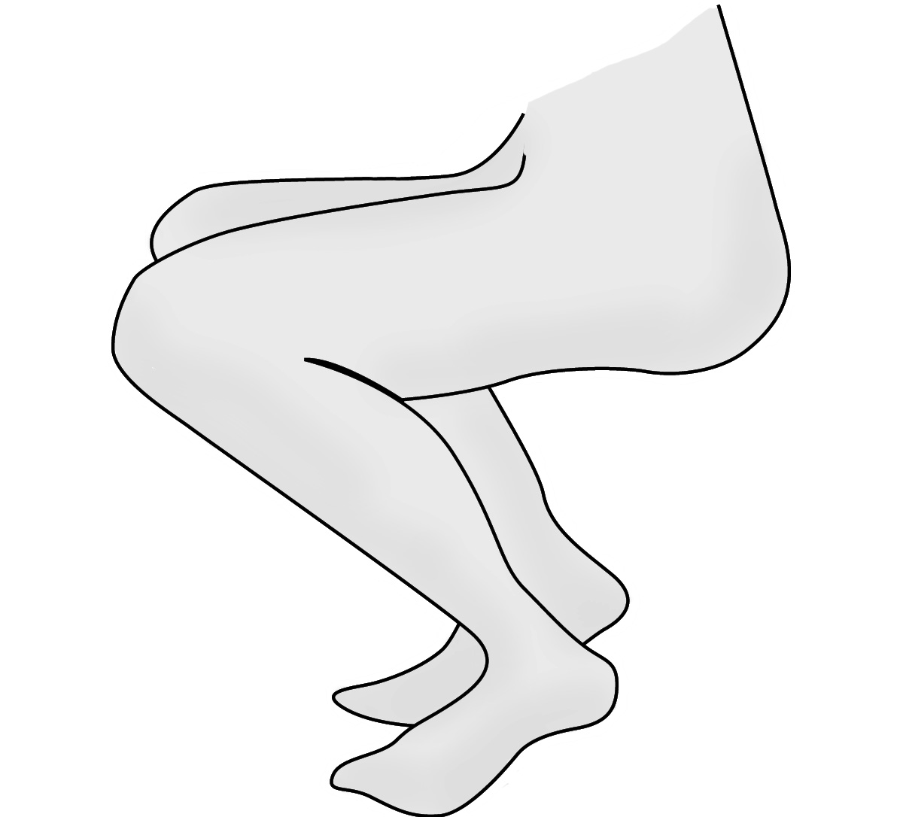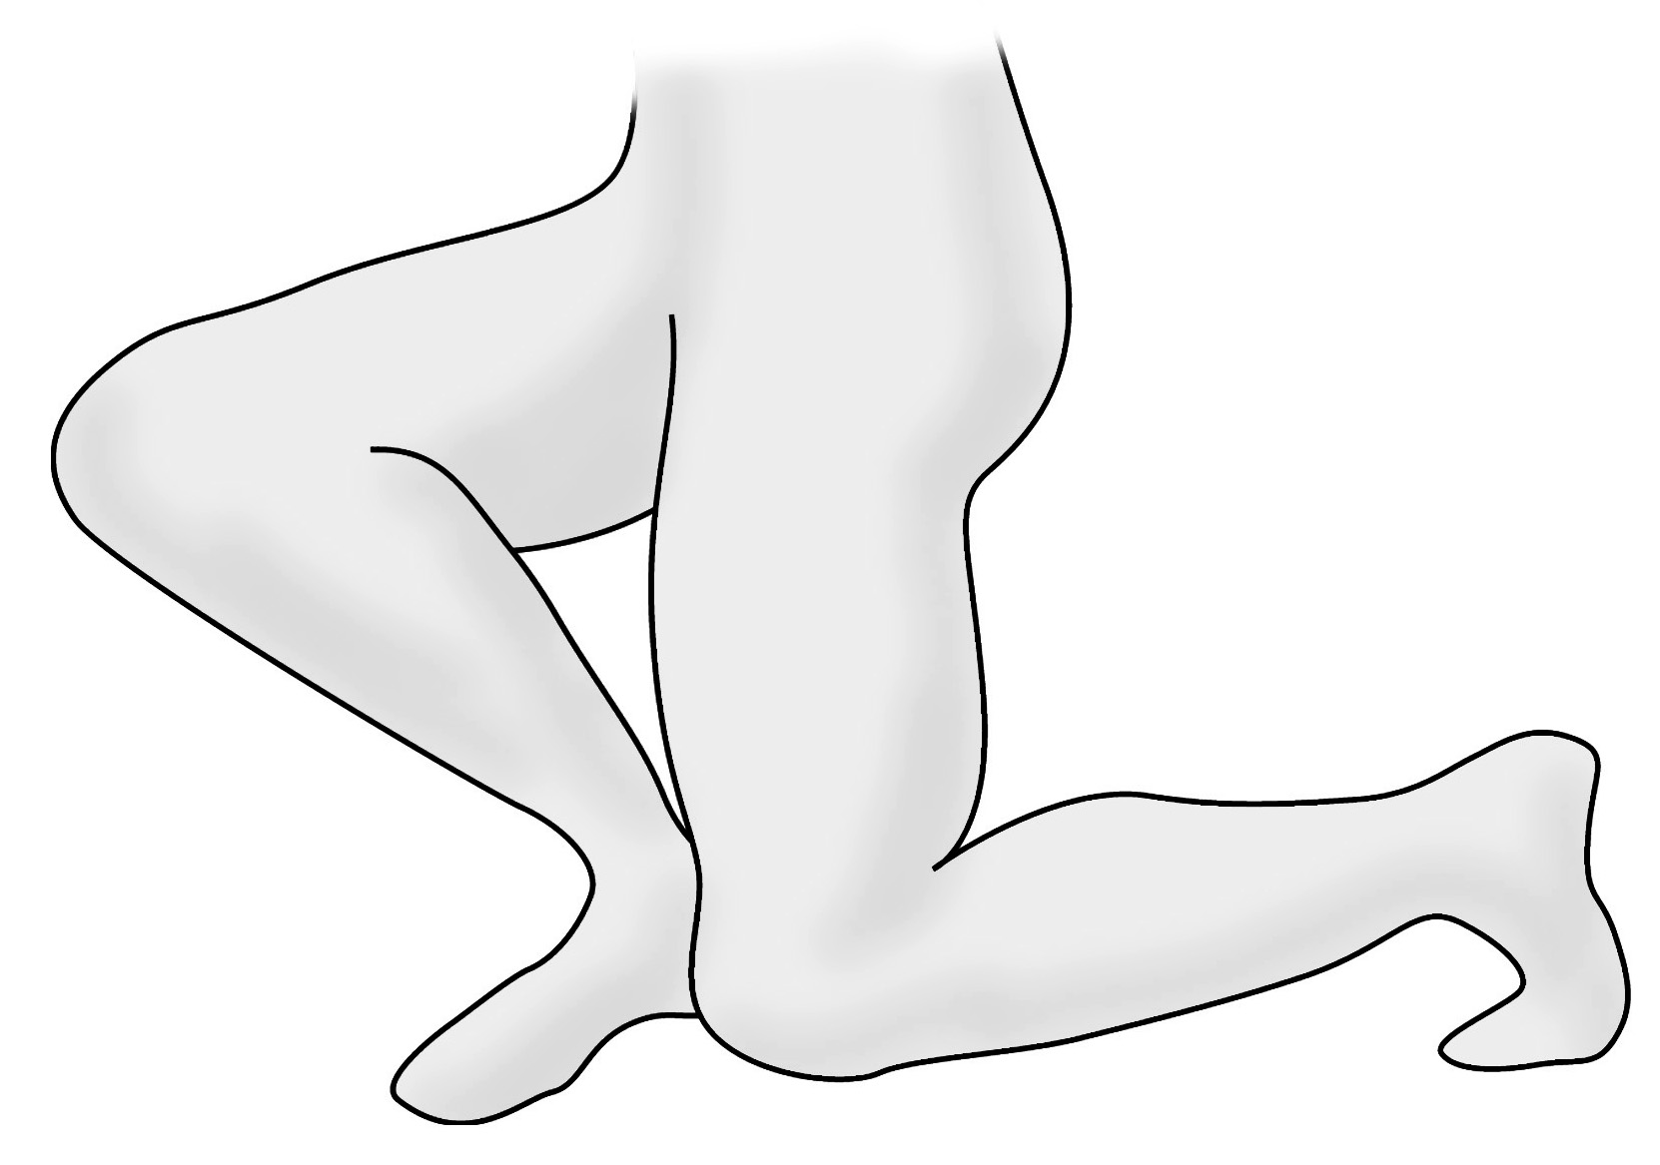Is there squatting or kneeling?

Static Postures | Compounding Factors | Comments/Recommendations?
- Is there standing in one spot for a period of time? | - Hard ground or floor surface
 | - Rubber or steel toe footwear
 | - Standing surface is vibrating
- Is there sitting with no backrest? | - Poor chair design
 | - Inadequate clearance for legs
Repetitive Actions | Compounding Factors | Comments/Recommendations?
- Are repetitive movement’s performed every few seconds? | - Combined with awkward postures
 | - Combined with forceful exertions
Walking | Compounding Factors | Comments/Recommendations?
- Is there walking over rough, uneven, sloping or slippery surfaces?  - Is there climbing on stairs, ladders or equipment? | - Work boots are worn
 | - Vibration from walking surface
 | - Specific pace required
Whole Body Vibration | Compounding Factors | Comments/Recommendations?
- Does the worker sit or stand on vibrating ground, machinery, vehicles or equipment? | - No air suspension system
 | - Road/ground surface is rough
Segmental Vibration | Compounding Factors | Comments/Recommendations?
- Are vibrating tools used? | - While wearing gloves
 | - Used in cold or wet environment
 | - High grip force required
Contact Stress | Compounding Factors | Comments/Recommendations?
- Is knee or hand used as a hammer?
- Is part of the worker leaning against a hard or sharp surface, or is an object pressing into worker’s flesh?

Main Concern(s): ______________________________________________________________

____________________________________________________________________________

____________________________________________________________________________

____________________________________________________________________________

____________________________________________________________________________

