Right To Refuse Unsafe Work
Parks Maintenance Edger

Case Study

Cori began working in park maintenance as a grass cutter approximately three weeks ago. It is her first "real job" since graduating from high school and she is the youngest member of the crew. One of her workmates has an appointment and is going to have to leave the worksite for the remainder of the day. Cori's supervisor Mark asks her to take over operating the powered grass edger. The edger is a unique old machine that has been around for years and is designed to cut a border along the edge of the sidewalks and prevent the grass from growing over onto the concrete.

Cori has no experience in using this machine or anything like it. She is nervous about operating it, especially since she has heard a story that a couple years ago a temporary parks employee lost part of a big toe while operating the edger. She tells Mark that she is nervous about operating that piece of machinery. Mark responds that she will be fine and that she needs to do the job whether she likes it or not and they can talk about it later. She sees the other crew members watching her and she doesn't want them to think she is a wimp who can't do her share of the work. She is also worried that if she makes waves she will ruin her chances of getting on as a permanent member of the crew.

However, Cori decides to try to talk with Mark one more time about her concerns. Mark is impatient and tells her they are shorthanded as it is and he doesn't have time to listen to her complaints. If she can't handle the work maybe she shouldn't be working there.

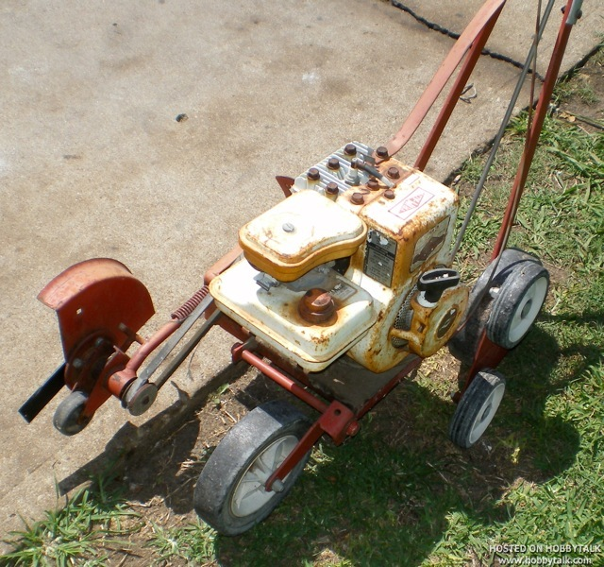

Answer questions on the following page.
Questions

PART A:

Would Cori be justified in refusing to use the edger? Why or why not

PART B:
Assume that Cori decides to refuse to operate the edger. Answer the following questions about the work refusal.

- What must Cori do when she decides to refuse?

- Who must investigate her report of a refusal to work?

- If Mark decides that the report is not valid, can Cori continue to refuse the work?

- What if this still does not resolve the matter?

- What protection against reprisals does Cori have?

- Can Cori be assigned to other work until the matter is resolved?

PART C:

What factors may have influenced Cori’s decision to do the work?

p:\oh&s\bcfl course materials\participants booklet\right to refuse unsafe work.docx/kn

