Alternate Measures of Control (AMC)

for Fine Screens (2) Confined Space Entries

Medium Hazard Atmosphere

City of Penticton AWWTP

January 11, 2017

**Alternate Measures Submission Elements:**

1. The two confined spaces are rectangular concrete channels that each house fine screen equipment. The fine screens are located just east of the plant entrance in the Headworks building. The channels are 1.2 m wide x 1.7m deep x 5 m long. There are two adjacent concrete channels, the inlet (upstream) channel and the outlet (Downstream) channel. The inlet (Upstream) channel is gravity feed from the Influent screw pumps and is typical of municipal raw wastewater (Typical water level (TWL) 600 mm). The outlet channel (downstream) is gravity feed from downstream of fine screens (TWL 400 mm).
2. The space is isolated by:
   1. The inlet gravity feed channel has a Armtec 1200mm x 1700mm aluminum in channel mounted gate for each fine screen (2). They were installed in 2012, and are exercised at a minimum annually (no provision for double block and bleed or blanking). Drawing attached. The total head pressure of water from the upstream channel to the bottom of fine screen channel is 700 mm or <1 psi of head pressure
   2. The outlet gravity feed channels (2) have 1200mm x 1700 mm Armtec in channel mounted hand pull gates. They were installed in 2012 and are exercised at a minimum annually (no provision for double block and bleed or blanking). Drawing attached. The total head pressure of water from the upstream channel to the bottom of fine screen channel is 500 mm or <1 psi of head pressure.
3. Glenn Robertson, CRSP the City’s Safety Coordinator 250-490-2553 [glenn.roberston@penticton.ca](mailto:glenn.roberston@penticton.ca) administers the Confined Space program for the City of Penticton. Glenn Robertson and Randy Craig (AWWTP Supervisor) prepared the Alternate Measures and Hazard Identification/Risk Assessment (HIRA). This AMC includes information from Gary Marsden (Op III) and Gord Austrom (Op III), workers health and safety representatives at the AWWTP
4. Hazards to be addressed see the attached HIRA. The characteristic of the water on both the upstream and downstream side is that of typical raw municipal wastewater. No work will be performed that will contribute to the likelihood of material flowing into the space. Work to be performed under this AMC includes both corrective and preventative maintenance as per the equipment manufacturers Operation and Maintenance manual.
5. Alternate Measures;

* The analysis of valves as a control measure should assume that all valves leak. However, there is no expectation that a properly installed and maintained valve will fail catastrophically if no work is being performed on it. It is recognized that systems will often permit some leakage; a means of pumping out the fluid will be undertaken.
* Any potential leakage from the upstream gate will be visually checked every 20 minutes by the standby person. The water level in the upstream channel will be continuously monitored with a local audio/visual high level float set to 1.2 m while space is occupied. If the water level rises above 1.2 m the alarm will sounds and a light will flash (leaving 500mm of freeboard). The confined space will be evacuated and the issue will be addressed prior to re-entry.

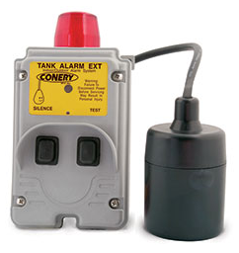

* Any potential leakage from the downstream gate will be visually checked every 20 minutes by the standby person he water level in the downstream channel will be continuously monitored with a local audio/visual high level float set to 1.2 m while space is occupied, if the water level rises above 1.2 m the alarm will sounds and light will flash (leaving 500mm of freeboard) and the confined space will be evacuated and the issue will be addressed prior to re-entry.
* See medium hazard entry procedure for ventilation and atmospheric monitoring requirements
* Communication will be verbal between worker and stand-by person. The stand-by person will have radio and cell phone contact
* See attached emergency procedures

1. Workers will be orientated to this AMC and required to sign off on their orientation
2. AMC will be supervised by AWWTP Supervisor and regular visits documented
3. Time frame that the AMC is needed is 3 years, with annual engineering reviews

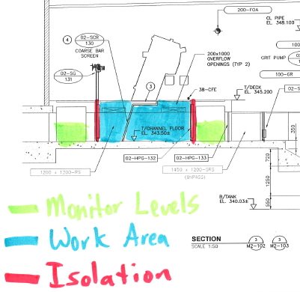

1. One worker will be allowed in the space only
2. The standby person will attend the confined space continuously
3. Decontamination of worker; worker in space will be wearing long sleeve coveralls and all pertinent PPE and if any contamination occurs, coveralls and PPE will be removed and laundered by our coverall service provider (Unifirst). There will also be an emergency wash station available to the worker at the site. Worker can shower if any area of their body gets contaminated.
4. Admin controls included in HIRA are; 3 point stance when on ladder, clean channel floor, good housekeeping, source of CO away from blower, pre flushing of space & sharps.
5. Leakage will be monitored by standby person and controlled with a small submersible pump installed in channel
6. If we had to extract the worker it would take <30 sec, to winch him out
7. Response time by the Fire Department is from Station 201 the response time from time of call would be 7min depending on traffic and road conditions
8. Fixed gas detection alarm set points in the headworks building are set at H2S low 5 ppm, high 10 ppm. LEL low 5 % LEL and high 10% of LEL
9. Portable gas detector (Industrial Scientific Ventis MX4 <http://www.indsci.com/products/multi-gas-detectors/ventis> ) used to monitor the confined space. The alarm set points are set at; H2S low 5 ppm, high 10 ppm. LEL low 5%, high 10%. CO Low 13 ppm, high 25 ppm, STEL 100 ppm, TWA 25 ppm. O2 low 20.5%, high 23.5 %
10. Evacuation will be by a Pelsue davit arm <http://www.pelsue.com/product/davit-arm-retrieval-system-2/> side mounted to the concrete channel. Rescue Winch is a DBI Self Retracting Lifeline (SRL) model # 23403-1 s/n # 033794, it was certified by Carleton Rescue on Jan 16th 2016
11. Historical records of fixed gas detection alarms in headworks building are not data logged, however in the last 2 years (far back as our records go) there have been no alarms to SCADA
12. Depth of the channel is 1.7 m
13. Air Changes in the headworks building are provided by local HVAC is 12 Air Changes per hour. Volume of channel empty is 10.2 m3, blower outputs 3000 cfm = 84.9 m3/m. 8.3 Air Changes per minute x 60 minutes = 500 air changes per hour.