QUALIFIED PERSON  Randy Craig Wastewater Treatment Plant Supervisor | DATE PREPARED  2018-12-19
TECHNICAL INFORMATION BY
Kelly Kaye Bsc, Randy Craig, Jason Jeffrey

INDEX OF SECTIONS
- Scope  - Description of Space  - Limitations  - Equipment & PPE Summary Checklist | - Overall Atmospheric Hazard Rating  - Hazard Identification & Risk Assessment  - Planning & Preparation  - Isolation & Lockout  - Ventilation | - Atmospheric Monitoring  - Equipment & PPE  - Supplementary Instructions  - Rescue Plan

- SCOPE
This Confined Space Entry Procedure and Rescue Plan are to be used for entry for the purpose of inspection and routine maintenance within a Sewer Lift Station with a mid-level platform when workers descent below the platform into the wet well.

Typical work procedures include:
- Pump base maintenance repairs or installing a pump base
- Rail install or re installing a rail that has dropped off the base
- Discharge piping repairs or replacement
- Isolation valve maintenance, repairs or replacement
- Check valve maintenance, repairs or replacement
- Flygt bulb maintenance, repairs or replacement
- Ultrasonic maintenance, repairs or replacement
- Removal of a stuck pump on base
- Pressure gauge and or pressure transmitter maintenance, repairs or replacement
- Removal of debris if remote means are unsuccessful
- Wet well structure (both concrete and fiberglass) inspection, repairs (could include grouting, application of specialized coatings) or Fiberglass repair/inspection
- Drilling in mounting brackets for instrumentation

Work below the platform (in the wet well) will require the station be isolated from influent sewage. This will be accomplished by installing Engineered plugs into the influent pipe(s) and either utilizing vacuum trucks or bypass piping and pumps upstream of the station to remove any sewage accumulation in the line. The pump being worked on will be de-energized and the isolation plug valve closed. The second pump will remain operational (energized). This will allow, in the event the engineered plug, bypass pumping or vacuum truck fails, for the operational pump to pump down the wet well. The entrant will immediately exit the station if this occurs.

 | Sewer lift Stations Included in this group include: | Address
 | - Lee Avenue | 3601 Parkview
 | - Wilson Street | 331 Wilson Street
 | - Marina (Front Street) | 201 Marina Way
 | - South Okanagan Events Center | 400 Alberni Street
 | - DESCRIPTION OF SPACE
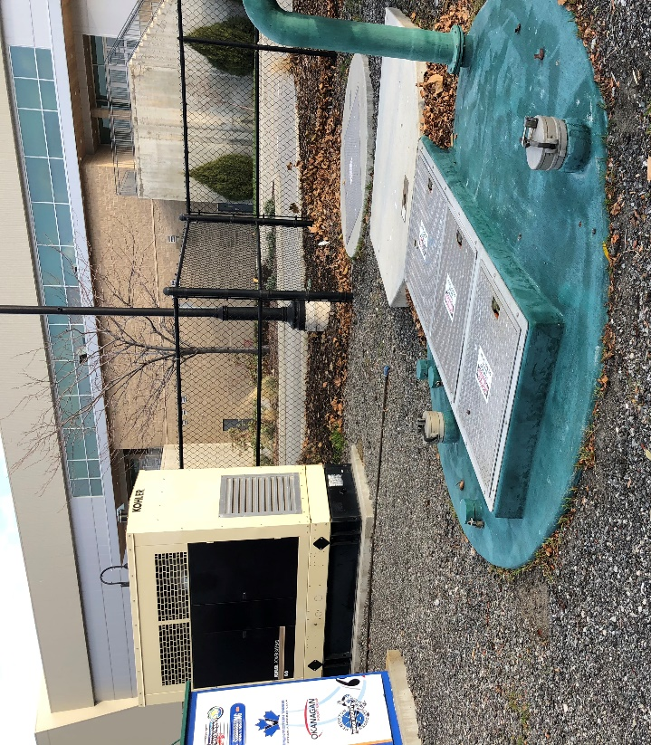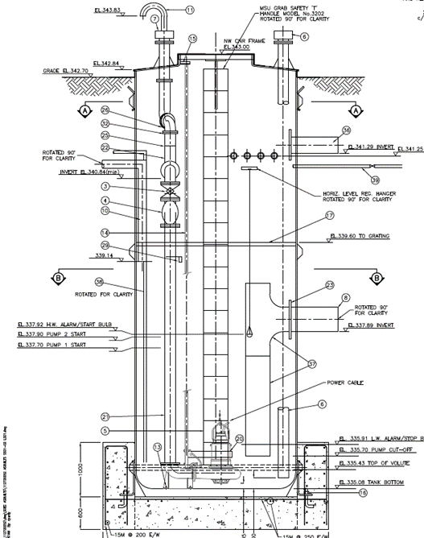
FUNCTION & DESIGN  - Vertical Barrels to cylinderical or rectangular flat bottom wet wells  - 1 or 2 gravity inlet pipes ranging from 150 to 525 mm  - Drain pipes from adjacent Vaults  - Sump with Submersible Pump(s) at bottom of the space  - Engineered Oulet piping with Check & Plug Valves  - Volume of sewage pumped /day up to 98 M³ |  |  |  |  | CONTENTS  - 230 to 600 V Submersible Pumps  - Engineered piping systems  - Electrical equipment  - Low and High Alarm sensors  Sewage – Maximum Flow rates of 6.3 L/sec for short durations (<10 minutes)
DIMENSIONS & VOLUME |  |  |  |  | ACCESS  - Fixed Ladder to intermediate platform with secondary hatch into wet well
Location | Depth | Diameter /Area |  | Volume
Lee | 6000 mm | 3700 mm | 4400 mm | 97.7 m³
Wilson | 4400 mm | 2438 mm Diameter |  | 20.5 m³
Marina | 4600 mm | 2438 mm Diameter |  | 21.5 m³
SOEC | 7760 mm | 3000mm Diameter |  | 54.9 m³
MATERIAL  - Reinforced concrete / Fiberglass chamber |  |  |  | VENTILATION  - Passive and mechanical ventilation through gooseneck  - Portable ventilation required for entry

- LIMITATIONS
- This procedure is for vertical ladder entry into the chamber. Workers will remain within communication of the standby person at all times.
- A separate HIRA and Safe Work Procedures will be completed for work activities which may generate additional hazards or influence risk associated with the entry.
- Whenever any of the required supplementary SWPs require a higher level of control or protection than is required by this CSE procedure, the higher level of control/protection will be used.

- EQUIPMENT & PPE SUMARY (all equipment must be inspected and confirmed in good working order)
- Full Body Harness with Dorsal D-ring | - Bypass Truck / Vacuum Trucks
- Ventilation Fan: Americ VAF 3000 Minimum 65m³/minute, 12” diameter, 1 x 90º bend @ Lee & SOEC  - Allegro STFJ-08B 21.5 m³ / minute, 8” diameter, 1 x 90⁰ bend @ Wilson & Marina | - Rubber (Nitrile) work gloves  - Hardhat (with chin strap for entrant)
- 2 x ISE M 40 one with built in pump and one passive – O₂, H₂S, CO, LEL | - Intrinsically Safe Portable Lighting as required
- Tripod / Davit Arm with winch and Type 3 SRL | - Raingear / Cotton Coveralls / Tyvek
- Lockout Devices; Personal Locks / Scissors /Tags | - High visibility clothing
- Level 1 First Aid Kit | - CSA Steel toed boots – good tread & ankle protection
- Sharps Container and Tongs | - Full face APR with OV.AG / HEPA cartridges
- Decontamination Supplies – water, soap, rags, etc. | - All Electrical Equipment must be GFCI Protected.

- OVERALL ATMOSPHERIC HAZARD RATING
MODERATE - is not clean respirable air but is not likely to impair the ability of the worker to escape unaided from the confined space, in the event of a failure of the ventilation system.

- HAZARD IDENTIFICATION AND RISK ASSESSMENT
 |  |  |  | Yes |  |  |  | Initial |  |  |  | P - Probability (1=low, 4=high)  C - Consequences (1=low, 4=high)  R - Risk (A=less, D=more) | Final
 | 1 |  | Carbon Monoxide  (CO) and other combustion by products |  | Yes |  | Exhaust from vehicles and equipment near the entrance.  (<10 ppm) |  | 2 | 2 | B | Ventilation (Sect. I), Atmospheric monitoring (Sect. J), Traffic control and staging on site (Sect. G) | 1 | 2 | A
 | 2 |  | Hydrogen Sulphide |  | Yes |  | H2S possible but unlikely from residual sewage in the line and sump, (< 5ppm) |  | 1 | 2 | A | Ventilation (Sect. I), Atmospheric Monitoring (Sect. J), Single Valve Isolation (Sect H) | 1 | 2 | A
 | 9 |  | Oxygen (O₂) Deficiency |  | Yes |  | O2 deficiency remotely possible; oxidation of metal; decomposition (>20.5%) |  | 1 | 2 | A | Ventilation (Sect. I), Atmospheric Monitoring (Sect. J) | 1 | 2 | A
 | 11 |  | Particulates |  | Yes |  | Bioaerosols from sewage – sewer line, sump, dried surface |  | 2 | 2 | B | Ventilation (Sect. I), Respiratory Protection (Sect D), Flushing of Sump (Sect G), Visual Inspection (Sect. L) | 1 | 2 | A
 | 13 |  | Vapours |  | Yes |  | Misc. Vapours (gasoline, solvents, etc) from residual sewage and run-off |  | 1 | 2 | A | Ventilation (Sect. I), Respiratory Protection (Sect D), Single Valve Isolation (Sect H), Visual Inspection (Sect. L) | 1 | 2 | A
 | 14 |  | Combustible Gases |  | Yes |  | < 500 ppm Methane from residual sewage in line and sump, no other gases with potential to reach combustion concentrations. |  | 1 | 2 | A | Ventilation (Sect. I), Atmospheric Monitoring (Sect. J), Single Valve Isolation (Sect H) | 1 | 2 | A
 |  |  | Hazards / Exposures
 | 17 |  | Toxic Material |  | Yes |  | Misc Contaminants (solvents, etc) in residual sewage |  | 1 | 2 | A | Protective clothing (Sect. D), Visual Inspection (Sect. L), Single Valve Isolation (Sect H), | 1 | 2 | A
 | 18 |  | Biological Hazards |  | Yes |  | Residual sewage |  | 2 | 2 | A | Protective clothing (Sect. D), Single Valve Isolation (Sect H), Decontamination (Sect L) | 1 | 2 | A
 | 19 |  | Sharps / Puncture Wounds |  | Yes |  | Razor blades, needles, metal shavings, nails, sharp edges. |  | 2 | 2 | B | Protective clothing (Sect. D), Visual Inspection (Sect. L) Sharps container and tongs (Sect. D) | 1 | 2 | A
 | 21 |  | Corrosive Material |  | Yes |  | Misc Contaminants (solvents, etc) in residual sewage |  | 1 | 2 | A | Protective clothing (Sect. D), Visual Inspection (Sect. L), Single Valve Isolation (Sect H), | 1 | 2 | A
 | 22 |  | Noise / Vibration Exposure |  | Yes |  | Ventilation / Traffic |  | 2 | 2 | B | Hearing protection if required (Sect D; Traffic Control Sect G) | 1 | 2 | A
 | 27 |  | Restricted Access / Egress |  | Yes |  | Ladder access |  | 3 | 2 | C | 3-point contact, fall protection (Sect. K); Rescue Plan (Sect M) | 1 | 2 | A
 | 28 |  | Congested / Restricted Area |  | Yes |  | Congested Area with piping and pumps |  | 2 | 2 | B | Good Housekeeping (Sect L), Awareness of surroundings (Sect L) | 1 | 2 | A
 | 29 |  | Ergonomic Hazards |  | Yes |  | Limited work space, awkward posture |  | 2 | 2 | B | Body Position and work breaks (Sect L), Awareness of Surroundings (Sect L) | 1 | 2 | A
 | 32 |  | Mechanical / Moving Parts |  | Yes |  | Submersible Pump |  | 2 | 2 | B | Lockout (Sect H) | 1 | 2 | A
 | 33 |  | Electrical |  | Yes |  | 230 to 600 V Submersible pumps, Power outlet in space |  | 2 | 3 | C | Lockout (Sect H), GFCI’s (Sect D) | 1 | 3 | B
 | 34 |  | Structural Hazards |  | Yes |  | Deterioration of structure / ladder |  | 2 | 2 | B | Visual Inspection (Sect L) | 1 | 2 | A
 | 36 |  | Entanglement |  | Yes |  | Lines for lowering equipment, lifelines, power cords |  | 2 | 2 | B | Line Management (Sect L, M), Awareness of surroundings (Sect L), Good housekeeping (Sect L) | 1 | 2 | A
 | 37 |  | Falling Hazard |  | Yes |  | While on ladder and around access point |  | 2 | 3 | C | Harness & Fall protection (Sect. D, L), Awareness of surroundings (Sect. L), | 1 | 3 | B
 | 38 |  | Slipping / Tripping Hazard |  | Yes |  | Trip over equipment, slip on ladder rungs or floor |  | 2 | 3 | C | Footwear (Sect. D, K), Awareness of surroundings (Sect. L), | 1 | 3 | B
 | 39 |  | Restricted Visibility / Light Level |  | Yes |  | No source of light other than natural in station |  | 2 | 2 | B | Portable lighting as required, intrinsically safe | 1 | 2 | A
 | 41 |  | Vehicle / Pedestrian Traffic Contact |  | Yes |  | Vehicle or Pedestrian traffic |  | 2 | 2 | B | Traffic Control Plan (Sect G); Hi Vis Clothing (Sect D), Awareness of surroundings (Sect L) | 1 | 2 | A
 | 44 |  | Insect / Animal Bites |  | Yes |  | Insects, Spiders in space |  | 2 | 2 | B | Awareness of surroundings & Visual Inspection (Sect L) Protective clothing (Sect D) | 1 | 2 | A
 | 47 |  | Vehicle / Heavy Equipment Hazards |  | Yes |  | Vehicles, Equipment at entrance to space |  | 2 | 2 | B | Traffic Control Plan (Sect G) | 1 | 2 | A
 | 50 |  | Overhead / Falling Object Hazards |  | Yes |  | Tools/equipment dropped into space |  | 2 | 2 | B | Awareness of surroundings (Sect. L), Good housekeeping (sect L), Raise and lower tools securely (Sect. L), Hard hats (Sect. D) | 1 | 2 | A
 | 51 |  | Restricted Communication |  | Yes |  | Potential for equipment noise in area |  | 2 | 2 | B | Standby radio contact / check in (Sect. L). Verbal communication between worker and standby person | 1 | 2 | A

- PLANNING & PREPARATION
- Secure work area. Wear high visibility (hi-vis) clothing.
- A minimum of 5 workers must be onsite to perform this entry (entrant, attendant, rescuer, 2 vacuum truck / bypass workers)
- Ensure vehicles are positioned away from fan air intake, turn off engines if possible.
- Inspect all equipment & PPE to ensure everything is good working order.
- Ensure Traffic Control is in place as required.
- Conduct a tailboard meeting with all workers involved to review:
  - This procedure prior to starting entry
  - The scope and staging on the tasks to be performed on site and in the space
  - Any applicable safe work procedures to be used in conjunction with the entry
  - Check surroundings for any changes in conditions or obstructions in the working area
  - Discuss Rescue Plan – refer to section M
- Start the Confined Space Entry Permit and ensure all documents are on site (Safe Work Procedures, WSBC Terms of Acceptance…..).
- A worker must be designated to monitor the pressure in the plug as per manufacturer’s instructions
- A worker must be designated to monitor the sewage flow upstream of the station. If sewage cannot be controlled by the bypass piping / pumps or vacuum trucks the entry will be aborted.
- Call Dispatch at 250-490-2305 and report:
  - City of Penticton
  - Confined Space Entry
  - Your Name
  - Address of Work
  - Duration of Work.
- ISOLATION & LOCKOUT
- Isolation is not possible as per WSBC 9.18. WSBC Terms of Acceptance for Alternate Measures must be on site.
- Install High Pressure Plug(s) as per Manufacturer’s instructions
- Verify Vacuum trucks / bypass piping and pumps are sufficient to ensure no back up of sewage on the plug.
- De-energize pump being worked on.
- Close Isolation Valve on pump being worked on
- An electrician must verify there are no ground faults prior to entry
- VENTILATION
Fan Specification: Lee & SOEC  - Minimum: 65 m³/minute  - Minimum: 15 ft., 12” dia. duct  - Maximum: 1 bend  - Deliver minimum 39 m³ /minute to worker | Fan Specification: Wilson & Marina  - Minimum: 21.5 m³ / minute  - Minimum 15’, 8” diameter ducting  - Maximum: 1 Bend  - Deliver minimum 11 m³/minute to worker
- Confirm ventilation fan specification/output (review label on fan).
- Position blower to direct ventilation to the area of occupation
- Position the end of the duct close to the bottom of the space. Orient ducting outlet to promote effective air mixing in all areas of the space.
- Only push air into the space. Do not pull air out of space.
- Ventilate a minimum of 15 minutes prior to entry to ensure there is clean respirable air throughout the space.
- Space must be continuously ventilated while workers are inside.
- If ventilation fails, exit space immediately. Only re-enter after it is checked and re-established.

- ATMOSPHERIC MONITORING
ALARM SETTINGS
CO: 13 ppm | H₂S: 5 ppm
LEL: low 5% High: 10% | O₂: low = 20.4 %; high = 23.0 %
- Ensure monitor is calibrated.
- Monitor must be bump tested on day of entry, prior to use.
- Clear peaks and zero monitor in fresh air prior to use.
- Conduct pick test around access point before opening.
- Pre-entry test atmosphere to bottom of space (all levels/areas of space) – use gas detector with built in pump and tubing. Allow two seconds per foot of tubing to allow for the sample to travel to the monitor’s sensors.
- Atmosphere must be continuously monitored while workers are inside the space.
- Readings must be recorded every twenty minutes while workers are inside the space (minimum).
- All monitor readings must be recorded on the confined space entry permit.
- Pre-entry testing must be repeated before re-entry if workers vacate the space.
- If the monitor alarms at any time, immediately exit the space and investigate why monitor went into alarm mode:
  - Reassess the position of the ventilation fan is away from any contaminants and continue with ventilation
  - Reassess that the monitor is working properly; confirm readings in the space with backup monitor
  - Only re-enter space after the alarm has been investigated and the readings return to acceptable ranges
  - If monitor continues to alarm, contact the qualified person (QP)
- EQUIPMENT & PPE
- Set up Pelsue Davit rescue arm or Tripod / Type 3 SRL & Winch over access point.
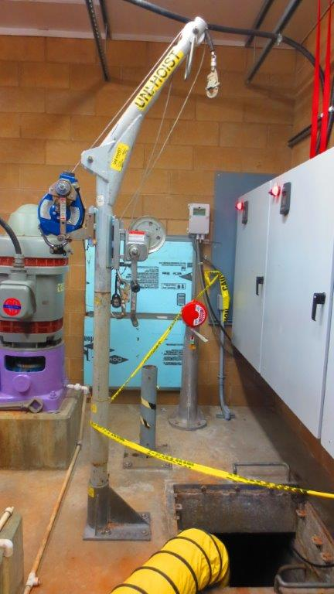
- Set up ventilation system as per specifications in Section I. Ensure no more than 1 bend (90º) in the ducting.
- Entrants must wear a harness with a dorsal D-ring during entry. Entrants to be connected to dorsal D-ring to SRL throughout the entry.
- Ensure ladder extends 3 feet above access plane and is secured. Maintain 3-point contact while on ladder.
- Entrants / Workers must wear a hard hat with chin strap and all protective clothing
- Entrants / Workers must wear CSA rated rubber boots/hip waders with good tread.
- SUPPLEMENTARY INSTRUCTIONS
- A standby person will be designated by the responsible supervisor and must:
  - be stationed at entrance of space while it is occupied,
  - visually observe and check on the well-being of workers in the space every twenty minutes (minimum)
  - prevent any unauthorized entry and manage all lines, equipment, and tools at entry point
  - record atmospheric monitor readings
  - have a radio/cell phone as means to communicate / check in
- Visually inspect each space for any hazards (as per the HIRA) prior to and during entry.
- Install bypass piping and pump / vacuum truck(s) at a manhole upstream from the station.
- Utilize a vacuum truck to clean out the station
- Install Cherne High pressure plug into influent pipe following manufacturers procedures
- Entrants / Workers will be aware of their surroundings. Any new hazards found must be reported to supervisor.
- In the event sewage in the upstream manhole cannot be controlled by the vacuum truck(s) / bypass piping & pump(s) and sewage levels rise 1 foot over the crown of the pipe of the pipe in the manhole the worker must inform the standby person and the confined space entry suspended until the sewage inflow can be controlled.
- Entrants / Workers and standby person will communicate verbal via radio or hand signals. Ensure communication is effective.
- Raise and lower tools and equipment in a secure manner (i.e., safety bucket).
- Ensure good housekeeping around openings and within space.
- Working surfaces may be slippery. Wear CSA approved footwear with good treads and use caution.
- Avoid working in awkward positions for long durations by taking frequent breaks. Good body positioning.
- In case of accidental contact with sewage (eyes, mouth, non-intact skin), decontaminate.
- Upon exiting the space, wash and clean up all tools, equipment & PPE. Wash hands and face.
- Call dispatch at 250-490-2305 and inform them when the work is completed

- RESCUE PLAN
Personnel | Role | Responsibility
As noted on the Confined Space Entry Permit | Rescue Team | Confined Space Team Personnel will assume the role of coordinating rescue efforts at the site in the event of an incident until the injured is safely out of the confined space. In the event a worker requires advanced first aid the Fire Department is on Standby as a backup rescue team.
As noted on the Confined Space Entry Permit | First Aid Attendant / Rescuer | One of the site personnel with a first aid certificate will provide first aid.
As noted on the Confined Space Entry Permit | Standby Person | Designated worker, who communicates with the entry personnel, is stationed at entry point, manages lines, summons rescue personnel and keeps records of entry personnel and atmospheric readings.

Confined Space Entry Rescue Plan:
- Set up rescue equipment. All equipment must be fully set up and inspected prior to entry. Note: Entrants will be connected to the SRL throughout the entry.
On Initiation of Rescue
- In the event of an emergency of any type in the confined space, entrants in the space will evacuate the space.
- All confined space team members (including additional rescue personnel) must know their duties and responsibilities. These must be reviewed during the tailboard meeting.
- If a worker is injured or is otherwise unable to leave the space, the standby person will call dispatch at 250-490-2305 & give the exact location of the incident (listed on confined space entry permit).
- The Standby Person will:
  - Never enter the tank to perform a rescue. The standby must wait for additional persons to arrive who are qualified to act as rescuers if required.
  - Lift the injured worker from the tank utilizing the Type 3 SRL in the winch mode.
  - In the event rescuers must enter to assist the injured worker ensure Rescuers are attached to the winch cable at all times during the rescue.

- The Rescuer will (if necessary):
  - Enter the tank attached to the winch. Remain attached throughout the rescue.
  - Assist the worker through the platform hatch as they are being lifted on the Type 3 SRL.

- The OFAA will:
  - Maintain basic care of the patient until the ambulance service is on site.
  - If the situation is life-threatening, secure and move the injured worker to ground level for transfer to the ambulance service.
  - Record the patient’s vital signs and any treatment of life-threatening observations immediately following the rapid body search.
- The confined space will continue to be ventilated in accordance with this procedure and the atmosphere continuously monitored to maintain atmospheric readings in accordance with the confined space entry permit.
- Workers requiring medical treatment will be transported to the nearest Hospital or Medical Center as noted on the Confined Space Entry Permit (Injured/rescued workers must not transport themselves to seek medical attention).
- Inform the supervisor when the rescue operation is completed, secure the scene and await further direction.

