Falling Objects
These hazards occur when a falling objects drop from an elevation to a lower level. Hazards related to falling objects can encompass everything from tools, building materials, suspended load coming loose to a structures collapsing on to a worker. It is important to understand and locate potential falling object hazards before performing a task as well as identifying other locations on the overall job site that can impact the safety of you and your co-workers.

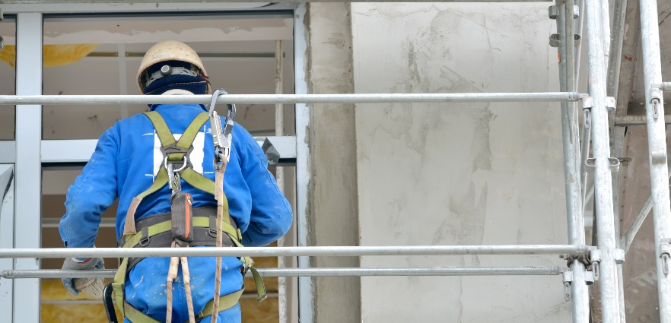
Here are some common examples of Falling Objects
- Power or hand tools
- Screws, Nut, Bolts
- Loose building materials
- Objects falling from a vehicle or other equipment
- Section from a cut away structure falls

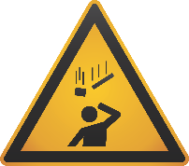
How to protect yourself and others:
These hazards can cause injuries that include a person being struck-by, crushed, pinned, or caught under a falling object or load.
- Never position yourself under a suspended load.
- Tools and materials should be secured using toe boards or screens to prevent objects falling.
- Never throw or drop any tool or object.
- Stay clear of hazards using job briefings and three-way communication.
- Ensure you always wearing proper the right Personal Protective Equipment for the task(s) but remember it is the last line of defense.
- Wait for the all clear from the worker using power tools, machinery or equipment before approaching.
- Beware of unbalanced loads.
- Be sure to be properly trained before using power tools, machinery or equipment.
- Make sure that all workers are in the clear before dumping or lifting objects.
- When pushing or pulling objects stack and secure the materials to prevent sliding, falling, or collapse.
- Use the hierarchy of controls and plan your work accordingly
Summary
It is difficult to fully eliminate all the hazards that result in struck-by incidents, but through proper task planning and preparation you can mitigate yourself and your co-workers exposure to these potential hazards. Evaluate your work tasks to see if there are any unnecessary risks to you or your co-workers due to the mentioned hazards above.
Let’s discuss what could affect you and your co-workers
Can you list the falling object hazards in your work area?
How can we eliminate some or all of these hazards?
What are some other ways we can protect ourselves from struck-by hazards at our site?

MEETING DESCRIPTION
Meeting Date: |  | Time:
Location: |  | Supervisor:
Number in Crew: |  | Number Attended:
Attended By: |  |  | Absent

REVIEW ITEMS FROM PREVIOUS MEETING | INCIDENTS/INJURIES REVIEWED

TOPICS DISCUSSED
- Striking Hazard – Falling Objects

WORKERS CONCERNS

CORRECTIVE ACTIONS TO BE TAKEN

MEETING CONDUCTED BY
Supervisor: |  | Manager:
Date: |  | Date:

