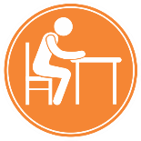
Why Talk About Computer Ergonomics?
What can I do to prevent an injury?
Adapt the workstation to suit you. Don’t adapt your body to the workstation.
Ergonomics is the science of fitting a job to a worker and a product to its user. When workplace conditions and job demand match their capabilities, safety and productivity improve. Ergonomics can reduce the risk of strains and sprains and other related musculoskeletal injuries (MSIs). MSI is the most common work-related injury in BC. MSI claims account for approximately 30 percent of all claims and approximately 20 percent of all claim costs.
- Check your posture
- Adjust elements of your workstation (ie. Monitor, chair, keyboard, backrest)
- Rearrange your workstation so items you use frequently are within reach. Keep it Close!
- Improve lighting and minimize glare
- Take breaks
- Take micropauses. Pauses of 20 seconds to 2 minutes will help combat muscles soreness. Change it Up!
- Exercise. Daily exercise helps reduce soreness and tension as it provides changes in posture
- Reach out to your supervisor or health and safety advisor for more support
- Use the hierarchy of controls and plan your work accordingly
Musculoskeletal injury (MSI) is an injury or disorder of the muscles, tendons, ligaments, joints, nerves, blood vessels or related soft tissue including a sprain, strain, and inflammation, that may be caused or aggravated by work.
What are some of the risk factors associated with Computer Ergonomics?
- Repetition-doing a task that uses the same muscles over and over with little change for rest or recovery
- Force-excreting force on an object as a part of a task
- Work Posture-position of different parts of the body when taken outside of the comfortable range of motion
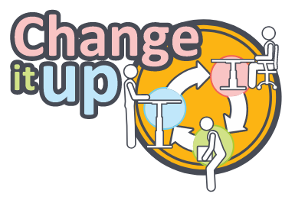
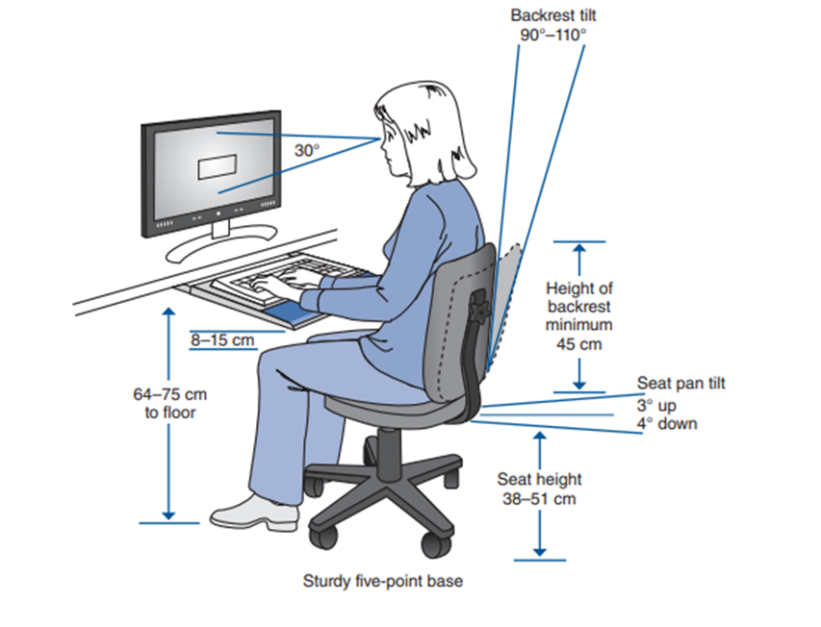
- Contact Stress- a hard or sharp object coming in contact with the skin
MEETING DESCRIPTION
Meeting Date: |  | Time:
Location: |  | Supervisor:
Number in Crew: |  | Number Attended:
Attended By: |  |  | Absent

REVIEW ITEMS FROM PREVIOUS MEETING | INCIDENTS/INJURIES REVIEWED

TOPICS DISCUSSED
- MSI – Posture – Computer Ergonomics

WORKERS CONCERNS

CORRECTIVE ACTIONS TO BE TAKEN

MEETING CONDUCTED BY
Supervisor: |  | Manager:
Date: |  | Date:

