What is Traffic Control?
Traffic control is “the use of temporary traffic control devices, traffic arrangements or layouts and procedures to protect workers and move traffic safely through a work zone.”

Section 18.6 of the OHS Regulation establishes that traffic control arrangements for a workplace may use a traffic control person only when the use of signs, devices and/or procedures is not sufficient to provide effective traffic control.

What controls should be put in place?
Order of controls should be reflected in the risk assessment and traffic control plan (TCP).
- Employer must eliminate worker exposure to traffic by isolating the work zone via use of constructed detours, alternative routes, barriers, or other effective measures.
Daytime apparel above and nighttime apparel below
- If it is not practicable to isolate workers from traffic, then worker exposure should be minimized using devices and procedures that are appropriate to the level of risk
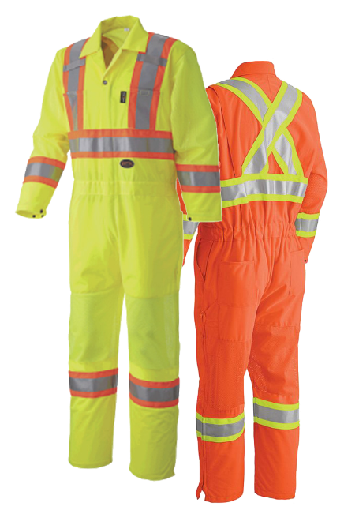
  - The use of temporary devices, layouts and arrangements without the use of TCPs
  - Admin controls to reduce worker exposure
  - Use of TCPs in conjunction with above options
- Use the hierarchy of controls and plan your work accordingly.

Your Traffic Control Plan (TCP)
Must include:
- Control measures to mitigate the hazards on site
- Instructions for implementation
- Clear roles, duties and responsibilities assigned
- A schedule for reviewing the plan and updating
- The plan must be available to all workers at any time during work
If the risk assessment is updated, then the traffic control plan must be reviewed and updated

Traffic Control Plan (TCP) communication
TCP’s are NOT permitted to: | Proper Communication includes:
- Use electronics, including iPod’s and cell phones while working on road way  - Turn their back to traffic  - Use profanity, profane gestures or aggressive body language toward traffic | - Use TCP signals  - Where more than one TCP is present and controlling traffic, employer must ensure that effective means of communication provided and the TCP uses it to communicate between them

Regulatory Amendment Changes
July 2021, WorkSafeBC Board of Directors approved changes to sections of Part 18 of the Occupational Health and Safety Regulation relating to traffic control. These amendments took effect on December 1, 2021. To learn more about the changes watch the webinar “New OHS Regulation Requirements for Traffic Control Persons”: https://www.bcmsa.ca/what-we-do/webinars/
For resources checkout out BCMSA's
Course catalogue: https://www.bcmsa.ca/category/course-catalogue/
MEETING DESCRIPTION
Meeting Date: |  | Time:
Location: |  | Supervisor:
Number in Crew: |  | Number Attended:
Attended By: |  |  | Absent

REVIEW ITEMS FROM PREVIOUS MEETING | INCIDENTS/INJURIES REVIEWED

TOPICS DISCUSSED
- Line of Fire Safety – Traffic Control

WORKERS CONCERNS

CORRECTIVE ACTIONS TO BE TAKEN

MEETING CONDUCTED BY
Supervisor: |  | Manager:
Date: |  | Date:

