WorkSafeBC defines occupational disease as “conditions or disorders that result from the nature of your work.”
Understanding the level of risk in the workplace
It is important to understand workplace health hazards that can cause occupational disease. Find out what materials and substances are being used in your workplace and how to work safely around the materials and equipment in your workplace
Communicable disease prevention involves understanding the level of risk in your workplace.
- Review your organizations Communicable Disease Policy/Plan.
- Follow prevention measures.
- Know the steps your workplace has in place for a pandemic.
- Know who in your organization is responsible for monitoring and assessing communicable disease related information. This includes orders, guidance, advise and recommendations.
- Participate in training or information sessions.
- If you are a member of the Joint Occupational Health and Safety Committee, consult with your employer to identify and resolve workplace health and safety issues.
- Be kind to your colleagues. Help maintain an environment of support and care.
- Participate in workplace inspections.
- Plans can change and the workplace may need to adjust policies. Follow requirements set by the employer.
- If you don’t feel safe, talk to your supervisor
Workplace health hazards that cause an occupational disease:
- Dust, gases, or fumes
- Noise
- Toxic substances (poisons)
- Vibration
- Radiation
- Infectious germs or viruses
- Extreme hot or cold temperatures
- Extremely high or low air pressure
Three specific disease outcomes from the common workplace hazards include: cancers, asthma, and hearing loss. It’s important to ensure that these most significant risks are effectively managed. Identify hazards, evaluate risk, and implement the appropriate controls specific to the on-site activities.
Right to Refuse Work
Workers have the right to refuse unsafe work if they believe it presents an undue hazard. If you have a reasonable cause to believe that performing a work process or using a tool puts you or someone else at risk, you must not perform the job or task. You must immediately notify your supervisor or employer. As a worker you will not be disciplined or penalized for following these steps. Your employer should temporarily assign a new task, at no loss of pay.
Report an exposure
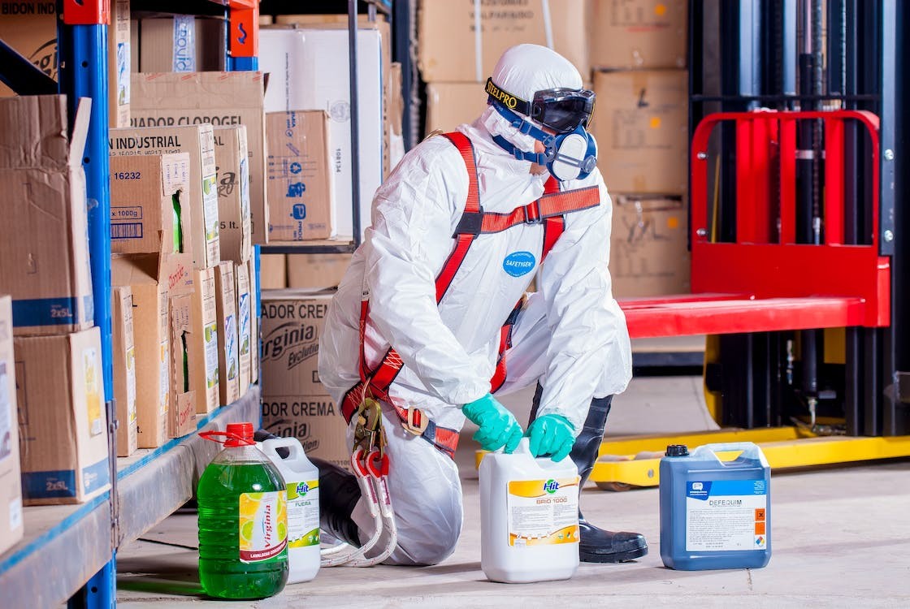
It is important to report exposure to chemical, physical or biological hazards as soon as possible. If you have been exposed to a harmful substance and are not experiencing any immediate effects, it is still important to report it. Many occupational diseases are dormant and may develop over a long period of exposure. Symptoms may not present themselves for years. This is important even if you are not working or you have changed jobs.
Exposure Registry: https://www.worksafebc.com/en/resources/health-care-providers/forms/exposure-registry-program-form-41m1?lang=en
For resources checkout out BCMSA's Course catalogue: https://www.bcmsa.ca/category/course-catalogue/
MEETING DESCRIPTION
Meeting Date: |  | Time:
Location: |  | Supervisor:
Number in Crew: |  | Number Attended:
Attended By: |  |  | Absent

REVIEW ITEMS FROM PREVIOUS MEETING | INCIDENTS/INJURIES REVIEWED

TOPICS DISCUSSED
- Personal Risk Factors: Occupational Diseases

WORKERS CONCERNS

CORRECTIVE ACTIONS TO BE TAKEN

MEETING CONDUCTED BY
Supervisor: |  | Manager:
Date: |  | Date:

