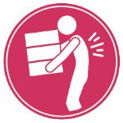
Why talk about Lifting and Carrying?
How can I reduce the risk of an injury?
When you lift and carry items you apply force on the muscles, joints, bones, ligaments, and tendons.
Here are some tips to prevent an injury from occurring:
- Use mechanical aids or enlist the help of a co-worker to lift or carry heavy or large items.
- Use a cart to carry items longer distances.
- Use proper lifting technique.
  - Feet shoulder width apart or around the load if possible.
  - Firm grip on item.
  - Elbows close to your body.
  - Back straight and head up.
  - Lift with your legs while engaging your core.
  - Breathe.
- Keep an object close to your body while carrying it.
- Carry fewer items at a time. Make multiple trips if needed.
- Plan your path of travel before lifting. Make sure it is free of obstructions and slippery surfaces.
- Ensure your view is not obstructed and you can see where you are going.
- Wear appropriate slip-resistant footwear.
- Take micro breaks between lifts.
If you apply too much force, these structures may become damaged. Without sufficient recovery this damage could lead to an MSI.

What are some of the hazards associated with Lifting and Carrying?
Lifting and carrying load hazards:
- Lifting or carrying loads that are too heavy or too large.
- Carrying items long distances.
- Twisting, turning and bending to lift an object greatly increases stress on the back and lower spine.
- Lifting awkward items.
- Lifting or carrying loads away from your body, increasing the stress on shoulders, arms, back, and legs.
- Carrying items that obstruct your view.
- Carrying multiple pieces at a time.
- Carrying loads with limited footwear traction.
- Lifting and carrying at a high frequency with minimal breaks in between.
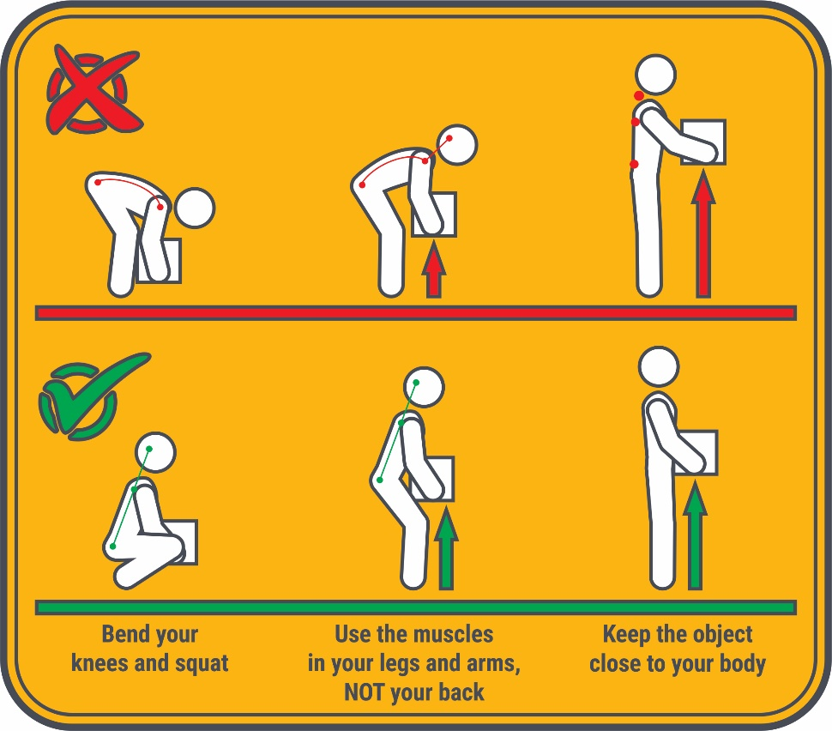
MEETING DESCRIPTION
Meeting Date: |  | Time:
Location: |  | Supervisor:
Number in Crew: |  | Number Attended:
Attended By: |  |  | Absent

REVIEW ITEMS FROM PREVIOUS MEETING | INCIDENTS/INJURIES REVIEWED

TOPICS DISCUSSED
- MSI -Lifting and Carrying- Force

WORKERS CONCERNS

CORRECTIVE ACTIONS TO BE TAKEN

MEETING CONDUCTED BY
Supervisor: |  | Manager:
Date: |  | Date:

