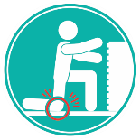
Why Talk about Contact Stress?
How can I reduce the risk of an injury?
Contact Stress can easily lead injury by cutting off circulation to a localized area leading to discomfort and a possible MSI. Common areas for contact stress in the upper extremity are the shoulders, wrists and forearms. A common sign would be a depression, or a divot, left in the skin or pale skin after contact stress.
Here are some tips to working safely and preventing an injury from occurring.
- Properly fitting gloves to pad the hands.
- Pad or round the edges of sharp-edged workstations.
- Distribute pressure by using tools with handles that don’t dig into the palm of your hand.
- Use the proper tool for the task.
- Avoid resting elbows on a hard work surface by using a jig or a vice during precision work.
- Use soft wrist and mouse rests at computer workstations if necessary.
- Elevate the chair height to position the hand and elbow at the same height and, if necessary, use a footrest to support the feet in the elevated position.
- Keep work close to your body

What are some of the hazards associated with Contact Stress in the Upper Extremity?
- Carrying heavy loads on your shoulders.
- Using the hand as a hammer.
- Digging holes using a shovel handle that is too small.
- Using tools with a sharp edge
- Improperly designed handles that are too small or too big
- Resting on a surface for a prolonged period of time.
- Typing or using a mouse at a desktop that is too high creating pressure over the wrist or forearm.
- Gloves that are too tight or ill-fitting.
- Over-reaching when completing primary work tasks
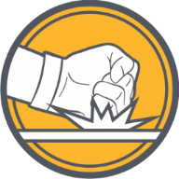
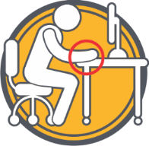
Leaning against an edge of a hard surface.
Using your fist as a hammer.

MEETING DESCRIPTION
Meeting Date: |  | Time:
Location: |  | Supervisor:
Number in Crew: |  | Number Attended:
Attended By: |  |  | Absent

REVIEW ITEMS FROM PREVIOUS MEETING | INCIDENTS/INJURIES REVIEWED

TOPICS DISCUSSED
- MSI – Contact Stress – Upper Extremity

WORKERS CONCERNS

CORRECTIVE ACTIONS TO BE TAKEN

MEETING CONDUCTED BY
Supervisor: |  | Manager:
Date: |  | Date:

