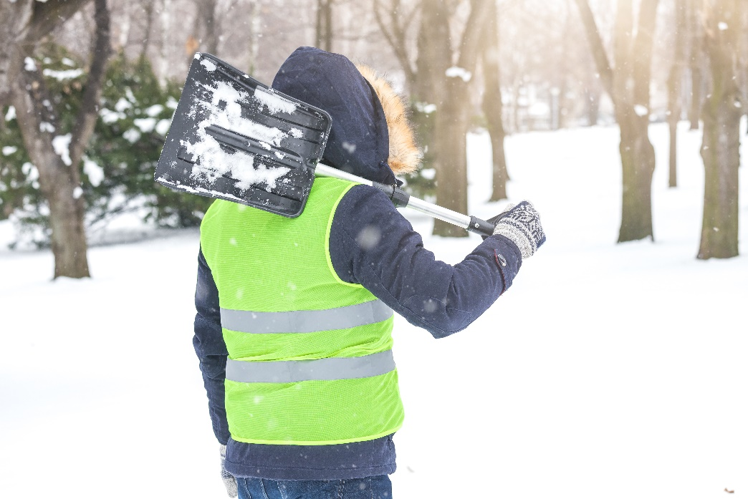**Working in the Cold – Cold Stress and Hypothermia**

Working in winter can easily be taken for granted. Many factors play a role in the physical fitness of the worker, including their overall health, age and weight. Equally important is the environmental conditions they work in, and how it affects their body, such as the onset of Cold Stress or hypothermia.

Cold Stress is when the body is unable to warm itself by constricting the flow of blood in your arms and legs. By doing this, your body is trying to keep the critical organs warm by leaving your extremities. If the worker is continually exposed to this environment, they can acquire hypothermia as the body’s core temperature drops below 35°C.

**Symptoms of Cold Stress and Hypothermia:**

**If you *see something, say something and follow up*.**

Report potential cold stress and hypothermia symptoms to your supervisor.

**Cold Stress**

**Let’s discuss what could affect you and your co-workers**

List the areas in your workplace you and others can take short warm breaks?

Can you list some other ways we can protect ourselves from acquiring cold stress or hypothermia at our site?

Ask yourself, did I take the necessary precautions to prevent cold stress and hypothermia before leaving my house today?

* A pins and needles sensation followed by numbness or pain in your extremities.
* Skin looks pale while feeling hard and cold. (These exposed areas become red and painful when they thaw.)

**Hypothermia**

* Excessive shivering.
* Slow to no breathing and a weak to no pulse.
* Blue lips and fingers.
* Slurred speech.
* Poor coordination and confusion.

**Let’s discuss what could affect you and your co-workers**

List the areas in your workplace you and others can take short warm breaks hazard?

Can you list some other ways we can protect ourselves from acquiring cold stress or hypothermia at our site?

Ask yourself, did I take the necessary precautions to prevent cold stress and hypothermia before leaving my house today?

* A loss of consciousness.

**How to protect yourself and others:**

* Cover your ears, head and hands with PPE and gear that is appropriate for the weather conditions.
* Dress in layers of light-weight clothing. Use synthetic or cotton for your innermost layer. Remove layers as necessary to prevent from overheating and sweating.
* Wear the correct footwear for the task and the weather conditions.
* Eat meals with enough calories and nutrients to fuel your body so it can maintain itself.
* Drink warm beverages. Avoid caffeine and alcohol as these both impair your body’s ability to generate heat.
* Take frequent short breaks out of the cold weather.

**Summary**

Safety doesn’t end at the work site. Winter brings many potential hazards that can follow us to and from work. Whether it is driving in poor conditions, or having to clear snow, any task done in winter increases the chance of injury.

|  |  |  |  |
| --- | --- | --- | --- |
| **MEETING DESCRIPTION** | | | |
| **Meeting Date:** |  | **Time:** |  |
| **Location:** |  | **Supervisor:** |  |
| **Number in Crew:** |  | **Number Attended:** |  |
| **Attended By:** |  |  | **Absent** |
|  |  |  |  |
|  |  |  |  |
|  |  |  |  |
|  |  |  |  |

|  |  |
| --- | --- |
| **REVIEW ITEMS FROM PREVIOUS MEETING** | **INCIDENTS/INJURIES REVIEWED** |

|  |  |
| --- | --- |
|  |  |
|  |  |
|  |  |

|  |
| --- |
| **TOPICS DISCUSSED** |

|  |
| --- |
| 1. **Winter Work – Working in the Cold** |
|  |

|  |
| --- |
| **WORKERS CONCERNS** |

|  |
| --- |
|  |
|  |

|  |
| --- |
| **CORRECTIVE ACTIONS TO BE TAKEN** |

|  |
| --- |
|  |
|  |
|  |
|  |
|  |

|  |  |  |  |
| --- | --- | --- | --- |
| **MEETING CONDUCTED BY** | | | |
| **Supervisor:** |  | **Manager:** |  |
| **Date:** |  | **Date:** |  |