Working with electricity can be dangerous. Engineers, electricians, and other professionals work with electricity directly, including working on overhead lines, cable harnesses, and circuit assemblies. Others, such as office workers and salespeople, work with electricity indirectly and may also be exposed to electrical hazards.
General Safety Tips
General Safety Tips
Rules of Electricity:
- Inspect tools, power cords and electrical fittings for damage or wear prior to each use.
- Repair or replace damaged equipment immediately.
- Do not use nails or staples to hang or hold down cords.
- Do not tie power cords in tight knots; they can cause short circuits and shocks.
- Use cords or equipment that are rated for the level of amperage or wattage you are using.
- Don’t overload electrical outlets.
- Unusually warm or hot outlets may be a sign that unsafe wiring conditions exist. Unplug any cords to these outlets and do not use until a qualified electrician has checked the wiring.
- Risk of electrical shock is greater in areas that are wet or damp.
- Label all circuit breakers and fuse boxes clearly.
- Do not block access to circuit breakers or fuse boxes.
- Do not touch a person or electrical apparatus in the event of an electrical accident. Always disconnect the current first.
- Travels in a completed circuit
- Tries to travel to ground
- Always travels in the path of least resistance
- A person is usually the least resistance
- The person forms a completed circuit when touching the ground

The electrical current in regular businesses and homes has enough power to cause death by electrocution!
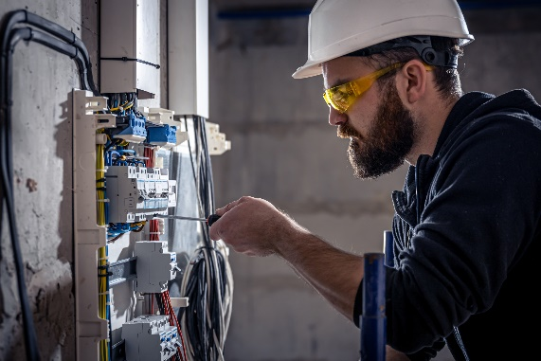
If you are a vehicle or equipment and a power line has fallen on or outside the vehicle:
If you are safe inside the vehicle, turn the vehicle off and stay there. Your tires will keep you grounded and act as insulation. Do not touch metal parts in the vehicle or use electronic equipment. Wait for help but warn others to stay clear of the vehicle.
If you must leave the vehicle because of fire or other danger: The ground around the vehicle may be energized. The electricity moves outward in all directions in a ripple effect, similar to a pebble in water. Jump from the vehicle (don’t touch the ground and vehicle at the same time). Keep your feet close together and shuffle away from the area. By keeping your feet close together, you will avoid what is called “step potential”!

For resources checkout out BCMSA's Course catalogue: https://www.bcmsa.ca/category/course-catalogue/
Scan the QR Code to watch a video on Electrical Safety.
MEETING DESCRIPTION
Meeting Date: |  | Time:
Location: |  | Supervisor:
Number in Crew: |  | Number Attended:
Attended By: |  |  | Absent

REVIEW ITEMS FROM PREVIOUS MEETING | INCIDENTS/INJURIES REVIEWED

TOPICS DISCUSSED
- Electrical Safety

WORKERS CONCERNS

CORRECTIVE ACTIONS TO BE TAKEN

MEETING CONDUCTED BY
Supervisor: |  | Manager:
Date: |  | Date:

