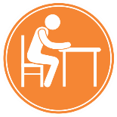
Why Talk About Work Posture?
How can I reduce the risk of an injury?
Working in one position for an extended period has the potential to cause discomfort and pain and working in non-neutral body positions does not allow for the muscles, tendons, and joints to work efficiently, which increases the chances of an injury.
Here are some tips for working safely and preventing an injury from occurring.
- Minimize reaching distance by moving objects closer.
- Raise yourself or lower the work to prevent over-shoulder reaching.
- Position objects in front of you to reduce or eliminate twisting.
- Use the appropriate tools to keep the wrist straight.
- If possible, raise, lower, or tilt the work (area) for better visual access to reduce your head tilt.
- Take frequent micro-breaks to give muscles adequate recovery time from static postures.
- Keep the work are clear and free of clutter and obstacles you may be forced to work around.
If the work environment or requirements results in prolonged static or awkward compensatory postures, injury could result.
What are some of the hazards associated with Work Posture?
- Reaching above shoulder heights repetitively and for extended periods.
- Awkward wrist and hand positioning while working
- Using the wrong tool for the task.
- Kneeling, squatting and bending forward for long periods of time.
- Working with your neck bent forward or backward for extended periods.
- Bending or twisting your torso to lift an object from low or distant locations.
- Improper workstation setup encouraging awkward postures.
- Working around obstacles due to poor housekeeping.
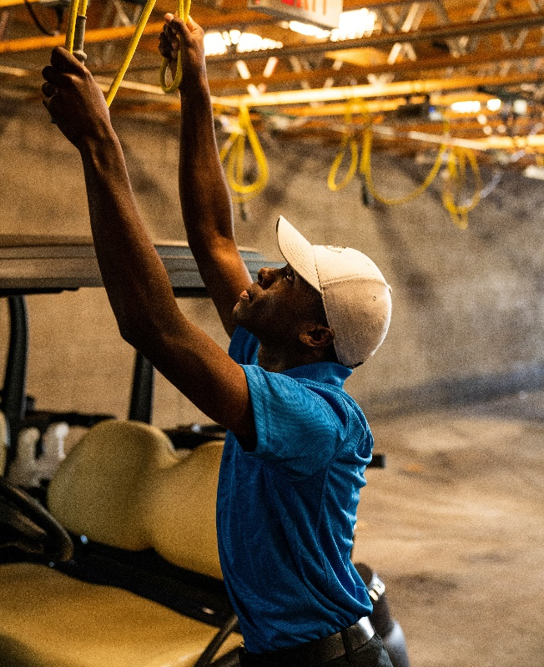
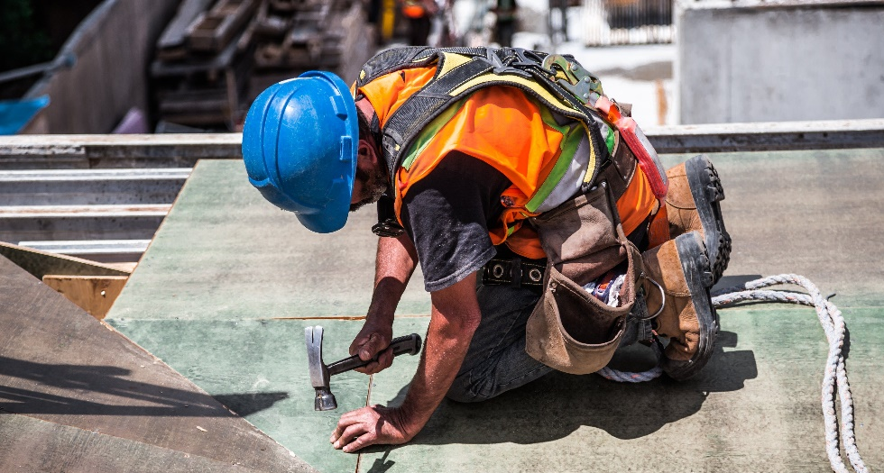
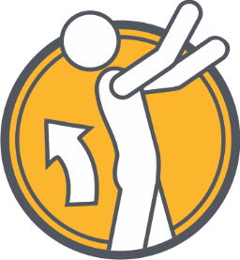
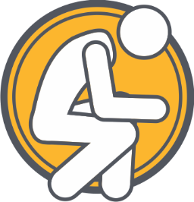
Kneeling, squatting and bending at the waist.
Reaching above shoulder heights.
MEETING DESCRIPTION
Meeting Date: |  | Time:
Location: |  | Supervisor:
Number in Crew: |  | Number Attended:
Attended By: |  |  | Absent

REVIEW ITEMS FROM PREVIOUS MEETING | INCIDENTS/INJURIES REVIEWED

TOPICS DISCUSSED
- MSI – Posture

WORKERS CONCERNS

CORRECTIVE ACTIONS TO BE TAKEN

MEETING CONDUCTED BY
Supervisor: |  | Manager:
Date: |  | Date:

