2023 CITY OF EXCELLENCE
AWARD NOMINATION FORM

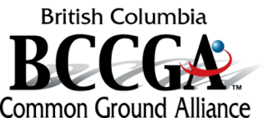
OBJECTIVE OF THE AWARD:
To recognize local governments for activities that improve ground disturbance,
safe excavation techniques and best practice at or around underground infrastructure,
in the year previous to the award.

ELIGIBILITY:
Any BC local government - including City, Village, Township, District, Municipality,
Regional District, First Nation community and Tribal Council - that demonstrates
and meets the criteria of this award and is an active user of BC One Call.

AWARDS AVAILABLE:

Gold Standard Award - An award for a Recipient showing exemplary practices
in all aspects of ground disturbance practices.

Innovation Award - An award for innovation in ground disturbance and
excavation practices.

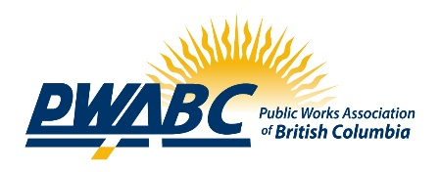
Education Award - An award for exemplary education to promote safe
excavation practices.

All nominees not receiving an award will receive a recognition letter.

METHOD OF AWARDING:

All awards will be presented at the BCMSA/PWABC Joint Annual Conference,
September 26th – 27th in Penticton, BC.

HOW TO APPLY:

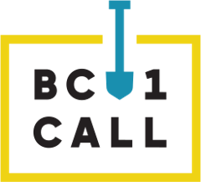
Please send an email titled “City of Excellence Award Nomination” to mroberts@bcmsa.ca including this form, supporting letters and other supporting documents. Please note: your submission will be evaluated based on the information the Committee receives so be sure to include as much supporting documentation as you feel necessary. We may ask shortlisted candidates to do
a presentation to the selection committee, in person or by electronic media.

Deadline for application is July 31st, 2023
WHICH AWARDS ARE YOU APPLYING FOR?
(you may apply for any number of awards)

- City of Excellence “Gold Standard” Award – Required to be active users of BC One Call
- Innovation Award
- Education Award

BACKGROUND DATA
APPLICANT INFORMATION
Local Government
Primary Contact
Position, Department
Street Address
City, Postal Code
Phone
Email
ADDITIONAL INFORMATION
Does the organization use Contractors exclusively for ground disturbances? | Yes No  (double click box to make your selection)
Does the organization have a ground disturbance and/or an excavation program? | Program Yes No  If no, organizations are not eligible for any of the above awards.  (double click box to make your selection)

PRIMARY CRITERIA | # HITS WITHIN JURISDICTION |  |  | COMMENTS
 | 2020 | 2021 | 2022
Performance - evidence of low level of incidents/hits/accidents

In no more than 500 words, explain why your organization should receive the specific award or awards. Provide specific examples or a pattern of contributions that distinguishes your organization from other dedicated local government organizations.

SUPPORTING DOCUMENTATION – required (i.e. supporting documentation of the program, policy, procedures, stats or innovation)?

Please list the name or titles of the supporting documents included in the submission:

ORGANIZATIONAL SUPPORT

Please provide at least one signature from the Director of Engineering, Public Works, Parks or Development Services or an individual in a senior management role supporting the submission.

NAME | JOB TITLE/ POSITION | SIGNATURE

Applications must be received by email, mroberts@bcmsa.ca

Submit nomination package (with subject title “City of Excellence Award Nomination”) to:

Mike Roberts
Submission checklist:
- Completed nomination form
- Required documents
- Signatures of Organizational Support
CEO
BC Municipal Safety Association
E: mroberts@bcmsa.ca
P: 778-835-3435

