Why talk about Pushing and Pulling?
How can I reduce the risk of an injury?
Injuries caused from overexertion while pushing or pulling are considered to be some of the most common forms of MSI. In most cases injuries as a result of pushing or pulling are preventable.
Here are some work safety and injury prevention tips:
- When possible, push rather than pull the load. This puts less stress on the shoulders.
- Keep your elbows close to your body and your hands within the sides of the cart or equipment when pushing or pulling.
- Always use both arms to move a load.
- Ensure your view is unobstructed and you can see where you are going.
- Avoid moving too fast. Pace yourself.
- Plan your path of travel.
- Make sure path is free of obstructions and slippery surfaces.
- Secure a load before moving it.
- Stop and secure a load if it becomes unstable.
- Stay clear and do not try to catch an unsecured load falling load.
- Wear footwear with appropriate traction.
- Maintain carts. Report and repair carts immediately.

What are some of the hazards associated with
Pushing and Pulling?

Pulling or pushing hazards:
- Pulling with arms stretched behind the body increases the risk of injury.
- A load being pulled while walking backwards causing you to not watch the direction you are pulling.
- Pulling or pushing a load on uneven or cluttered floors.
- Pushing or pulling a load using only one hand.
- Trying to manage unstable loads while pushing or pulling.
- Stopping an unsecured object from falling from a cart.
- Pushing or pulling a load too quickly can cause a fall.
- Wearing inadequate footwear increases the chance of slipping while pushing or pulling.
- Wheels that are not working properly.
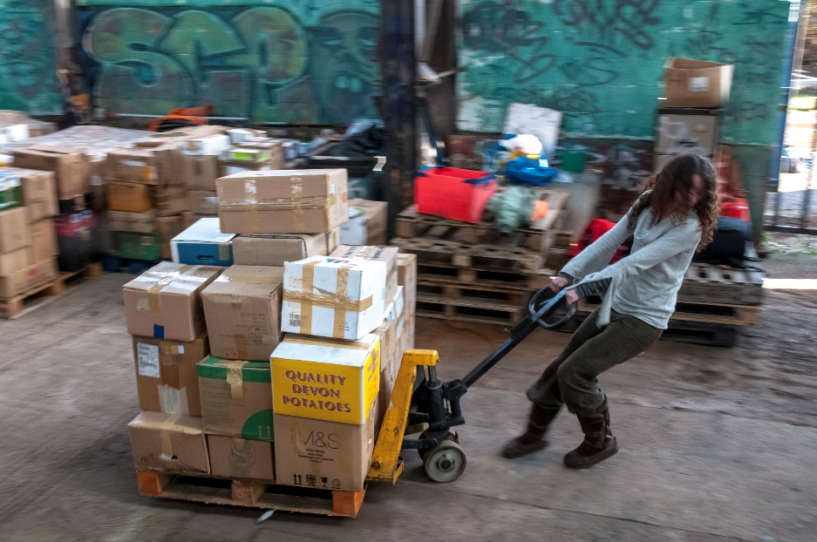
MEETING DESCRIPTION
Meeting Date: |  | Time:
Location: |  | Supervisor:
Number in Crew: |  | Number Attended:
Attended By: |  |  | Absent

REVIEW ITEMS FROM PREVIOUS MEETING | INCIDENTS/INJURIES REVIEWED

TOPICS DISCUSSED
- MSI – Pushing and Pulling- Force

WORKERS CONCERNS

CORRECTIVE ACTIONS TO BE TAKEN

MEETING CONDUCTED BY
Supervisor: |  | Manager:
Date: |  | Date:

