An employee’s successful return to the workplace and continued support in their recovery while on the job can be beneficial for both the employee and organization. By enabling an employee’s ability to undertake certain tasks and responsibilities modified to their recovery needs it helps facilitate a continued professional relationship that can help mitigate prolonged absenteeism. Considering the significant tole that work plays in a person’s life, maintaining ties with the workplace and feeling valued in a professional capacity can aid in helping workers recover faster. It has been noted that recovering at work is the healthiest option for most individuals experiencing work-related injuries.

Coming back to work varies for every employee as each person's recovery journey is unique. Those who resume work sooner often undergo a swifter recovery and tend to maintain better mental health and well-being during this process.
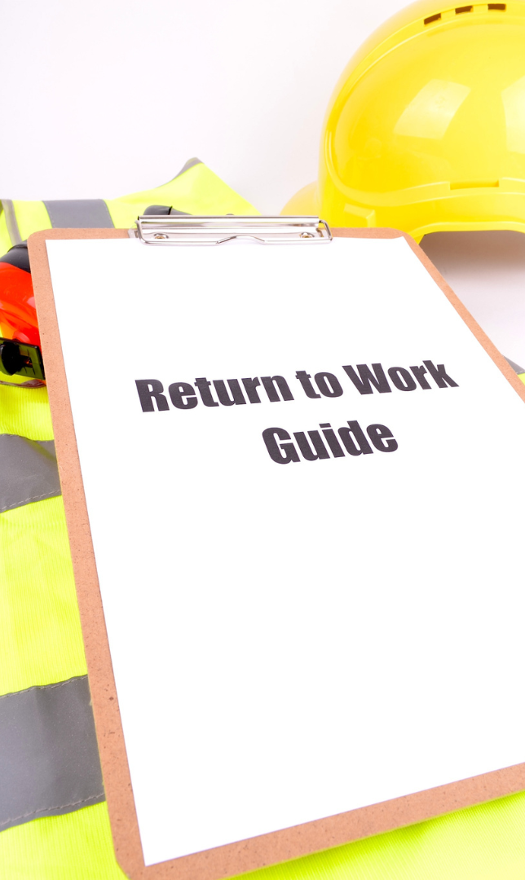
Full recovery isn't always needed before returning; they can contribute within their injury's limits.
The benefits of return to work and recovering at work:

As an employer:
- Reduces retraining needs and costs;
- Increases retention of experienced workers;
- Enhances employee relations;
- Minimizes productivity dips and interruptions in workflow;
- Reduces workload transfer to co-workers; and
- Addresses legislative requirements.
As an employee:
- Preserves worker skillset;
- Ensures employment stability;
- Sustains financial stability;
- Preserves personal value and self-worth;
- Maintains internal benefits; and
- Assists in return to normalcy.

Steps to support your return to work and recovery plan:
- Communicate with your employer: Maintain open communication about your condition and needed supports.
- Request reasonable accommodations: If needed, ask for accommodations to help you transition back to work such as modified work hours or changes in job duties/workload.
- Follow-up and adjust: Regularly follow-up with your healthcare team to assess your progress, ensuring to acknowledge any setbacks or improvements that may affect your work plan.
- Create a gradual return to work plan: Propose an individualized plan outlining gradual reintroduction to tasks setting realistic milestones and timelines.
- Take it slow: As you reintegrate into your work responsibilities, ensure to pace yourself and prioritize your recovery.
- Maintain open communication: Keep in touch with your employer throughout your recovery journey, providing updates on improvements, setbacks or any needs you may have in the workplace.

MEETING DESCRIPTION
Meeting Date: |  | Time:
Location: |  | Supervisor:
Number in Crew: |  | Number Attended:
Attended By: |  |  | Absent

REVIEW ITEMS FROM PREVIOUS MEETING | INCIDENTS/INJURIES REVIEWED

TOPICS DISCUSSED
- Return to Work/Recover at Work

WORKERS CONCERNS

CORRECTIVE ACTIONS TO BE TAKEN

MEETING CONDUCTED BY
Supervisor: |  | Manager:
Date: |  | Date:

