Why Talk about Repetition & Duration?
How can I reduce the risk of an injury?
If you use the same body parts for an activity repeatedly without resting, your muscles will become fatigued and increase the risk of injury. Injuries from repetition and duration can happen even when using a low force when performing a task.
Here are some tips to working safely and preventing an injury from occurring:
- Use an appropriate power tool for the task if feasible.
- Rotate the job function or task between workers.
- Take micro-breaks.
- Always take your allocated breaks.
- Avoid working through lunch and take your lunch away from the work area.
- When possible rotate between work areas to allow a variety of tasks that use different body areas and muscles.
What are some of the hazards associated with Repetition and Duration?
- Using a twisting or extraneous motion when using hand tools.
- Poor technique when completing repetitive tasks.
- Using a manual tool when a power tool could be used.
- Repeated impact to limbs and joints.
- No variety in movement.
- Doing the same task over and over.
- Not taking micro-breaks / stretch breaks / standard breaks.

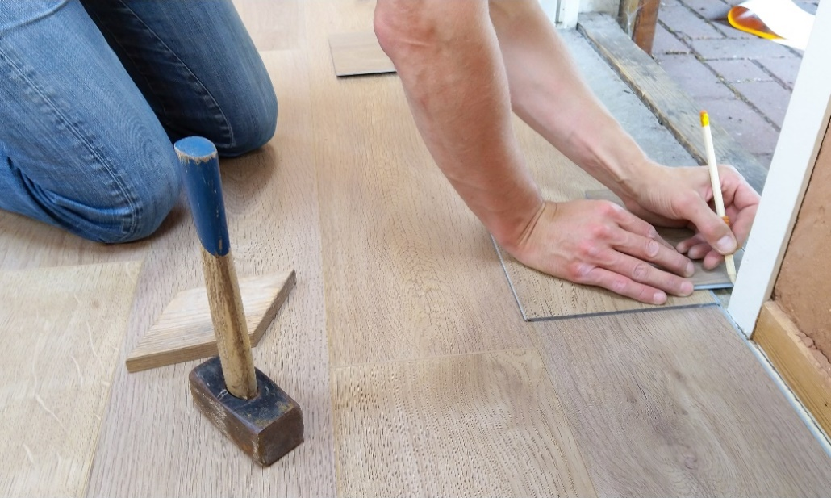
MEETING DESCRIPTION
Meeting Date: |  | Time:
Location: |  | Supervisor:
Number in Crew: |  | Number Attended:
Attended By: |  |  | Absent

REVIEW ITEMS FROM PREVIOUS MEETING | INCIDENTS/INJURIES REVIEWED

TOPICS DISCUSSED
- MSI – Repetition & Duration

WORKERS CONCERNS

CORRECTIVE ACTIONS TO BE TAKEN

MEETING CONDUCTED BY
Supervisor: |  | Manager:
Date: |  | Date:

