Post Traumatic Stress Disorder (PTSD) is a mental illness that can occur at any age. Symptoms can begin within the first three months after trauma, although there may be a delay of months, or even years, before criteria for the diagnosis is met. PTSD is described as an exposure to actual or threatened death, serious injury, or sexual violence in one (or more) of the following ways:
- Directly experiencing the traumatic event(s).
- Witnessing, in person, the event(s) as it occurred to others.
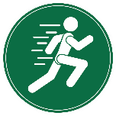
- Learning that traumatic event(s) occurred to a close family member or close friend. In cases of actual or threatened death of a family member or friend, the event(s) must have been violent or accidental.
What can a workplace do to support someone experiencing PTSD?
- Experiencing repeated or extreme exposure to aversive details of the traumatic event(s) (e.g., first responders responding to a mass casualty incident; police officers repeatedly exposed to details of child abuse).
To support someone experiencing PTSD or any mental health issue:
- Educate yourself on PTSD.
- Reduce stigma and encourage conversations.
- Have open discussions and offer support if you recognize signs or symptoms.
- Ask the individual how you can support them.
- Help them find support.
- Encourage them to talk to someone they trust.
- Encourage workers to support concerns or incidents so that events can be investigated and addressed.

For more resources and support:
- EFAP
- FirstRespondersFirst.ca
- CMHA
- Family Doctors

Which occupations may be more exposed to trauma?
- Military Personnel | - Dispatch Receivers
- Paramedics | - Corrections Officers
- Firefighters | - Nurses
- Police | - Doctors
- Other Emergency Personnel
Anyone may experience a traumatic event in their life. There are groups who are at a higher for developing PTSD:

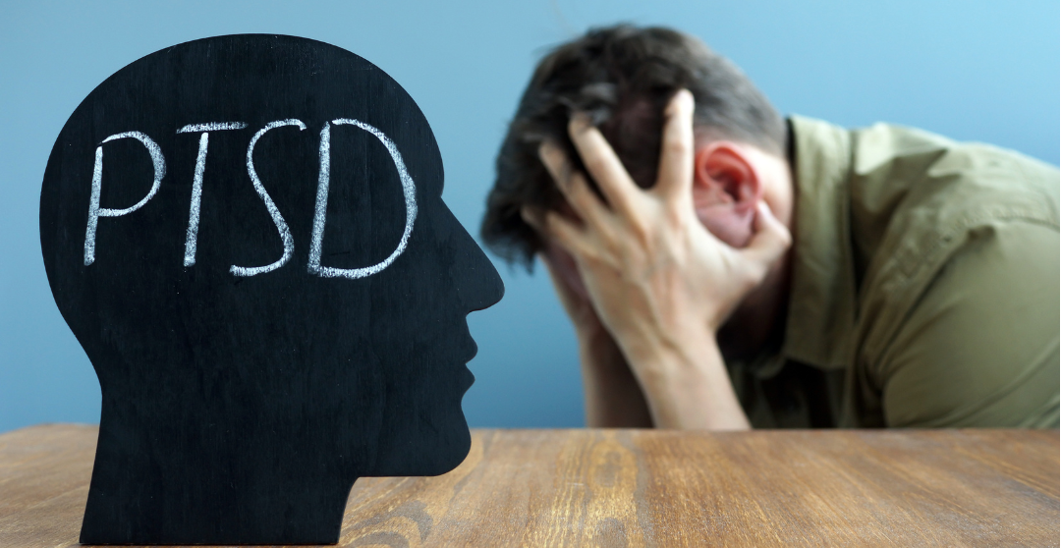

Common Symptoms and Difficulties
PTSD Symptoms may include nightmares, uncontrollable memories, trouble concentrating, overwhelming shame or guilt, and/or severe anxiety. Examples of difficulties include:
- Feeling nervous, fear, guilt | - Avoid public areas or crowds
- Feeling numb or detached | - Turning to substance abuse
- Being startled or frightened | - Consistently “on guard”
- Avoiding places, people, activities | - Troubles concentrating
- Dissatisfaction with work and life

MEETING DESCRIPTION
Meeting Date: |  | Time:
Location: |  | Supervisor:
Number in Crew: |  | Number Attended:
Attended By: |  |  | Absent

REVIEW ITEMS FROM PREVIOUS MEETING | INCIDENTS/INJURIES REVIEWED

TOPICS DISCUSSED
- Psychological Health & Safety: Post Traumatic Stress Disorder

WORKERS CONCERNS

CORRECTIVE ACTIONS TO BE TAKEN

MEETING CONDUCTED BY
Supervisor: |  | Manager:
Date: |  | Date:

