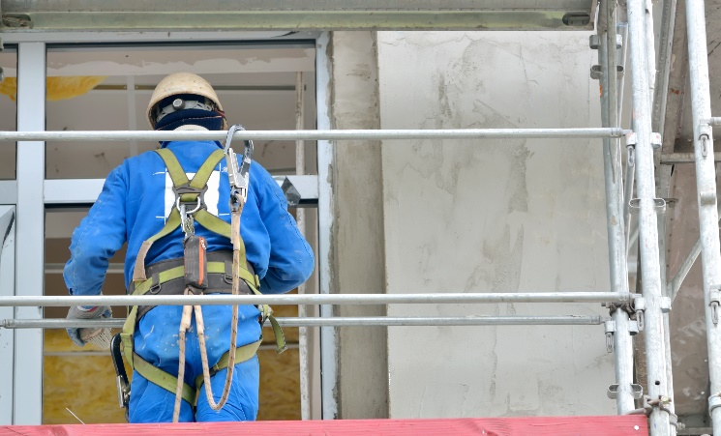
Dressing Appropriately
When it comes to deciding what clothing to wear each day many factors can play a role. Weather, worksite Personal Protective Equipment (PPE) requirements, the type of work and their hazards.

Here are some examples that can lead to injury:
- Wearing loose fitting shirts or jackets when operating powered machinery or equipment.
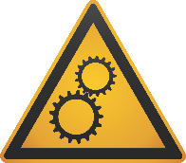
- Wearing clothes with tears and holes.
Remember that how you dress and the PPE you wear reduces the risk but doesn’t eliminate the hazards.
- Using worn or tattered gloves when performing tasks.
- Wearing overalls or pants that are too long.
- Wearing jewelry while operating powered machinery or equipment.
- Wearing the wrong foot wear for the work site.
- Not being dressed appropriately for the weather conditions.

How to protect yourself and others:
- Ensure that the PPE you are wearing has been inspected and is not damaged before starting work.
- Never wear a loose fitting jacket, keep it buttoned or zippered shut at least chest high while working around moving machinery.
- Never wear overalls or pants with cuffed or rolled up legs to prevent from tripping or having them caught onto or in machinery.
- A safe work boot should not be to long, have thick soles to prevent punctures and a steel toes to protect against toe injuries.
- Do not wear loose jewelry like watches, chains, rings or keys on belt. Avoid any item that might hook on something and place you in a hazardous position.
- Ensure you are always wearing the proper Personal Protective Equipment for the task(s).
- Bring extra clothing with you to work in case your clothing comes in contact with chemicals, becomes wet/torn.
- Ensure you are always wearing the proper Personal Protective Equipment for the task(s) but remember it is the last line of defense. Note: Do not wear gloves around rotating equipment.

Summary
Don’t put yourself in the Line of Fire, take the time to plan for your work environment whether you work indoors or out. Wear clothes that protect you and fit comfortably while wearing your PPE. Feeling comfortable in your clothing while working will help you focus, be more productive and efficient.
Let’s discuss what could affect you and your co-workers
List the areas in your work space that your clothing can be considered as potential hazard?
How can we eliminate some or all of these hazards?
Can you list some other ways we can protect ourselves from Crushing Hazards at our site?
Can you list off all of the PPE you are required to wear on this site and for your task?

MEETING DESCRIPTION
Meeting Date: |  | Time:
Location: |  | Supervisor:
Number in Crew: |  | Number Attended:
Attended By: |  |  | Absent

REVIEW ITEMS FROM PREVIOUS MEETING | INCIDENTS/INJURIES REVIEWED

TOPICS DISCUSSED
- Crushing Hazard – Dressing Appropriately

WORKERS CONCERNS

CORRECTIVE ACTIONS TO BE TAKEN

MEETING CONDUCTED BY
Supervisor: |  | Manager:
Date: |  | Date:

