Flying Objects
These hazards occur when an object is propelled across a space. This includes situations when a piece of material separates from a tool, machine or other equipment striking a worker. It is important to understand the specific hazards before performing a task as well as the potential flying hazards possibly impacting the overall job site.

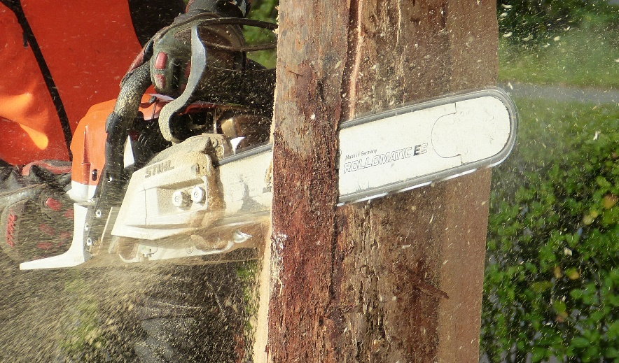
Common Examples of Flying Objects
- Materials are expelled from a power tool, machine or other equipment.
- Compressed air used for power tools or to clean surfaces that can hurl objects.
- Debris from grinding or cutting tools.
- Nail, Staple gun discharges.

How to protect yourself and others:
- Always be aware of hand/body placement.
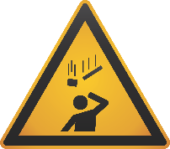
- Inspect equipment to ensure protective guards are in place and in good condition.
Objects can travel with speed and force potentially causing serious harm from broken bones to blindness when a worker is struck.

- Stay clear of hazards using job briefings and three-way communication.
- Ensure you always wearing proper the right Personal Protective Equipment for the task(s) but remember it is the last line of defense.
- Wait for the all clear from the worker using power tools, machinery or equipment before approaching.
- Reduce compressed air pressure to 30psi when cleaning surfaces.
- Be sure to be properly trained before using power tools, machinery or equipment.
- Inspect all tools, machinery and equipment before operation.
- Report all broke tools, machinery and equipment to your supervisor.

Summary
It is difficult to fully eliminate all the hazards that result in struck-by incidents, but through proper task planning and preparation you can mitigate yourself and your co-workers exposure to these potential hazards. Evaluate your work tasks to see if there are any unnecessary risks to you or your co-workers due to the mentioned hazards above.
Let’s discuss what could affect you and your co-workers.
What are some of the flying object hazards in your work area?
How can we eliminate some or all of these hazards?
Can you list some other ways we can protect ourselves from struck-by hazards at our site?

MEETING DESCRIPTION
Meeting Date: |  | Time:
Location: |  | Supervisor:
Number in Crew: |  | Number Attended:
Attended By: |  |  | Absent

REVIEW ITEMS FROM PREVIOUS MEETING | INCIDENTS/INJURIES REVIEWED

TOPICS DISCUSSED
- Striking Hazard – Flying Objects

WORKERS CONCERNS

CORRECTIVE ACTIONS TO BE TAKEN

MEETING CONDUCTED BY
Supervisor: |  | Manager:
Date: |  | Date:

