Driving a vehicle or truck for a short and/or prolonged period of time can have an impact on the body. The posture you are mindful of maintaining while at a desk is different from when sitting in a car. Key differences include arm position when holding the steering wheel, extending your leg forward to press the brake or accelerator pedals and much more. Below are a few things you can keep in mind to lessen the risk of injury while driving a vehicle or truck.

Prepare for the drive:
- Adjust the seat so you can comfortably reach the steering wheel and pedals.
- Adjust the steering wheel to the appropriate height for your use and comfortability.
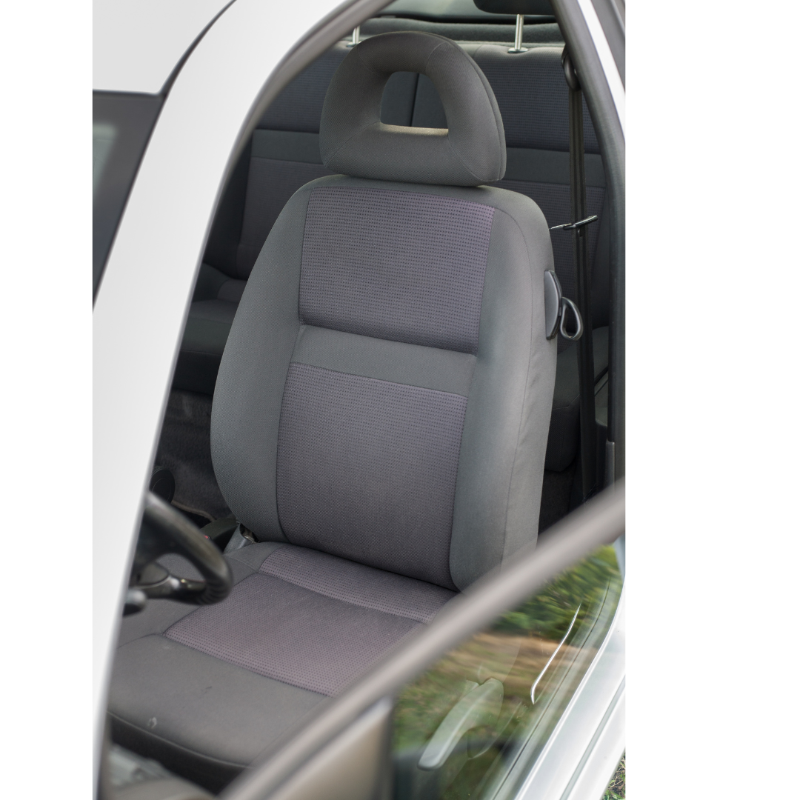
- Keep a slight bend at the elbows when holding the steering wheel. Try not to hold the wheel tightly. Keep a light grip.
- Ensure your knees are not positioned higher than your hips.
- Keep your back rested against the seat.
- Provide lumbar support using the seat functions or with an additional cushion.
- Adjust the head rest so it is behind your head and able to provide support.

Tips for driving comfortably:

- Adjust your hand position frequently and do not grip the steering wheel.
- Adjust your mirrors to avoid awkward posture.
- Have all regularly used items within direct reach before departing.
- Secure loose items that could roll or slide under your feet or the pedals.
- Ensure heavy objects and cargo are secured.

Tips for after the drive:
- When getting in and out of the vehicle, use the handle and steps ensuring to maintain three points of contact.
- Before stepping out of the vehicle, check for any hazards or environmental conditions.

Additional Resources:
- To learn more about adjusting your seat: https://roadsafetyatwork.ca/resource/tool-kit/driving-for-work/
- Distracted Driving: www.worksafebc.com/en/health-safety/hazards-exposures/driving-work/types/distracted-driving

MEETING DESCRIPTION
Meeting Date: |  | Time:
Location: |  | Supervisor:
Number in Crew: |  | Number Attended:
Attended By: |  |  | Absent

REVIEW ITEMS FROM PREVIOUS MEETING | INCIDENTS/INJURIES REVIEWED

TOPICS DISCUSSED
- Driving Ergonomics

WORKERS CONCERNS

CORRECTIVE ACTIONS TO BE TAKEN

MEETING CONDUCTED BY
Supervisor: |  | Manager:
Date: |  | Date:

