First aid processes are implemented at an organization to minimize injury and future disability. It is an employers responsibility to ensure first aid services are provided at all workplaces. All new employees or employees who switch workplaces should be oriented on instructions on how to receive first aid treatment.

First Aid Requirements
First aid requirements are dependent on these factors:
- The number of workers at a workplace;
- The type of hazards present; and
- The travel distance to a hospital or availability of medical assistance.
To familiarize yourself with your workplace first aid procedure reach out to your supervisor.
What you need to know about first aid
Only workers with the identified first aid training should treat a victim. Do not provide first aid if you have not received training. You need to understand:
- Procedures that should be followed if you require first aid.
- Which type of injuries should be reported and who to call for help.
- Location of first aid room and/or first aid kit.
- Location of the list of first aid attendants.
- Location of the list of organization’s key personnel by name, title and telephone number.
- After hours reporting.
- How to report non-work related injuries.
It is important to report as soon as possible to ensure you receive effective treatment and minimize delays in the claims process. If medical treatment is sought for a non-work related injury, still report the injury to your supervisor to prevent any delays in receiving support.

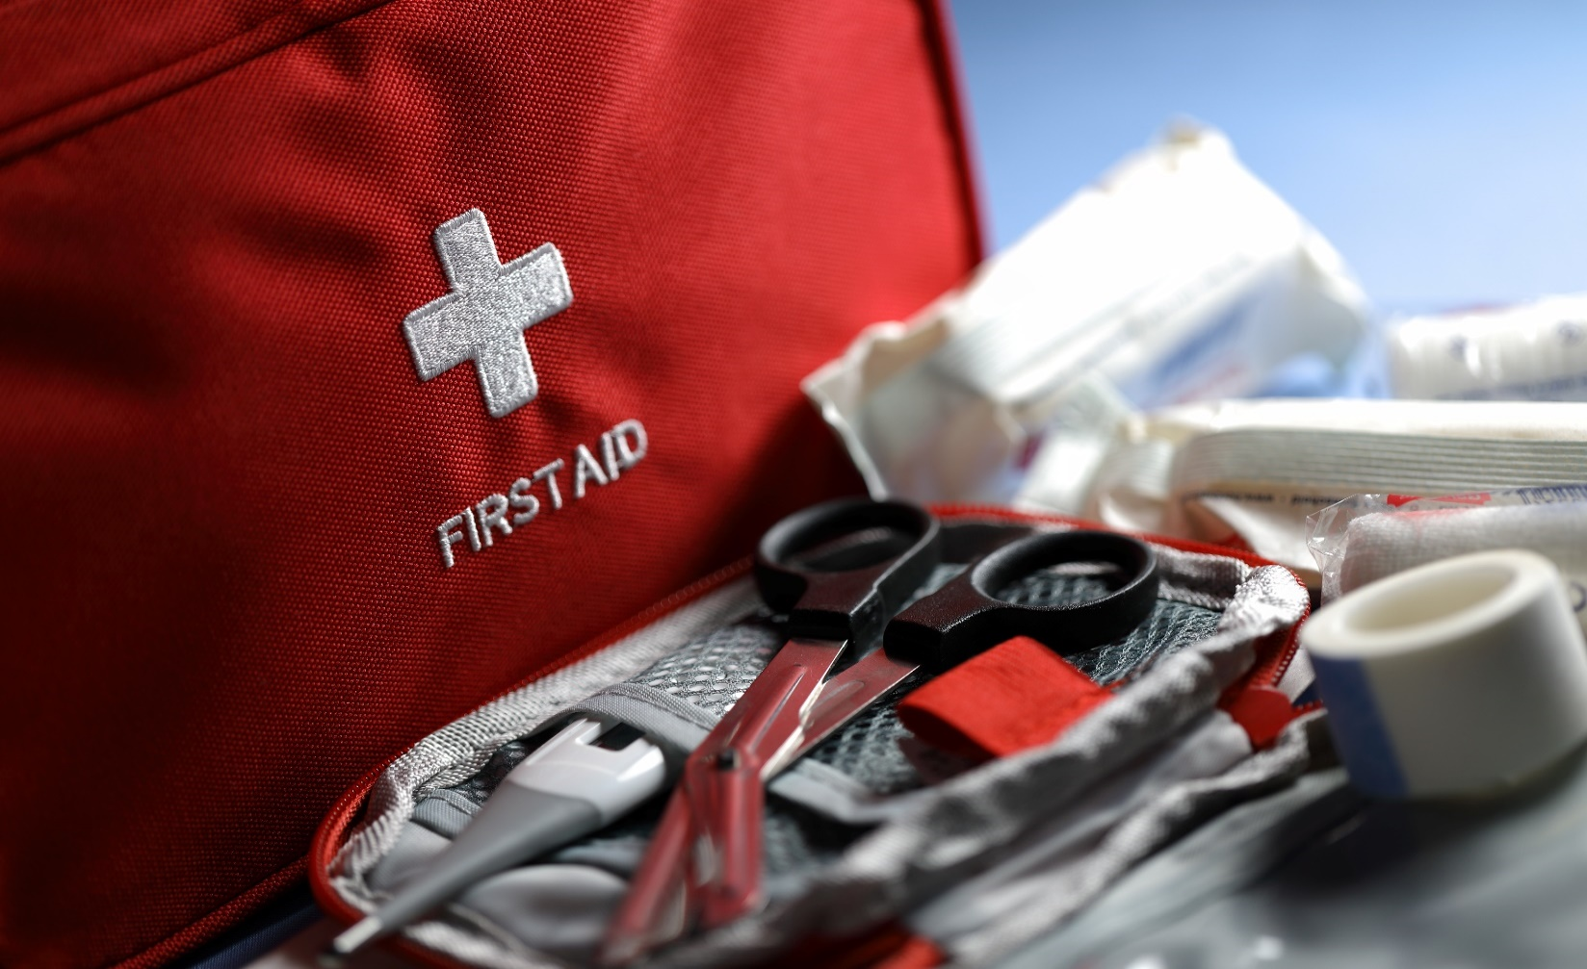
MEETING DESCRIPTION
Meeting Date: |  | Time:
Location: |  | Supervisor:
Number in Crew: |  | Number Attended:
Attended By: |  |  | Absent

REVIEW ITEMS FROM PREVIOUS MEETING | INCIDENTS/INJURIES REVIEWED

TOPICS DISCUSSED
- First Aid

WORKERS CONCERNS

CORRECTIVE ACTIONS TO BE TAKEN

MEETING CONDUCTED BY
Supervisor: |  | Manager:
Date: |  | Date:

