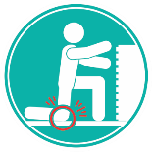
Why Talk about Contact Stress?
How can I reduce the risk of an injury?
Contact Stress can easily lead to injury by cutting off circulation to a localized area leading to discomfort and a possible MSI if the pressure is prolonged or repetitive. Common areas of pressure in the lower extremity is the knee, thigh, or foot. A common sign would be a depression, or a divot, left in the skin or pale skin after contact stress.
Here are some tips to working safely and preventing an injury from occurring.:
- Use knee pads or a kneeling pad.
- Round or pad the edges of sharp or uneven workstations.
- Sit in a properly sized chair.
- Use the proper tool for the task at hand.
- Use a mallet instead of using the knee or foot as a hammer.
- Set up the work area to accommodate the worker.
- Change the work area to minimize overreaching.
- Use a footrest or lower the chair height to prevent pressure against the back of the thigh.
- Wear Properly Fitted Steel Toed Boots.
What are some of the hazards associated with Contact Stress in the Lower Extremity?
- Using the knee or the foot as a hammer.
- Kneeling for long periods of time while performing a task.
- A poorly set up workstation. E.g. A file cabinet positioned too close to the seated position of an office worker creating contact stress.
- Leaning against the edge of a hard or sharp work surface.
- Pressure against the back of the thigh when sitting in an elevated chair without foot support.
- Sitting on an improperly fitted chair.
- Dropping an item on the foot.
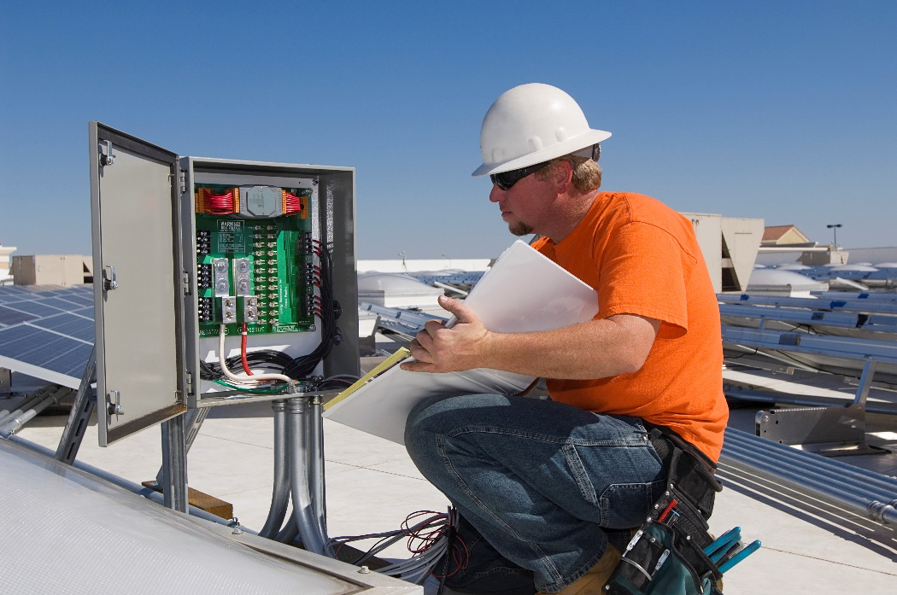
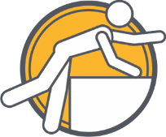
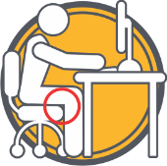
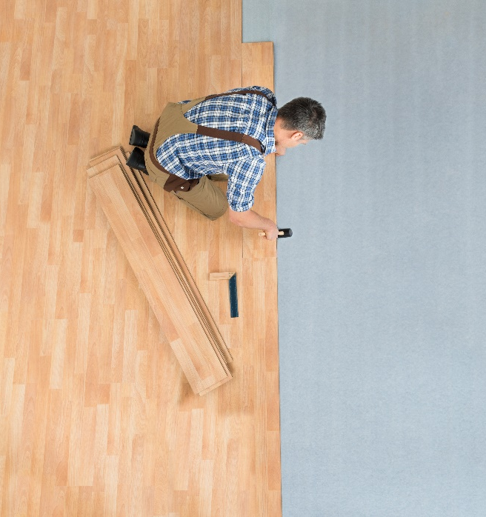
Awkward posture to complete a task.
Chair pressing up against the back of the knee.
MEETING DESCRIPTION
Meeting Date: |  | Time:
Location: |  | Supervisor:
Number in Crew: |  | Number Attended:
Attended By: |  |  | Absent

REVIEW ITEMS FROM PREVIOUS MEETING | INCIDENTS/INJURIES REVIEWED

TOPICS DISCUSSED
- MSI – Contact Stress – Lower Extremity

WORKERS CONCERNS

CORRECTIVE ACTIONS TO BE TAKEN

MEETING CONDUCTED BY
Supervisor: |  | Manager:
Date: |  | Date:

