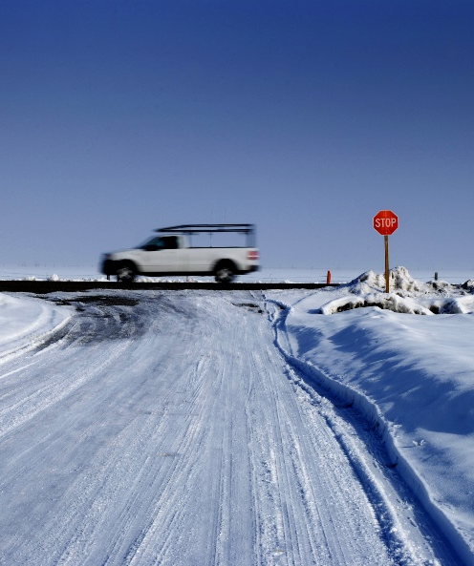
Winter Work – Winter Driving
Accidents while driving in the winter increase dramatically and many people don’t understand winter driving or fail to foresee how the weather conditions will impact their journey.
Here are some examples that can lead to injury while driving:
- Poor traction caused by slippery roads or vehicle tires leading to an inability to start or stop moving a vehicle.
- The inability to see other vehicles or be seen by other vehicles caused by snow or ice covered windows.
- Speeding and not driving to the weather conditions.
- Distracted driving, like using a cellphone, doing your make up, letting your mind wander off task.
Have a Journey Management Plan.

Let your supervisor (or loved one) know of your route, when you leave, when you plan to get there, and when you arrive.
- Following too closely to the vehicle in front of you increasing the risk of a rear end collision.
How to protect yourself and others:
- Remove your summer tires and ensure your winter tires are winter ready, having at least 6/32 inch deep tread for adequate traction.
- Check the tire pressure at least and ensure it is at or near its recommended PSI.
- Clear the vehicle of snow and the windows of ice so you have maximum visibly while driving.
- Make any adjustments to your vehicle mirrors, temperature, seat, radio etc. before you start driving.
- Secure any loose objects to limit distractions.
- Assess the weather forecast and road conditions so you can better time and plan your trip.
Summary
Driving defensively demands the driver’s be responsible, alert and cautious. Planning, and preparing your journey will help mitigate the potential hazards before your start to drive. You’re the only one who can control your vehicle, so don’t rush, be alert, be cautious and take it slow.
Let’s discuss what could affect you and your co-workers:
List some of the potential hazards you can think of on your journey to work today?
Can you list some ways to eliminate or mitigate the hazard(s) you mentioned above?
Ask yourself, did I take the necessary precautions to ensure my vehicle is winter ready before leaving my house today?
MEETING DESCRIPTION
Meeting Date: |  | Time:
Location: |  | Supervisor:
Number in Crew: |  | Number Attended:
Attended By: |  |  | Absent

REVIEW ITEMS FROM PREVIOUS MEETING | INCIDENTS/INJURIES REVIEWED

TOPICS DISCUSSED
- Winter Work – Winter Driving

WORKERS CONCERNS

CORRECTIVE ACTIONS TO BE TAKEN

MEETING CONDUCTED BY
Supervisor: |  | Manager:
Date: |  | Date:

