Job Title: Surveyor Assistant Department: Engineering
Location: Worksyard

Purpose
The Surveyor Assistant working for the Corporation of Delta is responsible for assisting the Survey Technician in all aspects of conducting varied survey assignments including assisting the Survey Technician in moderately complex tasks in survey work, operating all survey instruments, and performing non-complex survey assignments independently.

Essential Duties
The Surveyor Assistant performs the following essential duties:
- Assists a Survey Technician in moderately complex tasks in construction and topographical survey work; determines appropriate placement of equipment to ensure precise measurements; recognizes important features or elements and informs the Survey Technician; participates in the operation and set-up of the Total Station and Global Positioning System (GPS).
- Operates a transit, level and related survey instruments as required; makes survey computations and calculations as required.
- Performs non-complex survey assignments independently; searches out plans, locates buried utilities using an M-scope and matches utilities to plan markings; checks monuments and records condition.
- Takes linear measurements as directed with a steel tape or chain; cuts, drives and marks posts and stakes.
- Assists in establishing lines and grades using a leveling rod, prism pole, tape measure and plumb-bob.
- Uncovers survey pins, exposes shallow utilities; independently conducts traffic counts including setting up equipment; makes elementary notes, sketches and computations.
- Clears trees, weeds, brush and other obstacles using an axe, machete, power saw or related equipment.
- Performs various maintenance and simple repair tasks of hand tools and equipment.
- Operate computer as required (~30% of shift).
- Operates light truck or van as required (~20-25% of the shift); transports equipment and tools from various locations as required; monitors the functioning of the vehicle, performs minor maintenance as required, and reports any problems to the mechanic.
- Uncover manholes to measure depth of manhole, determine size of piping, direction of flow and / or what is in the manhole.

Description of Non-essential Tasks
Not applicable.

Summary of Demands
 | Sedentary | Light | Medium | Heavy | Very Heavy | Comments
Physical |  |  | ✓ |  |  | Based on strength requirements
Cognitive |  |  | ✓ |  |  | Based on driving requirements; ability to interact appropriately with colleagues and public
Workers require physical endurance since they stand and walk continuously (i. e., for between 67-100 % of their shift).

Shift Structure
The Surveyor Assistant works from 8:30 a.m. to 4:45 p.m. The Surveyor Assistant is allowed a 30 minute meal break and two 10-minute rest breaks.

Frequency Rating Definitions
The frequency rating definitions used in the Summary Table are from the Dictionary of Occupational Titles (DOT, 1991, 4th edition) published by the US Department of Labor. A similar classification is used for each Essential Duty, but the percentages are changed to reflect % of Duty rather than % of shift.

 | Time per Day | Percentage of Shift
Never | 0 minutes | 0 %
Rare | 0 - 5 minutes | 0-1 %
Infrequent | 6 - 25 minutes | 2-5 %
Occasional | 26 minutes – 2.5 hours | 6-33 %
Frequent | 2.6 - 5.25 hours | 34-66 %
Constant | 5.26 - 8 hours | 67-100 %

STRENGTH
Strength Category | Weight Handled
- Limited | Up to 5 kg.
- Light | 5 kg. to 10 kg.
- Medium | 10 kg. to 20 kg.
- Heavy | >20 kg

Job Demands Analysis – Surveyor Assistant

- Physical Demands |  | Frequency During Shift |  |  |  |  |  |  |  | Weight |  | Comments
 |  | Never |  | Rare |  | Infrequent | Occasional | Frequent | Constant | Usual (kg) | Max (kg)
Strength | Lifting – Floor to Knuckle |  |  |  |  |  | ✓ |  |  | 2-6 | 12 | Lifting / lowering equipment from ground (e.g., surveying instrument box – 9.5 kg, tripod – 6 kg, sledge hammer – 2.3 - 3.6 kg, rope reel – 3 kg; pail – 2 kg, monument lid – 5.5 kg, back sight – 1.5 kg, shovel – 2.3 kg); shovel with soil (12 kg)
Strength | Lifting – Knuckle to Waist |  |  |  |  |  | ✓ |  |  | 2-6 | 12 | Retrieving and placing equipment in vehicle (e.g., surveying instrument box – 9.5 kg, tripod – 6 kg, sledge hammer – 2.3 - 3.6 kg, rope reel – 3 kg; pail – 2 kg, monument lid – 5.5 kg, back sight – 1.5 kg, shovel – 2.3 kg); shovel with soil (12 kg)
Strength | Lifting – Over Shoulder |  |  |  |  |  | ✓ |  |  | 6 |  | Sack of sticks; tripod (6 kg)
Strength | Carrying – with Handles |  |  |  |  | ✓ |  |  |  | 2 | 10 | Surveying instrument box (9.5 kg); pail (2 kg)
Strength | Carrying – without Handles |  |  |  |  |  | ✓ |  |  | 2-6 | 6 | Equipment (e.g., tripod – 6 kg, sledge hammer – 2.3 - 3.6 kg, rope reel – 3 kg; monument lid – 5.5 kg, back sight – 1.5 kg, shovel – 2.3 kg)
Strength | Pushing – Upper Extremity |  |  |  |  |  | ✓ |  |  |  |  | Pushing branches / signs in the way
Strength | Pushing – Hips/Legs assist |  |  |  |  |  | ✓ |  |  |  |  | Pushing branches; shoveling
Strength | Pulling – Upper Extremity |  |  |  |  |  | ✓ |  |  |  |  | Pulling rope while lane marking
Strength | Pulling – Hip/Leg Assist |  |  |  |  |  | ✓ |  |  | <42 | 42 | Pulling manhole lids using manhole lifter (force obtained from Ergonomic Risk Assessment – Water Main Flushing); shoveling

Job Demands Analysis – Surveyor Assistant (continued)

- Physical Demands (continued) |  | Frequency During Shift |  |  |  |  |  | Comments
 |  | N | R | I | O | F | C | Comments
Mobility | Reach – Shoulder or Above |  |  |  | ✓ |  |  | Clipping hedges; using machete
Mobility | Reach – Below Shoulder |  |  |  |  |  | ✓
Mobility | Handling |  |  |  |  | ✓
Mobility | Fine finger movements |  |  |  |  | ✓ |  | Setting up total station and engineering level; spray painting
Mobility | Neck - Static Flexion |  |  |  |  | ✓ |  | Holding prism pole (depends on employee stature)
Mobility | Neck – Static Neutral |  |  |  |  | ✓ |  | Holding prism pole (depends on employee stature)
Mobility | Neck – Static Extension |  | ✓
Mobility | Neck – Rotation |  |  |  |  | ✓
Mobility | Throwing |  | ✓
Mobility | Sitting |  |  |  | ✓ |  |  | Driving; while using the computer
Mobility | Standing |  |  |  |  | ✓ |  | While holding leveling rod / prism pole
Mobility | Walking |  |  |  |  | ✓
Mobility | Running/Jumping |  | ✓ |  |  |  |  | Jumping ditches; climbing over fences
Mobility | Climbing |  |  |  | ✓ |  |  | Climbing hills / ditches; climbing over fences; climbing into van to get supplies (step ht. 53 cm)
Mobility | Bending/Stooping |  |  |  |  | ✓ |  | Setting up total station / leveling rod / prism pole; hammering concrete nails into ground; painting on road; using tape measure; setting up and removal of traffic cones / signage; clipping / cutting hedges; using welder’s magnet
Mobility | Crouching |  |  |  | ✓ |  |  | Squatting while hammering and spray-painting stakes for marking property lines; squatting while pulling rope while lane marking
Mobility | Kneeling |  |  |  | ✓ |  |  | While hammering concrete nails into ground (avg. 30-40 nails per job)
Mobility | Crawling |  | ✓
Mobility | Twisting |  |  |  |  | ✓ |  | While clipping hedges; while shovelling
Mobility | Balancing |  | ✓
Mobility | Travelling |  |  |  | ✓ |  |  | Driving
Job Demands Analysis – Surveyor Assistant (continued)

- Physical Demands (continued) |  | Frequency During Shift |  |  |  |  |  | Comments
 |  | N | R | I | O | F | C | Comments
Sensory / Perception | Hear/Conversations |  |  |  |  |  | ✓ | Radio communication
Sensory / Perception | Hear/Other Sounds |  |  |  |  |  | ✓
Sensory / Perception | Vision/Far |  |  |  |  |  | ✓
Sensory / Perception | Vision/Near |  |  |  |  |  | ✓
Sensory / Perception | Vision/Colour |  |  |  | ✓ |  |  | Viewing laser pointer; driving tasks
Sensory / Perception | Vision/Depth |  |  |  |  |  | ✓
Sensory / Perception | Perception/Spatial |  |  |  |  |  | ✓
Sensory / Perception | Perception/Form |  |  |  | ✓
Sensory / Perception | Feeling |  |  |  |  |  | ✓
Sensory / Perception | Speech |  |  |  |  |  | ✓
Work Environment | Inside Work |  |  |  | ✓
Work Environment | Outside Work |  |  |  |  | ✓
Work Environment | Slippery |  |  |  | ✓ |  |  | Depends on site and weather
Work Environment | Congested worksite |  |  |  | ✓ |  |  | Depends on site
Work Environment | Chemical Irritants |  | ✓ |  |  |  |  | Pesticides; paint
Work Environment | Confined Space Entry |  | ✓
Work Environment | Vapour Fumes |  |  |  |  | ✓ |  | Traffic fumes; paint; sewage
Work Environment | Noise |  |  |  |  | ✓ |  | Equipment / vehicles used at site; traffic noise
Work Environment | Proximity to moving objects |  |  |  |  | ✓ |  | While driving; depends on site
Work Environment | Hazardous Machines |  | ✓ |  |  |  |  | Depends on site (e.g. construction equipment)
Work Environment | Electrical hazard |  | ✓ |  |  |  |  | Depends on site (e.g. electric fences)
Work Environment | Sharp Tools |  |  |  | ✓ |  |  | Machete; hedge clippers; nails
Work Environment | Radiant/Thermal Energy |  | ✓ |  |  |  |  | Depends on site (e.g. asphalt)
Work Environment | Hot/Cold |  |  |  | ✓ |  |  | Constant during inclement weather
Work Environment | Humid |  |  |  | ✓ |  |  | Constant during inclement weather
Work Environment | Dust |  |  |  | ✓ |  |  | Depends on site
Work Environment | Organic Substances |  | ✓ |  |  |  |  | Depends on site (e.g. animal waste, agricultural ditch water)
Work Environment | Lighting – Direct |  |  |  |  | ✓ |  | Natural light outdoors
Work Environment | Lighting – Indirect |  |  |  | ✓
Work Environment | Vibration – Whole Body |  |  |  | ✓ |  |  | While operating vehicle on uneven surfaces (depends on road conditions and vehicle)
Work Environment | Vibration – Hand/Arm | ✓

Job Demands Analysis – Surveyor Assistant (continued)

- Cognitive and Psychosocial Demands | Frequency During Shift |  |  | Comments
- Cognitive and Psychosocial Demands | Never / Rare | Infrequent / Occasional | Frequent / Constant | Comments
Degree of Supervision |  | ✓
Time Pressure |  | ✓ |  | Self-paced
Attention to Detail |  |  | ✓
Memory Requirements |  |  | ✓
Interact with co-workers |  |  | ✓
Interact with public |  |  | ✓
Work Alone |  | ✓ |  | Looking at property; getting supplies; property pins
Reading |  |  | ✓ | Plans
Writing |  | ✓ |  | Painting on roads; writing on stakes; documenting particulars on manholes
Irregular Hours | ✓ |  |  | Overtime hours (optional)
Operating Equipment |  |  | ✓ | Vehicle

Physical Environment
Majority of the work (70% of the shift) takes place outdoors in a variety of climatic conditions. The employee walks on all kinds of terrain and drives in all kinds of weather and road conditions.

Staffing Levels
The Surveyor Assistant usually works in pairs but sometimes may work alone or in teams of three.

Tools and Equipment Used
The Surveyor Assistants uses a variety of equipment and tools.
- Vehicle | - Prism pole | - Steel tape
- Computer | - Leveling rod | - Chain
- Machete | - Transit | - Tape measure
- Hedge clippers | - Survey pins | - Plump-bob
- Axe | - Total Station tripod (6 kg) | - Concrete nails
- Power Saw | - Posts | - Stakes
- Shovel (2.3 kg) | - Manhole lifter (1.6 kg) | - Sledge hammer (2.3 - 3.6 kg)
- Rope reel (3 kg) | - Back sight (1.5 kg) | - Hammer
- Can of spray paint | - Stripping gun | - Welder’s magnet
- Nail vise grip | - Surveying Instrument box (9.5 kg) | - Radio
- Traffic signs | - Traffic cones | - M-scope

Other Equipment
CSA Approved boots (required). Other safety equipment as needed: gloves depending on task (leather, rubber, latex, all-purpose Thinsulate with padding), high visibility safety vests, hard hat, eye protection and hearing protection.

Data Collection
An ergonomics consultant from WorkWell Consulting (Ms. Farzana Ismail, CCPE) conducted the JDA assessment on March 23rd 2011. Two Surveyor Assistants were interviewed and observed performing the job.

Contact for the on-site assessment
Janyce Mah (Safety & Claims Advisor) was the contact for the on-site assessment.

JOB TASK OR WORKSTATION ILLUSTRATIONS:

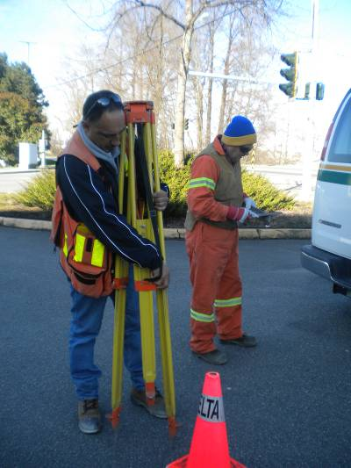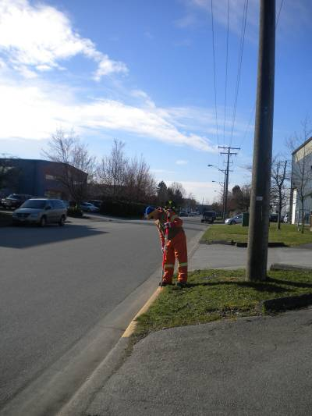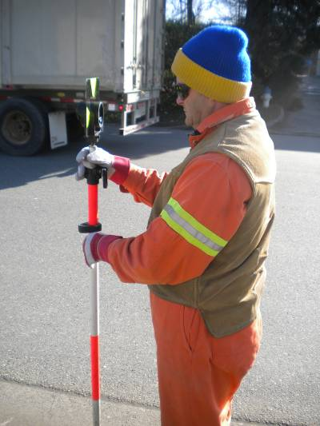
Setting up Total Station Setting up leveling rod Standing while holding leveling rod

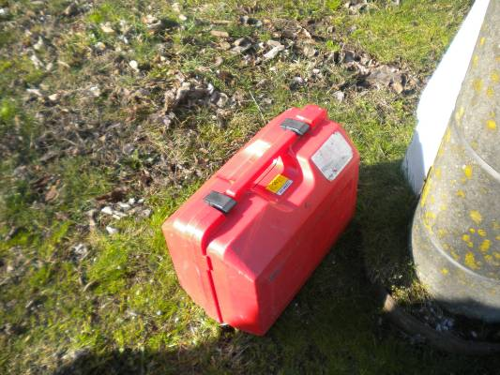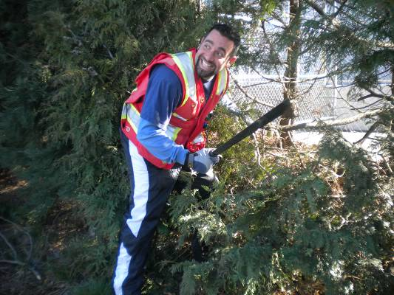
Surveying instrument box (9.5 kg) Using machete

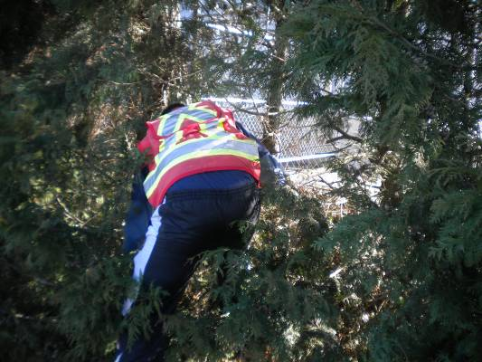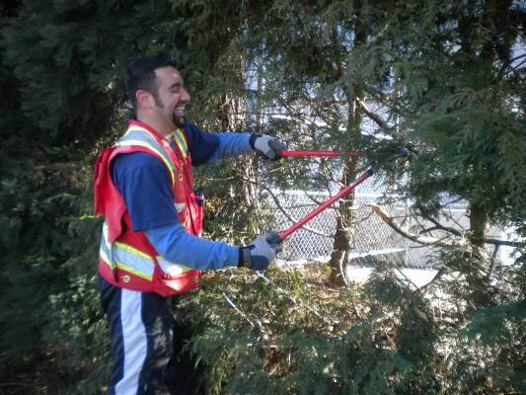
Bending and twisting while cutting hedges Using hedge clippers

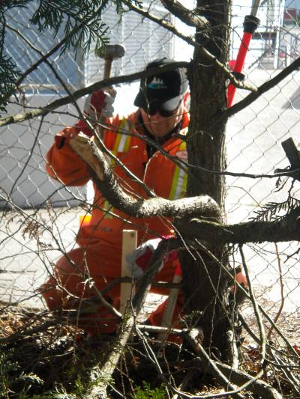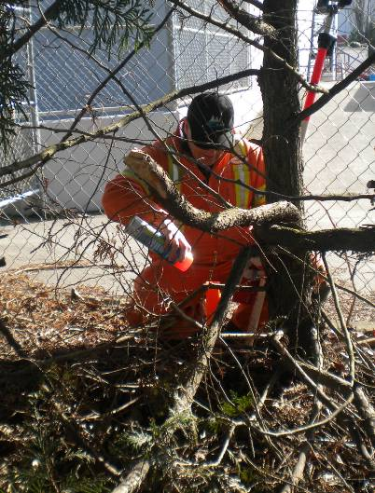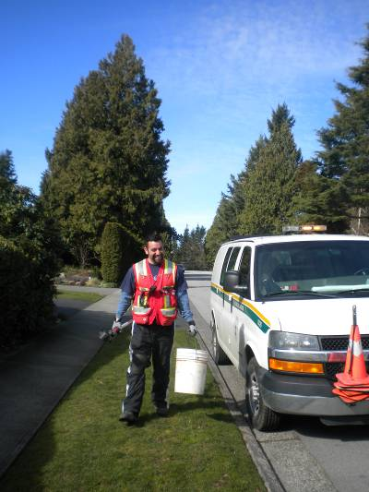
Using sledge hammer on stakes Spraying paint on stakes Pail with equipment (2 kg)

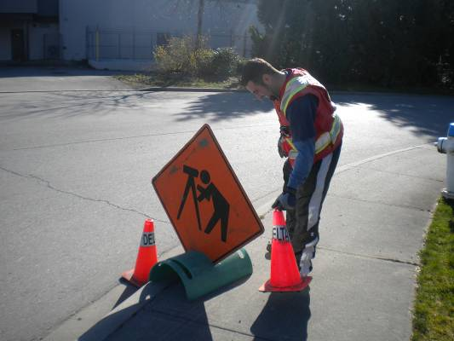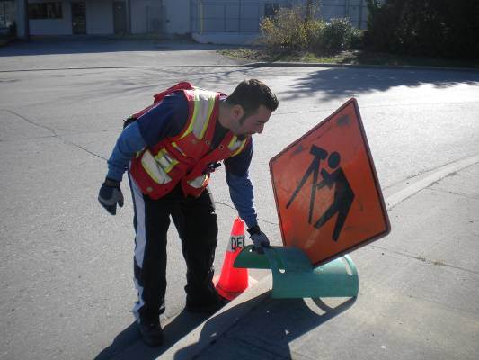
Setting up traffic cones Setting up traffic signs

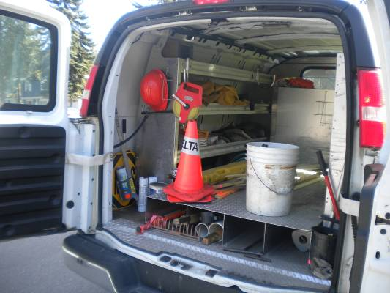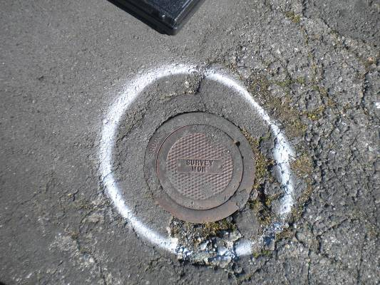
Storage deck in van (ht. 94 cm) Legal marker

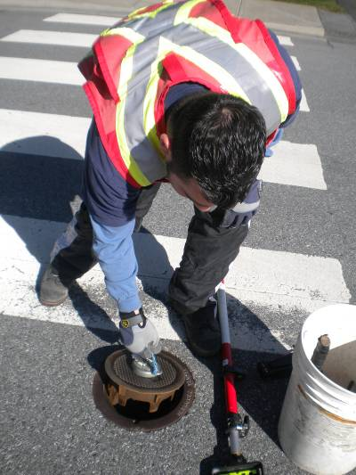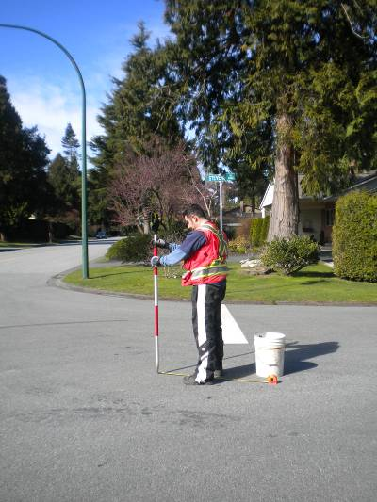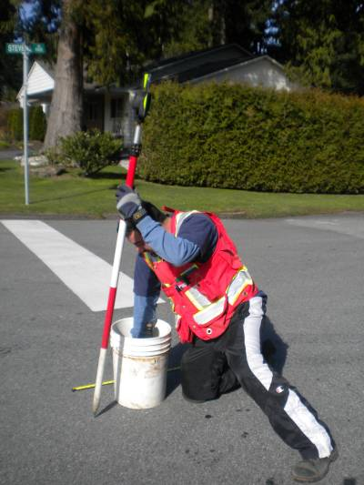
Using welder’s magnet Holding leveling rod Retrieving equipment from pail

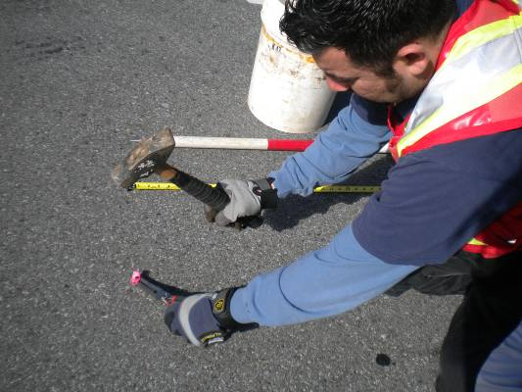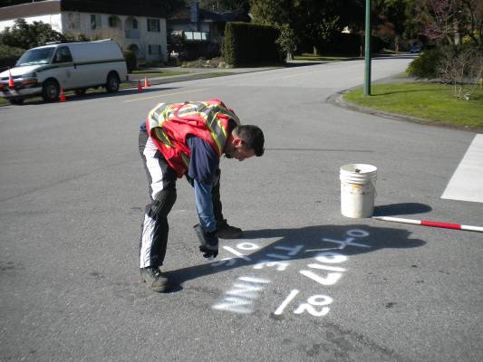
Hammering concrete nails into ground Painting on road

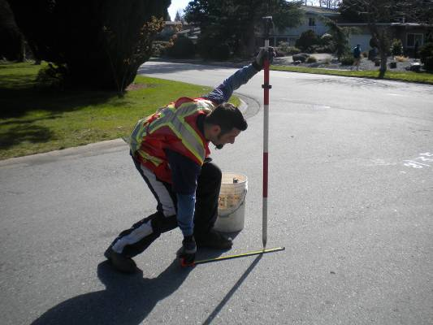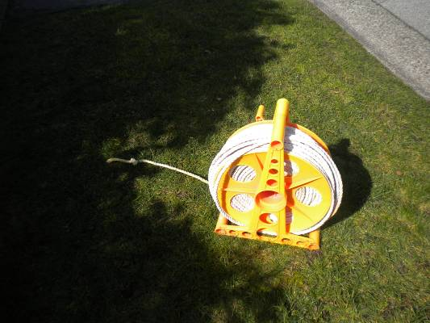
Using tape measure Rope reel (3 kg)

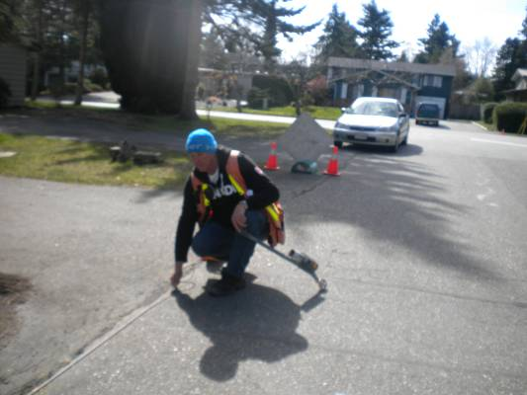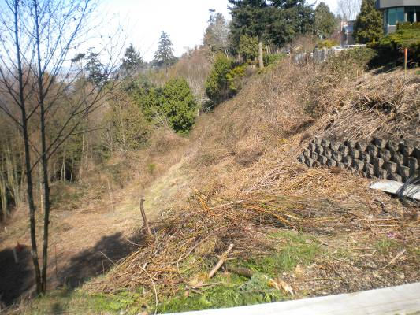
Pulling rope while lane marking Uneven terrain

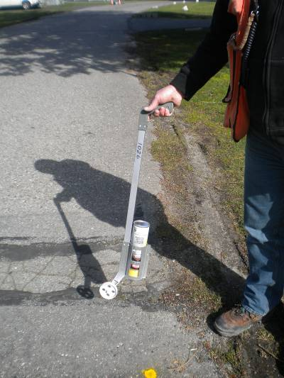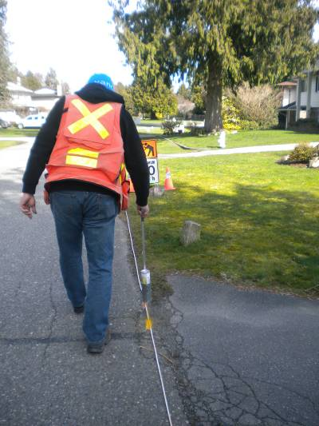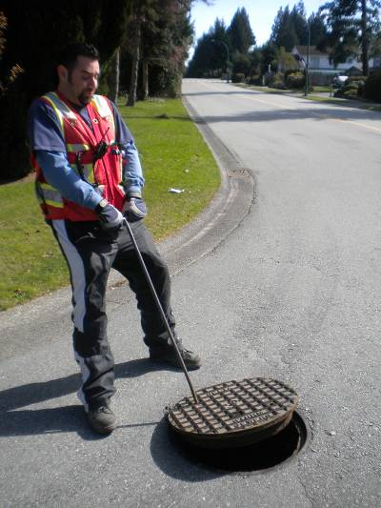
Striping gun Using striping gun Lifting manhole lids

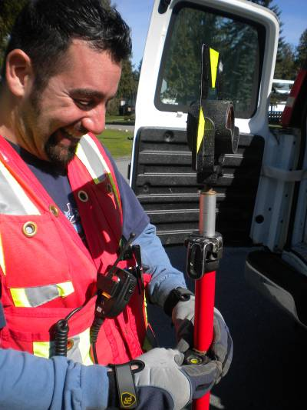
Viewing laser pointer

