Department: | Eng & Public Works | Area: | Roads
Subject: | Bitamous Applicator

SAFEWORK PROCEDURE – BITAMOUS APPLICATOR

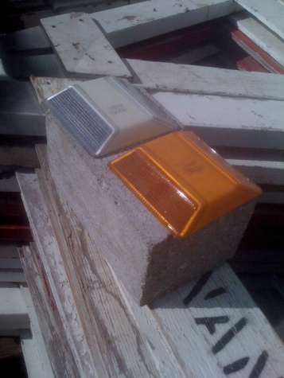
Background:
This unit is used to apply melted bitamous (tar-like) material on roadways where reflectors (cat eyes) are being installed.

Using this machine requires four workers: two trucks with drivers, the applicator operator and a worker installing reflectors.

HAZARDS:
- Burns

PPE:
- Gloves | - Safety glasses | - Long sleeves

Operation:
- Tools required: heavy hammer, panelling bar
- Break up two blocks of bitamous and place into Applicator.
- Ensure propane cylinder is full.
- Light the burners on the front of the Applicator with a butane torch.
- Allow 20 minutes for bitamous to melt, then take off lid and stir with wooden stick.
- Once ¾ of material has melted, add another bitamous block and continue heating for up to an hour.
- While waiting for bitamous to melt, break up 2-3 more bitamous blocks for later use.
- Load the truck with cat eye reflectors (300 yellow and 100 white).
- Once material has melted, load unit onto trailer and go to pre-determined location.
- Set up lane closures and work zones as per traffic control procedures.
- Line up “lead” truck, Applicator operator, Reflector installer and then “rear” truck with arrow board.
- The “lead” truck operator will watch for broken reflectors and will chip them off when necessary with the panel bar.
- Once removed, the Applicator operator will put down a 4” puddle of bitamous tar and the Reflector installer will put a reflector directly onto puddle and step on it to “set it”. Note: when placing white reflectors, ensure the reflective side is facing oncoming traffic.
- Distances are pre-set for reflector spacing.
- At the end of the day/job, dump excess bitamous from applicator back into the original boxes they came out of.

Date Written: 2010-Mar-15  Revision Date: | Written by: Fred Walkosky  Manager’s Approval: Brian Denbigh

