Department: | Public Works | 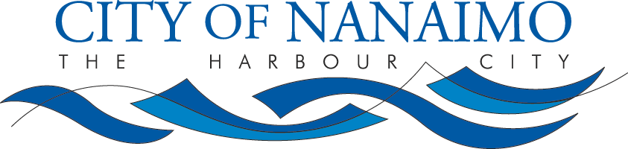
Subject: | Jet Away Machine

JET AWAY MACHINE

PURPOSE:
The Jet Away Machine is an accessory to be used in conjunction with Unit #417 to flush or root cut pipelines which are not accessible by Unit #417. It is a hose reel with virtually identical controls to that of #417. This hose reel attaches to our bobcat and is fed water by #417.

HAZARDS:
- Moving parts | - High pressure water | - Mobile equipment contamination from biohazards flying debris.
PPE:
- Eye protection | - Hearing protection | - Hands free radio
- Gloves | - Safety boots | - High -visibility vest or coveralls.

Pre-Setup
- Setup safe work zone
- Use traffic control when required

Setup:
- Connect hose reel attachment to bobcat
- Connect main rodder hose to connection available on bobcat. Make sure connections are tight
- Slowly advance bobcat toward destination – this operation is done in conjunction with main operator at hose reel controls on Unit #417
- As bobcat advances, feed hose out accordingly
- Use at least one spotter with a two-way radio to ensure hose doesn’t get hung up while advancing reel.
- Once hose reel is set-up over manhole or pipe opening, follow safe work procedure for #417 flushing.

Post Setup:
- Once flushing is completed and water supply is turned off at #417, disconnect rodder hose at bobcat
- Using spotter, retract rodder hose back to Unit #417

Summary:
- Always maintain communication between Jet Away machine operator and operator of Unit #417
- Always have operator of #417 ready to shut down in case of emergency
- Operator of Jet Away Machine can bypass water flow to ground in an emergency via bypass valve at front reel

 | Written by: Riley St. Luke
Date written: 2010-Mar-30  Revision Date | Approved by: John Elliot

g:\adminstration\reference material\unit jet away machine.docx

