**Lift Truck Work Platform Basket SWP**

***Warning***

**The use of this equipment may be hazardous. Safety precautions must be observed to reduce the risk of personal injury. It is important to fully understand and observe the following safety precautions and procedures. If not familiar with the use of this equipment refer to the user manual and obtain practical instruction from a competent operator or supervisor. Do not operate without thorough training or unless under the direct supervision of an instructor. Do not operate if guard is missing or not working appropriately. Do not operate Forklift without current certification.**

**Background:**

The City of Nanaimo Traffic Division is responsible for installing and removing Christmas Decorations each year prior to and following the winter holiday season. This task is completed in various ways depending on the height of the decorations and the nature of the roadway. This procedure will outline the steps for installing and removing Christmas decorations utilizing a Work Platform supported by a Lift Truck.

All of the procedures outlined herein are compliant to: *WorkSafeBC Standard: 13.30 Work Platforms Supported by Lift Trucks (February 2008)*, all other applicable WorkSafeBC regulations, and all manufacturers’ specifications.

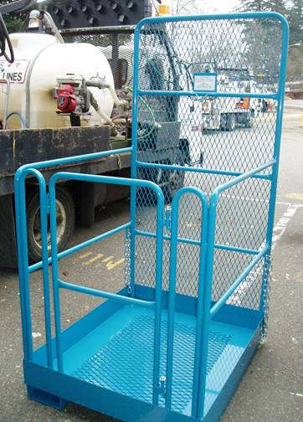

**Hazards:**

* Uneven ground
* Overhead hazards
* Weather
* Traffic
* Bystanders
* Mechanical Failure
* Electric shock / injury
* Working at a height

**PPE Required:**

* Hard hat
* Hand protection
* CSA Approved Footwear with ankle and toe protection
* Appropriate clothing for weather conditions
* High visibility apparel
* First aid kit on site
* Full body fall protection harness and lanyard

1. **Pre Set-Up:**

* Check condition of equipment and all safety guards

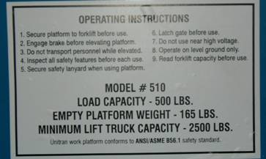

* Ensure Manufacturers operating instructions/capacity plate are visible
* Ensure traffic control is set up to the highest standard possible in the work zone, this may involve closing the road entirely, utilizing TCPs, or utilizing buffer vehicles with flashing arrow boards and coned off work zones.
* Perform and record Pre-Trip inspection of Lift Truck as per City of Nanaimo Forklift Training Program.
* Ensure that Lift Truck has a minimum lift capacity of 2,500lbs
* Ensure that occupants of Work Platform will not exceed 500 lbs collectively
* Inspect all PPE for defects, particularly the full body harness and lanyards
* Put on all PPE
* Lift Truck Operator must put on Seatbelt
* Ensure correct fork spread for Work Platform fork mounts

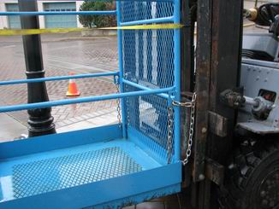

* Slowly drive Lift Truck Forks into the mounting holes until the backrest of the Work Platform is flush with the backrest of the Forklift.
* Engage the Parking Brake for the forklift once in correct position.
* Secure the Work Platform to the Forklift utilizing the securing devices provided by the manufacturer.

**2.0 Procedure:**

* Check for any hazards in the area
* Drive Lift truck to area where work is to be performed.
* Park Lift Truck so that the work platform is directly below area where decorations are to be installed.
* Engage parking brake (Parking brake must remain engaged until procedure is complete)
* Forklift operator performs a Trial Lift:

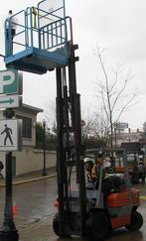

* + A trial lift must be performed at each task location immediately prior to raising personnel in the work platform to ensure:
    - the lift truck can be positioned on an appropriate supporting surface;
    - there is sufficient reach to position the work platform to allow the task to be done;
    - The mast is vertical or the boom travels vertically.
  + The tilt function for the mast may be used to assist with final positioning the work platform at the task location but the mast must travel in a vertical plane.
  + The trial lift must ensure adequate clearance can be maintained between the work platform and the elevating mechanism of the lift truck and any surrounding object such as a structure, overhead obstruction, storage rack, or scaffold, and from any hazard such as energized electrical wires and equipment.
* Worker(s) enter platform and secure gate behind them ensuring to take all required equipment and decorations.
* If there is more than one worker in the work platform basket, the workers must designate one worker in the platform to be the communication liaison with the Lift Truck Operator. That worker should have constant voice and predetermined hand signal communication with the Lift Truck Operator.

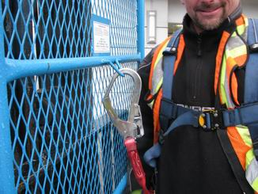

* Worker(s) secure their harnesses to designated anchor points on the Work Platform with their lanyards.
* Communication liaison signals to the Lift Truck operator that they are ready to be raised to the appropriate height to perform the task.

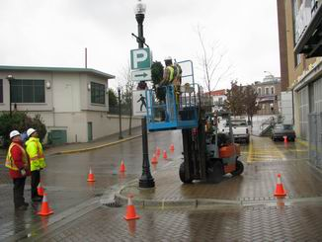

* Lift truck operator slowly raises worker to appropriate height keeping in constant communication with communication liaison.
* Lift Truck operator must stay at the controls AT ALL TIMES while workers are in the Work Platform Basket. Operator must also be able to communicate with workers.

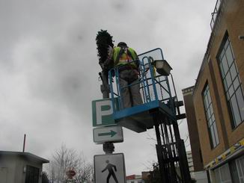

* Workers in the Platform must work from the platform and must not stand on the guardrails or use other devices to increase the effective working height of the work platform.

\

* Once the decoration installation is complete – Communication liaison signals to the Lift Truck Operator to lower the Work Platform Basket.
* The work platform must be lowered completely to the ground before the occupants may exit.
* Workers may exit the basket and secure the gate behind themselves once platform is resting on ground.
* Once workers are out of the Work Platform Basket, Lift Truck operator raises the forks just enough to transport the platform safely to the next pole or worksite and begins this procedure again. ***Workers must not be transported in the Work Platform Basket, including between task locations.***

**3.0 Post Procedure/Take Down**

* Transport Work Platform Basket to whatever means are being used (i.e. Flatbed Truck) to return it to the Operations Yard.
* Lower platform onto the transport vehicle.
* Remove devices which were securing the platform to the Lift Truck Backrest.
* Carefully back forks out of the platform fork mounts.
* Secure the platform to the transport vehicle.
* Transport forklift as per regulations and MOT/Insurance carrier requirements
* Once back at Operations Yard, unload platform from transport vehicle and store in designated location.
* Inspect for defects and report anything to the Shop right away if anything is found

4.0 **Summary**

* Workers must have Training and be authorized by Supervisor before using equipment.
* Ensure public and other workers are kept clear while operating this equipment
* Appropriate PPE must be worn at all times while operating equipment
* Workers must not be transported in the Work Platform Basket, including between task locations.
* Lift Truck operator must have valid certification to operate lift truck