SAFEWORK PROCEDURES – LINE LAZERS
Background:
The City has two manual-push paint striping machines used in small parking lots for painting parking stall lines, arrows, curbs and stencilling. Both machines have a hand gun and a liner gun and operate the same except for pump switch/valve locations on the machines.

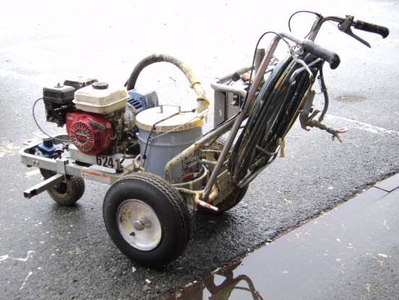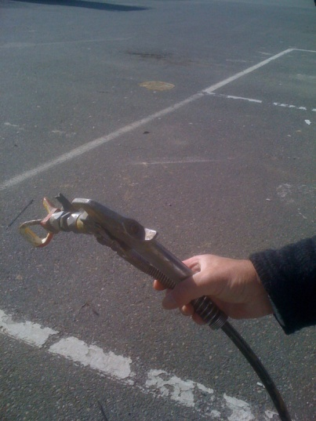

Preparation:
- Using a hand pump, fill the number of 5 gallon cans needed for the job from the 45 gallon barrels.
- Check fuel level on lazer machine.
- Ensure “anti-static” chain is touching ground.
- Place paint can on machine, start motor and allow to warm-up for a minute.
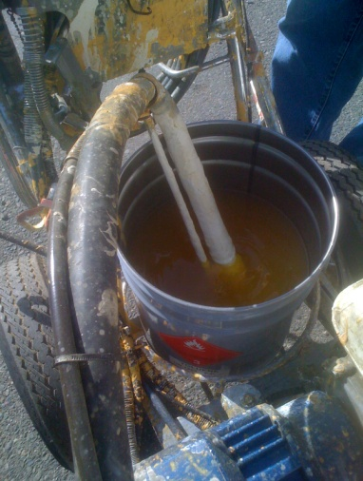
- Ensure recycle valve is open.
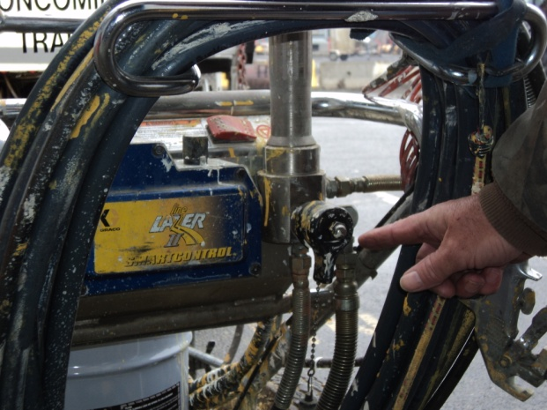
Recycle Valve
Paint pump
- Turn on pump and let it cycle for two minutes.
- Close recycle valve. Allow time for the pump piston to continue to cycle and slowly stop once paint line pressure builds up to operating pressure.
- The paint guns are now loaded and ready for operation.

NOTE: Never put your hands or any other part in front of spray gun tips while they are “charged”. There is enough pressure that paint could be injected through the skin causing serious injury and possibly death.

Shutdown:
- Open recycle valve.
- Turn off pump.
- Shut off engine.
- If it’s the end of the day:
- clean spray tips and in-line paint filter
- run paint thinner through paint pump with recycle valve open
- Shut off pump and place paint gun into empty paint can ensuring it is grounded and release line pressure by pulling paint gun trigger.
- fill paint cans

