Department: | Eng & Public Works | Area: | Traffic
Subject: | Installing/Removing Speed Reader Boards

INSTALLING/REMOVING SPEED READER BOARDS - SAFEWORK PROCEDURES

Background:
The City of Nanaimo has 2 “portable” speed readers which are moved around the City to the 12 fixed locations. When not in service they are stored and charged in the Public Works Warehouse. This task requires 3 workers: one in buffer truck and two in #428.

PPE Required:
- Hardhat with chin strap | - Gloves | - Harness | - Hi vis vest | - UHF radios x 3.

Pre Set-up:
- Lift speed reader into the back of #428.
  - Caution: the speed reader is awkward (30” x 30” x 6” deep) and weighs over 75 pounds.
  - Two workers are required to lift speed reader. Use good ergonomic techniques.
- Set up safe work zone:
  - Park buffer truck with signs one pole back from speed reader pole location.
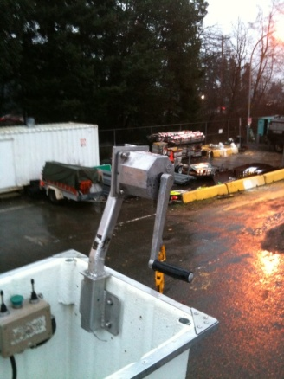
  - Ensure signage meets Ministry of Transport & Highways requirements.
  - Set up coned area on sidewalk for pedestrian safety.
- Install speed reader board engineered lifting winch (Jeamar Heavy Duty Wall Mount Winch Model WMA175):
  - One worker wearing harness will climb onto #428 roof and get into bucket and clip onto anchor point.
  - Install winch on bucket(see top photo at right). This manual winch has special clutch which will only wind up or down when pressure is applied to the handle and therefore will not slip.
  - Lower winch cable to ground.
  - Move speed reader to the front of #428

Set up: Install or Remove Speed Reader Board
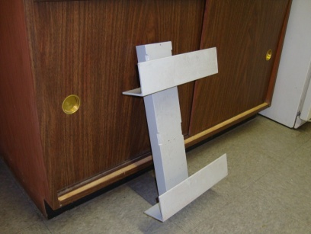
- Attach cable to speed reader board lifting chains and eyebolt.
- Raise speed reader board to top of #428 bucket.
- Telelift speed reader board with bucket controls to mounting bracket on street light pole. Board front must face #428 bucket.
- Position speed reader board just slightly above mounting bracket on pole and lower onto bracket with bucket controls or winch.
- Ensure speed reader is secure in bracket (photo at right) and disconnect lifting chain from winch.
mounting bracket
- Secure speed reader board to mounting bracket with long hose clamps.

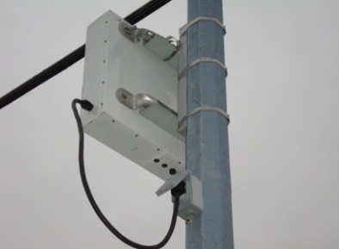 | 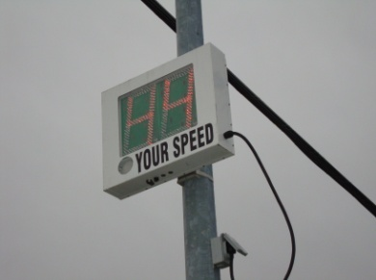
- Plug speed reader board streetlight receptacle.
- Turn unit “on” by using key in switch in bottom of unit.
- Check to see if speed reader board is working. It should flash “88” during warm up if
- Reverse procedure if removing speed reader board.

Post Set Up
- Return telelift to saddle
- Remove winch from #428 bucket.
- Once everything is clear, take down work zone

Revised: January 25, 2010 | Written by: Barry Hornby | Approved by: Bert Tanner  Manager’s Approval: Brian Denbigh

