Safety Procedure Title: | Disinfect Contaminated Equipment and Surfaces
Issue Date: | July 2002
Revised Date: | October 2015;  Charlotte Fetterly, M.Sc(A) Occupational Hygienist  Fetterly OHS Services Ltd.
Prepared by: | Carie Sandferd, Manager, Health and Safety
Document #: | 657793

DISINFECTION
Employees will decontaminate instruments, equipment, and surfaces that have been contaminated with blood and body fluids capable of transmitting infection by following the below disinfection guidelines.

Directions for Preparing and using chlorine-based Disinfectants

Concentrations of approximately 5000 ppm (1:10 dilution of household bleach) are effective at killing HIV, HBV and HCV viruses.
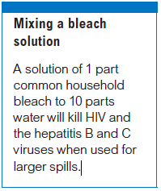
WCB BK.129

The manufacturer’s instructions for the use of germicides should be followed

Disinfecting Contaminated Tools and Equipment
Contaminated tools and equipment must be thoroughly disinfected following use.
Commercially available chemical disinfectants may be more compatible with certain equipment that might be corroded by repeated exposure to sodium hypochlorite, especially the 1:10 dilution. It is also important that the manufacturer’s specifications for compatibility of the equipment with chemical germicides be closely followed.

Disinfect City Vehicles
If blood or certain body fluids are splattered or dripped on vehicle upholstery:
- Advise your supervisor of the possible contamination and ask that the vehicle be taken out of service; or
- Take, or have taken, the vehicle to a company who will clean the vehicle; Do NOT take the vehicle to Engineering Operations, Fleet Services for cleaning.

Place some form of markings on the vehicle warning others of possible contamination.
Your supervisor will contact a company to disinfect and clean the upholstery.

