Safety Procedure Title: | Bloodborne Pathogens Hand Washing Technique
Issue Date: | July 2002
Revised Date: | October 2015;  Charlotte Fetterly, M.Sc(A) Occupational Hygienist  Fetterly OHS Services Ltd.
Prepared by: | Carie Sandferd, Manager, Health and Safety
Document #: | 732570

Efficient hand washing is the single most effective practice to prevent the spread of infection.

SOAPS AND ANTISEPTIC AGENTS
- Use any type of non-abrasive soap (i.e. soft liquid soap) to wash hands soiled with dirt, blood or other organic material. Plain soap and water will remove many transient organisms. Medicated soap adds no advantage.
- When provision of hand washing facilities is not feasible, an appropriate antiseptic hand cleanser in conjunction with clean cloth/paper towels or antiseptic towelettes will be provided. Hand washing with waterless/alcohol-based agents is equivalent to soap and water.

Table 02 shows some of the types of soaps and antiseptic agents for hand washing (see following page).

Table 02: Soaps and Antiseptic Agents for Hand Washing.
Product | Indications | Special Considerations
Plain soap, bar soap, liquid*, granules | For washing hands soiled with dirt, blood or other organic material. | Bar soap should be on racks that allow water to drain; small bars that can be changed frequently are safest.
Waterless antiseptic agents:  Rinses  Foams  Wipes  Towelettes | Demonstrated alternative to conventional agents  For use where hand washing facilities are inadequate, impractical or inaccessible (e.g. in patrol cars)  For situations in which the water supply is interrupted (e.g. planned disruptions, natural disasters) | Not effective if hands are soiled with dirt or heavily contaminated with blood or other organic material.  Follow manufacturer’s recommendations for use.  Efficacy affected by concentration of alcohol in product.  Hand creams should be readily available to protect skin integrity.

RECOMMENDATIONS ON HAND WASHING
The components of good hand washing include using an adequate amount of soap, rubbing the hands together to create some friction, and rinsing under running water. The mechanical action of washing, rinsing and drying removes most of the transient bacteria present.
Hands and other soiled or contaminated surfaces must be washed thoroughly with soap and water.
Wash your hands immediately, or as soon as feasible:
- After removal of PPE and before and after donning gloves. To avoid contaminating your hands by removing gloves improperly, follow the Single-use disposable glove removal guideline.
- After a glove tear or suspected glove leak.
- After handling materials that may be contaminated with blood or body fluids capable of transmitting bloodborne pathogens.
- Before leaving a work area (e.g., the laboratory).
- After unprotected exposure to blood or body fluids capable of transmitting bloodborne pathogens.
- When antiseptic hand cleansers or towelettes are used, hands shall be washed with soap and running water as soon as feasible.
Hand lotion may be used to prevent skin damage from frequent hand washing.

Hand Washing Procedure:
- Use soap and running warm water for 20 – 30 seconds.

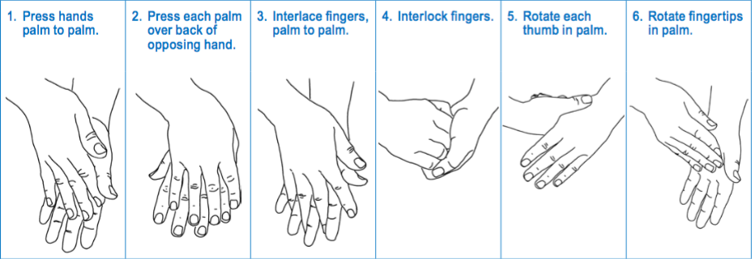
Source: WCB BK.129
Remember:
- Remove jewelry before washing hands
- Dry hands thoroughly with single-use towel or forced air dryer.

HAND WASHING FACILITIES
Hand washing facilities are conveniently located throughout the CNW workplace.
Ask your supervisor where your area’s hand washing facilities are located.
Sinks for hand washing should be used only for hand washing and not for any other purpose, e.g., as a utility sink.

