Safety Procedure Title: | Gloves for Bloodborne Pathogens
Issue Date: | July 2002
Revised Date: | October 2015;  Charlotte Fetterly, M.Sc(A) Occupational Hygienist  Fetterly OHS Services Ltd.
Prepared by: | Carie Sandferd, Manager, Health and Safety
Document #: | 776037

Personal protective equipment serves as a barrier against direct contact with bloodborne pathogens. Personal protective equipment (PPE) includes clothing, gloves, eye protection, masks, face shields, gowns and protective footwear.
When exposure to blood or body fluids capable of transmitting bloodborne pathogens is anticipated, appropriate personal protective equipment should be worn.
- Wear gloves as an additional barrier whenever the potential to contact blood or certain body fluids exists.
- Wear gowns or aprons during procedures that are likely to generate splashes of blood or certain body fluids.
- Wear masks and eye coverings to prevent mucous membrane exposures during certain procedures.
- Use mouthpieces, resuscitation bags or other ventilation devices to avoid mouth-to-mouth contact during resuscitation. Resuscitation equipment and devices should be used once and disposed of or, if reusable, thoroughly cleaned and disinfected after each use according to the manufacturer’s recommendations. pocket mouth-to-mouth resuscitation masks (i.e. double lumen systems) may be provided.

Gloves

Selection of Gloves
The type of glove and use will vary according to type of work.

Glove Types and Standards
Gloves are available in a variety of materials, including latex, vinyl, nitrile, neoprene, copolymer, and polyethylene. Gloves in all of these materials, when intact, will serve as adequate barriers to bloodborne pathogens (except in cases of needle stick injury). The incidence of employees contacting blood is lower among those who wear gloves.
The Canadian General Standards Board (CGSB) operates a program to certify examination gloves and surgical gloves to national standards that specify glove quality levels that exceed the minimum set by the Health Protection Branch (HPB). The CGSB may aid purchasers in their evaluation of glove quality. In Canada, the Medical Devices Bureau, HPB, and Health Canada produces information on the quality of gloves and on latex allergies, a compendium of non-latex gloves, and the results of tests on glove protein levels.
There are two types of gloves used in the CNW workplace, they are:
- Single-use Disposable Gloves.
- Reusable Gloves.

Recommendations of Glove Use
To ensure maximum protection put on, wear and remove gloves as per these guidelines.

Single-use Disposable Gloves.
Single-use disposable gloves are available at a variety of locations within the CNW workplace. If latex gloves are chosen then low protein and unpowdered gloves should be selected. Latex free gloves should be available for individuals with latex sensitivity.
- Single-use, disposable gloves should be worn for all procedures that might involve direct skin or mucous membrane contact with blood or fluid capable of transmitting bloodborne pathogens and if an employee has damaged skin (i.e. abrasions) and may be in contact with contaminated items or surfaces. Additional barriers, i.e., occlusive dressings, over non-intact skin (in addition to gloves) further reduces potential exposure.
- Whenever possible, carry gloves with you to facilitate quick application when necessary.
- Do not wash or disinfect gloves for reuse. Microorganisms adhere to gloves and are not easily washed off. Detergents may cause enhanced penetration of liquids through undetected holes, and disinfectants may cause deterioration of glove material.
- Disposable gloves should be replaced frequently and never reused. Gloves must be changed during lengthy procedures (before the development of punctures or tears, or when tears or perforations are suspected). Use new disposable gloves for each new task.
- When the risk of percutaneous injury is high, double gloving has been shown to decrease the volume of blood involved in needle stick exposures. Double gloving may be practiced, depending on the level of risk of the procedure (i.e. police search).
- After use, gloves should be removed carefully and disposed of appropriately. Refer to glove removal guideline below.

Use of gloves does not eliminate the need for hand washing. Hands should be washed whenever gloves are removed. Refer to hand washing guidelines. Wash your hands thoroughly with soap and water as soon as possible after removing gloves and before touching non-contaminated objects and surfaces.
Single-use Disposable Gloves Removal
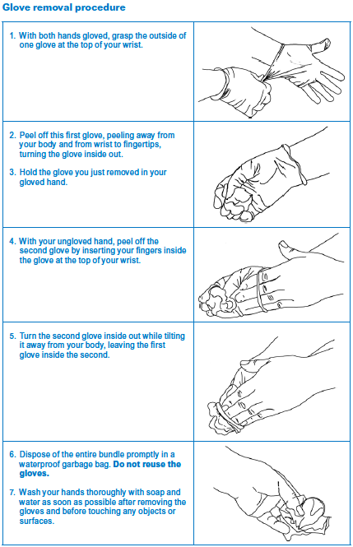
Follow these steps to make sure your hands do not contact any blood or body fluids left on used gloves:

Reusable Gloves
- For housekeeping activities, instrument cleaning and decontamination procedures general purpose reusable household gloves (e.g., neoprene, rubber, butyl) are recommended. Single-use disposable gloves are not durable enough for these activities.
- These can be washed and reused but should be discarded when they become peeled, cracked or discoloured, before to the development of punctures or tears.
- Generally, reusable gloves should be thoroughly washed and rinsed according to the manufacturer’s care instructions and allowed to air dry. Gloves should be replaced on a regular and frequent basis.
- Vinyl gloves should be used for short tasks or for tasks in which there is minimal stress to glove material.
- Use of gloves does not eliminate the need for hand washing. Hands should be washed whenever gloves are removed. Refer to hand washing guidelines. Wash your hands thoroughly with soap and water as soon as possible after removing gloves and before touching non-contaminated objects and surfaces.

Problems of Glove Use – Latex Allergies
Wearing disposable gloves manufactured in natural rubber (latex) can cause an allergenic reaction in susceptible individuals. Reactions are either due to exposure to the natural latex proteins or to chemicals added during the manufacturing process. In order to minimize exposure to latex allergens, low protein, unpowdered (“low powder or powder free”) latex gloves will be considered when latex gloves are purchased. Non-latex gloves may also be provided for those with latex allergies.
More information on these health problems can be found in the WCB Publication, Dealing with “Latex Allergies” at Work.

Glove Disposal
Dispose of gloves in a single use waste holding bag. Refer to the Manage Biomedical Waste guideline.

