Working Remotely Health and Safety Considerations

Ergonomics  It is crucial that your workstation is set up ergonomically to reduce the risk of musculoskeletal disorders. When using a laptop for long periods of time, it is important to have the screen elevated to eye level, and a separate keyboard and mouse connected to it. This enables you to have proper screen height and keyboard position. A suitable and ergonomically adjusted chair must be used as it allows for neutral postures. Stretch regularly and take frequent micro breaks.  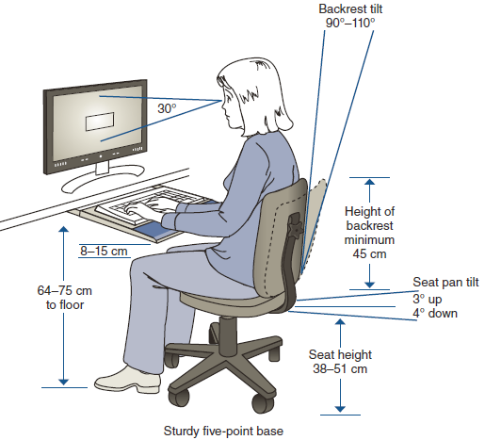  Electrical Safety  Always use 3-prong grounded electrical outlets or a surge-protected power bar to prevent the risk of an electrical shock. If using a power cord, check that it is in good condition and not broken or scorched. | Tripping & Falling  Prior to setting up your workstation, identify areas that could potentially cause an injury.  - Make sure that there is adequate visibility and lighting to allow you to see hazards  - Identify slippery or icy areas. Beware of obstructions in loose carpets, tiles or uneven floor surfaces.  - Remove all tripping or falling hazards  Environmental Hazards  If you are exposed to hazards or irritants such as tobacco smoke, cooking odors or other irritants in the neighbourhood, make the necessary adjustments to reduce or eliminate your exposure. Excessive noise or other distractions must be reduced or removed from the environment.  Workplace Stressors  Workload, distractions and competing priorities can affect your ability to work. If workplace stress is aggravated by working from home, remote work may not be a good option at this time. | Working Alone  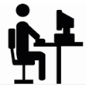  If you work alone all day, WorkSafeBC requires you to check-in with your Supervisor or Manager to confirm that you are safe. Depending on the hazard level identified in the Working Alone Risk Assessment, check-in intervals will vary based on the job task. At minimum, a check-in is required at the beginning of shift and end of shift.  Those working remotely should not be hosting meetings or inviting clients or other workers to their remote location or home.  Emergency Preparedness  Review the information below and know your responsibilities as a staff member so you’ll be prepared in the event of an emergency, regardless of your work location.  Emergency Kit Prepare an emergency kit with basics such as water, food, medications, light, money and contact lists and store it in an accessible location.  Fire/Smoke Alarms Ensure that smoke and carbon monoxide detectors work.  First Aid Maintain a basic first aid kit and report all injuries to your Manager immediately.  Contacts Maintain a list of numbers for contact, including Manager, Team Members, Clinics and 9-1-1.  Evacuation Plan Create an evacuation plan that outlines where to evacuate and who to contact in emergencies.
Note: If at any time you are concerned about your remote workstation, you have a duty to report your concerns to your Manager or the Health and Safety Team.

