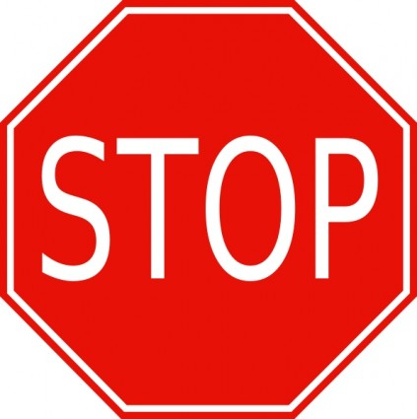

PLEASE DO NOT ENTER THE BUILDING IF YOU HAVE:

- A COUGH, FEVER OR EXPERIENCING BREATHING DIFFICULTIES
AND/OR
- BEEN TO AN IMPACTED COVID19 AREA (CHINA, IRAN, SOUTH KOREA, JAPAN, EUROPE) OR RECENTLY TRAVELED INTERNATIONALLY
AND/OR
- BEEN IN CONTACT WITH SOMEONE FROM AN IMPACTED AREA OR HAS BEEN EXPOSED

FOLLOW THE DIRECTION OF THE LOCAL HEALTH AUTHORITY,
BC CENTRE FOR DISEASE CONTROL AND
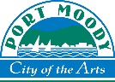
WORLD HEALTH ORGANIZATION
March 16, 2020

