Exposure Control Plan: Pandemic COVID-19 virus

Plan Administration:

Administration
Title | Name | Phone | Cell

Reviews and Revisions to this document:
Date | Description | Who

Exposure Control Plan: COVID-19 virus

SCOPE

This exposure control plan (ECP) applies to LOCAL GOVERNMENT staff who could be exposed to the COVID-19 virus while doing their assigned work.

STATEMENT OF PURPOSE

LOCAL GOVERNMENT is committed to providing a safe and healthy workplace for all of our staff. A combination of preventative measures will be used to minimize worker exposure to the COVID-19 virus, including the most effective control technologies available. Our work procedures will protect not only our employees, but also other workers and/or the public who enter our facilities. All employees must follow the procedures outlined in this plan to prevent or reduce exposure to the COVID-19 virus.
The purpose of this ECP is to protect employees from harmful exposures to the COVID-19 virus, to reduce the risk of infection in the event of an exposure, and to comply with the WorkSafeBC Occupational Health and Safety Regulation 5.54 and 6.3, Exposure Control Plan.
LOCAL GOVERNMENT will strive to find ways to control or eliminate exposure to the COVID-19 virus by developing and implementing proper risk controls, establishing safe work practices, raising awareness, and providing education and training for its employees. LOCAL GOVERNMENT will follow direction and controls as specified by the BCCDC, the Ministry of Health, and the Provincial or Island Health Medical Health Officer.

ACRONYMS

BCCDC – British Columbia Centre for Disease Control
ECP – Exposure Control Plan
EOC – Emergency Operations Centre
MHO - Medical Health Officer
PHAC – Public Health Agency of Canada
PPE – personal protective equipment
SWP – safe work practice
WHO – World Health Authority

RESPONSIBILITIES

NOTE: These responsibilities may change as LOCAL GOVERNMENT has activated its Emergency Operations Centre

LOCAL GOVERNMENT:
- Ensure that the materials (for example, gloves, alcohol-based hand rubs, and washing facilities) and other resources (such as worker training materials required to implement and maintain the plan) are readily available where and when they are required. If due to supply chain disruption, LOCAL GOVERNMENT becomes unable to obtain the necessary resources, LOCAL GOVERNMENT will advise the appropriate emergency agency and re-evaluate this plan.
- Select, implement and document the appropriate site- or scenario-specific control measures.
- Ensure that supervisors and employees are educated and trained to an acceptable level of competency.
- Ensure that employees use appropriate personal protective equipment – for example, gloves, gowns, eye protection, masks or respirators when required.
- Conduct a periodic review of the plan’s effectiveness.
- Maintain records as necessary.
- Ensure that a copy of the exposure control plan is available to managers, supervisors and employees.
- Through the EOC or Administration, modify service models and levels, using a risk based approach, unless otherwise ordered by national, provincial or local health authority.
- Ensure Managers/Supervisors follow the direction of the EOC or Administration.

OHS Manager:
- Ensure the exposure control plan is reviewed annually and updated as necessary.
- Support the development of supporting resources (such as Crew Talks, E-link, FAQs, posters, SWPs).
- Assist with the risk assessment process and consult on risk controls, as needed.
- Ensure a system for documenting instruction, training and fit testing is in place.

Managers:
- Assess the risk(s) related to the COVID-19 virus for the positions under their management
- Ensure that awareness and information resources are shared with employees
- Ensure that training, SWPs, PPE and other equipment are provided

Site Supervisors:
- Assess the risk(s) related to the COVID-19 virus for the positions under their supervision
- Share awareness and information resources with employees
- Provide or arrange for training, SWPs, PPE and other equipment necessary
- Ensure employees have been trained on the selection, care, maintenance and use of any PPE, including fit testing for those employees who may be issued a respirator
- Direct work in a manner that eliminates and if not possible, minimizes the risk to employees
- Ensure employees follow SWPs, use PPE
- Share information regarding worker concerns with Exempt Manager or Director.

Workers:
- Read awareness and information resources, ask questions and follow-up with supervisor to ensure understanding and adherence.
- Take part in training and instruction.
- Review and follow related SWPs.
- Selection, care, maintenance and use any assigned PPE as trained and instructed.
- Take part in fit testing if issued a respirator.
- Rely on information from trusted sources including LOCAL GOVERNMENT, Island Health, BCCDC, PHAC and WHO.
- Understand how exposure can occur and when and how to report exposure incidents.
- Contact 8-1-1 as appropriate and follow the directions of Island Health and/or the Provincial MHO.

LOCAL GOVERNMENT Fire and/or LOCAL GOVERNMENT Police may have additional or different responsibilities/protocols. These will be documented in the appropriate departmental documents.

RISK IDENTIFICATION AND ASSESSMENT

COVID-19 virus
The COVID-19 virus is transmitted via larger liquid droplets when a person coughs or sneezes. The virus can enter through these droplets through the eyes, nose or throat if an employee is in close contact with a person who carries the COVID-19 virus. The virus is not known to be airborne (e.g. transmitted through the particles floating in the air) and it is not something that comes in through the skin. The COVID-19 virus can be spread by touch if a person has used their hands to cover their mouth or nose when they cough or sneeze.
Droplet Contact: Some diseases can be transferred by large infected droplets contacting surfaces of the eye, nose, or mouth. For example, large droplets that may be visible to the naked eye are generated when a person sneezes or coughs. These droplets typically spread only one to two metres and are too large to float in the air (i.e. airborne) and quickly fall to the ground. Influenza and SARS are two examples of diseases capable of being transmitted from droplet contact. Currently, health experts believe that the COVID-19 virus can also be transmitted in this way.
Airborne transmission: This occurs when much smaller evaporated droplets or dust particles containing the microorganism float in the air for long periods of time. Transmission occurs when others breathe the microorganism into their throat or lungs. Currently, health experts believe that the COVID-19 virus cannot be transmitted through airborne transmission.

RISK ASSESSMENT

The following risk assessment table is adapted from WorkSafeBC Occupational Health and Safety Regulation Guideline G6.34-6. Using this guideline as a reference, we have determined the risk level to our workers, depending on their potential exposure in the workplace.

See Appendix A for the level of risk and risk controls in place for these workers.

Table 1: Risk assessment for pandemic influenza

 | Low Risk  Workers who typically have no contact with people infected. | Moderate risk  Workers who may be exposed to infected people from time to time in relatively large, well-ventilated workspaces | High risk  Workers who may have contact with infected patients or with infected people in small, poorly ventilated workspaces
Hand Hygiene | Yes (washing with soap and water, using an alcohol-based hand rub, or using hand wipes that contain effective disinfectant) | Yes (washing with soap and water, using an alcohol-based hand rub, or using hand wipes that contain effective disinfectant) | Yes (washing with soap and water, using an alcohol-based hand rub, or using hand wipes that contain effective disinfectant)
Disposable gloves | Not required | Not required, unless handling contaminated objects on a regular basis | Yes, in some cases, such as when working directly with infected patients.
Aprons, gowns, or similar body protection | Not required | Not required | Yes, in some cases, such as when working directly with infected patients.
Eye protection – goggles or face shield | Not required | Not required | Yes, in some cases, such as when working directly infected patients.
Airway protection – respirators | Not required | Not required | Yes (minimum N95 respirator or equivalent).

RISK CONTROL

The Regulation requires the employer to implement infectious disease controls in the following order of preference:

Controls used to mitigate the risks of exposure include:
- Engineering Controls
- Administrative Controls
- Education and Training
- Safe Work Practices
- Personal Protective Equipment

Elimination of face-to-face contact is the best control possible. Controls would include distance control at reception counters, relying on phone, email or regular mail to answer public questions. If practicable, conduct financial transactions by electronic means rather than cash or cheque at the municipal counter.

Engineering controls would be such examples of working from inside an enclosure when receiving bill payments or selling passes/tickets online for public recreation facilities or events. Additional examples may include physical barriers, which limit personal human contacts.

Administrative controls include hand washing and cough/sneeze etiquette. Cover your mouth and nose with a sleeve or tissue when coughing or sneezing. Allow a reasonable personal distance space to reduce human-to-human transmission. An increase in cleaning frequencies for shared work surfaces and equipment, including City operated vehicles.

Personal Protective Equipment is the last resort of mitigation such, as wearing of masks, respirators, coveralls/turnout gear, gloves, goggles and/or face-shields. The use of PPE is required in high-risk situations, such as dealing with infectious patients.

SAFE WORK PRACTICES

Hand Hygiene

Hand washing, proper coughing and sneezing etiquette, and not touching your face are the key to the prevention of transmission and therefore minimize the likelihood of infection.

Proper hand washing helps prevent the transfer of infectious material from the hands to other parts of the body – particularly the eyes, nose and mouth – or to other surfaces that are touched.

Wash your hands “well” and “often” with soap and water for at least 20 seconds (the time it takes to hum the “Happy Birthday” song twice). If soap and water is not available, use an alcohol-based hand rub to clean your hands.

“Often" includes:
- upon arriving and when leaving work
- after coughing or sneezing
- after bathroom use
- when hands are visibly dirty
- before, during and after you prepare food
- before eating any food (including snacks)

“Well” means:
- wet hands and apply soap
- rub hands together vigorously for at least 20 seconds ensuring the lather covers all areas – palm to palm, back of hands, between fingers, back of fingers, thumbs, fingernails (using palm) and wrists
- rinse hand thoroughly with water
- dry your hands with paper towel (or a hand dryer), use the paper towel to turn off the tap and open the door, dispose of the paper towel

Additionally:

- Avoid touching your eyes, nose or mouth with unwashed hands
- Use utensils: consider using forks, spoons or tooth picks when eating and serving foods (especially snacks or “finger foods”)

See Appendix B for HANDWASHING and HAND HYGIENE TIPS – KITCHEN EDITION POSTERS

Cough/Sneeze Etiquette

All staff are expected to follow cough/sneeze etiquettes, which are a combination of preventative measures that minimizes the transmission of diseases via droplet or airborne routes. Cough/sneeze etiquette includes the following components:
- Cover your mouth and nose with a sleeve or tissue when coughing or sneezing to reduce the spread of germs
- Use tissues to contain secretions, and immediately dispose of any tissues you have used into the garbage as soon as possible and wash your hands afterwards
- Turn your head away from others when coughing or sneezing

Use of surgical masks

Masks should be used by sick people to prevent transmission to other people. A mask will help keep a person’s droplets in.

It may be less effective to wear a mask in the community when a person is not sick themselves. Masks may give a person a false sense of security and are likely to increase the number of times a person will tough their own face (e.g., to adjust the mask). (BC Centre for Disease Control)

It is not recommended that people who are well wear a mask to protect themselves from respiratory illnesses, including COVID-19. You should only wear a mask if a healthcare professional recommends it. A facemask should be used by people who have COVID-19 and are showing symptoms. This is to protect others from the risk of getting infected. The use of facemasks also is crucial for healthcare workers and other people who are taking care of someone infected with COVID-19 in close settings (at home or in a healthcare facility). (Centre for Disease Control)

Use of N95 Respirators

The N95 mask is typically worn by workers directly involved in an aerosol generating medical procedure (as defined by Health Canada). An N95 mask is a protective barrier that is worn on the face, covers at least the nose and mouth, and is used to contain large droplets generated during coughing and sneezing. N95s help minimize the spread of potentially infectious material. N95 masks must be fit tested.

NOTE: LOCAL GOVERNMENT Fire will have additional responsibilities and/or OG’s as it relates to PPE.

Hygiene and Decontamination Procedure

See Appendix C - ABOUT CORONAVIRUS DISEASE (COVID-19)

First Aid Attendant Procedure and Hygience and Decontamination Procedure

See Report regarding special considerations related to Occupational First Aid and COVID-19, March 16, 2020

Additional Safe Work Practices

Additional safe work practices are being developed as LOCAL GOVERNMENT responds as part of the COVID-19 response.

EDUCATION and TRAINING

LOCAL GOVERNMENT in response to the COVID-19 virus has established the following means of sharing information across the organization:
- COVID-19 information button on E-link front page
- COVID-19 information page
- All LOCAL GOVERNMENT staff emails – sent on a regular basis
- LOCAL GOVERNMENT poster series including PHAC
- Awareness, education and training materials are printed for those employees who do not have a LOCAL GOVERNMENT email

As COVID-19 is a public health matter, information noted above is intended for all staff.

Additionally, the OHS Division staff is working with various departments to create safe work procedures and provide training as needed in collaboration with Supervisor and Managers.

HEALTH MONITORING

Staff concerned that they may have come into contact with someone who may be ill, are to take the following actions:

- Report the incident to your supervisor.
- Call BC’s HealthLink at 8-1-1 to share information regarding the incident and determine if any action needs to be taken.

If you’re feeling stressed or worried, please remember that for CUPE, Fire and Exempt permanent staff, LOCAL GOVERNMENT’s Employee and Family Assistance Program (EFAP) is available for those who feel they need support of counselling services. Contact EFAP confidentially at 1-877-455-3561.

The Red Cross has information about preparing emotionally for disaster and emergencies for staff who don’t have access to our EFAP.

RECORD KEEPING

Records shall be kept as per LOCAL GOVERNMENT’s already established processes. Staff were reminded as part of the “Staff FAQs – March 16, 2020” staff were reminded to use LOCAL GOVERNMENT’s Exposure Incident Form and Workplace Injury Management (WIM) programs were appropriate.

APPENDIX A: POSITION RISK CHART ASSESSMENT

POSITION | LEVEL OF RISK | CONTROL PROCEDURES
Front Counter Staff Positions - Municipal Hall | Low to Moderate | Regular and effective hand hygiene
Parks & Recreation Facilities Front Counter Clerks, Program Leaders, Instructors, Childcare staff | Low to Moderate | Regular and effective hand hygiene
First Aid Attendants | Moderate | Regular and effective hand hygiene
Firefighter/First Responders | High | As outlined in Operating Guideline
Police | Moderate | Regular and effective hand hygiene, or as outlined in Operating Guideline
Lifeguard | Moderate | Regular and effective hand hygiene
Supervisors | Low | Regular and effective hand hygiene
General Staff | Low | Regular and effective hand hygiene

APPENDIX B: HANDWASHING and HAND HYGIENE TIPS – KITCHEN EDITION POSTERS

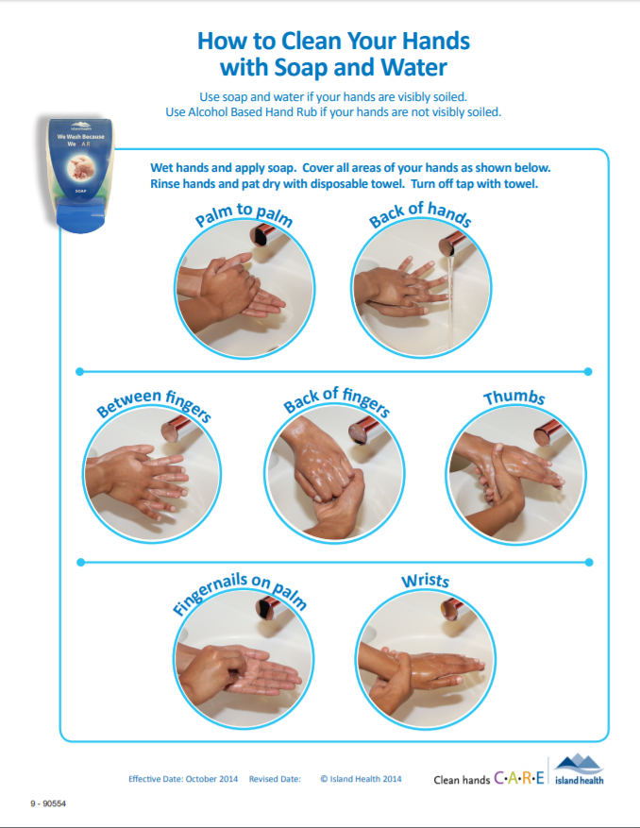

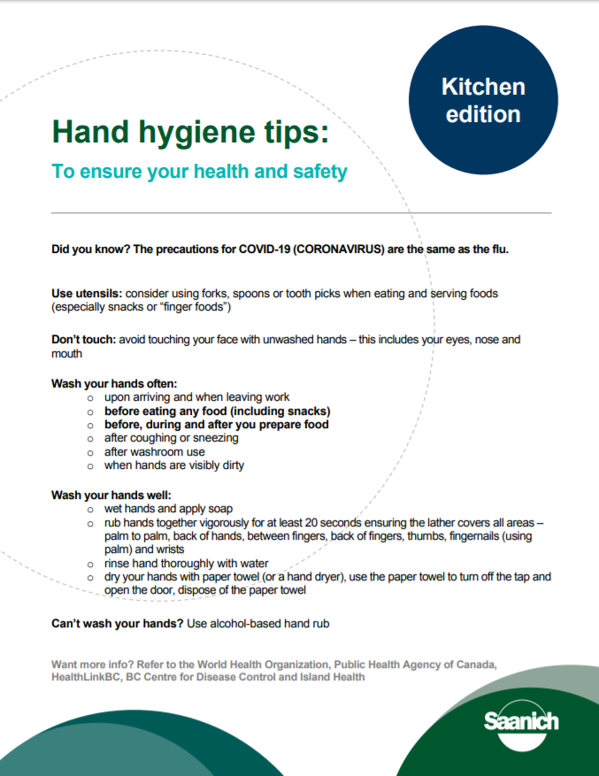
APPENDIX C: ABOUT CORONAVIRUS DISEASE (COVID-19)

