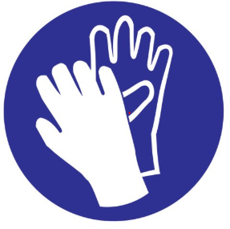
Quat Plus- Disinfecting Solution
Safe handling precautions: Avoid contact with skin, eyes or clothing. Do not breathe dust/fume/gas/mist/vapors/spray. Wash face, hands, and any exposed skin thoroughly after handling.
For more information consult the Safety Data Sheet which should be available at this cleaning station or look up online here: https://www.dustbane.ca/uploads/resource_library/Safety-Data-Sheet/Quat-Plus.pdf

