Report regarding special considerations related to Occupational First Aid and COVID-19
NOTE – Fire have First Responder protocols that address this issue
Purpose: to determine the best advice to provide to Occupational First Aid Attendants considering PPE is the last risk control method on the hierarchy, and supply of some first aid PPE may be limited.
Information sources used to prepare this report included:
- WorkSafeBC OFA Level 2 Manual
  - Chapter 3 – Initial Evaluation of the Trauma Patient
  - Chapter 43 – Communicable Disease
- MHO/BCCDC – Coronavirus COVID-19:
  - COVID-19 Patient ID and Assessment for Primary Care with MD/NP poster
  - The 5 steps to DON (put on) Personal protective equipment (PPE)
  - The 6 steps to Doff (take off) Personal protective equipment (PPE)
  - Environmental Cleaning and Disinfectants for Physician’s Offices

Instruction to Occupational First Aid Attendants:
REMINDER to follow Priority Action Approach
Initial Assessment of the Injured Worker
- Scene Assessment:
  - Determines the presence of hazards to the OFA attendant and the patient
  - Establishes the mechanism of injury
  - Determines the number of patients

Remember do not proceed with patient assessment if it exposes you and/or the patient to further risk

Remember standard precautions (evolved from universal precautions) are used for the care of all patients, regardless of their presumed infection status and that transmission-based precautions are additional precautions used only for patients known to be, or suspected of being, infected or colonized with serious pathogens that can be spread by airborne or droplet transmission or by contact with dry skin or contaminated surfaces. (WSBC OFA II Manual)

- Considering the COVID-19 virus, if critical intervention (see below) is not required, ask the following additional screening questions:

Does the patient report any of the following symptoms?
□ Fever
□ Cough – new onset or exacerbation of chronic cough
□ Difficulty breathing / shortness of breath

If yes:
- give patient a surgical mask to wear (or ask that they hold a paper towel/tissue over their face, ensuring to cover their nose and mouth)
- isolate the patient from others, and ask that they contact 8-1-1 or their own health care provider for further instructions

- Monitor the patient visually while ensuring at least 2 meters distance. If the patient’s symptoms change warranting critical intervention, arranged rapid transport (contacting 9-1-1) and don the appropriate PPE prior to providing critical intervention.

See MHO/BCCDC – Coronavirus COVID-19:
  - The 5 steps to DON (put on) Personal protective equipment (PPE)
  - The 6 steps to Doff (take off) Personal protective equipment (PPE)

Perform hand hygiene before, during and after patient care
Remember, critical intervention is:
- Airway with C-spine control
  - Clear an obstructed airway and maintain the airway (while protecting the cervical spine if necessary)
- Breathing
  - Ventilate using a pocket mask
  - Provide oxygen if indicated and you are trained, ensure use of pulse oximetry
- Circulation
  - Start CPR and ask for an AED if cardiac arrest has occurred
  - Control life-threatening hemorrhage
- Restrict spinal movement if spinal trauma is suspected

- Island Health is working in partnership with the Ministry of Health and the BCCDC. Island Health has opened a referral-only COIVD-19 screening clinic in Victoria to support testing of people how meet specific criteria. People living in the Victoria region who are assessed as requiring follow-up (by either 8-1-1 or their health care provider) will be directed to call the clinic. A triage nurse at the clinic will then assess referred patients over the phone to determine if any appointment for testing is needed.

Prepared by EOC Risk Manager on March 15, 2020

MHO/BCCDC – Coronavirus COVID-19:
- COVID-19 Patient ID and Assessment for Primary Care with MD/NP poster

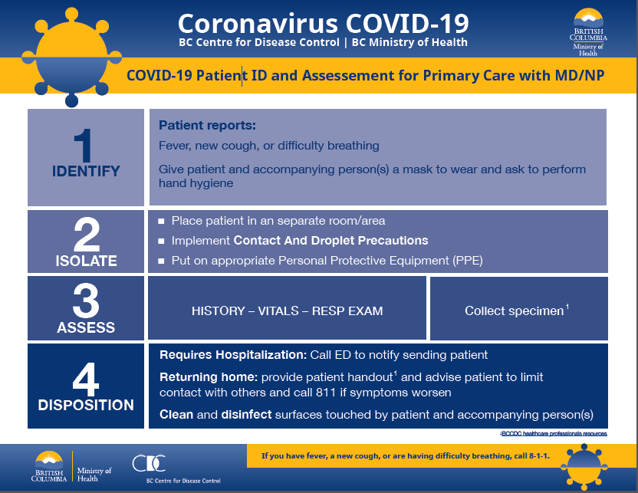
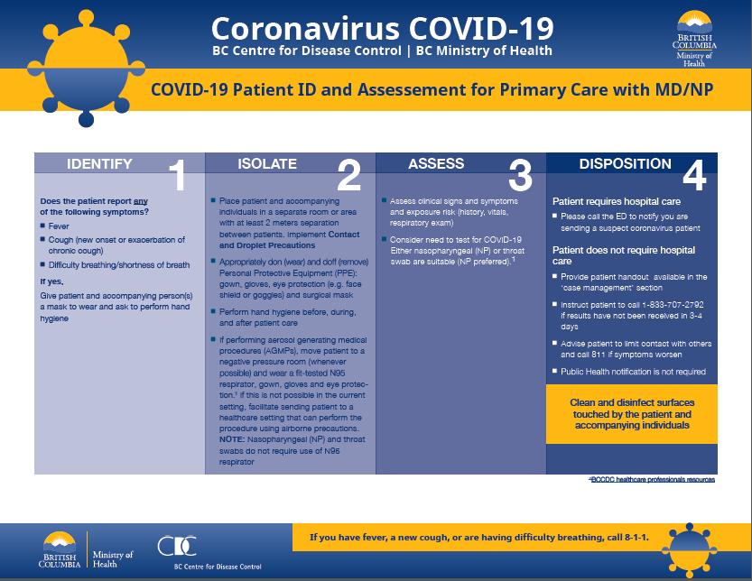
MHO/BCCDC – Coronavirus COVID-19:
- The 5 steps to DON (put on) Personal protective equipment (PPE)
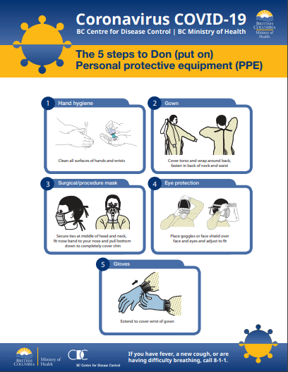

MHO/BCCDC – Coronavirus COVID-19:
- The 6 steps to Doff (take off) Personal protective equipment (PPE)

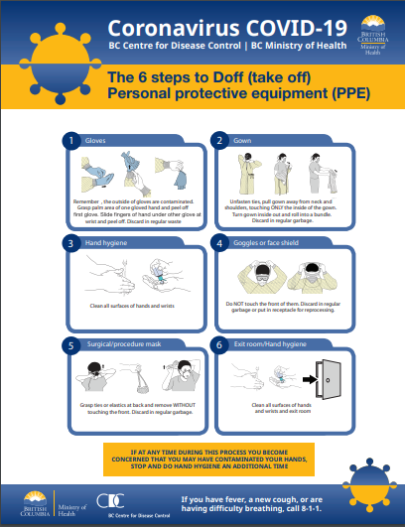

MHO/BCCDC – Coronavirus COVID-19:
- Environmental Cleaning and Disinfectants for Physician’s Offices
