SAFE WORK PROCEDURE
WORKING REMOTELY
DIVISION: All Applicable |  |  |  | DEPARTMENT: All Applicable |  |  |  |  | DOCUMENT:
PREPARED BY: A. Parnell |  |  |  | REVISED BY: |  |  |  |  | APPROVED BY: T. Savoie
DATE PREPARED: March 15, 2020 |  |  |  |  |  | DATE REVISED: March 20, 2020
REFERENCES: City of Port Moody Ergonomics Program, City of Port Moody Working Alone Program, HR Remote Work Policy
MATERIALS/EQUIPMENT: Office/computer equipment
HAZARDS: Ergonomics, working alone, electrical safety, slips trips and falls, lighting, environmental, emergency preparedness
PERSONAL PROTECTIVE EQUIPMENT: (X=REQUIRED PPE)
Gloves | High Vis Clothing | Dust Mask or Respirator | Eye Protection |  | Face Shield |  | CSA Footwear | Hearing Protection |  | Protective Clothing | Hard Hat
OBJECTIVE:

To ensure those who may be required or must work at home/remotely have appropriate provisions in place and follow recommended guidelines to ensure health and safety.

GUIDELINES:

Ergonomics

When using a laptop/home computer for long periods of time it is important to have the screen elevated to eye level, and separate keyboard and mouse connected to it. This enables you to have proper screen height and keyboard position. A suitable and ergonomically adjusted chair must be used as it allows for neutral postures.

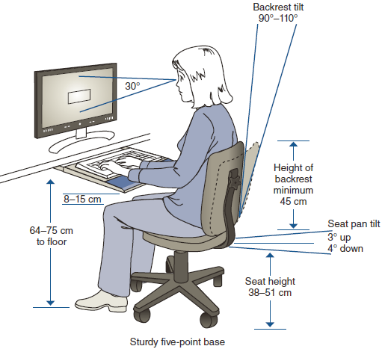

Electrical Safety

Always use 3-prong grounded electrical outlets or a surge-protected power bar to prevent the risk of an electrical shock. If using a power cord, check that it is in good condition and not broken or scorched.

Slips, Trips and Falls

Prior to setting up your workstation, identify areas that could potentially cause an injury.
- Make sure that there is adequate visibility and lighting to allow you to see hazards
- Identify slippery or icy areas. Beware of obstructions in loose carpets, tiles or uneven floor surfaces.
- Remove all tripping or falling hazards

Lighting

Ensure you work in a well-lit area that can ensure good visibility of your screen and not strain eye sight.

Environmental

If you are exposed to hazards or irritants such as tobacco smoke, cooking odors or other irritants in the area/neighborhood, make the necessary adjustments to reduce or eliminate your exposure. Excessive noise or other distractions must be reduced or removed from the environment. Workload, distractions and competing priorities can affect your ability to work.
Do your best to function in a clean distraction free area where possible.

Working Alone Safety Check In/Out

Workers may be required to follow working alone procedures and conduct safety checks. See Working Alone Safety Check In-Out Safe Work Procedure.

Emergency Preparedness

Review the information below and know your responsibilities as a staff member so you’ll be prepared in the event of an emergency, regardless of your work location.

Emergency Kit | Prepare an emergency kit with basics such as water, food, medications, light, money and contact lists and store it in an accessible location.
Fire/Smoke Alarms | Ensure that smoke and carbon monoxide detectors work.
First Aid | Maintain a basic first aid kit and report all injuries to your Manager immediately.
Contacts | Maintain a list of numbers for contact, including Manager/Supervisors, team members, clinics and emergency services.
Evacuation Plan | Create an evacuation plan that outlines where to evacuate/muster and who to contact in emergencies. Your immediate supervisors should be contacted as soon as possible.

Incident Reporting

Any safety incidents/injuries must be immediately reported to your direct supervisor. An Employee Incident Report Form must be completed. A site visit may be required to investigate and/or follow up. WorkSafeBC coverage for work-related accidents applies during normal business hours. The City of Port Moody is not responsible for non-work related injuries that may occur at any remote work location and compensation is limited to official work times.

