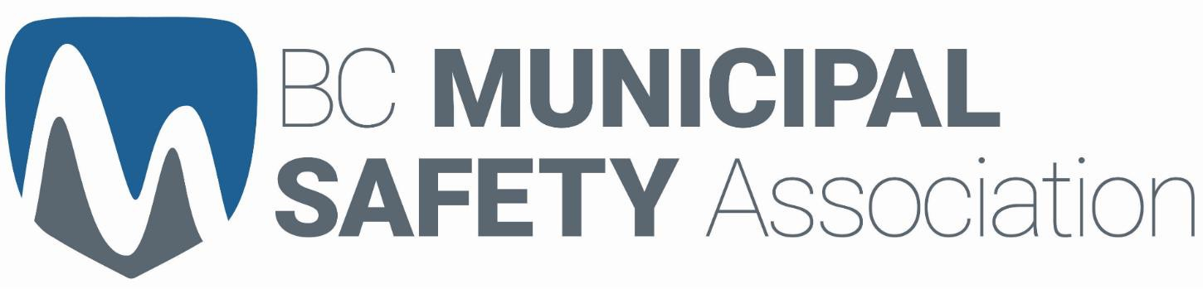

MUNICIPAL BEST PRACTICES
GUIDELINES
V8

Update: November 16, 2020
Abstract
This document outlines essential safety protocols that municipalities may adopt as they restart
or expand operations during the COVID-19 pandemic

Amendment Record Sheet

Date | Reason for Change | How communicated
May 19, 2020 | Municipal COVID-19 Health and Safety Best Practice Guideline - V1 | - Posted on BCMSA website: www.bcmsa.ca/resources/pande mic-exposure-control/  - Email BCMSA Yahoo User Group
May 20, 2020 | Municipal COVID-19 Health and Safety Best Practice Guideline - V2  - Formatting | - Posted on BCMSA website: www.bcmsa.ca/resources/pande mic-exposure-control/  - Email BCMSA Yahoo User Group
May 21, 2020 | Municipal COVID-19 Health and Safety Best Practice Guideline – V3  - Additional information in 3.2 Parks and Recreation re: Aquatic facilities, restrooms. Reference to Lifesaving Society BC & Yukon Branch Guidelines for Reopening BC's Pools & Waterfronts  - Identified that if municipality has a comprehensive exposure control plan, a separate Safety Plan is not required  - Amended Section: 2.2.1 Workplace Wellness/Sick Leave Policy  - Appendix F: COVID-19 Screening Tool, removed wording in the bold text, “or any members of your household”  - Added an amendment record sheet | - Posted on BCMSA website: www.bcmsa.ca/resources/pande mic-exposure-control/  - Email BCMSA Yahoo User Group
May 21, 2020 | Municipal COVID-19 Health and Safety Best Practice Guideline – V4  - Amended physical distancing section 2.4 to clarify space requirements  - Revised abstract on cover to say “may” instead of “should”  - Added link to WorkSafeBC publication “Designing effective barriers” | - Posted on BCMSA website: www.bcmsa.ca/resources/pande mic-exposure-control/
May 26, 2020 | Municipal COVID-19 Health and Safety Best Practice Guideline – V5  - Added to Aquatics reopening with additional information from WorkSafe BC  - Added WorkSafeBC posters as appendices I through K; moved Due Diligence to appendix L | - Posted on BCMSA website: www.bcmsa.ca/resources/pande mic-exposure-control/
November 1, 2020 | Municipal COVID-19 Health and Safety Best Practice Guideline – V6  - Revised recommended/requirement to wear face mask | - Posted on BCMSA website: www.bcmsa.ca/resources/pande mic-exposure-control/
November 16, 2020 | Municipal COVID-19 Health and Safety Best Practice Guideline – V7  - Add BCMSA COVID Screening Tool  - Sections: 1.4, 2.0, 2.1, 2.2.1 and 3.0 | - Posted on BCMSA website: www.bcmsa.ca/resources/pande mic-exposure-control/

Table of Contents
Amendment Record Sheet 1
1.0 Overview 5
1.1 Purpose 5
1.2 Public Health Directives 5
1.4 Right to refuse unsafe work 6
1.5 Recognize Hazards/Assess Risks 6
1.6 Exposure Control Plan 7
1.7 Return to Work Occupational Health & Safety Training 8
2.0 General Operating Guidelines 8
2.1 General Practices 8
2.2 Employee Policies 9
2.2.1 Workplace Wellness/Sick Leave Policy 9
2.3 Customer Policies 10
2.4 Physical Distancing 10
2.4.1 Physical Distancing for Employees 10
2.4.2 Physical Distancing During Worker Transportation 12
More Information On COVID-19 Municipal Best Practices: Physical Distancing In Vehicles Please Visit www.Bcmsa.Ca/Resources/Pandemic-Exposure-Control/ 12
2.4.3 Physical Distancing for Customers 14
2.5 Sanitation & Hygiene 14
2.5.1 Hand Hygiene 14
2.5.2 Personal Protective Equipment 15
2.5.3 Environmental Hygiene & Decontamination 15
2.6 Employee & Customer Communications 16
2.6.1 Employee Communications 16
2.6.2 Customer/public Communications 17
3.0 Potential Controls 17
3.1 Administration/Office staff 17
3.1.1 Worker to Worker 17
3.1.2 Public to Worker 18
3.2 Parks and Recreation 19
3.2.1 Worker to Worker – indoor or outdoor spaces 19
3.2.2 Public to Worker – outdoor spaces 21
3.2.3 Public to Worker – indoor spaces 22
3.2.3.1 Aquatic Centers 22
3.2.3.2 Gyms and Workout facilities 25
3.3 Engineering 27
3.3.1 Worker to Worker 27
3.3.2 Public to Worker 29
3.4 Fire Department 29
3.4.1 Worker to Worker 29
3.4.2 Public to worker 30
3.5 Library 30
3.5.1 Worker to Worker 30
3.5.2 Public to Worker 31
4.0 Links and Resources 33
Appendix A: Sample Return to Work Plan 34
Appendix B: Sample Safe Work Procedure – Pandemic Response 40
Appendix C: Risk assessment for pandemic influenza 46
Appendix D: Risk Assessment for Office and Field Workers 47
Appendix E: Personal Protective Equipment 49
Appendix F: COVID-19 Screening Tool 50
Appendix G: Hand Hygiene 51
Appendix H: Glove Donning and Removal 52
Appendix I: WorkSafeBC Poster: Cover Coughs and Sneezes 53
Appendix J: WorkSafeBC Poster: Occupancy Limits 55
Appendix K: WorkSafeBC Poster: How to use a mask 56
Appendix L: Returning to Safe Operations – Due Diligence Document 57

Municipal Best Practices Guidelines

Overview

Purpose
Municipalities resuming operations following work interruptions related to COVID-19 must develop a COVID-19 safety plan. This document provides practical advice and guidelines to ensure safe operations for workers, as municipalities seek to reopen or expand their operations during the COVID-19 pandemic.
An Exposure Control Plan meets the WorkSafeBC requirements to protect the health and safety of workers. (See section 1.6)

Public Health Directives
The Provincial Health Officer is the senior public health official for BC and is responsible for monitoring the health of the population across the province, providing independent advice to the ministers and public officials on public health issues. Recommendations from the Public Health Officer have been included in this Best Practice Guideline.
The responsibilities of the Provincial Health Officer (PHO) are outlined in the Public Health Act and include the following:
    - provide independent advice to the ministers and public officials on public health issues;
    - monitor the health of the population of BC and advise on public health issues and on the need for legislation, policies and practices;
    - recommend actions to improve the health and wellness of the population of BC;
    - deliver reports that are in the public interest on the health of the population and on
government’s progress in achieving population health targets;
    - establish standards of practice for and conduct performance reviews of Medical Health Officers; and
    - work with the BC Centre for Disease Control and Prevention and BC’s Medical Health Officers
across the province to fulfill their legislated mandates on disease control and health protection.
  - WorkSafeBC Directives (Workers Compensation Act/OHS Regulation Requirements)
WorkSafeBC is a provincial agency dedicated to promoting safe and healthy workplaces across BC. They partner with workers and employers to prevent work-related injury, disease, and disability. Their services include education, prevention, compensation and support for injured workers, and no-fault insurance to protect employers and workers.
WorkSafeBC helps businesses meet their obligations under the Workers Compensation Act and the Occupational Health and Safety Regulation. All employers in British Columbia have an obligation under the Act to ensure the health and safety of workers and other parties at their workplace. With respect to COVID-19, that responsibility includes protecting workers by following the orders issued by the office of the provincial health officer, guidance provided by the BC Centre for Disease Control and the latest news released from the government. In addition, employers must implement policies and procedures to protect workers from the risk of exposure to COVID-19.

WorkSafeBC has provided a template for a COVID-19 Safety Plan. Municipalities may choose to use this, or any other format they choose, as long as it meets the key requirements:
    - Assess the risks
    - Implement protocols
    - Develop policies
    - Develop communication plans and training
    - Monitor workplace and update plans as necessary
    - Assess and address risks from resuming operations

As noted above, these are all elements of an exposure control plan.

An example of a completed safety plan, entitled Return to Work plan, is in Appendix A. The corresponding Safe Work Procedure is in Appendix B.

Employers should consider how best to communicate to workers about potential exposure to COVID-19 in the workplace. A system should be introduced so workers (including joint health and safety committee representatives and worker representatives) are able to inform management of concerns related to being exposed to COVID-19 in the workplace. Open communication is key to finding out about specific tasks that concern workers as well as gaining input on appropriate control measures to keep workers safe.

Workers should know and understand their workplace health and safety responsibilities — and those of others. Workers have three key rights:
    - the right to know about hazards in the workplace;
    - the right to participate in health and safety activities in the workplace; and
    - the right to refuse unsafe work.

Right to refuse unsafe work
Workers in BC have the right to refuse work if they believe it presents an undue hazard. An undue hazard is an “unwarranted, inappropriate, excessive, or disproportionate” risk, above and beyond the potential exposure a general member of the public would face through regular, day-to-day activity. In these circumstances, the worker should follow some specific steps within their workplace to resolve the issue. The worker should report any undue hazard to their supervisor for investigation. Each refusal of unsafe work is dealt with on a case-by-case basis. If the issue is not resolved between the worker and the supervisor, the joint occupational health and safety committee is notified of the concern and an investigation is conducted. If the matter is not resolved, the worker and the supervisor or employer must contact WorkSafeBC and a prevention officer will then investigate and take steps to find a workable solution for all involved.

If entering the workplace, workers should:
    - Comply with the employer’s instructions around minimizing exposure to COVID-19.
    - Wash their hands frequently, and/or use hand sanitizer.
    - Take steps to minimize exposure to COVID-19 while away from work.
NOTE: Worker screening is required prior to start of shift https://myopinionsmatter.ca/f/l/COVID-19_Self-Screening_Tool_BCMSA

Recognize Hazards/Assess Risks
Every municipal workplace is unique. Employers must regularly assess all the hazards within their operations, taking appropriate steps to eliminate or control the associated risk. This process is referred to as a risk assessment.
Within municipalities, there are many routine situations where staff will have contact with customers, coworkers and the physical environment itself (surfaces, doors, equipment etc.). These encounters could give rise to contact with COVID-19, if not controlled adequately.
All municipalities must think about the risks in their workplace and take steps to control them. Such controls will include adhering to current public health orders, if applicable, public health advice, as well as implementing best practices to keep your employees and customers safe.
A Risk Assessment table, adapted from WorkSafeBC Safety Regulation Guideline G6.34-6, is in Appendix
- A position-based risk assessment is in Appendix D. Employers may choose to use these tables as a reference when completing their own risk assessments. Many more risk assessment tools are available on the BCMSA website.

We have outlined some best practices that employers should consider when implementing COVID-19 related controls in the workplace. When selecting a safeguard or a combination of safeguards, always start at the top of the hierarchy shown below to control the hazards. Choose a less effective safeguard only when more effective solutions are impracticable and continuously monitor to ensure they are providing the best level of protection to workers.
The hierarchy of controls (in order of their effectiveness):
Elimination or substitution: Has the employer fully considered eliminating or postponing work tasks that may create a risk of exposure to COVID-19? Are there opportunities to work from home or can work processes be changed to eliminate or reduce contact with others?
Engineering controls: Are engineering controls, such as physical barriers, practicable?
Administrative controls: Has the employer fully considered how work practices can be altered to minimize exposure, such as physical distancing or enhanced cleaning protocols?
Personal protective equipment (PPE): This last form of protection should only be considered after careful consideration of the previous control measures. The use of gloves and face masks may be considered where none of the above controls are possible/effective. If gloves and masks are used, proper usage guidelines should be followed. On October 26, 2020, the Public Health Officer recommended the use of non-medical face masks whenever in public spaces. See Appendix E for possible PPE.

Exposure Control Plan
Formal exposure control plans are required for municipalities, as occupational exposure to COVID-19 could be reasonably anticipated for some employees.

The exposure control plan must incorporate the following elements:
- a statement of purpose and responsibilities;
- risk identification, assessment and control;
- education and training;
- written work procedures;
- hygiene facilities and decontamination procedures;
- health monitoring, when required;
- documentation.

The plan must be reviewed at least annually and updated as necessary by the employer, in consultation with the joint committee or the worker health and safety representative, as applicable. Sample exposure control plans can be found on the BCMSA website.

Employers must also undertake regular inspections of the workplace and remedy unsafe or harmful conditions without delay. With respect to potential COVID-19 exposures:
  - Employers should ensure that physical distancing is maintained wherever possible
  - Review work procedures to ensure appropriate distancing
  - Identify potential means of transmission on surfaces and minimize worker contact with those surfaces
  - Employers must stay informed of all public health orders, directions, and requirements, and take appropriate action in their workplace to prevent transmission of the virus.

Return to Work Occupational Health & Safety Training
Upon returning to work after a period of absence where hazards of the work may have changed, workers must receive refresher orientation training from their employer. Therefore, everyone returning to work after a reduction in work due to COVID-19 must receive a refresher orientation. Every worker must be informed of new or revised procedures to eliminate or reduce potential for exposure to COVID-19.
Training must be
- Specific to the workplace and, in addition to acting as a refresher, it should also include any new arrangements or controls developed in response to the COVID-19 pandemic
- Should explain essential health and safety information, such as worker rights and responsibilities, work rules, hazards and safe work procedures
- Information around specific COVID-19 protocols or procedures, including
  - Rules around physical distancing
  - Hand washing
  - Reporting COVID-19 symptoms
  - General cleaning procedures to ensure a consistent approach by all

General Operating Guidelines

General Practices
While every workplace is different, and practices may vary depending on the location and nature of the department, there are some general guidelines that apply:
- Maintain good personal and environmental hygiene
- Ensure good ventilation
- Maintain proper function of washrooms, drains and pipes.
- Cover nose and mouth with tissue paper while sneezing or coughing, dispose of tissue and wash hands immediately. (see poster in Appendix I)
- Maintain physical distancing (at least 2 meters)

- Keep hands clean and wash hands properly:
  - before touching eyes, nose and mouth if there is a need to do so
  - after handling objects soiled by respiratory or other body secretions
  - after touching high contact surfaces or equipment, such as escalator handrails, elevator control panels or door handles
- People with symptoms of COVID-19 should self-isolate and contact their doctor or 8-1-1. Anyone with these symptoms are not to be in the workplace. The BCMSA COVID-19 screening tool may be used to identify these situations. (Appendix F)
- People returning from outside the province/country should follow public health guidelines after the trip, are currently required to self-isolate for a minimum of 14 days.
NOTE: Worker screening is required prior to start of shift https://myopinionsmatter.ca/f/l/COVID-19_Self-Screening_Tool_BCMSA

Employee Policies
Employees Must
    - Practice physical distancing by working at least 2 meters apart from co-workers whenever possible
    - Continue to follow all other safe work procedures. If it is unsafe to work, talk to a supervisor, joint health and safety committee or worker representative, and/or union, if present
    - Stay home if they are sick or might be sick. Use the BC Ministry of Health tool for self-assessment.
    - NOTE: Worker screening is required prior to start of shift https://myopinionsmatter.ca/f/l/COVID-19_Self-Screening_Tool_BCMSA
    - Avoid touching their face
    - Wash their hands for a minimum of 20 seconds at the start of their shift, before eating or drinking, after touching shared items, after using the washroom, after using a tissue, after handling cash or credit/debit cards, after touching common items, after each delivery (if contact was made) and at the end of their shift. Remove jewelry while washing. (see Appendix G)

Workplace Wellness/Sick Leave Policy
Employers should ensure that workers do not come to work if they are displaying symptoms of COVID-19. This includes workers who fall into the below categories:

      - Anyone with COVID‐19-like symptoms such as a sore throat, fever, sneezing, or coughing must self‐isolate at home for a minimum of 10 days from onset of symptoms, until their symptoms are completely resolved. Anyone with these symptoms should call 8-1-1 and possibly be tested for COVID-19. The BCMSA COVID-19 Screening tool may be used by supervisors or Human Resources (Appendix F)
      - NOTE: Worker screening is required prior to start of shift https://myopinionsmatter.ca/f/l/COVID-19_Self-Screening_Tool_BCMSA
      - Workers who have travelled internationally. In these cases, they must remain away from the workplace and self-isolate for at least 14 days.
      - Workers who live in the same household as a confirmed or clinical COVID-19 case who is self- isolating.

If workers report having COVID-19-like symptoms while at work:

      - Send them home to recover for the prescribed self-isolation period. Advise them to call 8-1-1 for direction.
      - Clean and disinfect their work station and any areas or tools that they were using as part of their job.
      - Follow any directions from public health with regard to detailed cleaning, temporary closure and trace contacting.
Employers should ensure that these policies are communicated to their managers, supervisors, and workers and they must have a process for communicating with workers who may fall into one of the categories of those who should not come to work.

Employers must ensure they have clear policies that address the following:
      - Expectations from employees when they report to work (e.g. washing hands, abiding by distancing protocols, wearing PPE, undergoing COVID-19 screening) NOTE: Worker screening is required prior to start of shift https://myopinionsmatter.ca/f/l/COVID-19_Self-Screening_Tool_BCMSA
      - What employees do when they feel sick (e.g. reporting procedures)
      - Sick leave entitlement

Customer Policies
Messaging to Customers
    - If you have underlying medical conditions, it is recommended that you not visit our municipal hall or facilities
    - Anyone displaying symptoms of COVID-19, including cough, fever, shortness of breath, difficulty breathing or chills, will not be permitted on the premises. If you are sick, please stay home
    - If you have travelled outside Canada, you are not permitted on our premises until you have self- isolated for a minimum of 14 days
    - If you are displaying symptoms of COVID-19 or you live in a household where someone is showing symptoms of COVID-19, please stay home
    - NOTE: Screening is recommended for visitors https://myopinionsmatter.ca/f/l/COVID-19_Self-Screening_Tool_BCMSA
    - Physical distancing is required at all times (minimum of 2 meters)
    - Failure to observe physical distancing risks the closure of the facility, and as such, you will be asked to leave the premises
    - Washrooms on the premises are disinfected frequently; hand sanitizers are located at (identify the location, recommend at a minimum, the entrance to the facility)
    - If your request can be handled over the phone, please call the appropriate department for assistance rather than attending the municipal hall in person
    - We ask that any financial transactions be conducted electronically and not in cash

Physical Distancing

Physical Distancing for Employees

There are various ways to determine space considerations to allow for appropriate physical distancing, depending on circumstances.

Involving your joint health and safety committee (or worker representative) in brainstorming
physical distancing measures that could work in the spaces they work in. Have your joint committee consider the interactions they have with others, solicit input from the team and encourage all workers to promote the approved physical distancing measures. Spread the message that the most considerate thing your workers can do for their co-workers and customers is to keep a distance of two meters between themselves and the people they work with. Encourage workers to use a standard greeting with each other that is positive but reminds others to keep a safe distance.

Considerations for Physical Distancing

Types | Description
Physical Distancing | - Allow for 2 meters (6 feet) of physical distance between workers or between workers and public or public and public.
Indoor Employee Space | - Where employees will not be moving around or need to navigate around obstacles, allow for 3.3 square meters (36 square feet) of unencumbered space per person to calculate occupancy
Indoor Employee/Public Space | - calculate the total unencumbered square meters available and divide that by 5, to allow for 5 square meters (54 square feet) of space per person. The resulting figure is the maximum occupancy for that space.
Events Numbers | - The maximum number of participants is fifty (50), including workers and public, providing adequate space is available.

There are many ways that employers can organize work to ensure that physical distance between workers is maintained. Some options may include:

      - revising work schedules or implementing work-from-home policies for some staff to limit the number of workers on site at a given time
      - staggering start and end times if crowding at entry and exit locations means the physical distancing requirement of at least 2 meters cannot be maintained.
      - designating doors for entry and exit to prevent workers and others from coming into proximity with one another.
      - establishing and posting occupancy limits on elevators, rooms and other small spaces, using the calculation shown previously (see Appendix J)
      - Identifying the maximum number of people (including staff) and communicate and enforce this limit
      - reducing in-person meetings and other gatherings
      - using tape to mark off areas where workers can and cannot walk, or to mark off areas where workers may walk only in one direction (such as down an aisle or narrow corridor)
      - posting signage to remind workers to maintain their distance when interacting
      - postponing, re-arranging, or planning work tasks in such a way that workers are not required to work in proximity to one another
      - using machines or other equipment to assist with job tasks usually performed by two workers, such as lifting or carrying heavy objects
      - managing worker transportation so that two workers are not required to travel in a single vehicle
      - Restrict eating to a clearly identified and dedicated area with handwashing stations, cleaning and disinfecting supplies, and adequate space to maintain the physical distancing requirement.
      - Designating additional rooms as break areas
      - Eliminating food sharing stations
      - Limiting the number of workers allowed in common areas at any one time. Consider staggered break times to reduce large gatherings and encourage workers to take breaks at their own desk or outside. Limit or stagger workers entering change areas or rooms with assigned lockers.

      - distancing the tables in lunchrooms, limiting the number of chairs, placing “x’s” on tables where
people should not sit, or installing barriers at the tables made from plexiglass, acrylic, polycarbonate, or similar materials. See WorkSafeBC publication “Designing effective barriers”.
      - If breaching the physical distancing requirement is unavoidable, plan the work task and provide instructions to workers to ensure that time spent in close proximity is minimized. All workers in this situation should wear face masks.
The aim is to do everything possible to limit in-person interactions, while finding new and more protective ways to operate within the physical infrastructure of the workplace. With this in mind, everyone in the workplace must adhere to the following:
      - do not come to work if you are sick
      - report to work committed to abiding with physical distancing processes
      - continue to follow all existing safe work procedures in the workplace
      - wash and sanitize hands regularly, cough/sneeze into tissue or upper sleeve or elbow (not your hands)
      - avoid physical contact with others
      - if you notice that another employee is not abiding by the physical distancing policy, you must report it to a supervisor
      - reconfigure the workplace to maintain appropriate distance between workers

Physical Distancing During Worker Transportation

More Information On COVID-19 Municipal Best Practices: Physical Distancing In Vehicles Please Visit www.Bcmsa.Ca/Resources/Pandemic-Exposure-Control/

If workers are travelling by road vehicle, the following control measures should be considered:

      - Employers should limit the number of workers being transported at any one given time and employ measures to ensure distance between workers is maintained. This could include adjusting the number of workers transported, adding physical barriers between workers, blocking seats and using larger or multiple vehicles. Distancing is also important when loading and unloading.
      - Employers should have hand-washing facilities or sanitizing stations available to workers as they
enter and exit the vehicle.
      - Whenever possible, workers should travel alone in their vehicles in order to practice physical distancing. (Consider working alone or in isolation controls, in this situation).
      - If it is not possible to ensure 2 meters of distance between workers in a vehicle, the employer must consider other control measures, such as physical barriers where practicable. If more than one person is in the vehicle, a face mask should be worn by all.
      - Employers must ensure that high-contact surfaces within the vehicle are routinely cleaned. These include seatbelts, headrests, door handles, gear shift levers, steering wheels and hand holds.
      - Employers may consider installing a physical barrier, similar to a “sneeze guard,” in vehicles transporting workers. While this may be feasible in some vehicles depending on their size, type, and configuration, employers should be aware that modifying vehicles in any way may introduce additional hazards to the vehicle and occupants. Any barriers should be installed in such a way that they:
        - are not rigidly affixed to the vehicle, and
        - do not introduce hazards, such as restricting the drivers field of vision, means of escape in the event of an accident, or access to controls.
      - Any changes to the passenger compartment and vehicle used for transportation of workers must still be consistent with requirements set out in the Occupational Health and Safety Regulation. Any barrier installed should be made of a material that can be cleaned and disinfected and should be regularly cleaned as part of the overall cleaning practices for the vehicle used to transport workers.

Physical Distancing for Customers
From a customer perspective, municipalities must implement physical distancing to reduce opportunities for interactions among large groups that could have prolonged close contact, such as during tax payment time. Practically this might mean limiting the number of patrons who enter your business and discontinuing service in areas where physical distancing cannot be practiced (e.g., counter service).
Ways in which businesses may achieve physical distancing among customers include the following:
      - Use signs and markings to direct customers, to indicate appropriate distances to stand, to mark direction of travel, to designate entrances and exits, or to identify a drive-thru lane or pick up zone
      - Promote one-way travel
      - Limit the number of customers allowed into your city hall or facility. It is strongly recommended that there are five square meters of space per person. This unencumbered space would be floor space minus floor space used for change rooms, desks, etc. Identify the maximum number of people (including staff) and communicate and enforce this limit
      - Provide a waiting area outdoors with markers to designate safe distances if it is safe to do so
      - Install barriers at and between cash registers to prevent encroachment
      - Install barriers between workers and customers made of plexiglass, acrylic, polycarbonate, or similar materials. See WorkSafeBC publication “Designing effective barriers”
      - Mark the floor at 2 meter intervals to promote physical distancing in aisles and line ups
      - Label certain tables and chairs unavailable for use, or remove entirely, to maintain appropriate distances between customers.

Sanitation & Hygiene

Hand Hygiene

Respiratory viruses like COVID-19 spread when mucus or droplets containing the virus get into your body through your eyes, nose or throat. Most often, this happens through your hands. Hands are also one of the most common ways that the virus spreads from one person to the next. During a global pandemic, one of the cheapest, easiest, and most important ways to prevent the spread of a virus is to wash your hands frequently with soap and water.

Below is a step-by-step process for effective handwashing, to remove all traces of the virus:

      - Step 1: Wet hands with running water
      - Step 2: Apply enough soap to cover wet hands
      - Step 3: Scrub all surfaces of the hands – including back of hands, between fingers and under nails
– for at least 20 seconds.
      - Step 4: Rinse thoroughly with running water
      - Step 5: Dry hands with a clean cloth or single-use towel
      - Step 6: Use towel to turn off the faucet

Employers should ensure that materials for adhering to hand hygiene are available on their premises. Provide receptacles for used tissue paper disposal. Provide conveniently-located dispensers of alcohol- based hand sanitizer; where sinks are available, ensure that supplies for handwashing (i.e., liquid soap and disposable towels) are consistently available. Remove or cover hand air-drying stations.
A poster identifying hand hygiene is in Appendix G.

Personal Protective Equipment
Personal Protective Equipment (PPE) is specialized clothing or equipment worn by an employee for protection against infectious materials. It should serve as a last resort that should not replace any other risk control and infection control measures. However, sufficient stock of PPE should be kept to ensure its provision to protect employees from exposure to infectious agents in the workplace. The common PPE used includes:
Surgical mask: Wear a surgical mask to protect mucous membranes of the nose and mouth during procedures that are likely to cause exposure to blood or body fluids. Non-surgical (cloth) masks do not protect the wearer but may prevent the wearer from exposing others to the virus.
Particulate respirator: Use a particulate respirator (e.g., N95 respirator) for first aid attendants/First Responders, or for maintenance work on ventilation or sewage systems.
Non-Medical face mask: On October 26, 2020, the Public Health Officer recommended the use of non-medical face masks be worn by everyone when in public spaces.
Gloves: Wear disposable gloves when touching blood, body fluids, mucous membrane or contaminated items. Remove gloves promptly after use and perform hand hygiene immediately. Gloves do not replace hand hygiene.
Gown, apron or impervious disposable coveralls: Worn to protect skin or trunk and to prevent soiling of clothing during procedures that are likely to generate splashes or sprays of blood, body fluids, secretions, or excretions. Wear a coverall for conducting high pressure water spraying during ventilation system or sewer system maintenance or when substantial whole-body contamination is anticipated. Remove soiled garment as promptly as possible and perform hand hygiene to avoid transfer of microorganisms to other people or environments.
Goggles / Face shield: Wear goggles / face shield to protect the mucous membrane of the eyes when carrying out procedures that are likely to generate splashes or sprays of blood or body fluids of the person (e.g., changing dust filters of the ventilation system, working in sewer system, or for first aid attendants). Wear goggles / face shield when conducting high pressure water spraying for sanitary sewer system maintenance. Ordinary spectacles do not provide adequate protection. Goggles / face shield should be changed after procedure or whenever contaminated. Reusable goggles / face shield should be washed and decontaminated in accordance with manufacturer’s instructions.

Environmental Hygiene & Decontamination
Current evidence suggests that COVID-19 may remain viable for hours to days on surfaces made from a variety of different materials. The thorough cleaning of surfaces and structures, followed by disinfection, is therefore a best practice measure for prevention of COVID-19.
As of the date of this document, the BC Center for Disease Control recommends the following:
For disinfection purposes, common household disinfectants such as ready-to-use disinfecting wipes and pre-made solutions (no dilution needed) can be used. Always follow the manufacturer’s instructions printed on the bottle or on the Safety Data Sheet. Ensure that the disinfectant product has a Drug Identification Number (DIN) on its label. Look for that number on Health Canada’s list of approved products. If your product is not on this list, it has not been approved for this use.

Always follow product instructions for dilution, contact time and safe use. All visibly dirty surfaces should be cleaned with water and detergent before disinfecting (unless otherwise stated on the product label).
Always ensure that the disinfectant you use is approved for use in a food processing or food service application, if applicable. Some disinfectants can be toxic and are unsuitable for food premises or food contact surfaces.
If you do not have access to pre-made disinfection products, the following bleach concentrations should be applied, taking great care when mixing. Ensure WHMIS labelling requirements are followed.

Surface disinfection: Chlorine (household bleach – sodium hypochlorite, 5.25%) should be applied at a concentration of 1 part bleach to 100 parts water (10 ml bleach per litre water). This concentration should be used for disinfecting surfaces (e.g., hand railings, grab handles, door knobs, cupboard handles). Make fresh daily and allow surface to air dry naturally.
Disinfecting surfaces contaminated with body fluids: Chlorine (household bleach - sodium hypochlorite, 5.25%) should be applied at a concentration of 1 part bleach to 50 parts water (20 ml bleach per litre water). This concentration should be used for disinfecting surfaces contaminated with body fluids and waste like vomit, diarrhea, mucus, or feces (after cleaning with soap and water first). Make fresh daily and allow surface to air dry naturally.
Quaternary Ammonium Compounds (QUATs), noted as ‘alkyl dimethyl ammonium chlorides’ on the
product label, may be used for disinfecting surfaces (e.g., floors, walls, furnishings).
Cleaning equipment should be designated for particular areas and colour coding may assist in the identification of specific equipment that is used for specific tasks. Ensure WHMIS criteria is met for labeling, use, and review of Safety Data Sheets, and that incompatible substances are not mixed.

Employee & Customer Communications

Employee Communications
Effective communications to employees are an important element of a good workplace. It assumes even greater significance at times of crisis. The current situation is constantly evolving, and employees are having to deal with multiple personal and professional changes. Ensuring employees are kept informed, and fully understand, expectations around hygiene, municipal policies, safe work practices and protocols to be followed will not only ensure better compliance but will also go a long way in obtaining employee commitment. Face to face communication can take place if proper physical distancing measures are observed but other options for communications should also be utilized, such as emails, posters, virtual meetings, short videos etc.
Ensure workers’ mental as well as physical health is maintained. Communicate to all workers how to contact your Employee and Family Assistance Program. The Canadian Mental Health Association has resources which may be of help.

Customer/public Communications
Municipalities must develop standard communications that they can share with customers visiting, or planning to visit, their premises. This communication should include
      - A message welcoming them to the premises
      - Specifics about current operation environment (e.g. provincial health directives that apply)
      - Expectations outlined in the customer policies section above
      - An overview of all the efforts that you are undertaking to ensure customer health & safety
This communication should be available in English and other languages as appropriate and should be featured on the municipal website, signage at the premises and be included in any social media information.

Potential Controls
The following information contains potential controls/recommended best practices for five main employee groups in municipalities. Each municipality must follow the hierarchy of controls to establish the greatest level of worker safety possible and include these controls in their COVID-19 Safety Plan.
NOTE: Worker screening is required prior to start of shift https://myopinionsmatter.ca/f/l/COVID-19_Self-Screening_Tool_BCMSA

Administration/Office staff

Worker to Worker
      - Ensure workers who have been away, or are new to the workplace, are oriented as necessary so that all COVID-19 related procedures are explained and understood.
      - Where possible, communicate using telephone, text message, email, or other communication technology instead of face to face.
      - Workplaces should stagger start and end times if crowding at entry and exit locations means the physical distancing requirement of at least 2 meters cannot be maintained.
      - Consider designating doors for entry and exit to prevent workers and others from coming into proximity with one another.
      - Ensure touch-free hand sanitizer is available to workers as they enter the building and counter staff who deal with the public have hand sanitizer available for just their use.
      - Post signage banning access to the workplace to those who are exhibiting symptoms of COVID-19.
      - Ensure cleaning products are readily available, monitored daily and restocked daily as required.
      - Ensure high touch surfaces such as counters, handles, control switches are cleaned a minimum of twice per day with regular household cleaning products, disposable wipes or a diluted bleach solution. Follow the directions on the product label.
      - Maintain a record of cleaning and disinfecting completed.
      - Consider the use of thin micro-shields on computer keyboard, computer mouse, point of sale machines and any other equipment that must be shared. Each worker to be issued their own shields and be responsible for proper use and cleaning.
      - Consider cleaning and disinfecting eating areas every hour.
      - Ensure that whatever changes you make to the usage of communal areas is clearly communicated to workers.
      - Limit the number of workers allowed in common areas at any one time. Consider staggered break times to reduce large gatherings and encourage workers to take breaks at their own desk or outside. Limit or stagger workers entering change areas or rooms with assigned lockers.
      - Consider distancing the tables in lunchrooms, limiting the number of chairs, placing “x’s” on
tables where people should not sit, or installing dividers at the tables made from plexiglass, acrylic, polycarbonate or similar materials. See WorkSafeBC publication “Designing effective barriers”
      - If breaching the physical distancing requirement is unavoidable, plan the work task and provide instructions to workers to ensure that time spent in close proximity is minimized.
      - When face to face meetings cannot be avoided, consider requiring staff to wear cloth face masks.
      - Restrict eating to a clearly identified and dedicated area with handwashing stations, cleaning and disinfectant supplies, and adequate space to maintain the physical distancing requirement.
      - Require workers to bring their own dishes and utensils.
      - Refrain from providing and consuming communal foods.
      - Allow communal doors to remain open throughout the workday to reduce contact with door handles.
      - Instruct workers to use their own equipment, such as pens, staplers, headsets, and computers.
      - Minimize the number of people using previously shared office equipment or other items (photocopiers, coffee machines, microwave ovens, etc.). Shared equipment should be cleaned and disinfected after each use.
      - Establish hygiene practices that address the needs of the workplace that includes the requirement to wash or sanitize hands after coming into contact with public items.
      - Restrict travel between offices or work locations to critical business functions.
      - Minimize the use of shared vehicles. If required, follow appropriate disinfection procedures before and after travel for vehicle surfaces such as the steering wheel, gear shift, and door handles.
      - Consider requiring the use of cloth face mask in meetings
      - First Aid Attendants should follow the WorkSafeBC Guideline “OFAA Protocols during the COVID- 19 Pandemic”

Public to Worker
      - Where possible, visits to the workplace (i.e. municipal hall) should be prearranged, staggered, and safety protocols should be communicated before entry into the workplace (e.g., email and/or signage posted to entrance). If possible, keep a record of visitors to the workplace should contact tracing be necessary.
      - When booking appointments, visitors should be reminded to reschedule if they experience symptoms typical of COVID-19 or are placed on self-isolation.
      - Minimize non-essential in-person interaction between workers and visitors (e.g., use of virtual meeting tools, email, or telephone).
      - Visitors should attend appointments alone and minimize time spent in waiting area before their appointments (e.g., request visitors to wait in vehicles and text message or call when ready).
      - Encourage taxpayers to make payments and grant applications online, or by mail.
      - Discourage payment in cash.
      - Post signage at the workplace to inform every one of the measures in place.
      - Waiting areas should be arranged to maintain physical distancing requirement. Install barriers between staff and visitors made from plexiglass, acrylic, polycarbonate or similar materials. See WorkSafeBC Publication “Designing effective barriers”
      - Place markings on the floor directing visitors where to stand when approaching front counters.
      - Remove non-essential communal items, such as candy, magazines, and pamphlets.
      - Beverages (coffee, tea, water) should not be offered at this time.
      - Provide a safe place for visitors to dispose of used sanitizing wipes and other personal protective equipment.
      - Ensure that delivery zones are clearly identified and limited to receivers and deliverers only.
      - Arrange for suppliers and/or delivery persons to drop off goods at building entrance to avoid searching for departments within the premises.
      - Request contactless delivery to maintain physical distancing requirement (e.g., delivery person leaves packages in a pre-arranged location). This option may be limited if signing or proof of receipt is required, or theft of items is possible before being retrieved by staff.
      - Request that members of the public wear face masks in public spaces, particularly within any municipal buildings.

Parks and Recreation

Worker to Worker – indoor or outdoor spaces
      - Review and coordinate roles and responsibilities with all contractors, suppliers, and staff. Employers should develop procedures to ensure contractors are aware of your health and safety program requirements, including relevant COVID-19 related protocols, and are following protocols of their own.
      - For locations where parks staff are working from multi-ministry or regional offices, coordination is required to ensure plans align across locations.
      - Limit the number of staff on shift to the number required.
      - Stagger arrival and departure times.
      - Assign staff to one facility only
      - Limit the number of workers allowed in common areas at any one time. Consider staggered break times to reduce large gatherings and encourage workers to take breaks at their own desk or outside. Limit or stagger workers entering change areas or rooms with assigned lockers.
      - Consider distancing the tables in lunchrooms, limiting the number of chairs, placing “x’s” on
tables where people should not sit, or installing dividers at the tables made from plexiglass, acrylic, polycarbonate or similar materials. See WorkSafeBC publication “Designing effective barriers”
      - If breaching the physical distancing requirement is unavoidable, plan the work task and provide instructions to workers to ensure that time spent in close proximity is minimized.
      - If face to face meetings cannot be avoided, consider requiring staff to wear cloth face masks.
      - Restrict eating to a clearly identified and dedicated area with handwashing stations, cleaning and disinfectant supplies, and adequate space to maintain the physical distancing requirement.
      - Consider having cleaning staff disinfect eating areas hourly.
      - Require workers to bring their own dishes and utensils.
      - Refrain from providing and consuming communal foods.
      - Allow communal doors to remain open throughout the workday to reduce contact with door handles.
      - If face to face meetings are unavoidable, consider holding them outdoors and maintain appropriate physical distance at all times. Consider requiring staff to wear face masks.
      - If meetings must occur indoors, limit face to face participation to only those absolutely required to be present. Ensure proper cleaning and disinfecting before and after meeting room use.
      - Review staffing levels and adjust as needed to ensure enhanced cleaning of high-touch areas and enhanced staff presence to manage park visitors.
      - Determine the maximum number of people in each area or space to maintain physical distancing requirements. See the COVID-19 Safety Plan template for guidance on establishing occupancy limits.
      - In welcoming visitors, send out information through regular marketing channels and social media about limitations, rules, limited facilities, and service to manage expectations during partial openings.
      - Provide signage and information regarding rules and process throughout the Parks and Recreation facilities including parks, beaches, sport courts, and general outdoor areas. Consider posting signage in other majority languages or provide pictograms.
      - Consider enhanced measure to maintain the physical distancing requirement
      - Control entry and exit points for visitors and workers
      - Manage the flow of people by implementing one-way walkways or marking off designated walking areas
      - Consider creating cohorts of workers who work together and who do not interact with other cohorts. This will assist in reducing transmission throughout the workplace in the event that a staff member becomes ill. Even workers who are “cohorts” should wear face masks if they must be within two meters of each other.
      - Ensure workers who have been away, or are new to the workplace, are orientated as necessary so that all COVID-19 related procedures are explained and understood.
      - Identify situations where personal protective equipment (PPE) will be required. Clarify who will provide PPE and train workers accordingly.
      - Identify a process to regularly review and/or update protocols and include workers and the joint occupational health and safety committee in your review process.
      - Establish and post occupancy limits for office spaces, lunchrooms, vehicles and other common areas. Ensure physical distancing can be maintained. It is recommended that five square meters of unencumbered space be available for each person (staff and public).
      - Establish hygiene practices that address the needs of the workplace that includes the requirement to wash or sanitize hands after coming into contact with public items.
      - Post cleaning procedures and worker expectations in all common spaces.
      - Before entering any shared space such as vehicle or office, wash hands or use hand sanitizer.
      - Clarify procedures to wipe down or disinfect shared office equipment before use.
      - Consider the use of thin micro-shields on computer keyboards, computer mouse, point of sale machines and any other equipment that must be shared. Each worker to be issued their own shields and be responsible for proper use and cleaning.
      - Maintain at least a 2 meter distance from other workers. If the physical distancing requirement cannot be maintained, hold a meeting to address solutions, which may include physical barriers and face masks.
      - Employers should assess the number of workers being transported or sharing vehicles at any given time and employ measures to ensure at least 2 meters of distance between workers is maintained.
      - Whenever possible, workers should travel alone in their vehicles. Employers must implement all the necessary safeguards related to working alone or in isolation to ensure the safety of these workers.
      - Measures that may be taken to ensure at least 2 meters of distance include the following:
        - Have workers sit one to a seat
        - Stagger riders to allow for maximum distance
        - Adjust the number of workers per trip and the overall number of trips needed to transport workers to a worksite
        - If possible, use larger vehicles or multiple vehicles
        - Track who drives which vehicles and minimize changes in teams or vehicle assignments. Consider creating consistency in crews of workers using vehicles together and performing shifts or work tasks together.
      - If it is not possible to ensure 2 meters of distance between workers in a vehicle through these measures, the employer must consider other control measures, such as physical barriers where practicable and the use of face masks.
      - Employers must also implement a process that allows for physical distancing when loading and unloading vehicles. Workers waiting for loading and unloading should maintain physical distancing while remaining safely away from traffic.
      - Employers should have handwashing facilities or sanitizing stations available to workers as they enter and exit the vehicle.
      - Employers must ensure that high contact surfaces within the vehicle are routinely cleaned and disinfected. These include seatbelts, headrests, door handles, steering wheels, and hand holds.
      - Incorporate end-of-shift vehicle wipe downs, include a method for tracking end of shift cleaning and provide workers with appropriate supplies, like soap and water, hand sanitizer, and disinfectant wipes.
      - Manage location of personal gear and care items to minimize exposure.
      - Clarify and follow cleaning and disinfecting schedules.
      - First Aid Attendants should follow the WorkSafeBC Guideline “OFAA Protocols during the COVID- 19 Pandemic”

Public to Worker – outdoor spaces
      - Ensure any workers that are expected to manage groups of visitors are trained in protocols.
      - Ensure staff have the support and strategies for dealing with visitors who may be unwilling or are unable to understand the approach to managing visitor volumes. This should include reviewing your violence risk assessment, policies and procedures, and training and reporting requirements under the Occupational Health and Safety Regulations for minimizing the risk of violence to workers.
      - Provide signage and determine how crowd limits and spacing will be controlled, and who will be responsible. During Phase 2 of business re-opening, the maximum number of persons allowed at a single event is 50, including staff.

      - Provide markers or indicators to ensure spacing:
        - Limit parking
        - Space out or limit bike valet or bike racks
        - Space out or limit the number of picnic tables, and put signage on table for the maximum number of people per table
      - When working amongst members of the public, set up barriers or tape to delineate the worksite and to discourage the public from entering the area.
      - Ensure there is sufficient staff to manage the volume of customers and associated line ups and food pick-up areas.

Public to Worker – indoor spaces
As the Province navigates through and beyond Phase 2 of the provision of services during the COVID-19 pandemic, aquatic centers, fitness and recreation facilities may be re-opened. As information becomes available it will be added to this document.

The following information has been provided to allow municipalities to prepare for re-opening of indoor recreational spaces.

Aquatic Centers
At this time, there is no evidence that COVID-19 can be spread to humans through pool water. Proper operation, maintenance, and disinfection (e.g., with chlorine and bromine) of pools and hot tubs spas, should inactivate the virus that causes COVID-19. Appropriate care should be taken both in and outside the pool, to protect workers and public.

Prior to opening, ensure all mechanical systems (including, any relevant toxic process gas) are maintained, restarted properly and operated in good condition.
- If employer operates multiple facilities, identify staff that work at different locations and consider methods to eliminate or reduce travel between sites.
- Develop a staffing plan to reopen spaces/facilities/programs that takes into account additional cleaning, physical distancing and patron management to protect all staff in including those who may be vulnerable or high-risk.
- If workers will be responding to noncompliant or disgruntled patrons, ensure they are trained and supported in ways to do so
- Employees must wash their hands when arriving and leaving the aquatic facility, and before and after: eating, breaks, smoking, blowing one’s nose, coughing, or sneezing, going to the toilet, being in contact with animals or pets, using shared equipment (e.g. water test kit)
- Minimize personal items and clothing brought in by workers. Store workers’ items separately, with adequate space between each.
- When possible, operate with consistent work teams (same workers in shift work) to minimize the number of interactions.
- Each worker should have their own equipment needed for each shift (e.g. one rescue tube per lifeguard, first aid fanny packs).

- As there is currently no evidence that COVID-19 survives in treated pool water, there are no special disinfection procedures to put in place for equipment that is regularly in contact with disinfected water (toys, railings, slides, etc.).
- Develop and provide staff with training on cleaning plans and offer checklists outlining protocols and frequency. The BCCDC offers guidance. Also see WorkSafeBC Cleaning and disinfecting guide
- Employers should develop policies and provide on-site training to all cleaning staff prior to assigning cleaning tasks. Training should include when to use PPE, what PPE is necessary, how to properly don (put on), use, and doff (take off) PPE and how to properly dispose of PPE.
- Personal Protective Equipment (mask, face shield, gloves & goggles etc.) for workers conducting regular pool maintenance duties are not mandatory unless normally required for safety reasons (e.g. when handling pool chemicals). When eye protection is needed, use goggles or eye shields.
- Enhance cleaning and disinfecting of washrooms, change rooms and high touch areas.
- Clean and disinfect rescue equipment (rescue tube, rescue can, rescue pole, ring buoys at the end of the day) or during an exchange between lifeguards.
- After cleaning, leave the rescue equipment immersed in the water and store to dry overnight
- Control use of equipment to one group of users at a time and clean and disinfect between use.
- Create a list and control plan for all frequent touch points include vending machines, key pads, bank machines, shared computers and other office equipment, POS locations, as well as common switches, door handles, pay phone or public access phones, indoor furnishings, rental equipment etc.
- Plan for and procured adequate supplies of PPE for staff
- Provide clear and consistent signage/messaging for public and staff throughout the facility regarding COVID-19 transmission mitigation policies and procedures. Consider ESL needs.
- Establish self-isolation/containment area for staff or patrons showing symptoms of illness while waiting for transportation to a medical centre or home
- Be aware of, and follow, all applicable local government policies, Health Authority and Public Health guidance and orders. Adjust policies as directives change. Regional health authority restrictions may differ from region to region.
- Adjust emergency evacuation procedures and mustering arrangements to support physical distancing requirements in the case of building evacuation, fire etc.
- Train staff in emergency procedures a case or outbreak occur on your site
- Provide hand sanitizing station at entrance to facility and require public and staff to use it.
        - Limit the number of patrons in the facility (patrons and staff), to allow for appropriate physical distancing of 2 meters between each person. It is strongly recommended that each facility have five square meters of unencumbered space per person. (See Section 2.4)
        - Consider areas of the facility where physical distancing may not be possible (i.e. hot tubs, saunas, etc.) and determine if opening these features are feasible.
        - Designate and sign the direction of foot traffic; one way in and one way out, and one way circulation paths in corridors and stairs.
        - Mark physical distance requirements on floors
        - Arrange deck layout so standing and seating areas provide at least 2 meters distance between patrons
        - Limit any nonessential visitors, volunteers and activities involving external groups or organizations
        - Install barriers at front counters made of plexiglass, acrylic, polycarbonate or similar materials. See WorkSafeBC Publication “Designing effective barriers”
        - Consider health screening of staff and visitors. See Appendix F for the BCMSA COVID-19 Screening Tool.
        - Post signs at the entrance prohibiting entry to anyone with COVID-19 symptoms
        - Maintain a list of persons in the facility in case contact tracing is required
        - Consider the use of thin micro-shields on computer keyboard, computer mouse, point of sale machines and any other equipment that must be shared. Each worker to be issued their own shields and be responsible for proper cleaning.
        - Consider requiring patrons to make appointments with 1.5 hour increments with a 30 minute time buffer in between to allow staff to clear the facility and conduct cleaning/sanitizing prior to allowing next group of users’ entry and use.
        - Members arriving early are prohibited from entering building until their reserved time and will be encouraged to wait in their vehicles.
        - Members have to check in at desk
        - No passes will be sold
        - Remove non-essential items (magazines, newspapers, toys) from common areas
        - If bracelets (wrist-bands) are required, use self-applied bracelets and provide waste containers for their disposal.
        - Seniors will be encouraged to stay at home or consider a special time to be scheduled for Seniors only day
        - Signs to identify equipment that needs cleaning/sanitizing or is cleaned/sanitized
        - Equipment hard to sanitize will be prohibited
        - Encourage patrons to shower at home prior to arriving at the facility
        - Water fountains should be closed, communicate to patrons to bring their own water. If they are to remain open, ensure they are appropriately flushed after a facility shut down to reduce the possibility of Legionnaire’s Disease or other water-borne illnesses
        - Staff who have frequent contact with the public (cleaning public spaces, point of sale machine, first aid related emergencies) should utilize disposable gloves. Care must be taken to not cross contaminate other areas or work spaces when disposable gloves are utilized.
        - Train and orient workers in appropriate PPE (gloves, mask, face shields, goggles, coveralls) when performing cleaning routines or administering first aid.
        - Before putting on and after removing gloves staff should clean hands with soap and water following hygiene guidelines.
        - Gloves that become worn or visibly contaminated should be replaced.
        - Consider requiring staff to wear non-surgical cloth masks if they have frequent contact with the public and cannot maintain physical distance. Cloth masks are not to be worn in the water.
        - Recommended the public to wear face masks whenever in the facility (but not in the water)
        - When eye protection is needed, use goggles or eye shields
        - After removing PPE, always wash hands with soap and water for a least 20 seconds, or use hand sanitizer containing minimum 70% alcohol.
        - Launder towels and clothing in hottest water possible for the material and dry items completely.
        - Label containers for used equipment that has not yet been cleaned.
        - Protect shared furniture, equipment, towels, and clothing that has been cleaned and disinfected from becoming contaminated before use.
        - Ensure ventilation systems of indoor spaces operate properly.
        - Increase introduction and circulation of outdoor air as much as possible by opening windows and doors, using fans (provided fans do not blow from one patron onto another), or other methods. Do not open windows and doors if doing so poses a safety risk to staff, patrons, or swimmers.
- Assign specific workers to monitor handwashing, use of cloth face coverings or social distancing of others. Do not assign this to lifeguards who are actively lifeguarding.
- Ask parents to consider whether their children are capable of staying at least 2 meters apart from people they don’t live with before taking them to a public aquatic venue.
- First Aid Attendants should follow the WorkSafeBC Guideline “OFAA Protocols during the COVID-19 Pandemic”
- Communicate to first aid attendants that distance protocols still remain
- Specific protocols should be developed for rescues to ensure lifeguard interventions are not a source of COVID-19 transmission
- Install physical markers on the floor or walls (lines, stickers, cones, etc) to indicate appropriate physical distance of 2 meters between patrons at queues for diving boards and waterslides.
- Clean all touch points on waterslides and diving boards regularly.
- Conduct regular disinfection of common contact surfaces
- Rope swings should be prohibited at this time as it is believed they carry a higher transmission risk.
- Patrons should be encouraged to use their personal goggles to avoid mucus contamination; snorkels should be prohibited.
- Maintaining physical distancing while giving swimming lessons can be challenging, especially with younger children. Consider providing lessons in groups similar to infant lessons so each participant is accompanied by a parent or family member, or not providing lessons to people who cannot swim or who require physical support.
- Prioritize swimming and aquafit lessons classes to group levels where physical distancing measures can be easily implemented and followed.
- Avoid drop in lessons and keep the same group together for sessions in order to minimize turnover of learners.

For additional information on reopening aquatic facilities, see Lifesaving Society

Gyms and Workout facilities
        - Continually monitor current orders and best practices through the BCCDC, WorkSafeBC and BCMSA websites
        - Require all patrons to wear a face mask when entering, walking around and exiting the facility.
        - Limit the number of patrons in the facility at one time to allow for 2 meters of physical distance
        - Provide hand cleaning or sanitizing station at the entrance to the facility
        - Limit the amount of equipment in the facility to allow for 2 meters of physical distance between patrons; allow greater distancing for treadmills and other aerobic fitness equipment where a high exertion is common
        - Aerobic fitness equipment can be arranged in an “X” pattern to provide greater distancing
        - Physical barriers can also be helpful to create distancing or segregate exercise areas
        - Consider developing online sign-up systems on a first come, first serve basis with set-duration (one hour) workout periods
        - Consider creating specific hours for “reservation-only” admittance to limit access for older members
        - Train gym personnel on distancing guidelines and ways to communicate them to patrons
        - Use social media and other communication (signage/email/text lists) to educate patrons on the distancing guidelines and procedures
        - Utilize self-check-in or place barrier/partition between front desk staff and members
        - Consider offering planned circuit type workouts that facilitate distancing and allow for wiping/disinfection of equipment during recovery between exercises.
        - Group exercise classes should only be offered if distancing requirements can be maintained and there is no person-to-person physical contact. Mark a “square” on the floor for each patron to be within during class.
        - Basketball courts and other areas where sports with physical contact occurs should remain closed.
        - Staff should monitor physical distancing requirements in large whirlpools or swimming pools in outdoor or well-ventilated spaces and based on the size of the pool or whirlpool, limit the number of patrons.
        - Personal trainers and staff assisting patrons with exercise should consider distancing. If distancing cannot be maintained, the use of non-medical face masks should be used by both patrons and staff.
        - Water fountains must be closed, and patrons encouraged to bring their own water
        - Juice bars and other food service areas must follow guidelines for restaurants
        - Increase the number of wipe stations or hand cleaning facilities through the facility
        - Get fresh air into the gym; open windows and doors if possible.
        - Maximize fresh air through ventilation system.
        - Maintain relative humidity at 40-60%
        - Encourage outdoor activity and classes if feasible
        - Ensure restroom is under negative pressure
        - If fans, such as pedestal fans or hard mounted fans, are used in the gym, take steps to minimize air from fans blowing from one person directly at another. If fans are disabled or removed, ensure employees and patrons remain aware of, and take steps to prevent heat hazards.
        - Provide disinfecting materials for patrons to disinfect equipment before and after exercise at each location/station/piece of equipment
        - If feasible consider providing “ready to clean” tags that patrons can access and place on equipment after use. Trained staff can then ensure equipment is disinfected in a timely manner.
        - Establish a disinfection routine for staff at regular intervals.
        - Ensure disinfection protocols follow product instructions for application and contact time
        - Contact surfaces should be disinfected frequently.
        - Consider using a checklist or audit system to track how often cleaning is conducted.

      - Restrooms/Showers/Locker Rooms
- Doors to multi-stall restrooms should be able to be opened and closed without touching handles, if at all possible.
- Place a trash can by the door if the door cannot be opened without touching the handle
- For single restrooms, provide signage and materials (paper towels and trash cans) for individuals to use without touching the handles, and consider providing a key so disinfection measures can be better controlled.
- Place signs indicating that toilet lids (if present) should be closed before flushing.
- Place signs asking patrons and employees to wash hands before and after using the restroom.
- Provide paper towels in restrooms and disconnect or tape off hand air dryers.
- Only allow shower and locker room use if there are partitions, or place signage to maintain proper physical distancing. If partitions or proper distancing are not possible, these facilities should remain closed.
- Shoes should be worn in locker rooms/showers
- Double efforts to keep bathrooms/showers/locker rooms clean and properly disinfected frequently, every two to four hours.

Additional information specific to Parks and Recreation may be obtained through the following websites:

- BC Municipal Safety Association
- BC Recreation and Parks Association
- American Industrial Hygiene Association
- Lifesaving Society BC and Yukon

Engineering

Worker to Worker
      - Ensure workers who have been away, or are new to the workplace, are orientated as necessary so that all COVID-19 related procedures are explained and understood.
      - Review and coordinate roles and responsibilities with all contractors, suppliers, and staff. Employers should develop procedures to ensure contractors are aware of your health and safety program requirements, including relevant COVID-19 related protocols, and are following protocols of their own.
      - For locations where engineering staff are working from multi-ministry or regional offices, coordination is required to ensure plans align across locations.
      - Determine the maximum number of people in each area or space to maintain physical distancing requirements, i.e. 3-4 workers per 1000 square feet outdoors. In buildings, five square meters of unencumbered space per person should be established.
      - Establish and post occupancy limits for office spaces, lunchrooms, vehicles and other common areas. Ensure physical distancing can be maintained.
      - Maintain at least a 2 meter distance from other workers. If the physical distancing requirement cannot be maintained, hold a meeting to address solutions, which may include physical barriers, planning the work task so time spent in close proximity is minimized, and wearing face masks.
      - Communicate the use of non-surgical face masks when physical distancing is not possible.
      - Consider enhanced measures to maintain the physical distancing requirement:
        - Control entry and exit points for workers
        - Manage the flow of people by implementing one-way walkways or marking off designated walking areas
      - Consider creating cohorts of workers who work together and who do not interact with other cohorts. This will assist in reducing transmission throughout the workplace in the event that a staff member becomes ill. Even if working in cohorts, all workers should wear face masks.
      - Identify situations where personal protective equipment (PPE) will be required. Clarify who will provide PPE and train workers accordingly.
      - Identify a process to regularly review and/or update protocols and include workers and the joint occupational health and safety committee in your review process.
      - Limit in-person meetings and other gatherings and hold any completely necessary meetings in larger open spaces.
      - Establish hygiene practices that address the needs of the workplace that includes the requirement to wash or sanitize hands after coming into contact with public items.
      - Post cleaning procedures and worker expectations in all common spaces.
      - Before entering any shared space such as vehicle or office, wash hands or use hand sanitizer.
      - Provide hand sanitizer to each worker and instruct them to use it regularly.
      - Clarify procedures to wipe down or disinfect shared equipment before use.
      - Employers should assess the number of workers being transported or sharing vehicles at any given time and employ measures to ensure at least 2 meters of distance between workers is maintained.
      - Whenever possible, workers should travel alone in their vehicles. Employers must implement all the necessary safeguards related to working alone or in isolation to ensure the safety of these workers.
      - Measures that may be taken to ensure at least 2 meters of distance in vehicles include the following:
        - Have workers sit one to a seat
        - Stagger riders to allow for maximum distance (i.e. in crew cab vehicle, limit to two people, the driver and the passenger sitting on the far right of the back seat)
        - Adjust the number of workers per trip and the overall number of trips needed to transport workers to a worksite
        - If possible, use larger vehicles or multiple vehicles
        - Track who drives which vehicles and minimize changes in teams or vehicle assignments. Consider creating consistency in crews of workers using vehicles together and performing shifts or work tasks together.
      - If it is not possible to ensure 2 meters of distance between workers in a vehicle through these measures, the employer must consider other control measures, such as physical barriers and the use of face masks by all persons in the vehicle.
      - Maintain physical distancing when loading and unloading vehicles. Workers waiting for loading and unloading should maintain physical distancing while remaining safely away from traffic.
      - Employers should have handwashing facilities or sanitizing stations available to workers as they enter and exit the vehicle.
      - Employers must ensure that high contact surfaces within the vehicle are routinely cleaned and disinfected. These include seatbelts, headrests, door handles, steering wheels, and hand holds.
      - Incorporate end-of-shift vehicle wipe downs, include a method for tracking end of shift cleaning and provide workers with appropriate supplies, like soap and water, hand sanitizer, and disinfectant wipes.
      - Clarify and follow cleaning and disinfecting schedules.
      - Eliminate shared food stations.
      - Ensure workers use their own plates and cutlery.
      - Limit the number of workers allowed in common areas at any one time. Consider staggered break times to reduce large gatherings and encourage workers to take breaks at their own desk or outside. Limit or stagger workers entering change areas or rooms with assigned lockers.
      - Consider distancing the tables in lunchrooms, limiting the number of chairs, placing “x’s” on
tables or benches where people should not sit, or installing barriers at the tables made of plexiglass, acrylic, polycarbonate or similar materials. See WorkSafeBC Publication “Designing effective barriers”
      - First Aid Attendance should follow the WorkSafeBC Guideline “OFAA Protocols during the COVID-19 Pandemic”

Public to Worker
      - When working amongst members of the public, set up barriers or tape to delineate the worksite and to discourage the public from entering the area.
      - Ensure staff have the support and strategies for dealing with public who may be unwilling or are unable to understand the approach to managing physical distancing. This should include reviewing your violence risk assessment, policies and procedures, and training and reporting requirements under the Occupational Health and Safety Regulations for minimizing the risk of violence to workers.
- If possible, by-law and inspection staff should not enter any premises where other people are present. If this cannot be avoided, ensure physical distancing is maintained. Recommendation is all workers should wear face masks when in public spaces.
- Limit the number of workers who need to enter the premises, keeping in mind working alone or in isolation procedures and prevention of workplace violence protocols.

Fire Department
Fire Departments across the Province have not curtailed their operations, but this document provides some of the best practices currently in place to prevent exposure to COVID-19.

Worker to Worker
      - All personnel will perform good hand hygiene including frequent hand washing and sanitizing of hands when entering and exiting the fire station
      - No personnel will attend with symptoms of COVID-19 including fever, chills, cough, shortness of breath, sore throat and painful swallowing; they must self-isolate at home for a minimum of 10 days after the last symptom (see the COVID-19 Screening Tool)
      - Anyone under the direction of the provincial health officer to self-isolate must follow those instructions
      - Anyone who has arrived from outside of Canada, or who is a contact of a confirmed COVID-19 case, to self-isolate for 14 days and monitor for symptoms
      - Maintaining 2 meters physical distancing and not congregate prior, during or after training in training rooms, offices, apparatus bays, on apparatus or while donning or doffing PPE.
      - Identify where members are to wait prior to the start of training
      - Send home anyone who becomes sick during training
      - Ensure their attendance at any training event is logged
      - Communicate the procedure for cleaning apparatus and after use
      - Communicate the procedure for use and cleaning high touch surfaces
      - Communicate the procedure for use and cleaning of firefighting tools and PPE
      - Provide clear direction for all personnel upon arrival for training; personnel are informed of the identified risks and mitigation(s) for the planned training prior to commencement

Public to worker
      - Continue to follow Operational Guidelines to prevent exposure to blood or body fluids, including the use of appropriate personal protective equipment when physical distancing is not possible.
      - Gather as much information as possible through Dispatch; check for risk factors associated with COVID-19, such as: fever, acute respiratory illness or new/worsening cough, travel outside Canada, or direct contact with someone who has travelled or has been suspected of having COVID-19.
      - Direct contact can happen when treating individuals. Always follow routine practices and prevention measures, including:
        - Source control – Enhance screening procedures by assessing individuals beyond 2 metres, and put on appropriate PPE if positive results are noted or if screening results are uncertain.
        - Individual’s assessment - Only the required responders needed for care work should be within 2 metres of the individual. Other responders should remain 2 metres away from others. Ask the individual and any accompanying persons to wear a surgical mask. If this is not possible or not tolerated, ask the individual to cough or sneeze in their arm and to perform hand hygiene.
        - Hand hygiene – Clean hands with soap and water or alcohol-based hand sanitizers.
        - Contact and droplet precautions – When you are within 2 metres of an individual under investigation, wear turnout gear, gloves, a face shield, and an N95 respirator. Remove your eye or face shield after leaving the individual’s location. Perform hand hygiene and remove the N95 respirator using the straps. Always perform hand hygiene before, between, and after removing any pieces of PPE, and after leaving the individual.
        - Vulnerable community care – Be vigilant when entering facilities (e.g., nursing or retirement homes) associated with people who may have pre-existing conditions. Make sure responders do not have COVID-19 risk factors.

Library

Worker to Worker
- Coordinate the health and safety of workers, including volunteer staff
- Instruct workers to keep all flat surfaced countertops and desks clear of as many objects as possible for easier cleaning and disinfecting (e.g., admission counter, gift shop counter, staff and volunteer desks, simulator desk, kitchen counter, etc.)
- Consider the use of thin micro-shields on computer keyboard, computer mouse, point of sale machines and any other equipment that must be shared. Each worker to be issued their own shields and be responsible for proper use and cleaning.
- Consider how worker schedules can be staggered with customer capacity to decrease the amount of people in gathering areas
- Stagger worker lunch and coffee breaks
- Consider work at home and other remote options for workers, for example workers remotely monitoring security cameras
- Provide supervision and training to workers and volunteer staff
- Check and discard any supplies that have expired including any consumer and WHMIS regulated products (e.g., disinfectants, etc.)
- Have the workplace thoroughly cleaned prior to reopening.
- Reconfigure interiors and design public areas to maintain the physical distancing requirement for workers and visitors. (See Section 2.4)
- Reduce the number of computer terminals
- Provide hand sanitizing stations at all facility entryways for everyone to use.
- Post COVID-19 protocols using signage for both workers and customers throughout facility.
- Consider requiring staff to wear face masks.
- Wash your hands using good hygiene practices after touching common items.
- Consider creating cohorts of workers who work together and who do not interact with other cohorts. This will assist in reducing transmission throughout the workplace in the event that a staff member becomes ill. Even if working in cohorts, consider requiring the use of face masks when workers must be within 2 meters of each other.
- Do not allow workers to share tools, equipment and supplies (e.g. pens, paper, staplers, etc.)

Public to Worker
      - Establish an occupancy limit for the library. (See Section 2.4) Create a plan to manage the number of workers, customers and visitors in the facility.
      - Implement measures to restrict and control the number of people in the library at one time.
      - Reconfigure interiors and design public areas to maintain the physical distancing requirement for workers and visitors. This may include:
        - Reducing the number of computer terminals
        - Reducing access to spaces
        - Removing chairs and tables
        - reducing space dedicated to books, magazines, and tables and chairs
      - Recommended the public to wear face masks whenever in the library.
      - Ensure physical distancing is maintained during programs such as story time or workshops. Consider organizing digital programs.
      - Manage the flow of people by implementing one-way walkways or marking off designated walking areas.
      - Provide physical barriers, made of plexiglass, acrylic, polycarbonate or similar materials, at visitor information desks, loan out counters, and other locations where workers cannot maintain the physical distancing requirement.
      - Control access to entry points for workers, customers, and deliveries. Consider having limited points of entry. If you have more than one door, considering designating doors for entry and exit.
      - Provide touch-free hand sanitizing stations at the entrance(s).
      - Inform customers and visitors of policies and procedure prior to entering facility e.g. post information on webpages
      - Display visible signage and other indicators, such as floor decals and tape lines, to explain and enforce your policies on physical distancing, hand washing, and other requirements and recommendations
      - Limit the hours of operation – or offer extended hours of operation
      - Consider scheduled entry rather than walk in entry
      - Establish one-way flow through public accessed areas to facilitate physical distancing
      - Restrict or reduce visitors from attending the library and offer other services
        - Provide digital libraries and services such as virtual ebooks, digital audiobooks, eLending, and eLearning
        - Arrange in advance and schedule the pick-up of books for loan
        - Only allow returned book via an outside book drop
        - Provide drive-through pick-up and return of books
        - Schedule appointments and restrict walk ins
      - Reconfigure interiors and design public areas to provide appropriate physical distancing for workers and visitors by reducing the number of computers.
      - Prohibit programs such as story time or workshops at the facility, especially for groups at higher risk such as seniors. Organize digitally where appropriate
      - Close study spaces where people may spend a longer time in the company of others
      - Remove shared items such as toys or virtual reality headsets from circulation
      - Implement quarantine policies on returned books. Some strains of coronavirus can live up to five days on paper. (note: there are no definitive conclusions on how long COVID-19 can exist on paper)
- Provide disposable gloves to workers who are required to handle returned books and where frequent hand washing cannot be conducted
- Provide training on how to put on and remove disposable gloves or other PPE (see Appendix H)

4.0 Links and Resources

Below are links to relevant and useful information:

Back to Work Safely™
BC Center for Disease Control
BC Ministry of Health self-assessment for COVID-19
BC Municipal Safety Association
Canadian Center for Occupational Health and Safety
Canadian Mental Health Association
Lifesaving Society BC & Yukon Branch
Prevent the Spread (poster)
Take the Time to Wash Your Hands (poster)
WorkSafeBC Occupancy Limit poster
WorkSafeBC OFAA Protocols during the COVID-19 Pandemic
WorkSafeBC Publication “Designing effective barriers”
WorkSafeBC Template: COVID-19 safety plan

Appendix A: Sample Return to Work Plan
 | Policy Title:  Return to Work Plan During COVID-19 Pandemic | Policy No:
 | Authority: CAO | Classification: Human Resources
 | Date Adopted: | Motion No: N/A
Historical Changes:
Special Background:
The (insert here) has developed a Return to Work Plan (Plan) now that the pandemic curve is flattening. This Plan represents the minimum standards that employers must meet based on the information from the Provincial Health Officer (PHO), the Ministry of Health, the Province of BC and WorkSafe BC. The (insert here) will continue to take direction from the advice of the PHO and the Provincial Government. How the (insert here) interacts with the public will change.
To develop this Plan, a hazard analysis was completed based on the “Hierarchy of Controls for COVID-19” as recommended by the PHO. This framework addresses Physical Distancing followed by Engineering Controls, Administrative Controls and lastly, Personal Protective Equipment (PPE) to reduce transmission. The application of these control measures will assist in mitigating potential hazards to maintain a safe workplace.

Hazard Analysis:

HAZARDS  CONSIDER: Health and safety, damage to people, property, equipment or program/the categories of hazards; biological, physical, chemical, and psycho-  social. | CONTROL | MITIGATION
During the pandemic response, there is a risk of transmission whenever people come into contact with one another, share close physical space, and touch common surfaces.  - Physical: touching surfaces that are potentially contaminated with coronavirus particles  - Biological: inadvertent exposure to a viral contagion or inadvertent contamination of a shared workspace or common area with easily transmissible viral particles | Physical* | - Signage should be installed regarding physical distancing including visual cues (“step” stickers) for areas where customers are required to queue.  - Common areas (public and employee) should be arranged to allow for physical distancing.  - Alternative solutions to conducting business meetings should be considered  - Cleaning/disinfecting procedures for workspace, shared workspaces and common areas including vehicles to reduce surfaces that may potentially be contaminated with coronavirus particles, should be considered

HAZARDS | CONTROL | MITIGATION
Biological: inadvertent exposure to a viral contagion or inadvertent contamination of a shared workspace or common area with easily transmissible viral particles by an employee who is carrying or showing symptoms of COVID-19. | Engineering  (i.e. Renovations) | - Some workspaces may require physical barriers installed  - Workspaces that are shared between two (2) or more employees may be re-arranged to accommodate physical distancing or may require further steps of action to ensure physical distancing  - Provide means for the general public to provide payment with minimal or no contact with staff  - Place hand sanitizer station near entrance doors, pay station and other high touch locations for customers and employees  - Remove lids from garbage receptacles to allow “no-touch” disposal
Pandemic-related hazards include:  - Physical: touching surfaces that are potentially contaminated with coronavirus particles  - Biological: inadvertent exposure to a viral contagion or inadvertent contamination of a shared workspace or common area with easily transmissible viral particles  - Chemical: exposure to disinfectants/nitrile or latex gloves/environmental sensitivities  - Psycho-social: mental distress/anxiety | Administrative | Provide a Policy and/or a Procedure which address the following:  - Self-monitoring  - Guidance on document handling  - Cleaning/disinfecting procedures  - Signage  - Business Meeting Protocols (for both off-site and on-site  - Stress, anxiety and mental health awareness  - Proper hygiene practices
Biological and Chemical (as above) | Personal Protective Equipment (PPE)* | Note: information regarding use of PPE will be addressed by administrative policy and procedure
*Note: Fire fighters responding to emergencies for possible or confirmed COVID-19 emergencies will follow departmental directives, plans and BC Emergency Health Services (BCEHS) guidance. Fire fighters will also continue to wear PPE appropriate to the risk, and in accordance with BCEHS and PHO direction.

The (insert here) has focused on non-PPE controls being put in place, specifically physical distancing. Most (insert here) employees will not require PPE for protection against coronavirus unless they are in specific situations such as cleaning public washrooms or treating wastewater.
A large portion of the Plan relies on the implementation of the associated operating procedure which contains more details in respect to the controls listed in the table.

To address COVID-19 health and safety concerns in the workplace, the Chief Administrative Officer (CAO), or Managers as directed by the CAO, will be communicating updates in respect to the pandemic response and any changes to necessary steps or actions required.

Risk Matrix:
The risk of transmission in organizational settings and public institutions is subject to two variables that we need to modify to reduce transmission risk: contact intensity (how close you are to someone and for how long); number of contacts (how many people are in the same setting at the same time.

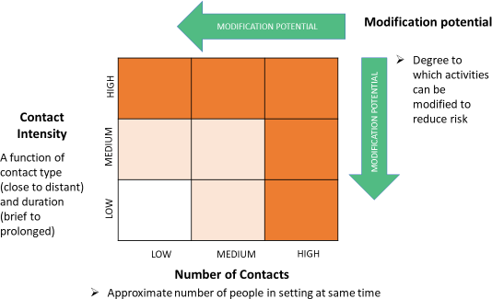

Modifying from high to low can be based on a range of actions:
- Physical distancing measures – to reduce density of people
- Engineering controls – physical barriers, increased ventilation
- Administrative controls – rules and guidelines
- Non-medical masks

Purpose:
To provide guidance for employees returning back to work during the COVID-19 worldwide pandemic.
Scope:
This policy applies to all employees, including exempt staff and Council, CUPE and IAFF members, committee members and volunteers.

Principles:

- STAYING INFORMED
  - Employees are encouraged to stay up-to-date and informed on the pandemic and follow public health advice, as information may change from time to time. Links can be found in the Related Publications section of this document.

- SELF MONITORING:
  - Pre-mitigation, including reporting and self-screening, will help to identify possible COVID-19 positive employees and proactively remove risks that they could inadvertently introduce coronavirus into the workplace.
  - Employees with COVID-19 symptoms must stay home and not come to work for at least ten (10) days, or longer if symptoms have not resolved. As per Healthline BC, after your ten (10) to fourteen
    - day self-isolation, you may return to your regular activities if:
      - At least ten (10) days have passed since any symptoms started, and
      - Your fever is gone without the use of fever-reducing medications (i.e. Tylenol, Advil), and
      - You are feeling better (there is improvement in runny nose, sore throat, nausea, vomiting, diarrhea, fatigue). Coughing may go on for several weeks, so a cough alone does not mean you need to continue to self-monitor and self-isolate, or
      - You were self-monitoring and never developed any symptoms.
  - Employees must also stay at home when sick to avoid spreading illness to others, even if symptoms are not consistent with COVID-19, as you may be non-symptomatic.

- PHYSICAL DISTANCING:
  - Physical distancing reduces the potential of coronavirus being transmitted through airborne droplets. There is a possibility that even non-symptomatic carriers of coronavirus may transmit the virus in this manner, so physical distancing should always be observed, even in cases when people do not display symptoms of COVID-19.
  - Access to (insert here) workplaces should be limited and alternative methods, such as video or conference calls, be used for conducting business to prevent close personal contact
  - Lunchrooms, break rooms, boardroom, reception and common areas will be arranged to follow physical distancing practices. However, employees are discouraged from using these areas whenever possible.
  - Employees should remain on their primary work floor and not visit other floors in the building unless absolutely necessary. Fire department staff should access the lounge and kitchen through the back stairwell. All other staff should access Council Chambers via the main stairwell. Use of the third floor kitchen and lounge is restricted to Fire Department staff.
  - Whenever possible, employees should travel alone in vehicles to ensure physical distancing.
  - Should a task require close personal contact, appropriate PPE and additional mitigation measures should be considered and discussed with your manager.
  - Only essential business travel should be considered until further notice.
  - If there are cases where, in a shared workspace, physical distancing cannot be maintained, a more comprehensive risk assessment should be undertaken in collaboration with the Joint Health and Safety Committee (JHSC). Consideration should be given to the type of task(s), and whether there are alternatives

- PERSONAL HYGIENE (please refer to Operating Procedure OP-22):
  - Employees should practice proper “hand hygiene” techniques often, as it is the single-most effective way of reducing the spread of infection.

  - Proper respiratory etiquette should also be followed.
  - Touching your face, including eyes, nose or mouth should be avoided and hands washed or sanitized following such touching.

- ENHANCED CLEANING/DISINFECTING:
  - Since janitorial services are provided (four (4) evenings a week for Municipal Hall and once weekly for Fire Halls 1 and 2); employees should disinfect common areas and other high touch surfaces before use.
  - Employees should ensure regularly touched surfaces are disinfected frequently within their own workspace(s). Follow the proper procedural guidelines outlined in Operating Procedure OP-22.

- SHARED WORKSPACES/EQUIPMENT INCLUDING VEHICLES:
  - Employees are discouraged from sharing equipment (i.e. pens, phones, other tools).
  - The need to share workspaces and equipment will be minimized.
  - When it is necessary to use a common workstation or piece of equipment, such as photocopiers or cash registers, the surface should be disinfected before and after use. If you are in doubt about the cleanliness of an area or item, employees are encouraged to disinfect the area or item before and after use to reduce the risk of contamination.
  - In the event of a potential COVID case in a shared workspace, workstation or with a person using shared equipment, the station/equipment should not be used until a deep clean can be performed which is to be delegated by the employee’s manager. Follow the proper procedural guidelines outlined in the Operating Procedure OP-22. Employees affected by the deep clean will be accommodated to ensure safety during the cleaning period, which will be delegated by your manager.
  - Limit the exchange of papers. If documents must be exchanged, follow the proper procedural guidelines outlined in the Operating Procedure OP-22.
  - Employees who use municipal vehicles must ensure that high contact surfaces within the vehicle are routinely disinfected. Follow the proper procedural guidelines outlined in the Operating Procedure OP-22.

- PERSONAL PROTECTION EQUIPMENT (PPE)
  - Facial masks and gloves are not mandatory. Facial masks have been recommended for essential health service workers only. If an employee chooses to use a facial mask, they are responsible for supplying their own, for proper disposal or frequent cleaning of them, dependent on which type they choose to utilize.
  - Gloves will be provided and while gloves may provide protection for your hands, they do not prevent of the transfer of coronavirus to other surfaces. Frequent hand washing is mandatory even when wearing gloves.
  - Firefighters will adhere to PPE requirements as specified by BCEHS and shall include fit-tested N95 mask, face shield, and nitrile gloves at a minimum. If COVID-19 symptoms are present, responders shall also wear a non-permeable gown in addition to N95 mask, face shield, and nitrile gloves. Proper PPE donning and doffing procedures, and disposal of PPE shall be followed.

- STRESS/ANXIETY/MENTAL HEALTH AWARENESS
  - Practice self-care. emotional stress, anxiety or concern is natural under the present circumstances. Anyone who feels they are experiencing negative mental health implications should seek assistance as soon as possible.

Documentation and training:

- The Head of Human Resources will train municipal hall employees on the policies, practices, and procedures due to the COVID-19 pandemic and keep records of that training.
- The Fire Chief, or designate, will train Fire Department employees on the policies, practices, and procedures due to the COVID-19 pandemic and keep records of that training.
- If employees have any concerns, they may discuss them with their managers or with the Joint Health and Safety Committee (JHSC).

Schedule for Returning to Work:

All employees are expected to return to the office and their regular work schedule on , 2020 unless they have an alternate agreement approved by their supervisor and CAO. Employees may have concerns with returning to work (i.e. family care, setup of office equipment or may require some other form of accommodation) and should contact their manager immediately to discuss return to work options.

Limited access to (insert here) Hall by the public is expected to commence , 2020 to accommodate tax payments and applications until necessary distancing and/or separation measures are in place.

References:

Policy Number:
Policy Owner:
Endorsed by:
Final Approval:
Date Approved:
Review Date:
Revision Date:
Related Policies, Procedures, Schedules:
Related Publications: | - WorkSafeBC  - BC Centre for Disease Control  - Provincial Government of BC

Contact Information:

Position:

Appendix B: Sample Safe Work Procedure – Pandemic Response

Operating Procedure #

SUBJECT:  Safe Work Procedure – Pandemic Response | SECTION:  Human Resources
Issued by:  Head of Human Resources | CAO signature
Date Issued:

PURPOSE
This Operating Procedure is to provide guidance to employees on the respiratory etiquette on how to minimize the risks during the Return to Work directive while the province is still in a State of Emergency in response to the COVID-19 pandemic. The (insert here) will continue to take direction on initiatives from the Province of BC and at the direction of the Provincial Health Officer.
HAZARDS
During the pandemic response scenario, there is a risk of transmission whenever people come into contact with one another, share close physical space, and touch common surfaces. Pandemic-related hazards include:
  - Physical: touching surfaces that are potentially contaminated with virus particles
  - Biological: inadvertent exposure to a viral contagion or inadvertent contamination of a shared workspace with easily transmissible viral particles
  - Chemical: exposure to disinfectants/nitrile or latex gloves/environmental sensitivities
  - Psycho-social: mental distress/anxiety
EQUIPMENT AND MATERIAL

Type | Criteria/Recommendation
Disposable Antiseptic or Disinfectant Wipes | 70% alcohol or more
Hand Sanitizer or Hand Rub | Alcohol-based hand rub (ABHR) approved by Health Canada or the Province of BC
Microfiber Cloth | n/a
Cleaning solution specific for computer screens | 70% isopropyl alcohol / 30% water solution
Tissues | n/a
Disposable Gloves* | Latex or nitrile based
*for cleaning purposes only and not as PPE

PERSONAL PROTECTIVE EQUIPMENT (PPE)* – not mandatory

Type | Criteria/Recommendation
Facial Masks (disposable or washable) | N95 (paper) or cotton cloth material (hand-sewn)
Disposable Gloves** | Latex or nitrile based
*Emergency responders are to adhere to PPE requirements as specified by BCEHS
**only for those that require them for particular work duties
PROCEDURES
The Operating Procedure ensures that proper steps take place before, during, and after an employee’s shift during a pandemic response. Procedures include requirements for orientation and screening prior to working, actions while at work (hygiene, physical distancing, cleaning, and monitoring) and follow up after work has concluded each day.

MITIGATION STEP | TASK INSTRUCTIONS  Define how each step is to be performed safely, ensuring all hazards are addressed.
SELF-MONITORING | Before entering into a workplace or vehicle, and throughout the day, employees should self-monitor for symptoms associated with COVID-19 by using the BC Health COVID-19 Symptom Self-Assessment Tool located here: https://bc.thrive.health/ and answer the prompted questions, which include:  - Are you experiencing symptoms consistent with COVID-19 (refer to the link above for the most up to date list of symptoms)?  - In the past fourteen (14) days have you been outside of Canada or BC?  - In the past fourteen (14) days have you been in close contact with anyone who is symptomatic or has been diagnosed with COVID-19?  If you answer ‘yes’ to any of the above questions, employees must stay home or if at work, go home immediately and contact their manager for advice.  (Note: As symptoms and information on the pandemic change, other questions may arise in the survey. Follow the advice provided after the survey has concluded and if advised to stay home, notify your manager immediately.)
PHYSICAL DISTANCING* | During all activities, maintain physical distancing from others, including co-workers and members of the public by:  - Remaining two (2)-metres or six (6)-feet apart; and  - Not engaging in any physical contact, such as handshaking.
PERSONAL HYGIENE | Handwashing  Employees should either:  - Wash your hands often with soap and water for at least 20 seconds; OR  - If soap and water are not available, alcohol-based hand sanitizer or rubs (ABHR) can be used to clean hands.

Respiratory
Employees should either:
- Turn their head away from others and cover their mouths with a sleeve (i.e. cough into elbow); OR
- Use a tissue when coughing or sneezing, and immediately after, discard tissue(s) into a garbage receptacle and wash hands
*While Fire fighters are required to maintain physical distancing wherever possible, it is recognized that the nature of their job does not always allow for it.

MITIGATION STEP | TASK INSTRUCTIONS  Define how each step is to be performed safely, ensuring all hazards are addressed.
CLEANING/ DISINFECTING  Note:  It is important to make the distinction between cleaning and disinfecting:  Cleaning refers to the removal of germs, dirt, and impurities from surfaces. It does not kill germs, but by removing them, it lowers their numbers and the risk of spreading infection.  Disinfecting refers to using chemicals, for example, Health Canada-registered disinfectants, to kill germs on surfaces.  Deep Cleaning  By disinfecting (kill germs) on a  surface after cleaning (removal of germs), it can further lower the risk of spreading infection. | Workspaces and Equipment  Employees should follow these steps at least twice daily (i.e. start and end of day) or more often when visibly soiled throughout the day:  - Wash your hands and then using hand sanitizer, disinfect your hands (and put on gloves if you choose to).  - If surfaces are visibly dirty, they should be cleaned using a detergent or soap and  water prior to disinfection (aka “deep clean”).  - Use a disposable antiseptic wipe to disinfect hard non-porous surfaces by wiping the surfaces. These include, but are not limited to:  - keyboard, mouse  - phone, headset  - desktop surfaces  - chair seats and armrests  - cabinet door, drawers  - doorknobs, handles  - light switches  - photocopiers, cash registers and other shared equipment or surfaces  - Carefully dispose of the wipe into a garbage receptacle immediately after use (and remove gloves and dispose of also if you have chosen to wear them).  - Wash your hands with soap and water or an alcohol-based hand sanitizer.  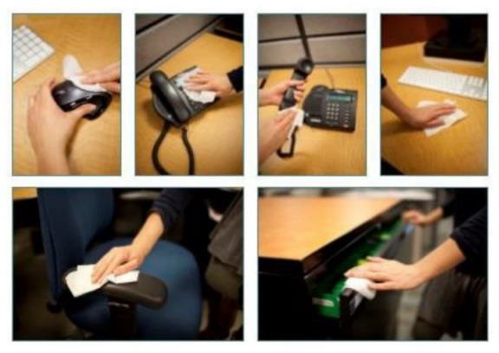

Soft (Porous) Surfaces
- For soft (porous) surfaces such as carpeted floor, fabric chairs, and drapes, remove visible contamination when present and clean with appropriate cleaners appropriate for use for the particular material of which it is made.
- After cleaning, dispose of items (such as cleaning cloth) as appropriate in
accordance with the manufacturer’s instructions.
Note: Never use a soiled or dirty cloth to clean any surface.
MITIGATION STEP | TASK INSTRUCTIONS  Define how each step is to be performed safely, ensuring all hazards are addressed.
CLEANING/ DISINFECTING  (Continued) | Vehicles  Disinfect high-touch areas every time you enter and leave a commonly shared municipal owned vehicle using these steps, (remembering to wear gloves if you choose to following Step 1):  - Using hand sanitizer, disinfect your hands.  - Using a disposable disinfectant wipe open the vehicle door.  - Using the same disposable disinfectant wipe, clean the following non-porous surfaces:  - Steering wheel  - Seatbelt clasp  - Door handles  - Visor  - Switches and knobs  - Seat base and back  - Other areas that are commonly touched  - Carefully dispose of the wipe immediately after use (and remove gloves and dispose of also, if you have chosen to wear them).  - Clean your hands with hand sanitizer.  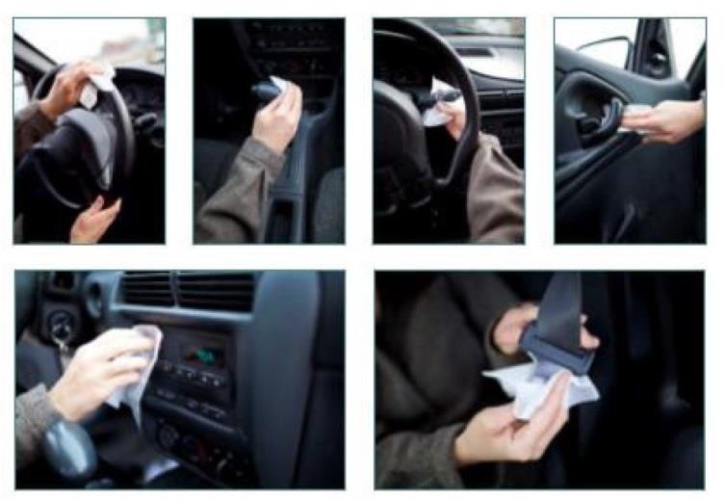

Electronic Screens
This process is for cell phone screens, tablets, touch screens, computer and TV monitors and other sensitive electronic products:
- Moisten a microfiber cloth with a mixture of 70% isopropyl alcohol / 30% water. The cloth should be damp, but not dripping wet.
- Wipe down monitor or computer screen.
- Dry surfaces thoroughly to avoid streaking or pooling of liquids.
MITIGATION STEP | TASK INSTRUCTIONS  Define how each step is to be performed safely, ensuring all hazards are addressed.
Notes:
- Using any material other than a microfiber cloth could cause damage to the product.
- Avoid using any of the following chemicals or products containing these chemicals:
  - Any chlorine-based cleaner, such as bleach
  - Peroxides (including hydrogen peroxide)
  - Solvents such as; acetone, paint thinner, benzene, methylene chloride or toluene
  - Ammonia (i.e. Windex)
  - Ethyl alcohol
SIGNAGE | Each morning front-end employees will set out or ensure the following signage is in place:  a) Post clear signs outside the main doors indicating distancing requirements.
BUSINESS MEETING PROTOCOLS | Employees should conduct business virtually as much as possible (i.e. conference calls, video conferences, email, telephone) with customers/clients and co-workers.  - Besides customers, limit business-related visitors to essential services only. This may include tradespeople, pest control or compliance officers. Schedule visits to eliminate people gathering in reception areas.  - When booking appointments, employees are encouraged to remind customers to reschedule if they become sick or are placed on self-isolation.
STRESS, ANXIETY AND MENTAL HEALTH AWARENESS | Anyone who feels they are experiencing negative mental health implications should seek assistance as soon as possible:  - Review the COVID-19 materials from the (insert here)’s employed health  assistance providers under the Resources section in SharePoint: AND/OR  - Contact the Employee Assistance Program (EFAP) hotline at 1-800-663-1142 AND/OR  - Contact the Head of Human Resources for more information or assistance.
DOCUMENT HANDLING | - Wash or disinfect their hands before and after contact.  - Gloves can be used at the employee’s discretion. Gloves should be properly disposed  of and hands washed or sanitized after removing gloves.

PPE* (not required) | Facial Masks  The use of face masks is recommended by the Public Health Officer for anyone in public spaces. If an employee chooses to wear one, they are responsible for proper disposal or frequent cleaning of them, dependent on which type they choose to utilize. Information for the care and disposal of facial masks can be found on the BC Centre for Disease Control website.  - Fabric masks should be laundered after each day and dried on the highest temperature setting possible. They must be thoroughly dried before re-use.  - Paper masks should be disposed of after each day of use in accordance to the link above.  Disposable Gloves  These are not required unless an employee is conducting first aid or carrying out duties that regularly require the use of them. Gloves are not to be used as replacement for proper and frequent hand hygiene. Wearing gloves may actually  help spread the coronavirus as workers may unintentionally touch something or someone contaminated with the coronavirus with their gloved hand.
* Emergency responders are required to wear PPE in accordance with risk of task and as specified by BCEHS. If a staff member is required to wear a protective mask (N95 or greater), they must be fit tested in accordance with WorkSafeBC and tested annually in accordance with Occupational Health and Safety Regulation 8.4(2.1)

Important Information:
The employee assumes responsibility and risk of infection if they do not follow the guidelines provided in this document.

Procedure Number:
Procedure Owner:
Endorsed by:
Final Approval:
Date Approved:
Review Date:
Revision Date:
Amendments:
Related Policies, Procedures, Schedules:

Contact Person:

Contact Person: Position: Phone:
Email:

Appendix C: Risk assessment for pandemic influenza

The following risk assessment table is adapted from WorkSafeBC Occupational Health and Safety Regulation Guideline G6.34-6. Using this guideline as a reference, and the recommendation from the Public Health Officer, the employer can determine the risk level to workers, depending on their potential exposure in the workplace.

 | Low Risk  Workers who typically have no contact with people infected. | Moderate risk Workers who may be exposed to infected people from time to time in relatively large,  well-ventilated workspaces | High risk  Workers who may have contact with infected patients or with infected people in small,  poorly ventilated workspaces
Hand Hygiene | Yes (washing with soap and water, using an alcohol-based hand rub, or using hand wipes that contain effective  disinfectant) | Yes (washing with soap and water, using an alcohol-based hand rub, or using hand wipes that contain effective  disinfectant) | Yes (washing with soap and water, using an alcohol-based hand rub, or using hand wipes that contain effective  disinfectant)
Disposable gloves | Not required | Not required, unless handling contaminated objects on a regular  Basis | Yes, in some cases, such as when working directly with infected  patients.
Aprons, gowns, or similar body protection | Not required | Not required | Yes, in some cases, such as when working directly with infected  patients.
Eye protection  – goggles or face shield | Not required | Not required | Yes, in some cases, such as when working directly infected  patients.
Airway protection – respirators | Not required | Recommended by not required | Yes (minimum N95 respirator or  equivalent).

Appendix D: Risk Assessment for Office and Field Workers

POSITION | LEVEL OF RISK | CONTROL PROCEDURES
Front Counter Staff Positions -  Municipal Hall | Low to Moderate | Regular and effective hand  Hygiene, face masks recommended
Parks & Recreation facilities Front Counter Clerks, Program  Leaders, Instructors | Low to Moderate | Regular and effective hand hygiene, face masks recommended
First Aid Attendants | Moderate | Regular and effective hand hygiene and PPE (depending on  injury)
Firefighter/First Responders | High | Hand hygiene, disposable gloves, turnout gear, goggles and/or face shield, N95  respirator
Lifeguard | Moderate | Regular and effective hand  Hygiene, face mask if not in water
Supervisors | Low | Regular and effective hand  Hygiene, face masks recommended
General Staff | Low | Regular and effective hand  Hygiene, face masks if in public spaces

OFFICE STAFF
Risk levels posed to office staff are dependent on the level of community transmission, where the workers are located (office or home), whether it is a front facing customer service office usually open to the public or a private office, and the size of staff in the office area. Figure 1 below identified risk levels based on different work type, location and capacity to allow for minimum of 2 meters distance apart.
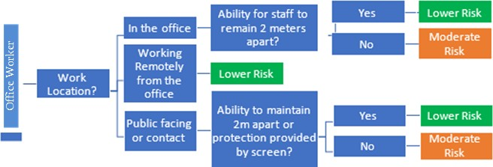

Appendix D Page 2

FIELD STAFF
Risk levels posed to field staff are dependent on the level of community transmission, the work being performed, where the worker is located and the size of the work crew. Figure 2 below identified risk levels based on different types of work type, location, and capacity to allow for a minimum of 2 meters distance apart. Note that in addition to work location, an increased exposure to members of the public (by by-law or inspection staff, for instance) could increase the risk level, and an in-field risk assessment must be performed.

Fig. 2 Field Staff Risk Assessment

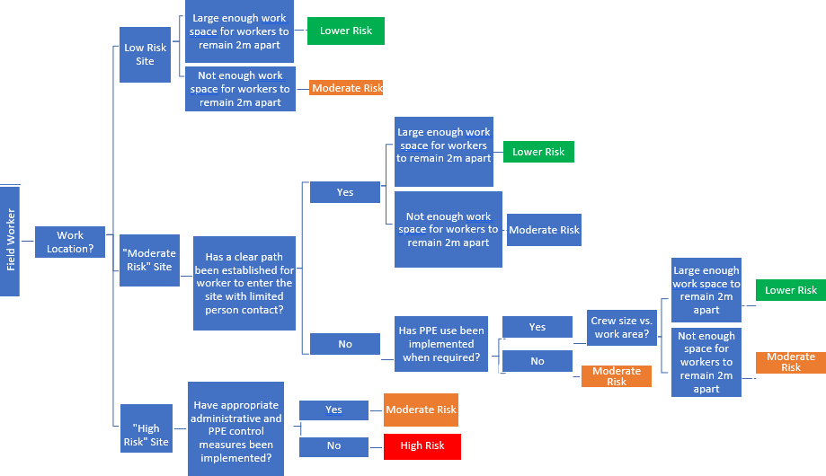

Appendix E: Personal Protective Equipment

Recommended
Optional
Not required

Hazard Risk Factors | Cloth Face Covering/Non-  Medical Mask | Respirator N95 or better (fit tested) | Gloves | Eye Protection: Glasses, Face Shield,  Physical Barrier | Apron/Gown/ Disposable  Coverall
Close Proximity to Co-Workers | Recommended |  |  | Optional – if not able to maintain physical distancing
Close Proximity to Public | Recommended |  |  | Optional – if not able to maintain physical distancing
Close Proximity to Potential Irate Individual – Spitting/Coughing |  |  | Optional |  | Optional
Close Proximity to Sick Persons
Caring for a Sick person
Providing CPR/Procedure Producing Aerosolized Droplets on a Sick Person.
Non medical mask must be
placed on patient.
Entering Private Residence | Recommended |  | Optional – Hand Hygiene mandatory | Optional – if not able to maintain physical distancing | Optional
Cleaning Biohazard/ Splashing
Cleaning Biohazard/ Non-
splashing
Handling Mail/ Packages/ Internal Paperwork |  |  | Optional – Hand Hygiene preferred
Customer Service Counters | Recommended |  | Optional if exchanging documents/ other materials with customers | Optional – if not able to maintain physical distancing or physical barriers are not in place

Appendix F: COVID-19 Screening Tool

COVID-19 Screening Tool

Name (Print) |  | Department
In-Person | Yes No | Telephone call | Yes No
Date |  | Time

If you have traveled outside of Canada (including the United States) within the past 14 days you are not permitted to enter the facility.

Are you experiencing any of the following symptoms with unknown cause?
- Fever | yes | no
- Cough | yes | no
- Shortness of breath | yes | no
- Difficulty breathing | yes | no
- Chills | yes | no
Have you had contact with any person with these symptoms, or under  investigation for COVID-19 in the last 14 days? | yes | no
Office use only
In-person, the person being screened was:
- Unfit for work and sent home | yes | no
- Sent to/back to work | yes | no
- Advised to call 8-1-1 for guidance | yes | no
On the telephone, the person being screened was:  - Instructed to stay at home | yes | no
- Advised to call 8-1-1 for guidance | yes | no
- Advised they can come to work | yes | no
Comments:

Screening completed by:
Print name Signature

Position

Appendix G: Hand Hygiene

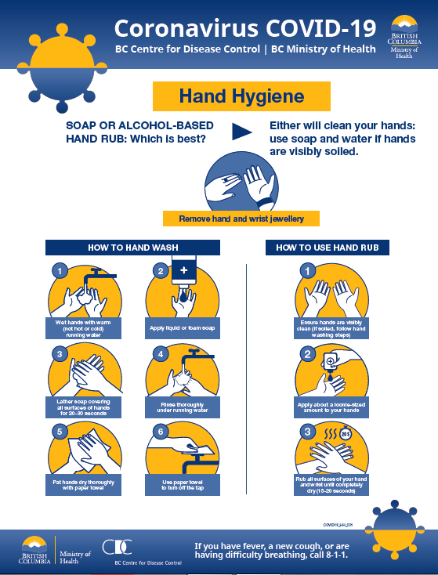

Appendix H: Glove Donning and Removal

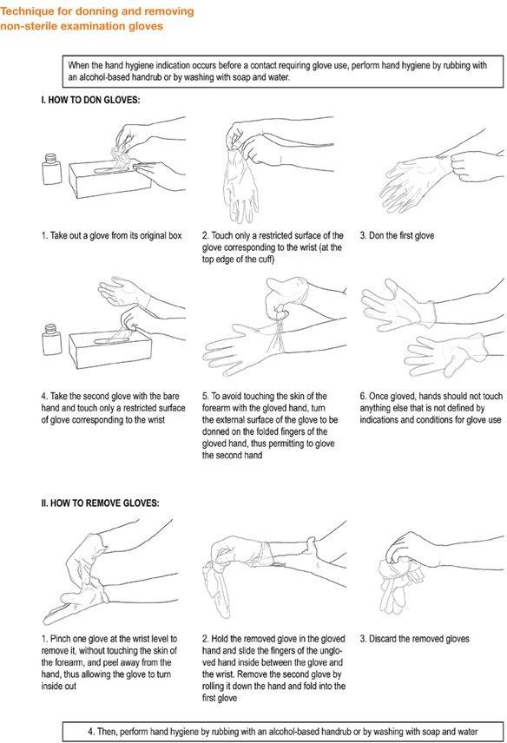

Appendix I: WorkSafeBC Poster: Cover Coughs and Sneezes

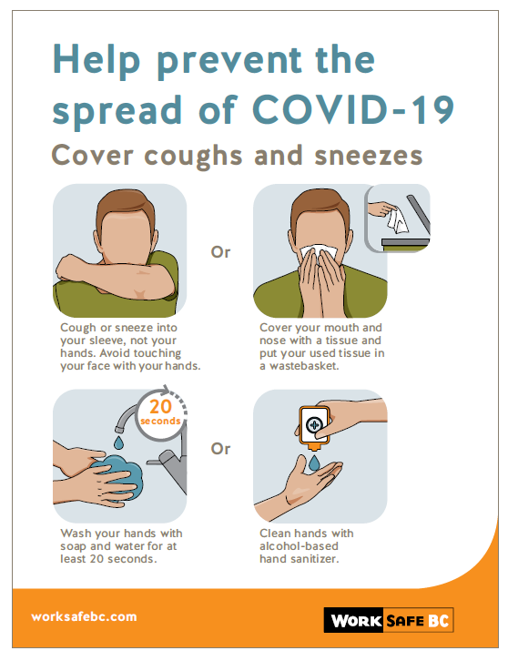

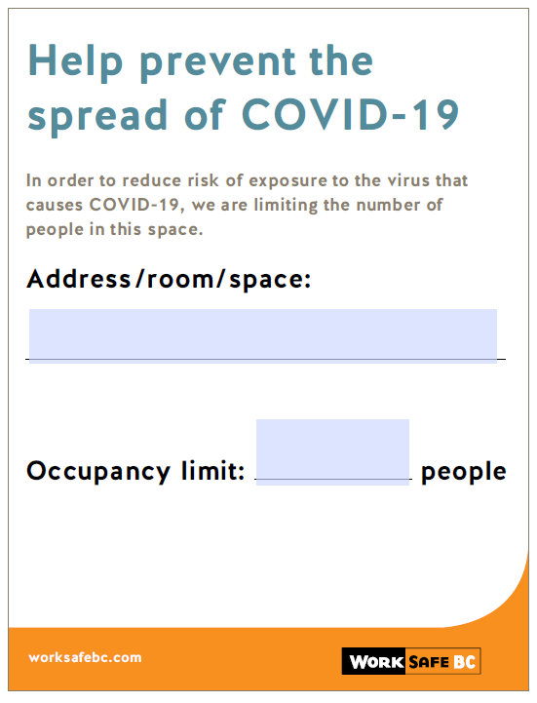
Appendix J: WorkSafeBC Poster: Occupancy Limits

Appendix K: WorkSafeBC Poster: How to use a mask
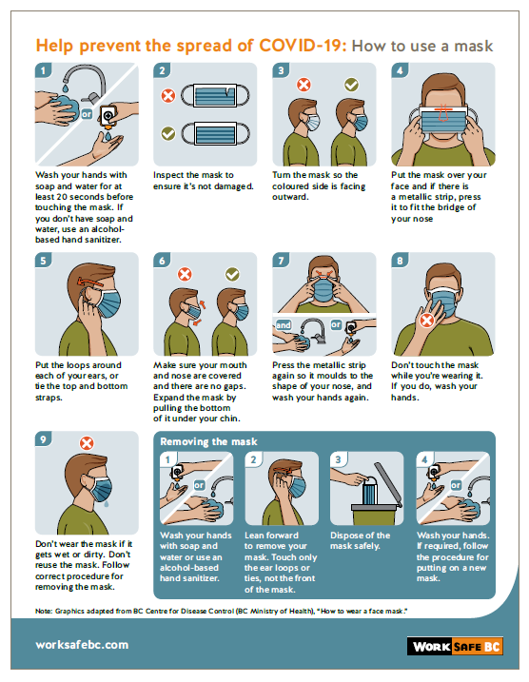

Appendix L: Returning to Safe Operations – Due Diligence Document

(Insert Logo here) | Return to Safe Operations Due diligence Document

Below is information copied from the following WorkSafeBC webpage with additional information completed by (insert your organization here)

Municipalities and COVID-19 safety – from WorkSafeBC website on May 13, 2020
WorkSafeBC is working with workers, employers, and industry associations to ensure municipal worksites remain healthy and safe during the COVID-19 outbreak.
We are providing information to workers and employers through worksite inspections focusing on the controls that the employer can use to limit exposure, including maintaining distance between workers and ensuring adequate hygiene facilities. We are continuing to engage in inspection, consultation, and education activities within the sector to ensure everyone in the workplace is fulfilling their obligations.
For more information from WorkSafeBC, please see:
- Preventing exposure to COVID-19 in the workplace: a guide that employers may use to assess the risks and controls in their workplace.
- COVID-19 health and safety information: general information for all employers and workers about staying safe at work
- Frequently asked questions: answers to questions from British Columbian workers and employers on how to maintain a healthy and safe workplace
Returning to safe operation
The B.C. government has announced a phased approach for reopening B.C. businesses. We are partnering in the initiative by developing specific resources for industries as they prepare to reopen. Learn more by viewing our general guide on COVID-19 and returning to safe operation and answers to frequently asked questions.

Controlling the risk of COVID-19 exposure
Employers must take all necessary precautions to minimize the risk of COVID-19 transmission and illness to themselves, workers, and others at the workplace.
Employers may consider some of the following advice or best practices to reduce the risk of worker exposure to COVID-19:
Background and general information: (Examples, activation of an EOC, COVID-19 information webpage on E-link, etc).
Who should come into the workplace
- Implement a policy requiring anyone with symptoms of COVID- 19 such as sore throat, fever, sneezing, or coughing to self-isolate at home for 10 days from onset of symptoms, as well as anyone advised by public health to self-  isolate. | (Examples, Pandemic COVID 19 Response – Employee Leave, staff Pandemic Leave, FAQs etc.)
- Prioritize the work that needs to occur at the workplace for you to  offer your services. | (Example, a list of essential and critical services)

Physical distancing and other preventative measures
- Stagger start times for  workers to prevent crowding at locations. | (Examples, staggered start times, how they report to work – either going to the yard or site, etc.)
- Eliminate in-person team meetings or  modify them to incorporate technology such as conference  calling and online meetings. | (Examples, conference calling options, in-person meetings taking place in large or open areas with sufficient physical distancing, some staff working from home, etc.)
- Modify work processes and practices to encourage physical distancing between them and customers, clients, and other  workers. | (Examples, closing all municipal facilities to the public, service by appointment only, etc.).
- Provide instructions to workers on methods for maintaining physical distance from customers, clients, and other workers, such as not greeting others by shaking hands, or removing or modifying proof of delivery signature requirements  and money collection requirements. | (Examples, safety talks, posters, procedures, etc.)

 | Cleaning and hygiene
- Ensure workers are provided with appropriate supplies, such as soap and water, hand sanitizer,  disinfectant wipes, nitrile gloves and  garbage bags, and  sufficient washing facilities. |  | (Examples, critical supplies identified and inventories created, etc.)
- Remind staff of effective personal hygiene practices. Add signage about best practices for personal hygiene for customers who may interact with  your workers. |  | (Examples, Special Advisory, posters, signage, etc.)
- Remove shared items where cross- contamination is possible (e.g., shared tools, coffee and water stations and snack  bins). |  | (Example, using disposable products, etc.)
- Enhance cleaning and disinfecting practices in high contact areas like door and cabinet handles, keyboards, light switches, steering wheels, and communications  devices. |  | (Examples, Cleaning risk assessments, cleaning schedules, etc.)
- Incorporate end-of-shift  wipe downs for all shared spaces. |  | (Example, establish a system to identify computer workstations that have been cleaned and disinfected, etc.)

Documentation and training
- Train your staff on changes you’ve made to work policies, practices, and procedures due to the COVID-19 pandemic and keep records of that  training. | (Example, establish corporate system.)
- Ensure that workers can raise safety concerns. This may be through  your joint health and safety committee. | Examples, ensure that staff have a plan to address COVID-19 concerns, set up a communication link etc.)

Worker transportation
- Whenever possible, workers should travel alone in their vehicles in order to practice physical distancing. If that is the case, employers must implement all of the necessary safeguards related to working alone or in isolation, to ensure the safety of these workers.  - Measures that may be taken to ensure appropriate distance include having workers sit one to a seat, with riders staggered to allow maximum distance between them; adjusting the number of workers transported per trip; and increasing the total number of trips needed to transport workers to a worksite. These measures may mean using larger vehicles to ensure maximum spacing or using multiple vehicles.  - If it is not possible to ensure 2 metres of distance between workers in a vehicle through these measures, the employer must consider other control measures,  such as requiring PPE where appropriate. | (Examples, Changes to fleet use establishing one person per vehicle. assessing risk, need and benefits of installing non-rigid impervious barriers, etc.)
- Employers must also implement a process that allows for physical distancing when loading and unloading vehicles. Workers waiting for loading/unloading should  maintain physical distancing while remaining safely away from traffic. | (Example, social distancing plan for unloading/loading vehicles, etc.)
- Employers should have hand washing facilities or  sanitizing stations available to workers as they enter and exit the vehicle. | (Example, Alcohol based hand sanitizer be available, etc.)
- Employers must ensure that high contact surfaces within the vehicle are routinely cleaned. These include seatbelts, headrests, door handles, steering wheels,  and hand holds. | (Examples, Risk assessment for cleaning vehicles, etc.)

Resolving concerns about unsafe work

- Workers have the right to refuse work if they believe it presents an undue hazard.  - An undue hazard is an “unwarranted, inappropriate, excessive, or disproportionate” hazard. For COVID-19, an “undue hazard” would be one where a worker’s job role places them at increased risk of exposure and adequate controls are not in place to protect them from that exposure.  - If the matter is not resolved, the worker and the supervisor or employer must contact WorkSafeBC. Once that occurs, a prevention officer will consult with workplace parties to determine whether there is an undue hazard and issue orders if necessary.  - For more information, see Occupational Health and Safety Guideline G3.12. | .

