Best Practice - Physical distancing for our inside environments
Physical distancing requires us to make changes to our everyday routines and to minimize close contact with others. This means keeping approximately 2 metres distance between ourselves and others (Source: WorkSafeBC).
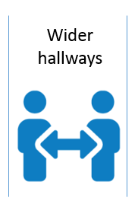
Hallways, walkways and stairways
- Wider hallways allow two individuals to pass each other while maintaining physical distance. As noted above, we are to maintain approximately 2 metres distance between ourselves and others. This means that wider hallways can still accommodate two individuals even if there is not a full two metres separation, as long as individuals do not congregate. To avoid congregation and congestion in hallways, conversations should be moved to open areas (e.g. lobby, meeting room, outdoors). If this is not possible, the two individuals should move to the same side of the hallway, maintain physical distancing, and open the other side of the hallway or walkway for others to use.
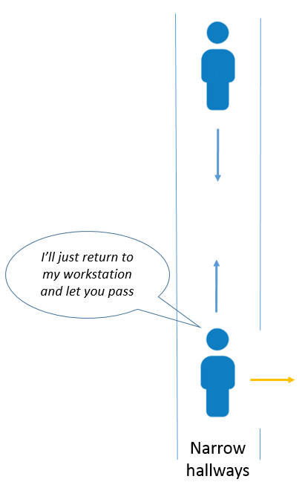
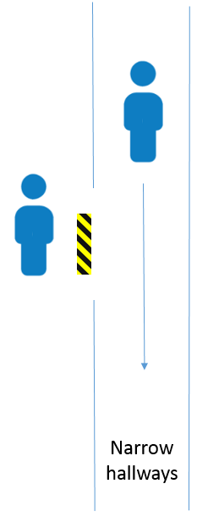
- Narrow hallways or walkways do not have sufficient space for two individuals to pass each other while maintaining physical distancing. If necessary, these hallways can be marked with a “1” using yellow and black floor tape, noting one person at a time.

- Staff exiting workstations or offices are encouraged to pause, look both ways and then proceed into hallways or walkway. Yellow and black floor tape can be placed at the end of workstations or offices as a reminder.

- In narrow hallways, where the path of two individuals cross, staff are encouraged to converse with their colleague to successfully navigate the hallway. This may mean one person backtracks to where they started or into an open area, providing the other person with the ability to pass.

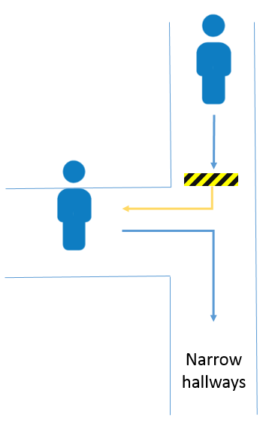
- If the path of two individuals cross at an “intersection” or corner, staff are asked to pause and wait for the other person to clear the area, prior to proceeding. In some situations, yellow and black floor tape can provide helpful visual cues.

- When using walkways adjacent to workstations, try to walk in a manner that provides the greatest physical distancing possible.

- A similar approach as outlined above for hallways and walkways is recommended for narrow stairways, however the use of yellow and black tape is not recommended on stairs.

- Staff are encouraged to work together rather than establishing a designated direction of travel in narrow hallways, walkways and stairways.

- When facilities re-open to citizens, there may be a need to establish a designated direction of travel considering that these individuals infrequently move through the facility.

Transaction counters and service points

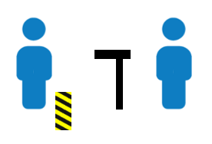
- Depending on the service provided, some transaction counters and service points can operate with physical distancing and no other risk control measures. Yellow and black floor tape can provide helpful visual cues. If use of the transaction counter is required, the staff members may be able to maintain physical distancing by moving back, allowing the person to use the transaction counter. Verbal cues can be used to inform the person when they should approach the transaction counter.
Remember that physical distancing means keeping approximately 2 metres distance between ourselves and others and that outstretched arms provide approximately this distance. This means that staff can pass lightweight items (such as paper) to others using an outstretched arm as long at the item is received with an outstretched arm. For heavier items, staff are encouraged to place the item down, step back and verbally cue the other person to pick up the item.
- Some transaction counters and service points may require additional risk control measures such as transparent barriers or counter extensions. Barrier should be at least 207 cm (81.5”) in height is sufficient as it represents the nose height of the 95th percentile male plus the 30 cm (12”) breathing zone.
- Barriers need to be wide enough to account for the normal movement of both people.
Workstations
- Physical distancing means keeping approximately 2 metres distance between ourselves and others. This distance should be measured from the head or facial area of one staff member to the head or facial area of another considering the areas that they are most likely to be working in (e.g. in front of computer or in areas of desk where paperwork is completed, handled or sorted).
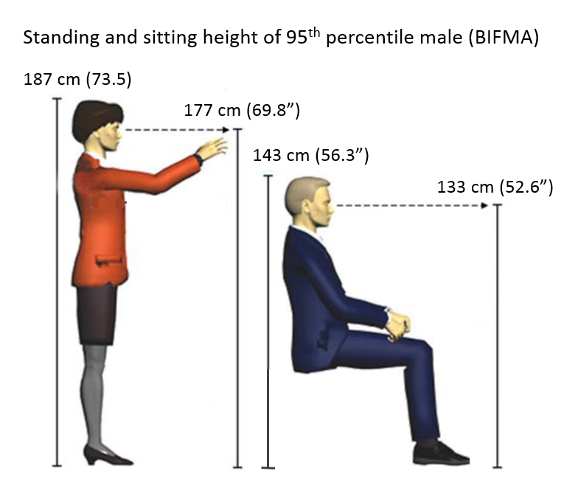
- Less than approximately 2 metres can separate spaces if there is a partition or barrier that separates the workstations:
  - If both individuals normally sit while working and there is not sufficient physical distancing, a partition or barrier between 133 cm (52.6”) and 143 cm (56.3”) in height is sufficient as it represents between eye height and top of head while sitting for the 95th percentile male.
  - If one or both of the individuals stand(s) while working and there is not sufficient physical distancing, a partition or barrier between 177 cm (69.8”) and 187 cm (73.5”) in height is sufficient as it represents between eye height and top of head while standing for the 95th percentile male.
- In areas where a walkway is adjacent to a workstation and where there is less than approximately 2 meters, the frequency and duration of foot traffic should be considered.
  - If foot traffic is infrequent (less than 15 minutes cumulative in the day), the partition or barrier can be at the sitting height noted above.
  - If foot traffic is frequent (greater than 15 minutes cumulative in the day), or if people tend to pause (e.g. to use a photocopier) or congregate, the partition or barrier should be at the standing height noted above.
  - For offices location on a corner where two hallways intersect or at the end of a series of workstations, foot traffic should be considered as above when determining the partition or barrier height.
  - The above takes into consideration risk information from BC Centre for Disease Control that describes walking by someone as a low risk or no risk activity.
- For workstations that share a common entry point, a partition or barrier should be considered if there is less than approximately 2 metres between the entry point and the areas that staff are most likely to be working in. Yellow and black floor tape can be used to cue staff to enter using the pathway that provides the best possible physical distancing. Additionally, as discussed in the Hallways, walkways and stairways section above, staff are encouraged to converse with each other to successfully navigate the entry point. This may mean that one person slides within their workstation to allow the other person to enter. Foot traffic should be considered as above when determining the partition or barrier height. Alternately, it may be possible to reconfigure the workstations as discussed below.
- Staff should be encouraged to congregate in more open areas rather than in hallways, walkways or adjacent to workstations.
Configuration of workstations
Some workstation configurations provide unique challenges for physical distancing. Below we address some of these and provide potential solutions:
- Multiple workstations in one area and the need to converse.

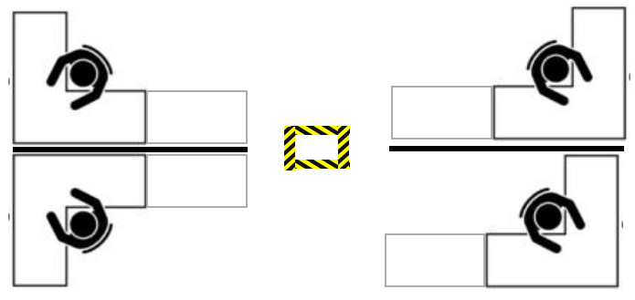
Recommendation: to measure between workstations to determine the best place for standing. This spot can be designated by creating a box with yellow and black floor tape and be used for speaking with any of the individuals.

- Workstations configured with open communal space in middle.

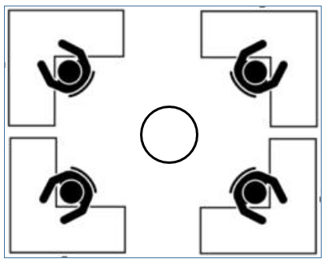
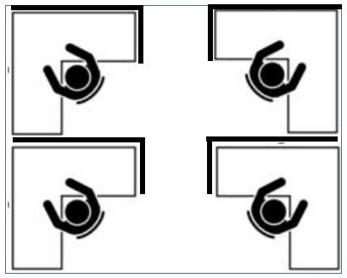
Recommendation to see if furniture can be reconfigured to allow use of all workstations with the addition of barriers or partitions. This may require some furniture to be temporarily relocated

- Open workstations adjacent to walkway within office.

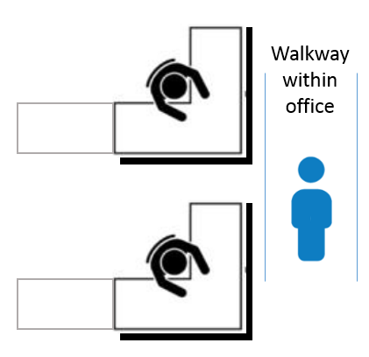
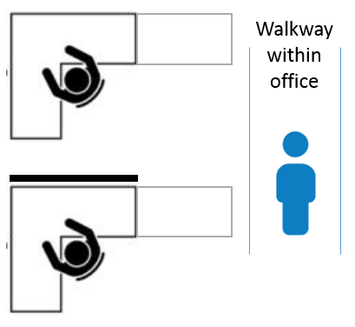
Recommendation to add barriers or partitions to create separation. Alternately, explore to see if workstations can be re-oriented to allow more distance between walkway and the areas that are most likely used for work (e.g. in front of computer or in areas of desk where paperwork is completed, handled or sorted).
Or

- There are many other configurations and every effort should be made to use as many workstations as possible, while still adhering to physical distancing.

- Options to reconfigure workstations should consider physical distancing, ergonomics, work flow, access to common areas (e.g. photocopier), phone and data access points, emergency egress and any challenges posed by the reconfiguration.

- Reconfiguration could result in staff moving into different workstations or areas within the office environment. The impact on the frequency and duration of foot traffic and conversations in hallways and pathways (considering physical distancing) should be considered.

- For any workstations that are not being used, departments are asked to contact Facilities and/or Occupational Health and Safety to discuss options. This allows us to maximize the number of available workstations.
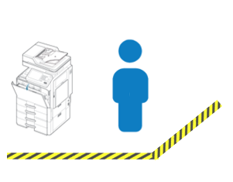
Common areas
- It may be beneficial to establish a 1-at-a-time approach for some common areas. Alternately someone can be designated to distribute materials
- Adding yellow and black floor tape to delineate these areas can be helpful.

Other considerations:
- Staff are reminded to wash their hands often with soap and water for at least 20 seconds. If soap and water is not available, alcohol based hand sanitizer can be used to clean hands as long as they are not visibly soiled.
- Staff are reminded to not touch their face, eyes, nose or mouth.
- Surfaces (including high touch surfaces) are cleaned and disinfected using a product approved by Health Canada or the BCCDC at the frequency determined by the Risk Assessment for Cleaning approved by the Emergency Operations Centre.
- Building ventilation should be considered so as to determine the best practices to support staff health and safety.
- Signage/visual cues and continued communication are needed to support physical distancing.
Questions regarding current workstation configurations should be referred to the Manager or Director for initial response. For additional information and assistance related to this Corporate Standard, please contact Occupational Health and Safety and/or Facilities.
This corporate standard has been created in the absence of other guidance from WorkSafeBC, BC Centre for Disease Control, Provincial Health Officer or Local Health Authority. If a similar document is published by an agency noted above, this document will be updated accordingly.

References used:
WorkSafeBC COVID-19 information and resources – Staying safe at work; Physical distancing section
https://www.worksafebc.com/en/about-us/covid-19-updates/health-and-safety/staying-safe-at-work
WorkSafeBC COVID-19 and returning to safe operation
https://www.worksafebc.com/en/about-us/covid-19-updates/covid-19-returning-safe-operation
WorkSafeBC COVID-19 health and safety: Designing effective barriers
https://www.worksafebc.com/en/resources/health-safety/information-sheets/covid-19-health-safety-designing-effective-barriers?lang=en&origin=s&returnurl=https%3A%2F%2Fwww.worksafebc.com%2Fen%2Fforms-resources%23sort%3D%2540fcomputeditemdatefield343%2520descending%26f%3Alanguage-facet%3D%5BEnglish%5D%26tags%3DCovid-19%7Ca96b6c96607345c481bb8621425ea03f
Ergonomics and Design: A Reference Guide (2006); Openshaw, S. and Taylor, E.
https://ehs.oregonstate.edu/sites/ehs.oregonstate.edu/files/pdf/ergo/ergonomicsanddesignreferenceguidewhitepaper.pdf
Navigating What’s Next: the Post-COVID Workplace (2020; Edition 1); Steelcase Inc.
https://www.steelcase.com/postcovid/
Interim Guidance: Public Health Management of cases and contacts associated with novel coronavirus (COVID-19) in the community (April 17, 2020); BC Centre for Disease Control
http://www.bccdc.ca/resource-gallery/Documents/Guidelines%20and%20Forms/Guidelines%20and%20Manuals/Epid/CD%20Manual/Chapter%201%20-%20CDC/2019-nCoV-Interim_Guidelines.pdf

