AQUATICS
POOL SAFETY PLAN
Prince George Aquatic Centre
Four Seasons Leisure Pool
COVID-19 Safe Operations

Staff Training Plan 5
Staff Health and Hygiene 6
Facility Admission & Access 9
Occupancy Limits – Dry Spaces – Maximum 40 public, up to 10 staff 11
Occupancy Limits – Pool Spaces 12
Disinfection Procedures 13
Aquatic Programming 16
Safety Education & Rule Enforcement Guidelines 19
Lifeguard Rescue-Ready Assessments 20
Lifeguard Safety Supervision Zones 21
Lifeguard Personal Protective Equipment 23
First Aid Procedures 26
References 31

Staff Training Plan
Category: COVID-19 Procedures
Approved by: Aquatic Manager: May 2020
Revised:
Procedure

Online Staff Training
The City of Prince George designed a blended learning staff training to re-activate staff prior to returning to work in Aquatics.
Online Training Topics – www.princegeorgeaquatics.thinkific.com
- Session 1: Staff Safety (All staff)
- Session 2: Facility Admission & Access (All staff)
- Session 3: Aquatic Programming (All staff)
- Session 4: Disinfection (All staff)
- Session 5: Safety Education (Lifeguards only)
- Session 6: Rescue-Ready Assessment (Lifeguards only)
- Session 7: Safety Supervision Zones (Lifeguards only)
- Session 8: Lifeguard Personal Protective Equipment (Lifeguards only)
- Session 9: First Aid Procedures (Lifeguards only)
- Session 10: Staff Awards (Lifeguards only)
In-Person Training Topics
- Rescue-Ready Assessment (Lifeguards only)
- Personal Protective Equipment (All staff)
- First Aid Procedures (Lifeguards only)
- Cleaning Procedures (All staff)
- Cleaning Chemicals (Maintenance only)
- Front Desk Procedures (Cashiers only)
All training must be documented and signed by both staff member and supervisor.

Staff Health and Hygiene
Category: COVID-19 Procedures
Approved by: Aquatic Manager: May 2020
Revised:
Procedure

COVID-19 Health Assessment
To avoid transmission between employees and bathers, every employee suspected or confirmed to have contracted COVID-19 must stay home.
Staff are required to verbally declare to their supervisor that they are symptom-free at the start of their shift.
Staff COVID-19 Self-Assessment
Any employee experiencing respiratory illness similar to the flu or a cold such as fever, chills, cough, shortness of breath, sore throat and painful swallowing, stuffy or runny nose, loss of sense of smell, headache, muscle aches, fatigue or loss of appetite should stay home from work and start to self-isolate immediately. Contact the Northern Health COVID-19 Information line at 1-844-645-7811 for advice. Follow the advice you receive and inform your supervisor.
It is likely that you will be required to self-isolate at home for a minimum of ten days from the onset of these symptoms and to stay home until these symptoms are completely resolved. If you are advised to be tested for COVID -19 and your test result is negative, you must continue to isolate until your symptoms are resolved.
Sick Workers
- Sick workers should report to first aid, even with mild symptoms.
- Sick workers should be asked to wash or sanitize their hands and provided with a mask, and isolated. Ask the worker to go straight home and call the COVID-19 information line for further guidance related to testing and self-isolation.
- If the worker is severely ill (e.g. difficulty breathing or chest pain), call 911.
- Clean and disinfect any surfaces that the ill worker has come into contact to.
Daily records are kept of staff who work together in the event there is a need for contact tracing on the part of the Medical Health Officer.

Hygiene
Hand Hygiene
Employees must wash their hands upon entry to the building and before and after:
- Eating
- Breaks
- Smoking
- Blowing one’s nose, coughing, or sneezing
- Using the toilet
- Being in contact with animals or pets
- Using shared equipment
- Providing routine care for customers needing assistance or first aid
Face Masks
- Aquatics will provide disposable 3-layered surgical masks for staff procedures.
- Staff should wear face masks if physical distancing cannot be maintained with other staff members.
- At this time, wearing a face mask at all times in the facility is not mandatory. This will be updated according to provincial health recommendations.
- Masks can become contaminated on the outside when touched by hands so employees should avoid touching or adjusting them often.
- Masks that become wet, soiled, or damaged are less effective and must be replaced immediately.
- Masks must be put on and taken off correctly, including not touching the front of the mask and washing hands before/after application and removal.
- Never share masks with others.
Personal Hygiene
- Avoid physical greetings such as handshakes and hugs.
- Employees must practice good hygiene throughout their shift including proper hand washing and cough/sneeze etiquette.
- There should be no sharing of cigarettes or vaping equipment.

Keeping Shared Spaces & Equipment Clean
Shared Staff Change Rooms
- Staff should arrive dressed in their uniform.
- A maximum of two staff in the change room. Physical distancing must occur at all times.
- Personal items brought in (e.g. bags, shoes, jackets) must be kept to a minimum.
- If personal items are in the change room, adequate space must be between each staff member’s items to encourage physical distancing.
- All belongings must be brought home at the end of each shift.
- Lockers must be emptied and disinfected at the end of each shift.
Shared Equipment
- Equipment and tools must not be shared between employees (PPE, fanny packs, whistles, keys, etc.).
- Lifeguards should only use one rescue tube per shift. Disinfect the rescue tube before and after the shift. If a rescue tube must be shared, it must be disinfected between use.
- Clean staff room table before and after each use.
- Do not share cups, glasses, or utensils.
- Avoid sharing common objects (e.g. pens).
- Uniforms should be washed at home at the end of each shift.
.

Facility Admission & Access
Category: COVID-19 Procedures
Approved by: Aquatic Manager: May 2020
Revised:
Procedure

Facility Admission
Prince George Aquatics is implementing the following facility admission protocols:
- At the entrance, signs are installed to inform patrons that:
  - Patrons must not enter if they suspect they have COVID-19 or if they have any of the known COVID-19 symptoms.
  - Patrons must maintain physical distance of 2 metres from other patrons and staff
  - On arrival, patrons must wash their hands with soap and water or use hand sanitizer.
  - Avoid aquatic facilities if patrons are at high-risk of COVID-19 contraction or severe illness.
- Patrons are encouraged to shower at home prior to entering the facility and to arrive in their bathing suit to limit time spent in the change rooms.
- Employees located at the front desk are protected by a plexiglass barrier. Employees should wear gloves while handling cash and locker tokens.
- Patrons must self-apply wristbands if required by age/swimming ability.
- A reservation system and swim time limitations are in place to avoid crowd gathering and wait times.
- Occupancy limit of 40 public and up to 10 staff.

Facility Access
- Facility access is provided with separate entry and exit points at the main entrance with a barrier ensuring physical distancing.
- Signage, floor markings and barriers are installed to guide patrons in and out of the building.
- Physical markers are installed on the lobby floor which indicate two metre physical distancing for patrons waiting in line.
- Signage and barriers are installed in the change rooms to encourage physical distancing.
- Lockers are spaced out to encourage physical distancing.
- Occupancy limits posted for all public and staff spaces.
- Staff visitors are prohibited.
- Staff must leave the building immediately after their shift ends.

Occupancy Limits – Dry Spaces – Maximum 40 public, up to 10 staff
Public Spaces | Maximum Occupancy
Men’s Change Room | 8
Women’s Change Room | 9
Universal Washrooms (2) | 1
Men’s Public Washroom | 1
Women’s Public Washroom | 2
Northwood Room | 8
Weight Room | 4
Proshop | 2
Staff Spaces | Maximum Occupancy*
Maintenance Rooms (2) | 1
Front Desk | 2
Offices (3) | 1
First Aid Room | 1
Guard Room | 3
Lunch Room | 2
Men’s Staff Change Room | 2
Women’s Staff Change Room | 3
Guard Tub | 1
Main Storage Room | 3
Wave Storage Room | 2
Deck Storage Rooms | 1
Timing Room | 2
*Staff spaces can have higher occupancy if a surgical mask is worn where 2m physical distancing cannot be maintained

Occupancy Limits – Pool Spaces
Pool Spaces | Maximum Occupancy
Main Pool (Adult/Senior Swim Set-up) | 16 (8 on each side, 1 max per lane)
Main Pool (Everyone Welcome Set-up) | 28 (14 on each side; 1 max per lane; 10 max per open space)
Wave Pool | 35 (1 max in the river)
Hot Tub | 3

Disinfection Procedures
Category: COVID-19 Procedures
Approved by: Aquatic Manager: May 2020
Revised:
Procedure
The disinfection procedures listed are in response to the COVID-19 pandemic. These cleaning measures are in addition to regular facility cleaning procedures which are located in Section 4 of the Pool Safety Plan.

Personal Protection
The risk of exposure to cleaning staff is inherently low, however cleaning staff should wear disposable gloves and appropriate PPE for all cleaning tasks, including handling trash. PPE should be removed carefully to avoid contamination of the wearer and surrounding area. Work uniforms should be washed after each shift.

Cleaning Procedures
Surfaces frequently touched by hands are most likely to be contaminated. These include doorknobs, handrails, light switches, cabinet handles, faucet handles, tables, countertops, and electronics. These areas are high priority cleaning areas within the facility.
Lockers and cubbies used by pool patrons/employees to store personal belongings are cleaned and disinfected between use.
Prince George Aquatics has created a detailed cleaning log which includes where, what, and how often cleaning is occurring. Log sheets and procedures are posted in the lobby maintenance room and are completed/signed off each time cleaning occurs.
Cleaning occurs in the change rooms every hour and cleaning/disinfection occurs during the designated cleaning blocks throughout the operational day/after-hours.
Cleaning/disinfection occurs after every 2-2.5 hour swim session.

Chemicals Used for Disinfection/Cleaning.
Product | Application | Who can Use | PPE | Dwell Time | Rinse | Mop/Bucket Colour
Daily Dual Disinfectant | Mop, trigger spray bottle, auto scrubber, pump sprayer | Maintenance, lifeguards | Goggles, gloves | 10 minutes | Rinse with water after 10 minutes | Blue bucket/green mop head
Sanibet Multi-Range (Disinfectant, Sanitizer, Deodorizer) | Mop, trigger spray, pump sprayer | All staff, Public | Staff – Gloves, goggles | 10 minutes | Optional | N/A
Velocity (Degreaser, Deodorizer) | Mop, trigger spray bottle, | Maintenance | Safety glasses, gloves | 3-5 minutes | Remove thoroughly after applied | Yellow bucket/blue mop head
Green Earth Glass Cleaner | Trigger spray bottle | Maintenance, lifeguards | Goggles, gloves | Not needed | Not needed | N/A
Green Earth Restroom Cleaner | Pump sprayer, trigger spray bottle | Maintenance | Safety glasses, gloves | 4-6 minutes | Remove thoroughly after applied | N/A
Assignment of Disinfection/Cleaning Tasks – Cleaning blocks (Reference Document #548019, Cashier cleaning #548190)
Staff | Change Rooms | Washrooms | Lobby | Weight Room | Staff Areas
Lifeguards | Showers, benches, change tables, walls, lockers, garbage containers, partition walls, door handles, counters, mirrors, soap dispensers, sinks, paper dispensers | Walls, sinks, doors, garbage containers, grab bars, mirrors, paper dispensers, soap dispensers | Door handles, vending machines | All equipment, floor, mirrors | Staff change room, Guard room
Maintenance | Floors, garbage, toilets, urinals | Floors, garbage, toilets, urinals, partitions, walls, doors, counters, sinks, floors | Public washrooms, floor
Cashiers |  |  |  |  | Admin areas, electronics, Lunch room

Assignment of Disinfection/Cleaning Tasks – After-hours (Reference Document #548033; Cashier cleaning #548190)
Staff | Change Rooms | Washrooms | Lobby | Weight Room | Staff Areas
Lifeguards | Showers, benches, change tables, walls, lockers, garbage containers, partition walls, door handles, counters, soap dispensers, mirrors, sinks, paper dispensers, floors | Walls, sinks, doors, garbage containers, grab bars, mirrors, paper dispensers, soap dispensers | Door handles, vending machines | All equipment, floor, mirrors | Staff change room, Guard room
Maintenance | Floors, hosing, showers, toilets, urinals | Floors, toilets, urinals | Public washrooms, floor
Cashiers |  |  |  |  | Admin areas, electronics, Lunch room

Aquatic Programming
Category: COVID-19 Procedures
Approved by: Aquatic Manager: May 2020
Revised:
Procedure

General
- Bather loads are reduced to allow appropriate physical distancing.
- Signage installed at the entrance to inform patrons that:
  - Users should not spit, urinate, or blow their nose in the water.
  - People at higher risk of COVID-19 should not participate in programmed activities.
  - Patrons should not share water bottles, towels, goggles, or any other equipment.
  - Water bottles should be filled at home.
  - The use of goggles is encouraged to avoid mucus contamination.

Patron Equipment
- There is no current evidence that COVID-19 survives in chlorinated pool water. There are no special disinfection procedures to put in place for equipment that is regularly in contact with chlorinated water.
- Snorkels are prohibited.
- Only essential equipment (PFD’s) are available for public.

Aquatic Programs
All aquatic programs are cancelled until further notice:
- Swimming lessons
- Aquafit
- Birthday parties
- Leadership courses
- Swim club rentals
Programs will resume in accordance with provincial health recommendations.

Public Swim Schedule
- Prince George Aquatics is offering an alternate swim schedule to limit the number of patrons in the building to 40 during a swim session.
- Booking is done either online or over the phone through PerfectMind software.
- Aquatics will retain all basic contact information of group attendees in the event that there is a need for contact tracing on the part of the Medical Health officer.

Lane/Lap Swimming
To maintain physical distancing of 2 metres, a maximum of (1) person or (1) family/household unit should be in a lane at one time.
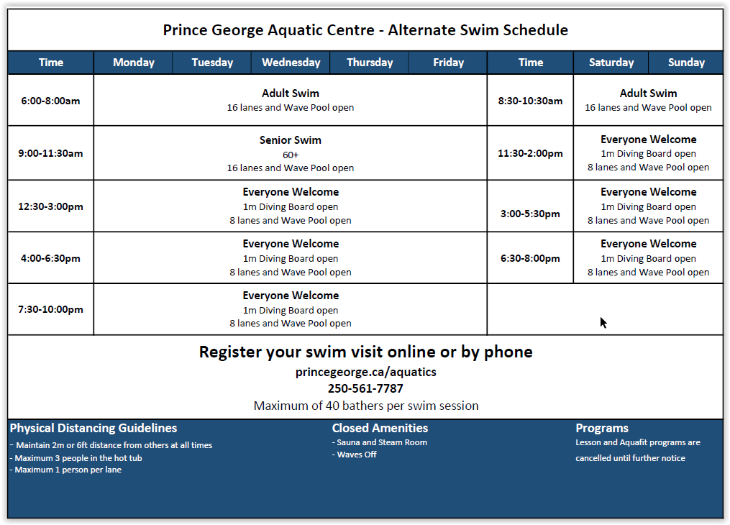

Aquatic Amenities
Diving Boards
- Floor markings installed to indicate physical distancing measures for line-ups.
- Clean all touch points as usual.
Sauna/Steam Room
- Saunas and steam rooms present a higher risk of COVID-19 transmission due to:
  - Design makes it more difficult to maintain appropriate physical distancing.
  - Challenging surfaces to keep clean and disinfected.
  - Potential for COVID-19 to be spread when patrons touch common surfaces.
- The sauna and steam room will remain closed until further notice.
Hot Tub
- Reduced bather load (maximum 3 patrons) to encourage physical distancing.
Water Features
Water features will be assessed per swim and closed if needed to encourage physical distancing.
- Waves turned off to encourage physical distancing

Safety Education & Rule Enforcement Guidelines
Category: COVID-19 Procedures
Approved by: Aquatic Manager: May 2020
Revised:
Procedure

Safety Education and Rule Enforcement
- When providing information to customers about new rules and COVID-19 guidelines, it is important for staff to remember that not all customers may be initially accepting of the new protocols.
- Aquatic staff should be patient and take a customer-focused approach to safety education. We’re Here to Help!
- When possible, lifeguards should maintain physical distancing while providing effective and consistent rule enforcement and accident prevention.
- Lifeguard staff performing safety supervision should not be engaged in any other activity.

Applying the Guidelines
- Prior to entering the facility, educate the public on new admission standards using signage, including health questions and their responsibilities regarding physical distancing from non-family members for all activities and while using all facility amenities.
- Educate patrons concerning one-way traffic measures around the facility.
- Educate patrons on measures put in place to avoid crowd gathering such as waiting lines for recreational equipment.
- Educate patrons about not sharing personal equipment such as water bottles, towels, goggles, etc.
- Lifeguards should maintain physical distancing while providing effective and consistent rule enforcement and accident prevention.
- Lifeguards should maintain physical distancing when providing information to other team members.
- Aquatic staff should follow and maintain new protocols regarding disinfection of common contact surfaces throughout the day.

Lifeguard Rescue-Ready Assessments
Category: COVID-19 Procedures
Approved by: Aquatic Manager: May 2020
Revised:
Procedure

Rationale
After an extended period of absence from work, aquatic staff must be ready to provide effective safety supervision and demonstrate competency in rescue techniques.
A rescue-ready assessment does not replace the need for a National Lifeguard Pool Option recertification or a Standard First Aid/CPR-C/AED recertification.
Rescue-Ready Assessments:
*No person-to-person contact is permitted
- Object recovery: starting in the water, swim 15m and surface dive to recover a 20lb object; surface and carry object 5m.
- Demonstrate anaerobic fitness: starting in the water, swim 50m head-up.
- Demonstrate effective management of a distressed or drowning victim (using a training manikin) in deep water.
- Demonstrate effective management of a submerged, non-breathing victim (using a training manikin) and perform 10 cycles of CPR on a CPR manikin.
- Demonstrate endurance and strength: starting in the water, swim to recover a submerged manikin located 25m away; carry the manikin 25m.
- Demonstrate effective management of a suspected spinal-injured victim: Enter and approach a face-down victim (using a training manikin), roll victim over, immobilize and carry 15m.
*All assessments signed off by employee and supervisor.

Lifeguard Safety Supervision Zones
Category: COVID-19 Procedures
Approved by: Aquatic Manager: May 2020
Revised:
Procedure
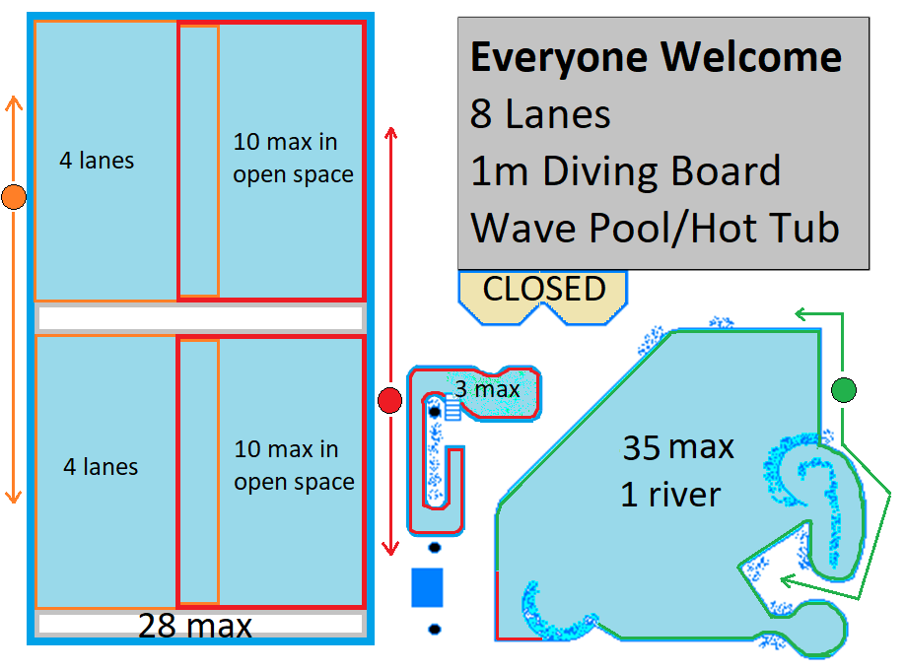
Everyone Welcome Swim Zones & Set-up

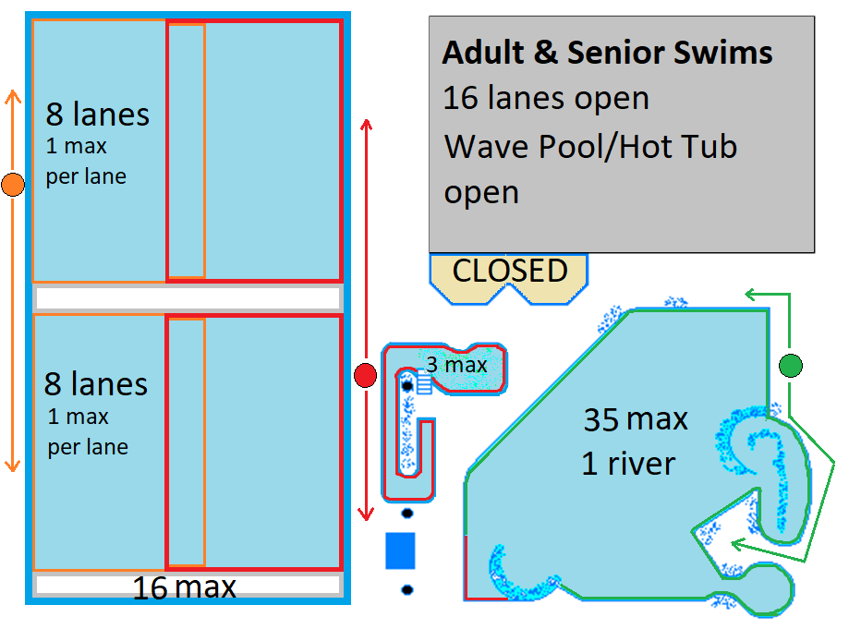
Adult and Senior Swim Zones & Set-up

Lifeguard Personal Protective Equipment
Category: COVID-19 Procedures
Approved by: Aquatic Manager: May 2020
Revised:
Procedure

Types of PPE used for First Aid
- Surgical mask (3-layered): Reduces transmission of aerosol by 50% and protects from contracting aerosol route infection from others by 75-80%. Surgical masks must be dry to be effective.
  - Masks and face coverings are prohibited in the water.
- Eye protection: Face shields or personal protective goggles prevent virus exposure of the eye mucosa. Protective goggles must fit the user’s facial features and be compatible with respiratory protection. Eye protection may be used once disinfected.
  - Corrective eye lenses and safety glasses are not approved PPE and should not be used for first aid purposes.
- Body protection: Long-sleeved water-resistant gowns should be used when performing high-risk first aid treatment. Practice personal hygiene following use.
- Bag-Valve-Mask (BVM) with viral filter: The viral filter or high-efficiency particulate air (HEPA) filter minimizes the risk of the virus spreading during ventilations. Viral filters must remain in their original packaging and remain dry to be effective.
- Most PPE is required to remain dry to be effective.

NO CONTACT | DIRECT CONTACT
2m physical distancing maintained | LOW RISK (Non-aerosol generating)  2m physical distancing not maintained | HIGH RISK (Aerosol generating)  Chest compressions, ventilations, oxygen administration, abdominal thrusts, back blows  2m physical distancing not maintained
Lifeguard  - Face Shield or Safety Goggles  - Surgical Mask  - Gloves  Victim  - Surgical Mask | Lifeguard  - Face Shield or Safety Goggles  - Surgical Mask  - Gloves  Victim  - Surgical Mask | Lifeguard  - Isolation gown  - Face Shield or Safety Goggles  - Surgical Mask  - Gloves  Victim  - BVM with viral filter & continuous seal maintained (CPR)  - Surgical mask (Compression-only CPR) or other treatment  - For CPR, mouth/nose must be covered at all times (sealed BVM or mask)

When to use Personal Protective Equipment for First Aid

Keeping PPE Dry and Organized
- Each lifeguard will have first contact PPE on their person including gloves and (2) surgical masks. The gloves and surgical masks must be kept in a re-sealable bag to avoid getting wet.
- Each focal point will have a dry storage container that includes PPE for (3) rescuers, (1) victim, and (1) bystander, along with resuscitation equipment (BVM with viral filter), hand sanitizer and disinfection wipes.
- Lifeguards will also have small bottles of hand sanitizer on their person as well as a pen for personal use.

First Aid Procedures
Category: COVID-19 Procedures
Approved by: Aquatic Manager: May 2020
Revised:
Procedure

General First Aid Protocols
- Universal approach – assume all victims are COVID-19 positive.
- For all rescues, minimize the number of rescuers who have contact with the victim.
- For in-water rescues, avoid face-to-face proximity with the victim and other rescuers.
- At each focal point, provide a dry container including hand sanitizer and PPE for (3) rescuers, (1) victim, and (1) bystander.²⁸
- Post rescue (resuscitation or first aid with bodily fluids): Hand hygiene, shower, change clothes, bag clothes to be washed, disinfect first aid equipment.²⁸

Respiratory Hygiene Measures
- Educate all victims to cover their mouth and nose with tissue or elbow when coughing or sneezing.
- Medical masks are available for lifeguards and public when performing first aid.
- Victims who require resuscitation should have a mask covering their mouth/nose or a continuous BVM seal for CPR.

Use of Oxygen
- The use of high-flow oxygen is considered high-risk as it generates aerosols and therefore should only be reserved for:
  - Victims requiring resuscitation (CPR)
  - Children and infant victims (pulse oximetry of less than 94%)
  - Drowning victims

First Aid for Children/Minors
- When possible, ask parents or caregivers to provide first aid to children or minors.
- Provide the parent or caregiver with PPE appropriate for the injury.
- Provide guidance to the parent or caregiver performing first aid.

Scene Assessment
- Ensure scene is safe.
- Assume universal approach – all victims COVID-19 positive.
- Minimize the number of rescuers in contact with the victim.
- 2m physical distancing at all times.
- Don appropriate PPE (self, victim, bystander)
- Victim history – COVID-19
- Mechanism of injury
- Continuous and dynamic scene assessment
Scene Assessment Guidelines
- Maintain physical distancing of 2m whenever possible.
- Collect information about the health status of the victim with regards to COVID-19:
  - It is important to pass this information on to EMS, allowing them to provide optimal treatment to the victim.
  - This information may be obtained from the victim, the victim’s caregiver, or bystander.
  - Determining the victim’s health status and COVID-19 infection can be accomplished by asking common questions.

Primary Assessment³²
** Conscious victims should self-examine where possible
- Level of consciousness
- Call EMS (if life-threatening illness found)
- Secure airway
- Check breathing
- Check circulation
- Treat for shock and prepare for transport if appropriate

Primary Assessment Guidelines
- Maintain physical distancing of 2m whenever possible.
- Determine if the victim’s condition requires the lifeguard to make direct contact with the victim.
  - Alternate options may include a victim’s caregiver or family member administering first aid with lifeguard direction for minor injuries.
  - Don the PPE required for the level of victim contact and first aid treatment. Both the rescuer and victim should don PPE.
- When the victim history indicated positive or suspected COVID-19, inform EMS.
- Proper hand hygiene is important after all first aid treatment.

Secondary Assessment³²
*Conscious victims should self-examine where possible
- Vital signs*
- History
- Head-to-toe exam (verbal exam for conscious victims)
Secondary Assessment Guidelines
- Maintain physical distancing (2m) whenever possible.
- *Only take vital signs that can be observed from a distance (i.e. skin colour, visual breathing check) or those required for victim treatment decisions (i.e. skin temperate on a possible heat stroke victim)

Post-Rescue Procedures³²
- Take care to remove and dispose of PPE in a safe manner.
- Disinfect all surfaces that may have come in contact with the victim or rescuer during treatment (chair, pen, clipboard, etc.).
- Practice hand hygiene and disinfection if required.

Guidelines for in-Water Rescue
- Prior to entering the water, the rescuer should remove any face coverings being worn.
- Approach the victim in a manner to avoid face-to-face proximity.
- Minimize the number of rescuers who have direct contact with the victim.
- Where possible, designate a rescuer to take the lead during first aid and resuscitation. This allows in-water rescuers to dry off and don PPE before continuing victim care.
- After each rescue, all rescuers should practice hand hygiene, shower with soap, change their clothes, and bag their clothes worn during the rescue to be washed.
- Disinfect all rescue equipment used.

Resuscitation (CPR) Guidelines
- In-water assessments should not be performed.
- In-water rescue breathing should not be performed.
- Pocket masks should not be used. Bag-valve-masks are the preferred ventilation device.
- PPE must be donned prior to resuscitation efforts.
- The victim’s mouth/nose must be covered (surgical mask, or sealed BVM mask).
Bag-Valve Mask Guidelines
- The device has three main components (bag, one-way valve, mask).
- The bag is self-inflating. Once the bag is compressed, it re-inflates automatically.
- The one-way valve allows air to move from the bag to the victim, but prevents the victim’s exhaled air from entering the bag.
- An oxygen reservoir should be attached and inflated.
- A HEPA viral filter should be attached and must remain dry to be effective.
- Two-rescuer BVM technique is preferred, since one rescuer is free to use two hands to hold the mask, while the other performs ventilations.
- If the one-rescuer BVM technique is used, an OPA must be inserted.
- Rescuers responding alone or with delayed back-up would perform compression-only CPR until the BVM arrives.
- A continuous seal must be applied to protect from airborne pathogens. If a continuous BVM seal is not applied, a mask must be covering the victim’s mouth/nose.
CPR/AED Training
- The bag-valve-mask replaces the pocket mask in CPR-C training. Two-rescuers (1 compressor, 1 ventilator) at a minimum are required for CPR with ventilations.
- Aquatics staff will continue using the same training protocols provided in the CPR-C/AED course.
- Compressions and AED would take priority over application of a BVM.
- The bag-valve-mask is a supplementary training item as a response to the COVID-19 pandemic.
- OPA’s must be used when using a bag-valve-mask.
- Training in the use of a bag-valve mask does not certify staff in CPR-HCP or BLS responder.
- CPR-C/AED award must remain current.

Examples of how First Aid Guidelines are applied:
Two Lifeguard  Rescue | Lifeguard 1: Signals and enters water with rescue aid.  Lifeguard 2: Initiates clearing the water, provides backup and assists with victim removal. Where backup is not needed in the water, Lifeguard 2 will don PPE.  All rescuers involved with victim care must dry off and don appropriate PPE prior to delivering first aid.  Provide surgical mask to victim during care.  If available, direct other facility staff to assist in complex rescues or to call EMS.  Follow disinfection protocols post-rescue.
Three Lifeguard  Rescue | Lifeguard 1: Signals and enters water with rescue aid.  Lifeguard 2: Initiates clearing the water, provides backup and assists with victim removal. Where backup is not needed in the water, Lifeguard 2 will don PPE.  Lifeguard 3: Remain dry. Don PPE and initiate victim care.  Lifeguard 1 and 2 must dry off and don appropriate PPE prior to delivering first aid.  Provide face mask to victim during care.  If available, direct other facility staff to assist in complex rescues or to call EMS.  Follow disinfection protocols post-rescue.

References
City of Prince George. (2020). COVID-19 Updates (FAQ). Retrieved from City Wide Web: http://cww/Projects/COVID-19/Pages/default.aspx#ctl00_PlaceHolderMain_pnlCPGPageFAQ
Lifesaving Society BC & Yukon. (2020, 05). Guidelines for Reopening BC's Pools & Waterfronts. Burnaby: Lifesaving Society. Retrieved from http://www.lifesaving.bc.ca
WorkSafe BC. (2020). COVID-19 Safety Plan.

(Lifesaving Society BC & Yukon, 2020), pg. 5
(Northern Health, 2020)
(City of Prince George, 2020)
(WorkSafe BC, 2020)
(Lifesaving Society BC & Yukon, 2020), pg. 5
(WorkSafe BC, 2020)
(Northern Health, 2020)
(Lifesaving Society BC & Yukon, 2020), pg. 6
(Lifesaving Society BC & Yukon, 2020), pg. 6
(Lifesaving Society BC & Yukon, 2020), pg. 7
(Northern Health, 2020)
(WorkSafe BC, 2020)
(Lifesaving Society BC & Yukon, 2020), pg. 8
(Lifesaving Society BC & Yukon, 2020), p. 49-51
(Lifesaving Society BC & Yukon, 2020), p. 49-51
(Northern Health, 2020)
(Lifesaving Society BC & Yukon, 2020), pg. 12
(Lifesaving Society BC & Yukon, 2020), pg. 12
(Lifesaving Society BC & Yukon, 2020), pg. 51
(Lifesaving Society BC & Yukon, 2020), pg. 14-15
(Lifesaving Society BC & Yukon, 2020), p. 12
(Lifesaving Society BC & Yukon, 2020), pg. 10
(Lifesaving Society BC & Yukon, 2020), pg. 11
(Lifesaving Society BC & Yukon, 2020), pg. 11
(Lifesaving Society BC & Yukon, 2020), pg. 41
(Lifesaving Society BC & Yukon, 2020), pg. 41
(Lifesaving Society BC & Yukon, 2020), pg. 36-37
(Lifesaving Society BC & Yukon, 2020), pg. 43-44
(Lifesaving Society BC & Yukon, 2020), pg. 43
(Lifesaving Society BC & Yukon, 2020), pg. 33
(Lifesaving Society BC & Yukon, 2020), pg. 30, 38
(Lifesaving Society BC & Yukon, 2020), pg. 38
(Lifesaving Society BC & Yukon, 2020), pg. 39
(Lifesaving Society BC & Yukon, 2020), pg. 43
(Lifesaving Society BC & Yukon, 2020), pg. 39
(Lifesaving Society BC & Yukon, 2020), pg. 42; Appendix B
(Lifesaving Society BC & Yukon, 2020), Appendix B
(Lifesaving Society BC & Yukon, 2020), pg. 29-30
(Lifesaving Society BC & Yukon, 2020), pg. 40

