CITY OF KAMLOOPS
COVID-19 – CORPORATE RESUMING OPERATIONS SAFETY PLAN

CITY OF KAMLOOPS
COVID-19 - RESUMING OPERATIONS SAFETY PLAN

Table of Contents

PURPOSE 4
SCOPE 4
RESPONSIBILITIES 4
PROGRAM DETAILS 5
List of Appendicies 10

This page intentionally left blank.

PURPOSE
The purpose of this plan is to outline the process for a safe return to operations at the City of Kamloops. Employers have been mandated by WorkSafeBC and the Provincial Health Officer to develop a COVID-19 Safety Plan prior to re-opening non-essential services.

This document details WorkSafeBC’s six-step process which must be completed by facility work groups prior to resuming operations. This plan will guide C.O.K. management and supervision through the six-step process.

SCOPE
This program applies to all City of Kamloops workplaces and employees. Special provisions may exist for some City of Kamloops operations such as Kamloops Fire Rescue and RCMP Support Services.

RESPONSIBILITIES
Directors are responsible for the following:

- Being knowledgeable of the COVID-19 – Resuming Operations Safety Plan and to ensure it’s implemented by managers as applicable in their areas of responsibility.

- Allocating resources as needed to address risks identified in workplaces that are resuming operations.

Managers and Supervisors are responsible for the following:

- Being knowledgeable of the Covid-19 Safety Plan and the six step process outlined.

- Working with the Safety Division and ensuring an area/work group specific risk assessment is conducted for their area of responsibility prior to resuming operations.

- Implementing controls that are identified in the risk assessment prior to resuming operations.

- Developing an area / group specific plan and staff training for their workplace with help from the Safety Division.

- Providing their staff with applicable safe work procedures and training that addresses identified risks and controls.

- Monitoring their workplace and updating their risk assessment and area / group specific plans as required.

Workers are responsible for the following:

- Providing input to risk assessments and plans completed for their area or work group.

- Following applicable safe work procedures developed for safe return to work.

- Reporting issues or risks not identified in their area/work group specific plan to their supervision.

The Safety Division is responsible for the following:

- Assisting Supervisors and Managers in the completion of their area / work group specific risk assessments and plans.

Joint Health and Safety Committees are responsible for the following:

- Assisting Supervisors and Managers in the completion of their area / work group specific risk assessments and plans.

- Monitoring the effectiveness of area specific plans and providing feedback to management and the safety division as required.

PROGRAM DETAILS
The 6 Steps of Returning to Safe Operations

The following steps which must be undertaken in the process of returning to safe operations:

- Assess the risks at the workplace.
- Implement controls to reduce risk.
- Develop Plans / Procedures.
- Communication and Training of Plans / Procedures.
- Monitoring the Workplace and Updating Plans as Necessary.
- Assess and Address Risks from Resuming Operations.
Details on how to complete each of these steps are as follows:

Step 1 - Assessing the Risks at the Workplace
Each work area or work group must complete a “Return to Safe Operations Risk Assessment” prior to resuming operations (see appendix A). For the purpose of this safety plan, the terms “work group” or “work area” have been chosen to give flexibility to supervision and management in determining the scope of their risk assessment(s).

For example – All of City hall might be considered a work group / work area which can be captured by one risk assessment, while TCC may require multiple risk assessments as there are significant differences in work areas, public interface, job tasks, and managers for the staff who occupy that building. Discretion is left to managers to determine the scope of their risk assessment as it relates to the work area / work group being assessed.

There are two risk assessment forms which need to be completed for each work group / work area:

- Return to Safe Operations Risk Assessment – Appendix A
(This is a general risk assessment which considers a wide range of risk factors including physical distancing, task specific risks, public interface, staffing numbers, facility arrangements, etc.).

- Cleaning Information and Risk Assessment Tool – Appendix B
(This risk assessment focuses on cleaning and disinfecting of tools, equipment, facility components and other common touch surfaces).
Each risk assessment must be completed in consultation with a Safety Committee representative and reviewed by a Safety Advisor (where possible a safety advisor may be present).

The risk assessments will determine what preparations will be necessary prior to resuming safe operations.

Step 2 - Implementing Controls to Reduce Risk
The above mentioned risk assessments will identify actions to be taken (or already being taken). These actions are control measures such as eliminating certain tasks, installing engineered barriers, implementing working procedures and protocols for staff to follow, or supplying staff with personal protective equipment.
Control measures being selected should consider the control hierarchy (see below).

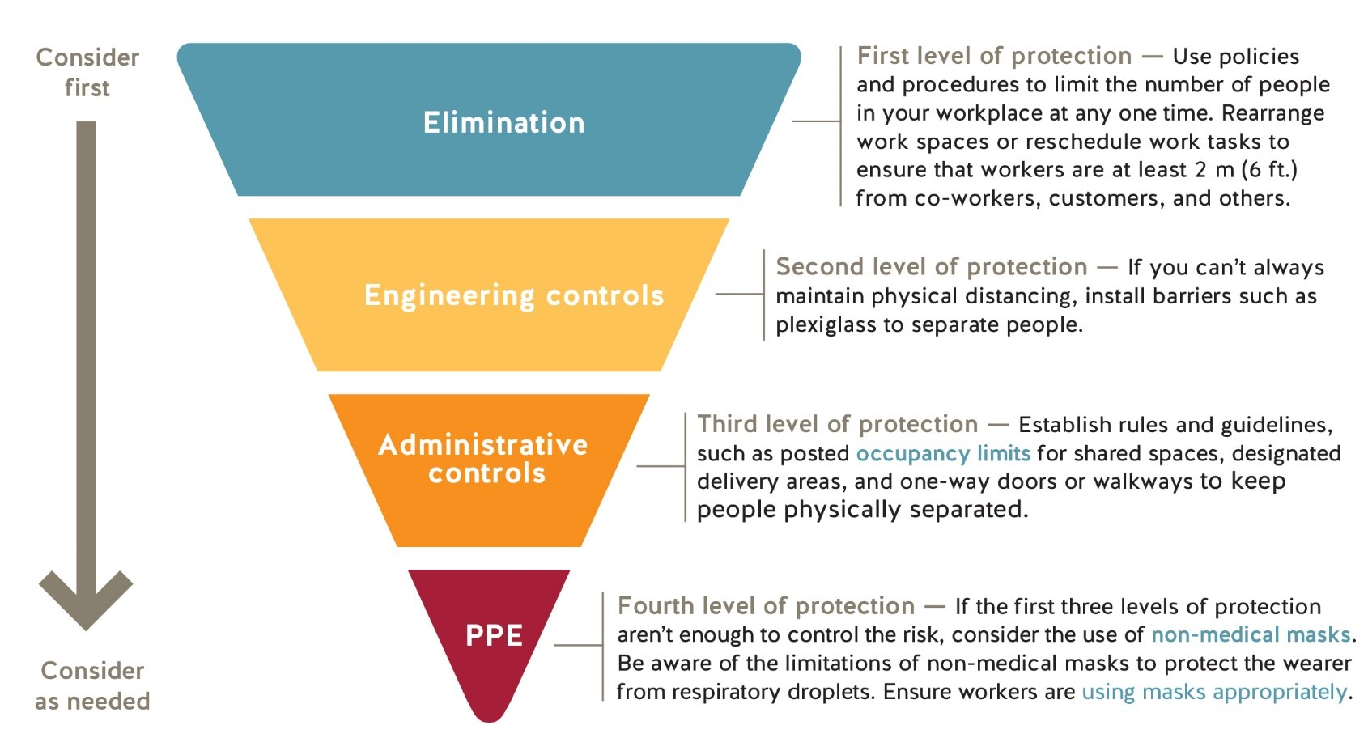
The Return to Safe Operations Risk Assessment tool has a number of recommended actions to consider. Note that you are not limited to selecting these as controls, and that the control hierarchy should be considered for any risks identified. Document your chosen controls in the Return to Safe Operations Risk Assessment Tool. Identify in risk assessment the considerations for each level of protection.
Step 3 - Developing Plans and Procedures
A number of General Safe Work Procedures and Signage have been developed and are available for tasks/situations relating to Covid-19.
These safe work procedures are available at the following link:
S:\Safety\OH&S Program Manual Master\SP8 Emergency Preparedness\Coronavirus Information\3. Covid 19 General SWPs
- SWP – Covid-19 – Cleaning Work Stations and Work Areas
- SWP – Covid-19 – Enforcing Distancing and Facility Protocols with Public
- SWP – Covid-19 – Handling and Transferring of Materials Between Staff and Public
- SWP – Covid-19 – Use of Meeting Rooms
- SWP – Covid-19 – Use of Neutral Disinfectant
- SWP – Covid-19 – First Aid Procedures
- SWP – Covid-19 – Hand Washing
- SWP – Covid-19 – Practicing Social Distancing
- SWP – Covid-19 – Removal of Gloves
- SWP – Covid-19 – Vehicle Cleaning
- SWP – Covid-19 – Working From Home
- SWP – Covid-19 – Workplace Exposure Protocol
- Signage – Do Not Enter if you are not Feeling well
- Signage – Covid Facility Instructions
- Directional / “Please stand here” signage
- Elevator signage
Following the risk assessment, a “Covid-19 – Area / Group Specific Plan” (appendix C) must be completed.

The Area / Group Specific Plan is a document that captures and communicates all the actions identified in the risk assessment to staff including any specific work procedures or written instructions for that group / area. This plan is to be reviewed and signed by all members of that work group / work area.

The risk assessment may also identify instructions that must be posted for the public to follow while visiting out facilities – These will be captured on the “Covid Facility Instructions” Document (appendix D).

Step 4 - Communication and Training of Plans and Procedures
Area / Group Specific Plans
Supervisors / managers will meet with their workforce to review and train staff to their Area / Group Specific Plans as well as applicable general safe work procedures. Attendance will be documented and forwarded to the Safety Division. These plans will be posted conspicuously in the workplace.
Posted Signage
If applicable to the work area / work group – the “Covid Facility Instructions” signage must be posted conspicuously for public to view. The “Do not enter if you are not feeling well” signage will also be posted conspicuously at entrances to city facilities.

Step 5 - Monitoring the Workplace and Updating Plans as Necessary
Things may change as our business operates. If staff or supervision identify a new area of concern, or if it seems like something isn’t working, take steps to update your policies and procedures. Involve a safety committee representative and the safety division in the process.
Staff should regularly communicate the effectiveness of their Work Area / Group Specific plan with their supervision.
Within the first week of an operation resuming, Supervision must complete a “Workplace Contact / Evaluation Form” (see appendix E). This should be completed regularly at a frequency determined appropriate by the area supervisor / manager.

Step 6 - Assess and address risks from resuming operations
If your workplace has not been operating for a period of time during the COVID-19 pandemic, you may need to manage risks arising from restarting your operations.
These risks are assessed in the final step of the “Returning to Safe Operations Risk Assessment” tool and consider hazards which may have developed as a result of having stopped the operation.

.

List of Appendicies

- Return to Safe Operations Risk Assessment
- Cleaning Information and Risk Assessment Tool
- Covid-19 Area / Group Specific Plan (template)
- Covid Facility Instructions (Template)
- Workplace Contact / Evaluation Form

