Contact Tracing and When to Self-Isolate

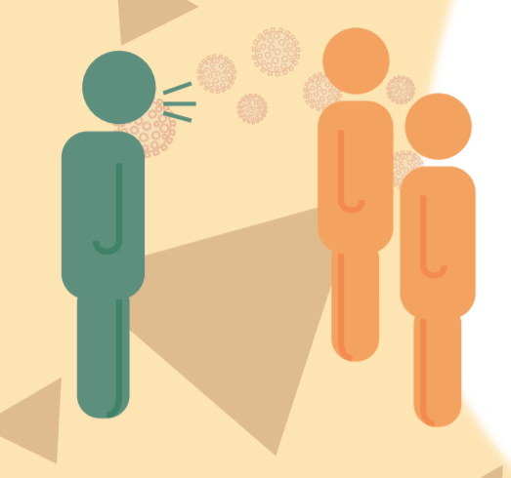
Introduction

Contact tracing is an important tool to help diagnose people who may have COVID-19 sooner and prevent the virus from spreading in your community.

If you are a contact of a confirmed case, a member of the public health team will contact you to let you know you may have been exposed. If you have symptoms, you will be sent for testing. If you do not have symptoms, you will be asked to self-isolate so that if you develop COVID-19, you won’t spread it to others in the community.
Have group watch this video: https://youtu.be/LE9Mhll30Ks

Self-isolation
Self-Isolation is required when:
- A person is returning from international travel
- A person has been exposed to the virus and been contacted by your regional health authority through the “contact tracing” process
- If experiencing COVID-19-like symptoms and required to test as directed by 8-1-1 or your public health authority

Contact Tracing
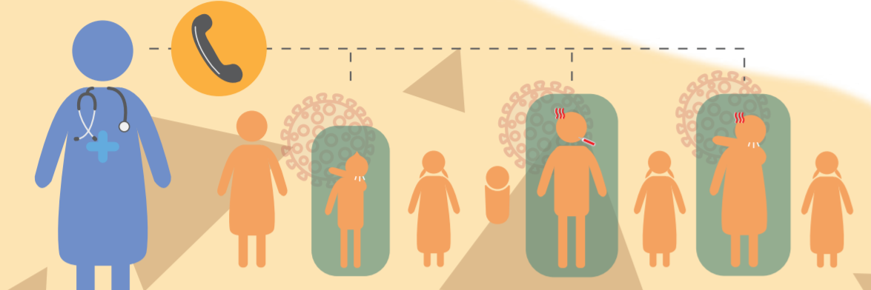
- When a person tests positive for COVID-19, they become a “case”.
- A public health nurse interviews the case to identify people they’ve spent time with. These people are “contacts.”
- Public health gets in touch with the contacts and asks them about symptoms of COVID-19.
- Not every contact needs to be identified: only those who could have been exposed to the case’s respiratory droplets from coughing, sneezing or speaking.
- Public health maintains the case’s privacy. A case can choose to tell others about their diagnosis but should not do their own contact tracing.
- Contacts with symptoms are sent for testing.
- If they test positive, they become a ‘case’ and the process repeats.
- Contacts with no symptoms are asked to self-isolate and monitor for symptoms for 14 days after their last contact with the case.
- Contact tracing helps people get diagnosed earlier and reduces the chance of spreading the virus

Toolbox talk Presenter ____________________________
Date: _______________
Time: ___________
Shift: ________________________________

Other safety issues or suggestions made by attendees:

Record of those attending:
Name: (please print) | Signature:
1.
2.
3.
4.
5.
6.
7.
8.
9.
10.
11.
12.
13.
(signature)
Manager/Supervisor remarks: ____________________________________________________________________________________________________________________________________________________________________________________________________________________________________________________________________________________________________________

Manager/supervisor __________________________________

