heat stress prevention - SAFE WORK procedure

PURPOSE
The purpose of this procedure is to provide Sample City departments with generalized guidelines for reducing the risk of heat-stress injuries (heat cramps, heat exhaustion, heat stroke) during heat waves.

Heat stress injuries occur when your body heats up faster than it’s able to cool itself – this can lead to serious heat disorders and potential injury. Everybody has different tolerance to working in the heat, based on personal factors (ex. acclimatization, clothing, hydration level, physical condition) and work environment factors (air temperature, humidity, work load, work rate).

SCOPE
This procedure covers the proper and safe ways to conduct work during summertime heat waves.

APPLICABILITY
These procedures apply to all Sample City employees. Additional procedures may be required for specialized work situations in the heat, such as firefighting.

PREREQUISITES
Not applicable

REFERENCE SOURCES:
- Sample City Safety Management System
- WorkSafeBC – Preventing Heat Stress at Work
- WorkSafeBC Regulations
  - 7.26 to 7.32 – Heat Exposure
- General – Heat Stress Prevention Risk Assessment

PPE REQUIRED:
- Task specific PPE

TOOLS AND EQUIPMENT REQUIRED:
- Task specific tools and equipment | - Water | - Hat (where applicable)
- Sunglasses (where applicable) | - Sunscreen (where applicable)

PRE – Work Procedure
Responsibility | Activity
Employer | - Ensure there is a heat stress program and that effective risk assessments and procedures are in place to mitigate the risk of heat stress injuries.
Employees | - Be aware of the contents of the heat stress prevention risk assessment and safe work procedure  - Follow the contents of the procedures, as applicable, as they are reasonable steps to reduce your personal risk of heat stress injury.
OHS Branch | - Provide guidance and support to the City’s divisions on managing the risk of heat stress in the workplace. This includes staying up to date on the regulation and best practices, and also advising on best course of action, particularly for high intensity work.

General knowledge
There are numerous factors that contribute to heat stress, it’s important for all to be familiar with them (Source: WorkSafeBC Preventing Heat Stress at Work)
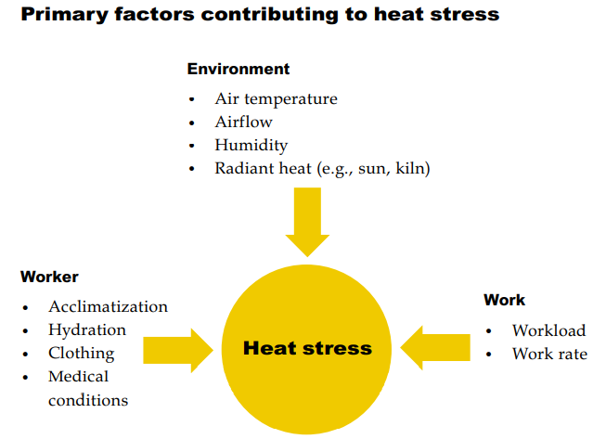
Heat stress is generally broken down into three types – heat cramps, heat exhaustion and heat stroke. Heat stroke is very serious, those suffering from it must be transported to hospital by ambulance for immediate attention.
Symptoms of heat disorders are:

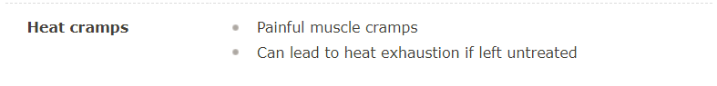

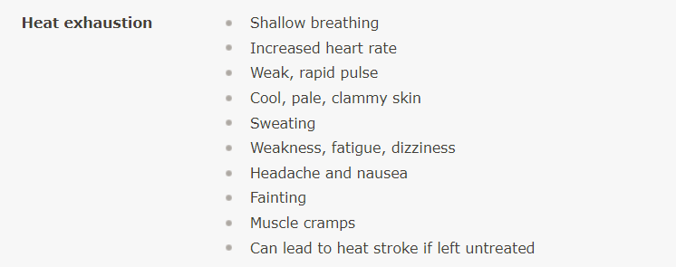
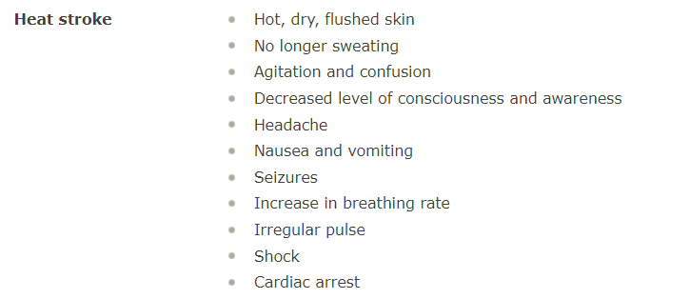

Safe Work Procedure – prevention of heat stress injuries
Responsibility | Activity
All | Take steps to reduce the likelihood of developing heat stress injuries. Engineering controls should be considered first as they provide a higher level of safety than administrative and PPE controls.  Reasonable steps include a combination of some of the following, and are dependent on the work scenario (ex. indoors vs. outdoors):  Engineering controls  - Reduce worker activity through automation or mechanization  - Cover or insulate hot surfaces to reduce radiant heat  - Shield workers from radiant heat  - Provide air conditioning or increased ventilation to remove hot air  - Provide fans for cooling (CAUTION: where temperatures in surrounding air is above 35 C, using fans may increase risk of heat stress)  - Reduce humidity in air using air conditioning and dehumidifiers  Administrative controls  - Gradually acclimatize your body to heat and work – it allows the body to modify its own functions to better cope with heat stress and to remove excess heat more efficiently  - Gradual acclimatization takes approximately 7 days of continues gradual exposure but can take as long as three weeks. Variation is due to personal risk factors such as age, fitness level, obesity, alcohol/drug use, and medical conditions (ex. chronic skin disorders, diabetes, hyperthyroidism)  - General acclimatization for an average person who has not previously worked in a hot environment can start at 20 percent of the full workload on the first day followed by a 10 to 20 percent workload increase during each subsequent day  - If workers are away from hot conditions for more than seven consecutive days, they could start at 50 percent of the workload on the first day they return and increase workload by 10 to 20 percent each day  - Avoid working alone in conditions where heat stress is possible – work in pairs, establish a check-in system etc.  - Schedule rest periods in to allow adequate time for workers to cool down  - Schedule hardest part of tasks for coolest part of the day  - Rotate work activities or use additional workers  - Move or relocate work away from direct sunlight or radiant heat sources, where possible  - Schedule routine maintenance and repair work during cooler seasons of the year, where possible  - For indoor work, schedule routine maintenance and repair work for times when hot operations are shut down  - Drink water – it’s important to replace fluids to maintain levels of hydration as sweating uses up a significant amount of fluid  - Recommendation from WorkSafeBC is to drink approximately two glasses (1/2 litre) of water prior to starting work in a hot environment and one glass every 20 minutes throughout the workday  - Employers have a responsibility to provide an adequate supply of cool drinking water close to the work areas for workers exposed to heat  PPE and clothing controls  - Wear loose fitting, light coloured made of fabrics such as cotton or silk – they allow air to pass through.  - Light-coloured clothing reflects the heat better than dark-coloured clothing, helping the body to keep cool

First aid for heat stress injuries
Responsibility | Activity
All | - Report all instances of work-induced heat stress injuries to a designated level 2 first aid attendant.
All | Heat cramp treatment (muscular pain or spasms, excessive sweating)  - Move worker to cooler environment, if possible, lay worker down and remove or loosen tight-fitting clothing  - Cool worker by sponging with cool water and fanning. Take care not to cool the worker too much – if a worker begins to shiver, stop cooling  - If the worker is alert and not nauseated, provide oral fluids – juice, non-caffeinated soft drinks, sport drinks, water (salt water with 1 teaspoon of salt and ½ litre of water is best) are best. Do not provide caffeinated beverages.
All | Heat exhaustion (cool/pale/clammy skin, sweating, weakness, fatigue etc. – see page 3 for additional symptoms)  - Move worker to cooler environment, if possible, lay worker down and remove or loosen tight-fitting clothing  - Cool worker by sponging with cool water and fanning. Take care not to cool the worker too much – if a worker begins to shiver, stop cooling  - If the worker is alert and not nauseated, provide oral fluids – juice, non-caffeinated soft drinks, sport drinks, water (salt water with 1 teaspoon of salt and ½ litre of water is best) are best. Do not provide caffeinated beverages.  In most cases, the patient’s symptoms will improve dramatically – they should still be transported to medical aid
All | Heat stroke (very serious condition – call 9-1-1 right away, notify first aid attendant – characterized by hot/dry/flushed skin, absences of sweating, agitation/confusion, decreased level of consciousness, nausea/vomiting, possibility of seizures, irregular pulse, increased respiration, cardiac arrest)  - Maintain airway, breathing and circulation  - Move worker to coolest place possible  - Lay supine (on back) unless they’re actively vomiting or having a seizure (place them laterally in these cases)  - Remove all outer clothing and apply cold water by either dousing or applying wet, cool sheets – spraying or sponging body with water is also effective, as is fanning  - If the worker is alert and not nauseated, provide oral fluids – juice, non-caffeinated soft drinks, sport drinks, water (salt water with 1 teaspoon of salt and ½ litre of water is best) are best. Do not provide caffeinated beverages.  - Transport to medical aid and continue to cool during transport

POST – House keeping
Responsibility | Activity
Employer (supervisor) | - Responsible to investigate all reports of heat stress injuries. Liaise with Safety Branch for assistance.

Written By: |  | Title: |  | Dept.

